**Assignment Project:**

**Instruction:**

1. **Change the details of your database in dbconfig.php**

**<?php**

**// Database connection parameters**

**$servername = "localhost"; // Change this if your database is hosted elsewhere**

**$db_username = "root"; // Change this to your database username**

**$db_password = ""; // Change this to your database password**

**$dbname = ""; // Change this to your database name**

**?>**

1. **Login Page:**

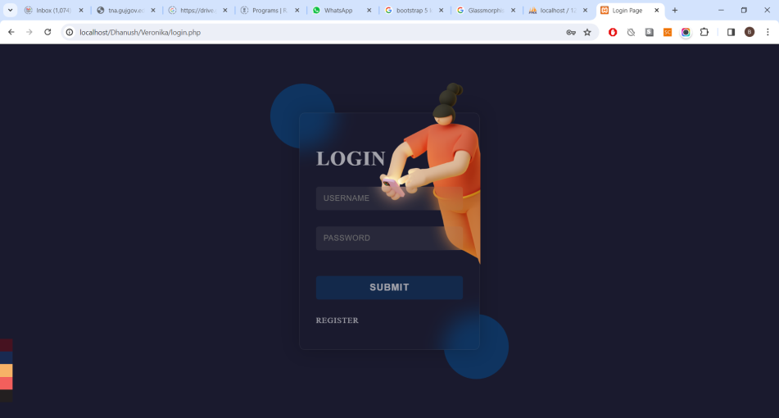

1. **Registration Page:**

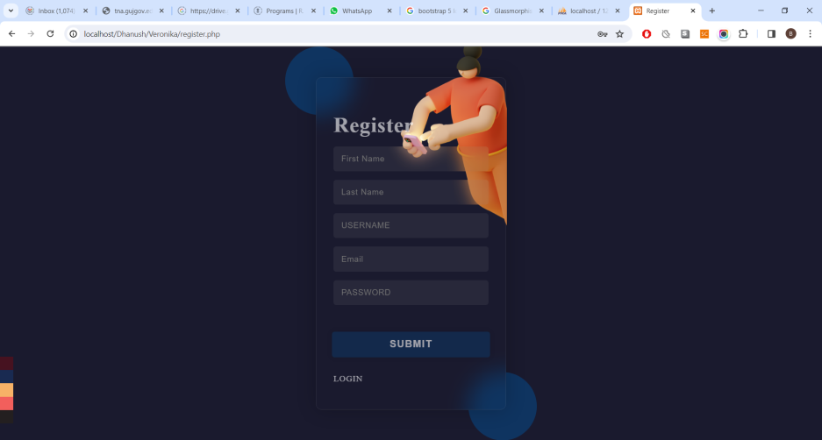

1. **Home Page:**

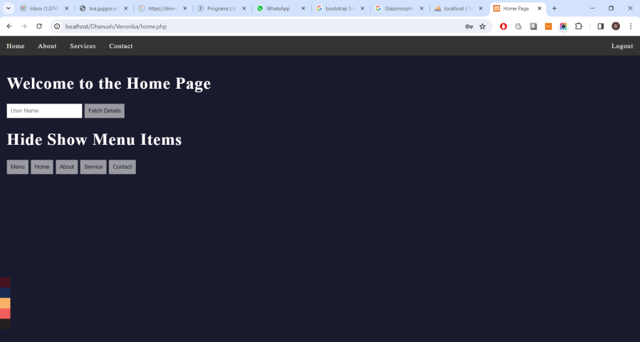

1. **Enter the username in the text field and hit “Fetch Details” Ajax based request will be sent to the server and JSON will be returned which will be displayed as below:**

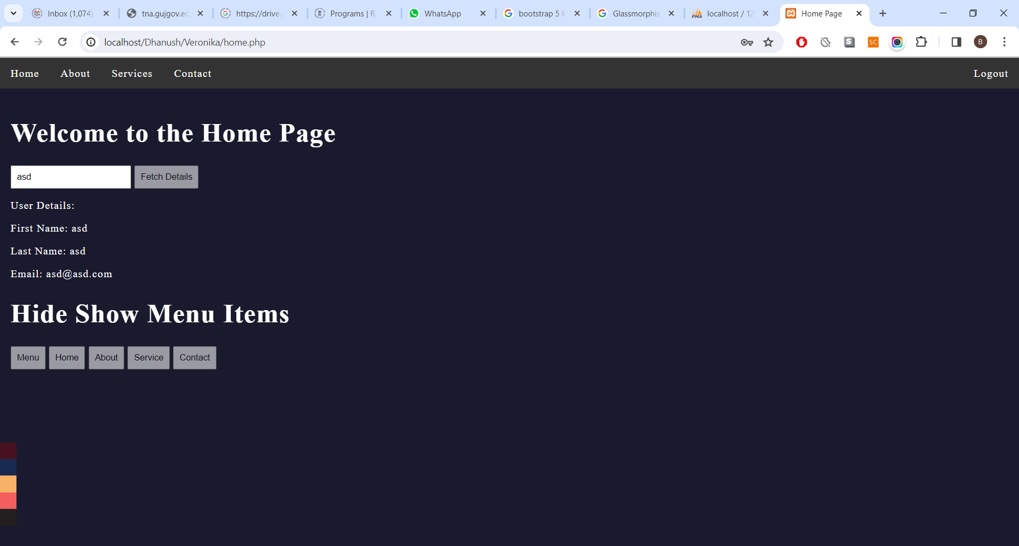

1. **You can toggle Menu Items using the following Buttons:**

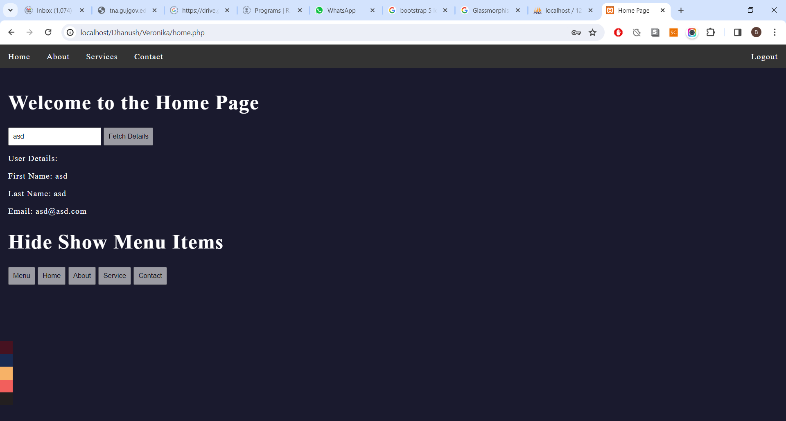

1. **On Every Page there is a color palette that can be used to toggle the color theme of the website:**

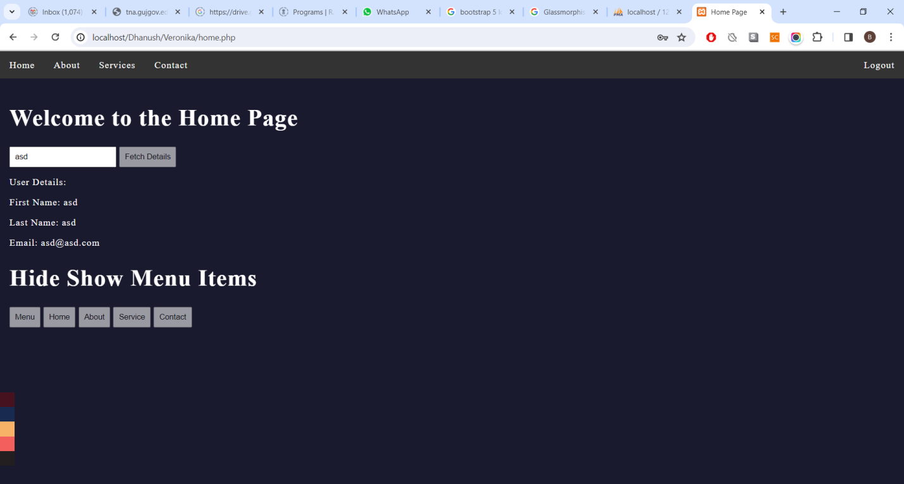

**For the Database Creation use the following queries:**

**CREATE DATABASE veronika;**

**USE DATABASE veronika;**

**CREATE TABLE `veronika`.`userdetails` ( `id` INT NOT NULL AUTO_INCREMENT , `username` VARCHAR(50) NOT NULL , `firstname` VARCHAR(50) NOT NULL , `lastname` VARCHAR(50) NOT NULL , `email` VARCHAR(50) NOT NULL , `pwd` VARCHAR(255) NOT NULL , PRIMARY KEY (`id`)) ENGINE = InnoDB;**