**Quick guide for updating Dexterit-E task on the new setup**

**Introduction**

During the months of February and March 2021, the Kinarm end point used in the lab of Philippe Lefèvre and Frédéric Crevecoeur at UCLouvain has been changed. Here is an exhaustive list of the pieces and software that have been changed :

* Dexterit-E computer (ie, Windows computer) has been upgraded (new GPU amongst others in order to handle the new 120Hz display)
* OS has been moved to Windows 10, Internet connection has been restored
* Dexterit-E software and Dexterit-E explorer has been updated to versions 3.8 and 1.15 respectively
* Dexterit-E toolbox software (ie the Matlab toolbox that handles the Kinarm) has also been upgraded to 3.8
* Robot computer has been upgraded (including a new PCI card and new connectors)
* The network switch has been upgraded

MOST IMPORTANT POINT : go to the end of the document to take a peek at the information about the analog inputs. If you do not take that into account, you will not be able to record EMG data!!!

**Detailed description – Robot computer**

The robot computer has been upgraded in March 2021 in order to fix a problem at the level of the motherboard or RAM memory. This robot computer is identified by a sticker “Robot computer” and is used for the real time communication with the Kinarm robot and all the peripherals. This is the computer concerned with data acquisition.

Besides the classical computer components, this computer has 3 cards installed on it. The first one from the is a National Instrument (NI) card (PCI 6229) that is connected through two cables to the two NI breakout boards. This acquisition card is responsible for dealing with the EMGs, the motors of the robot and Kingrip. The two connectors cables should never be disconnected! If they really have to be disconnected, please make sure that they are connected in such a way that the cable connected to the motor breakout box (the top box, with direct connections to the “Kinarm” box) is on the “Connector 0” slot of the card.

The second and third cards of the robot computer are the cards that are connected through ribbon cables to the “Kinarm box”. These cards should never be moved around. Their goal is to read the data directly from the Kinarm (kinematics data, events, etc).

The robot computer is also connected to the network switch using ethernet connection.

**Detailed description – Dexterit-E computer**

The Dexterit-E computer (aka the Windows computer) has been upgraded in February 2021 and is identified by a “Dexterit-E computer” sticker. This is the computer that the experimentator will use in order to perform experiments. This computer contains the classical computer components including an embedded Radeon GPU aiming at handling the VPIXX 120Hz display.

The internet connection has been restored with the OS upgrade to Windows 10. This means that the computer can now connect to chrome. Here is a series of recommendation regarding the internet connection on that specific computer :

* Do not have Google Chrome open while performing experiments. This will consume part of the bandwidth and data collection might be laggy or buggy…
* Do not install anything on that computer without Kinarm advice. The computer has been specifically designed to have enough RAM and CPU power to handle the setup, if softwares were to be added, this won’t be optimal anymore and it will get even more slow and buggy.
* Never ever do any Windows upgrades!!! They are blocked by default but Windows will show you popup windows asking for upgrades, don’t launch them as it will update the drivers to version that are not working with the setup.

This computer might be laggier now, this is normal regarding its configuration. You can always verify the ongoing processes (CTRL+MAJ+DEL) to see which ones are responsible for the lag… Sometimes the lag might be interpreted as a firewall problem by Windows (do not ask me why…), in this case restart the computer and it should be alright!

**Matlab**

Matlab has been upgraded to the version 2015a SP. This means that some functions have been added and some might not be working the same way as before (see Examples section for more details). This Matlab version also integrates Simulink and Stateflow that have to be used in order to program the robot. This new version is a little bit slower in terms of compilation at it involves more verification steps. While compiling a task, nothing should appear in the Matlab prompt, the log and eventual error messages will appear in a popup window.

As before, make sur that the matlab path is set to the directory where you want the Simulink model to be compiled. The compilation will create a series of files amongst which is the *dlm* which is the one that has to be fed to Dexterit-E (you have to put it in the folder Documents/Dexterit-E3.8Tasks/WhicheverFolderYouWant).

If you want to investigate the frequency at which each signal will be working in Simulink, you can display them by applying the following operations:

1. Right click on the model background
2. In the menu that appears, select “Signal frequency”
3. In the dropdown menu, click on color (even if its already checked)
4. The task will compile and you will have colors that appear alongside a legend (CTRL+J allows to diplay the legend if it’s not working)

The image below represents what it should look like

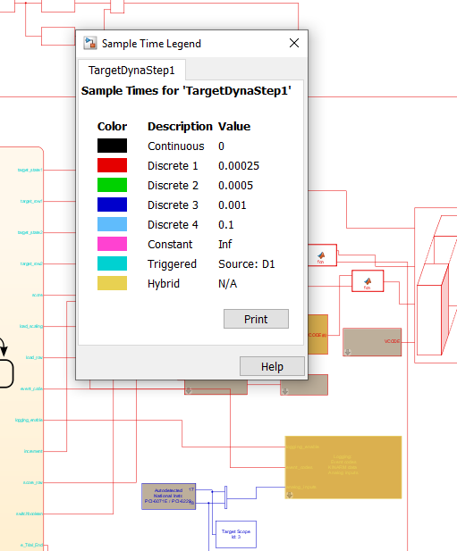

**Simulink – Stateflow**

After compiling a few tasks, the following bugs and error messages have been encountered. I hope the following list is exhaustive but, since all the tasks were not recompiled, it is possible that some new bugs show up. In this case, it would be nice if they were added to this document.

1. *Could not broadcast the analog outputs to …*

The following bug appears when you use a “bus creator” in your task. These blocks are now interpreted differently with the new Matlab and DTK versions and are not working the way they were before. They have to be replaced by the “mux” blocks see below. They can be found in the Simulink library (click on the icon with the four colored squares and search “mux” in the search engine).

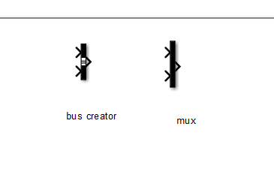

These two blocks are similar and replacing all the bus creators by muxes should be the fix for that bug!

1. *Rate transition block missing…*

This is a bug that was observed in recompiling some tasks. This occurs when we try to mix some signals that are sampled at different frequencies. The fix is to add a “rate transition” block that will automatically resampled signals to make them fit their buddies. See image below for an example

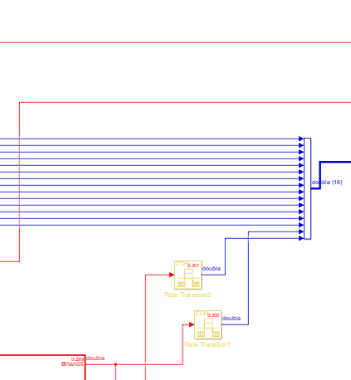

1. **This is not really a bug but you should be careful of the analog inputs you use!!!!**

Since we updated the PCI card to a newer version, the mapping of the analog inputs has changed. In the previous setup, the analog inputs were connected to channels 1-16 of the card. That means that in your code, the “channel” field of the analog inputs was filled with values in the range 1-16 that correspond to the channels to which you connected the electrodes.

This has changed now, the analog channels in the PCI card are channels number 17-32 so you have to change you channels in the Analog input box accordingly (see examples below). If you don’t do that, you will be recording motors and should observe something which is far from being EMG or any other analog inputs you connected…

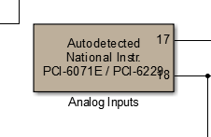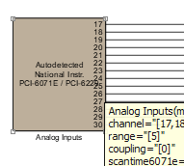

These two examples represent the new numbering for a block of 2 (left) and a block of 14 (right) analog inputs.