

Only move j or k alone if sum is not 0



Move k to index 4



If we take first element as candidate, possible element for b is index 1,2,3,4 and last one must be left for c so that

a+b+c=0

A possible combination is index 0 + index 4 + index 5

-3+1+2=0



The idea is to first set i to a fixed element, after we have 2 pointers j that moves to the right and k to the left

Notice that if [i]+[j]+[k]< 0 move j to a bigger number since it is sorted so naturally neighbor on the right are bigger and if [i]+[j]+[k]> 0 move k to the left since we need a smaller number and neighbor on the left are smaller



The problem is that we don’t want duplicates and we can see -3 are not in the same area meaning its very complicate to keep track of duplicates we will need to store a lot of elements to check if duplicate exist

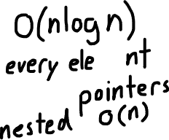

By sorting all elements in array, all duplicates will become neighboors so when we iterate if the current value is the same as the one of his left neighboor we know it’s a duplicate cuz we just considered the value in the previous iteration so we just skip the current iteration same goes for j and k(right nighboor instead)

