

Both intersect before reaching target position meaning they will for a fleet. A car behind another can only catch up to the one directly in front of him.

Both car meet at time 1, position 12

2(1)+10=12 or 4(1)+8=12.

Red car will slow down to match speed of blue car when he catches up.

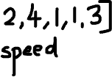

How do we know if 2 cars intersected before reaching the target destination ?

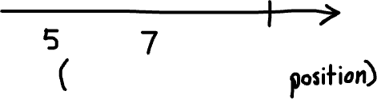

If car B took a longer time to reach target than car A they will never intersect before the destination



By calculating the time needed for car A to reach target position and the time needed for car B to reach target.

If car B took less or equal time to reach the target then both car A and car B will form a fleet before reaching target.



How to compute which car to keep representing the fleet ?

Keep the one closer to the target, the cars behind can only catch up then have the same speed so the closer one is the limiting factor.

