We want the min height since water will spill out if we take the max.

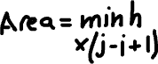

Solution is O(n^2), i will iterate through n elements in the array, for a single i, j will iterate through n-1, n-2, n-3, … for each we can approximate to O(n) too.



We want max height and max width, by starting pointers as far from each other increase chances of getting the max width as soon as possible.

No problem moving pointer of smaller height to find max width for area since we save max area and will only replace value if the combination of both width and height bigger than current max



Edge case is if both height are equal, we can move either one nothing will change.