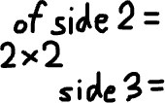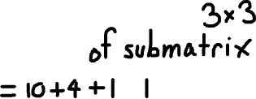

We start by going through the first column then the first row. They both can only have matrix of size 1x1 containing 1. We add it the count if the current element is 1.

Iteration of first row ranges from 1 to 3 because element at 0 already counted in first column so we don’t want to add twice.



At the current position we check 3 neighboors: the left, the diagonal and the top in the cumulative matrix. If the minimum of the 3 spot is 1 we know for sure all 3 spot are 1 and we add 1 (current position).

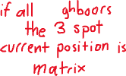





Not enough 1 to make 2x2 matrix

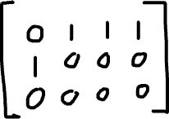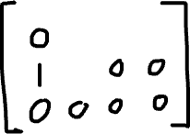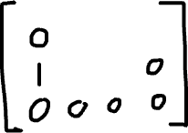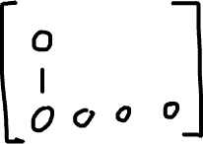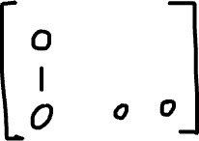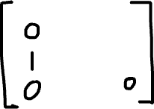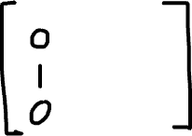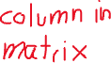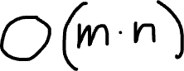

Cumulative matrix tells you how far you can stretch the square matrix of 1 so the at 3 we know all other neighboor are also square matrix of 1 and getting surrounded by the same sum means you can further stretch the matrix into a 3x3 of 1



|  |  |  |
| --- | --- | --- |
|  |  |  |
|  |  |  |
|  |  |  |

|  |  |  |
| --- | --- | --- |
|  |  |  |
|  |  |  |
|  |  |  |

The 2 is surrounded by different sum meaning some sides are not matrix of 2x2 but only 1x1 meaning at the current position we cannot stretch it into a matrix of 3x3, one of the neighboors’s neighboor is a 0 and will stop the expansion.