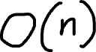

In the input there is never a negative value which means we can mark the original array to save memory.

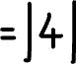

We check what index does the current element maps to then we go to that index and we convert the value at the index to negative.

All the missing values will not have their corresponding index’s element negative

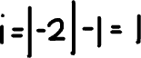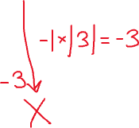

Index 1 was already overwritten to negative but nothing changes since we take the absolute value at that index

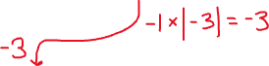

If we take the index with positive numbers and add 1 to them it gives use the missing numbers 4+1=5 and 5+1=6.