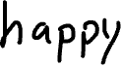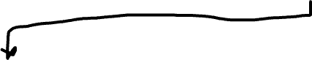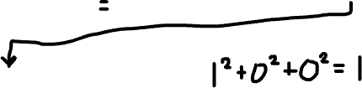

After transforming a few times any further transformation just endlessly stays at 1. It is a happy number. We know that once 1 is reached it will loop on itself endlessly.

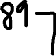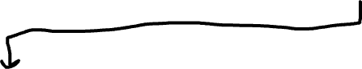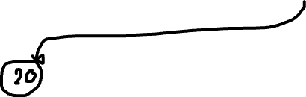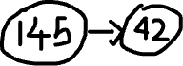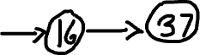

We can see that if the last number loops back to one of the numbers in the chain then it is not a happy number.

