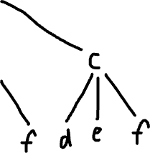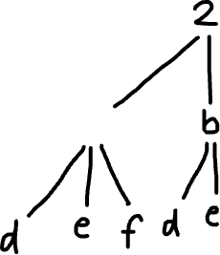

The time complexity is the number of combinations we have in this case 9. ad, ae, af, bd, be, bf, cd, ce, cf.

The time complexity we consider is always the worst case. In all

Digit, find the one with most letters which is 7 or 9.

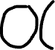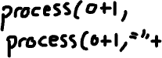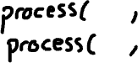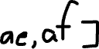

P(0,””)



P(0,”c”)

P(1,”a”)

P(1,”b”)

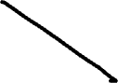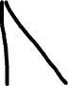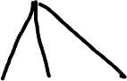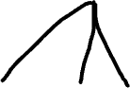

P(2,”ad”)

P(2,”cf”)

P(2,”ce”)

P(2,”cd”)

P(2,”bf”)

P(2,”be”)

P(2,”bd”)

P(2,”af”)

P(2,”ae”)

