

The idea is to first set the first letter of the substring with i then build the rest of the substring with j which is O(n^2)

Ex: s[i]=b,

ba, bab, baba, babad

s[i]=a,

ab, aba, abad



After acquiring the substring, a function will compare every single character from beginning and end to see if it is a palindrome therefore adding an O(n) nested complexity



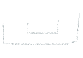

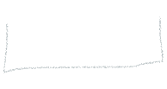



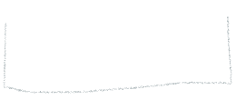



Have pointers start on a letter then expands outward, this case is for string with odd length



Have pointers point at different letters

