Ferre De Cordt – PR team
Belgian Junior Gliding Team
sponsorship brochure jwgc 2026
Belgian Junior Gliding Team

Introduction
On behalf of the Belgian Junior Gliding Team, we would like to thank you for taking the time to review this document. Your interest in our sport and ambitions is greatly appreciated. With this brochure, we present the opportunity to support our team and our sporting goals for the upcoming World Championships in Aalen, Germany (2-15 of August 2026), either financially or materially. In this document, you will find detailed information about our mission, the team, and the unique visibility we can offer our partners. Should you have any questions regarding sponsorship opportunities, the Belgian Junior Gliding Team in general, or if you wish to schedule a personal meeting, we cordially invite you to contact us.

On behalf of the Belgian Junior Gliding Team
Ferre De Cordt
PR-representative

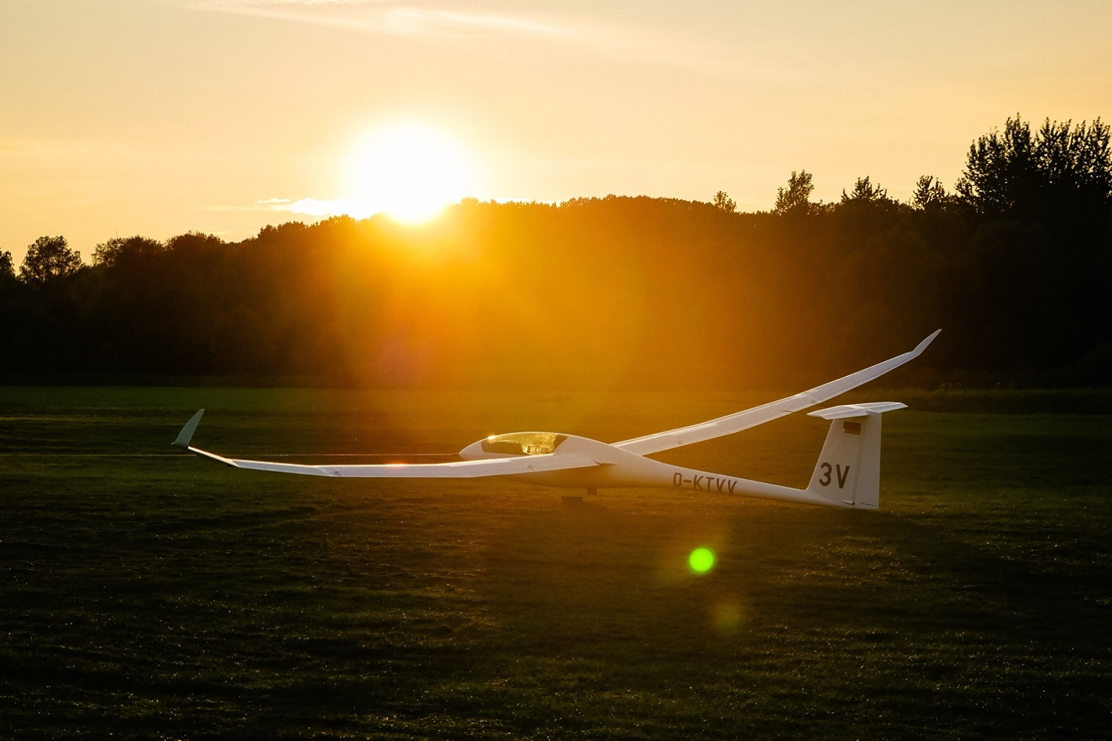

Our team
Every year, a number of pilots represent Belgium at the World Gliding Championships. These pilots are selected based on their results in various national and international competitions. Throughout the year, our pilots train intensively at different locations in Belgium. There is a growing emphasis on 'team flying': strategically sharing information and collectively making tactical decisions during the race. Thanks to the growing number of junior pilots and a very competitive national championship, the future of the Belgian team looks promising.

This year, our country is represented by a promising team consisting of Edwige Colson, Virginie Valck, Michiel Haemels & Wannes Smits. They are assisted by Guillaume Dohet, an experienced competition pilot who, as Team Captain, uses his expertise to strategically guide our juniors during the competition. The team is completed by Ferre De Cordt and Axl Bedert. As the PR team and logistical support, they ensure that the pilots can focus entirely on their sporting performances while maintaining the visibility of the team and our partners.
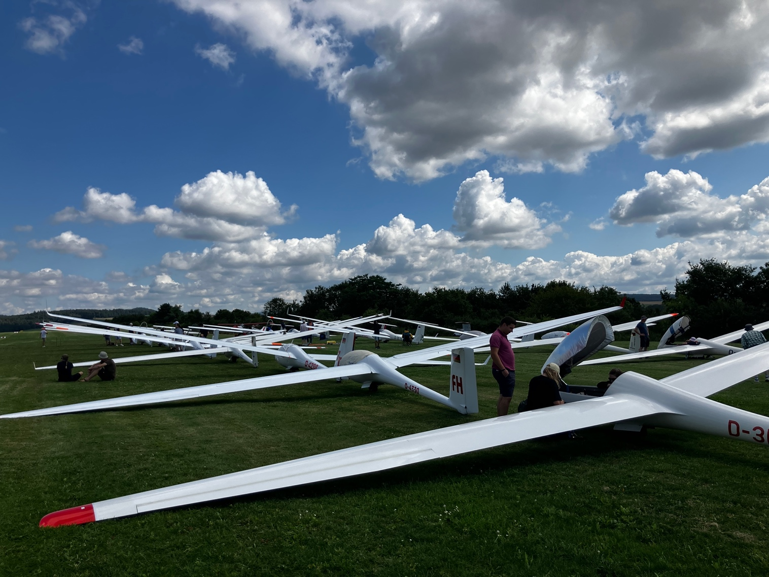

What is gliding?
Gliding is an exciting form of flight that allows pilots to navigate through the air without the use of a traditional engine. Instead, glider pilots rely on the natural forces of the atmosphere to keep their aircraft airborne.
The glider—a lightweight, aerodynamically designed aircraft without an engine—is typically towed into the air by a motorized plane or launched from the ground using a winch. Once in the air, the pilot uses their skills to utilize rising air currents, known as thermals, to gain altitude and extend their flight.
Key features of gliding:
- Silence: One of the most enchanting aspects is the absence of engine noise. Gliders slice silently through the air, offering an unparalleled connection with nature.
- Technology: Designed for efficiency, their sleek forms are a marvel of aerodynamic engineering. There is a strong focus on innovation, such as gliders with electric assistance, promoting sustainable aviation goals.
- Skill and technique: Pilots are highly trained in the "art of reading the sky". They must be adept at finding lift to enable long cross-country flights.
- Safety: Safety is a paramount topic. Gliders are equipped with features such as parachutes and emergency equipment.
- Community & equality: Gliding is a communal activity providing a sense of camaraderie. It is also one of the few competitive sports where men and women compete on equal terms.
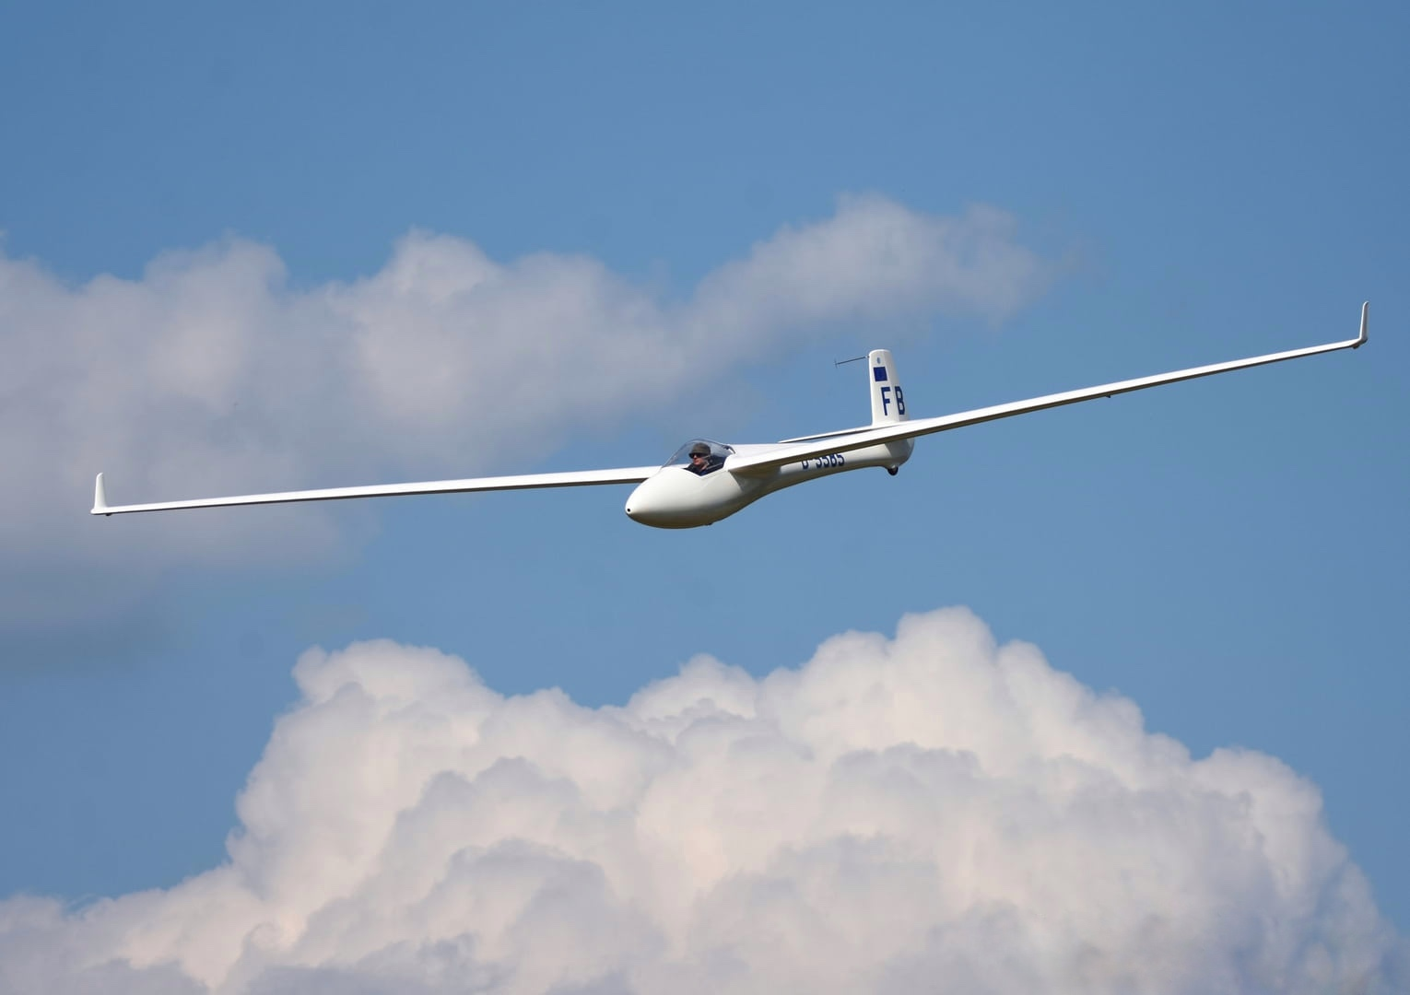

Gliding competitions
Competitive gliding is completely different from the image most people have of it. At the highest level, the best pilots race along predetermined courses, with distances and average speeds comparable to those of a Formula 1 Grand Prix.
For a pilot, altitude is the equivalent of fuel in the tank. In their glider, they constantly read the sky to determine the optimal route and find the strongest rising air (thermals). This allows them to climb efficiently and then fly at high speeds to the next source of lift. Pilots think several steps ahead: they often plan two to three climbs in advance, follow their opponents, learn from teammates' radio traffic, and strive for maximum efficiency.
A major competition, such as a World Championship, typically consists of about ten competition days. Each day starts with a briefing where the task is announced. Depending on the weather conditions, this involves a trajectory of 250 to 700 kilometers, along various turn points. The exact choice of route lies with the pilot.
Before the start, the gliders are lined up in grid order and launched using tow planes. Ten minutes after the last aircraft has taken off, the start line opens. From that moment on, each pilot chooses for themselves when to start, based on the conditions. After that, the goal is simple: to complete the course as quickly as possible. When the weather deteriorates and pilots do not reach the finish point, they must divert to another airfield or make a field landing. In that case, the pilot who has covered the greatest distance wins.
Per competition day, points are awarded based on speed and/or distance. These points are totaled over the entire competition, and the pilot with the highest total is declared the champion. Pilots can fly individually, but team flying is becoming increasingly common. In this practice, pilots stay close to each other and continuously exchange information via radio about the best routes and thermals. In this way, they help each other to fly more efficiently and avoid mistakes.
The verification of whether a pilot has correctly completed the trajectory is done via dataloggers on board the glider. These record the entire flight with GPS, including position and altitude. After landing, the data is analyzed. Any violations, such as entering controlled airspace, can lead to point deductions.

Our mission
The mission of the Belgian Junior Gliding Team is clear: to promote gliding and aviation in Belgium and to inspire young people. We focus on both girls and boys, aiming to introduce them to the unique and fascinating world of aviation. Our team encourages young people to discover their passion and actively participate in gliding.
Our goal is to deliver a strong performance in the team cup during the 14th FAI Junior World Gliding Championships in Aalen-Elchingen, Germany. By doing so, we aim to represent Belgium with pride on an international level. A good result not only contributes to the development of our pilots but also strengthens the visibility and appeal of gliding in Belgium.
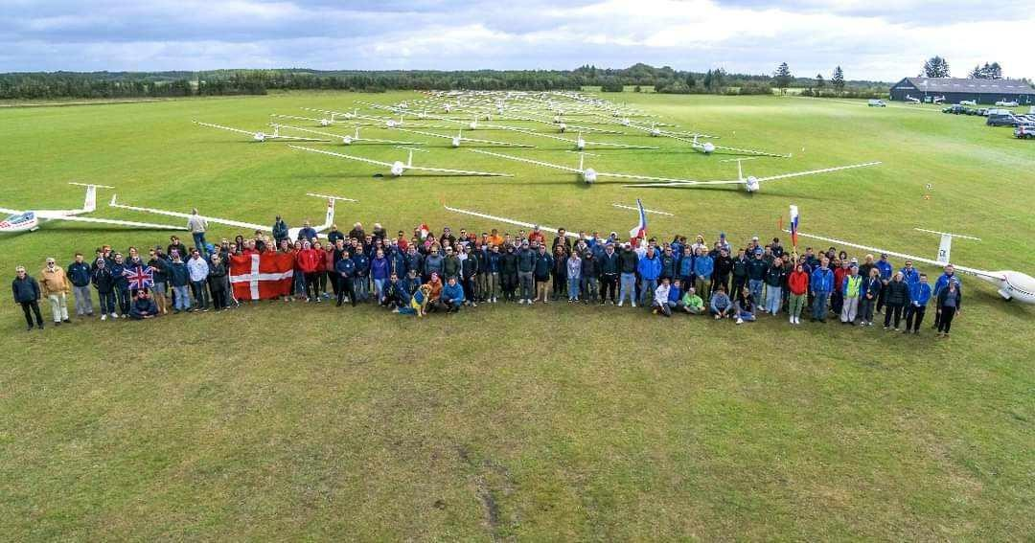

Cost of a championship
Participation in an international competition involves significant costs, which are currently largely borne by the participants themselves. With the support of sponsors, we want to ensure that every junior, regardless of financial background, has the opportunity to participate in a world championship. Thanks to external support, we can lower the financial barrier and give young talents the chance to represent Belgium internationally.
This budget is based on the participation of one pilot and one crew member during the 14th FAI Junior World Gliding Championships, and provides a realistic picture of the total cost.
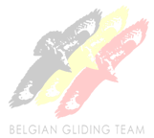
Budget 14th FAI Junior World Gliding Championships
Transport & logistics |  | € 2000,00
Accommodation & food |  | € 2300,00
Registration & flight costs |  | € 1700,00
Material & operational cost |  | €1000,00
Insurance & administration |  | € 300,00
Subtotal |  | € 7300,00
Contingency costs (15%) |  | € 1100,00
TOTAL |  | € 8400,00

Sponsorship opportunities
As a sponsor of the Belgian Junior Gliding Team, your company gets the opportunity to be visible during this international competition, while simultaneously supporting young talents in their dream to represent Belgium on a global level.
We offer various ways to put your brand in the spotlight:
- Logo on the glider – your brand literally flies along in the sky and will be noticed by both participants and visitors.
- Logo on the glider trailer – visibility during transport and at the airport or competition fields.
- Logo on our team clothing – worn by pilots and crew, both during competitions and public events.
- Logo on our website (www.belgianjuniors.be) – your brand present online for visitors of our website and blog.
- Sponsor post on our blog and social media – tell your story, show your involvement in sports and youth development.

Final words
Thank you for your time and interest in our work. We hope this brochure has provided you with a clear picture of our mission and ambitions. We would welcome the opportunity to discuss potential collaboration with you further.
CONTACT DETAILS
Ferre De Cordt
PR Manager
✉️ gliding@belgianjuniors.be
🌐 www.belgianjuniors.be
📞 +32 471 99 28 90 (Dutch & English)
Facebook page: https://www.facebook.com/profile.php?id=100063463810175
Instagram page: https://www.instagram.com/belgianjuniorglidingteam

