Implementation of Storage as a Service

**Create AWS S3 Buckets:**

1. Visit <https://aws.amazon.com>
2. Login to your **AWS account**.
3. Go to **Services** option in header’s top left corner.
4. Click on S3 Bucket.

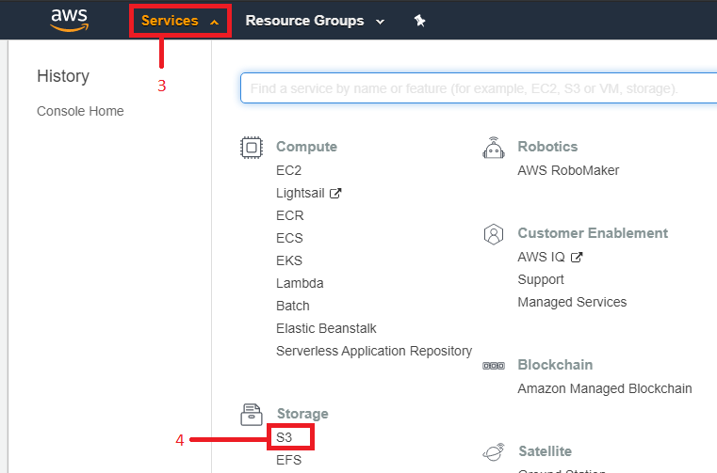

1. Click on **Create Bucket** button.

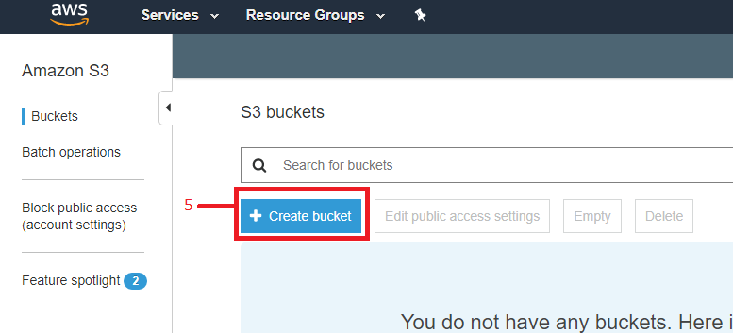

1. Give name to the bucket (It should not contain Uppercase Letters, Space, Special Characters)
2. Select **Region** where you want to create the bucket.
3. Click on **Next** Button.

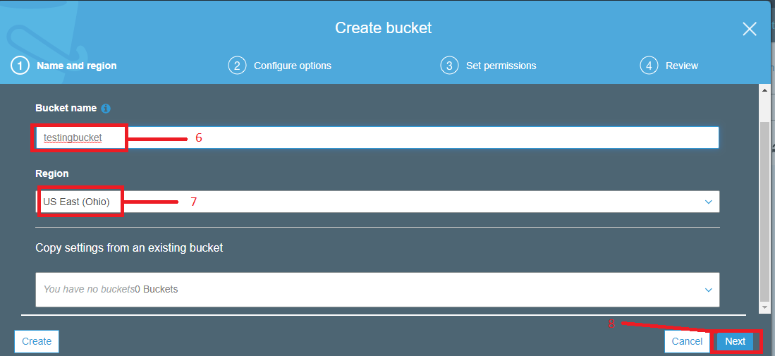

1. These are optional parts. (Here you will get logs like who access the server with the timestamp, you can also add tags for your reference here.)
2. Click on **Next** Button.

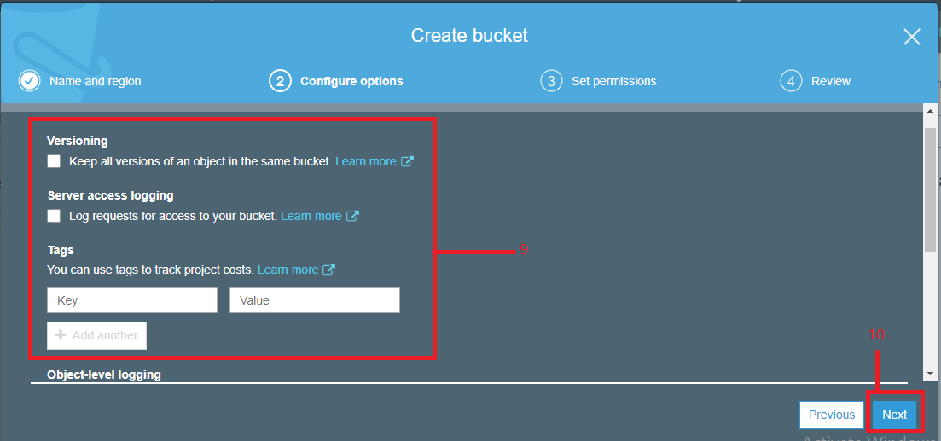

1. Tick this checkbox if you want to block public access. If you want to make this bucket accessible publically then you can untick this.
2. Click on **Next** to continue.

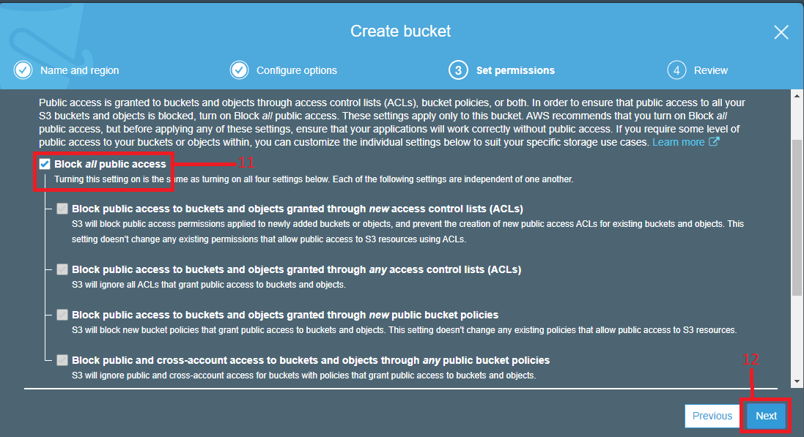

1. Review the Changes and click on **Create bucket** button.

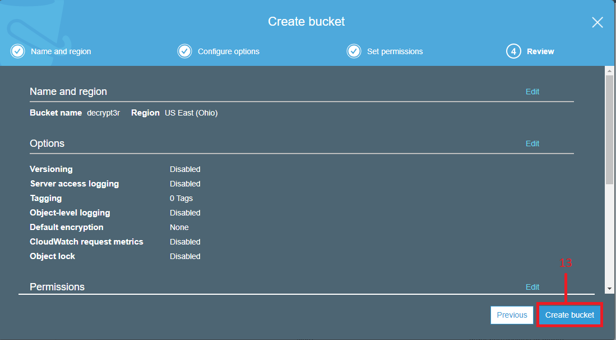

1. You have successfully created S3 Bucket, just click on the bucket name to make changes in the bucket or add some data in to the bucket.

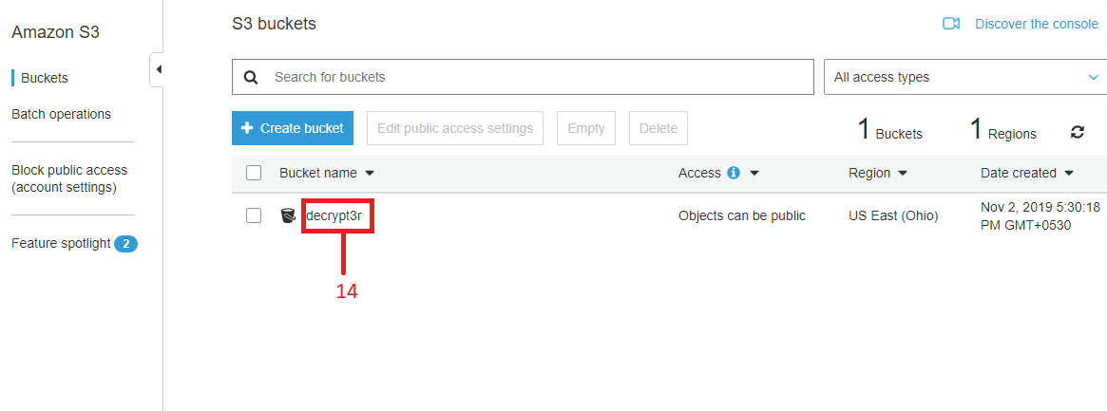

1. By using **Upload** you can upload files, images, pdfs, and documents in the bucket.
2. You can also **create folder** in the bucket.
3. In **Properties** you will find options like advance settings, encryption, logging, and many more.
4. **Permissions** is used to Allow/Block **public access**, set ACL (**Access Control List**), and add **Bucket Policy**.

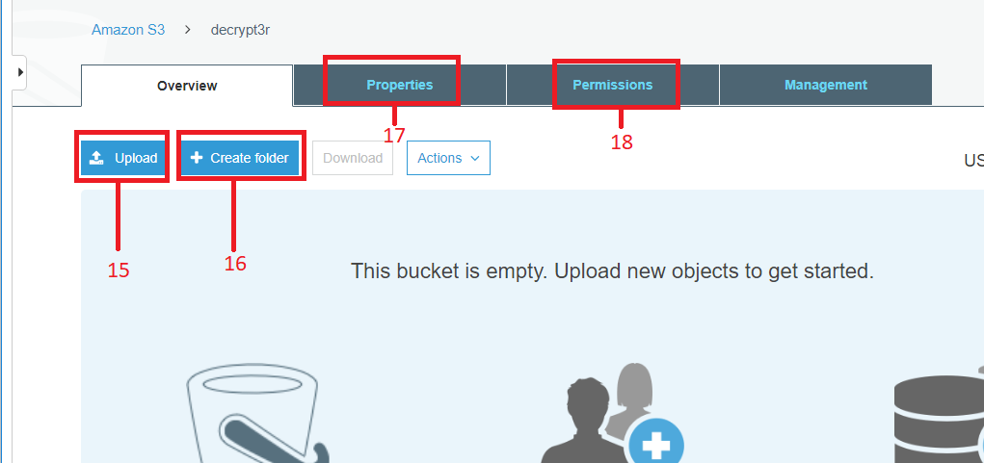

1. After step 15 (Upload), click on **Add files** and upload the file which you want to store on bucket.
2. **Upload** option is used to directly upload the added file to the bucket without any permission, if you want to add some permissions to the uploaded file then don’t use this option and go to next step.
3. Use **Next** button.

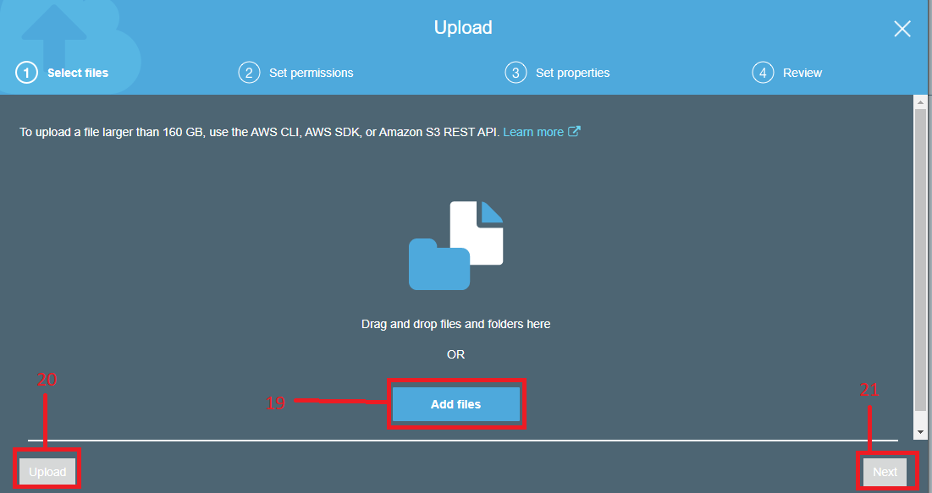

1. Set permission to the user. (Selected user will be able to access the uploaded file with those permissions only)
2. **Add account** will be able to add new user which can access uploaded file/document with defined permissions.
3. Click on Next to set properties.

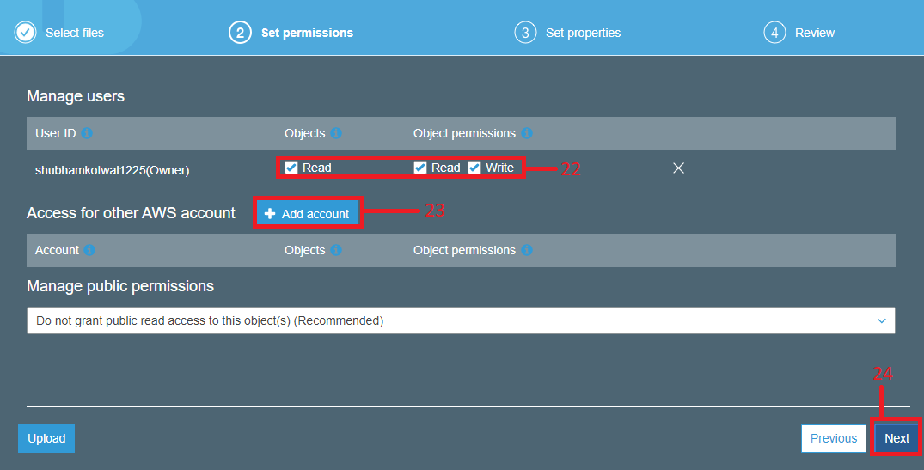

1. Don’t make any changes here and click on Next.

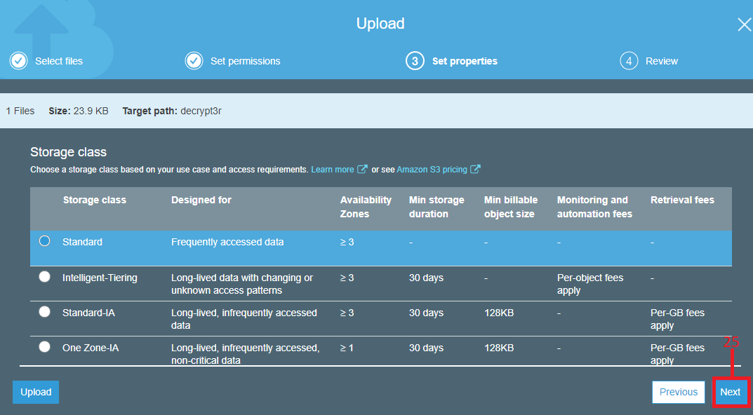

1. Review the changes and click on **Upload**.

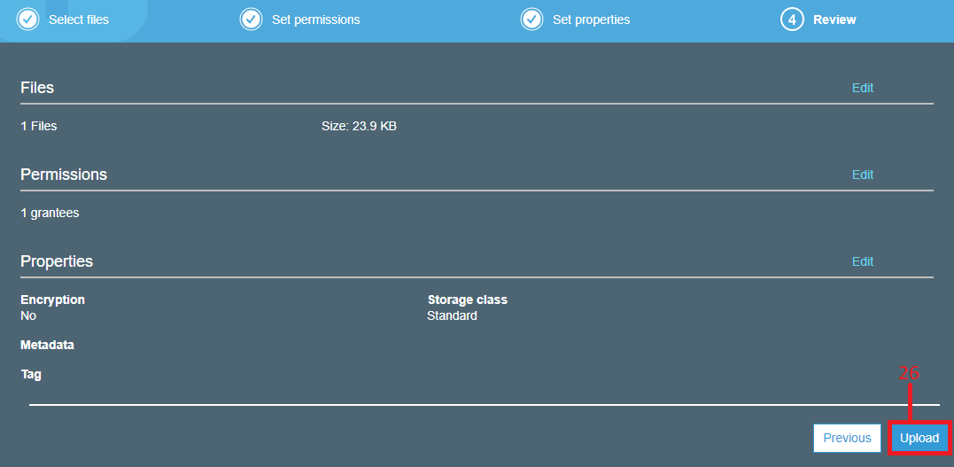

1. You have successfully uploaded file to the bucket. Now to access that file simply click on the file name which you have uploaded.

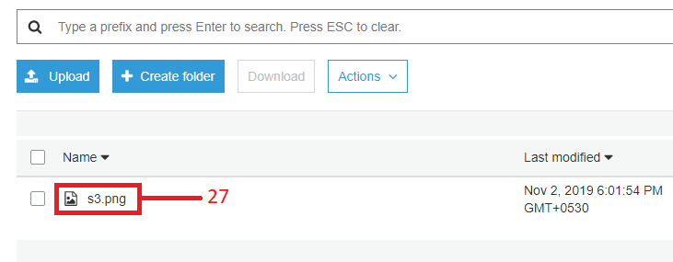

1. Click on **open** if you want to open the uploaded file.
2. **Download** to download that file.
3. You can copy and share the **URL** of the file if you have make it accessible publically.

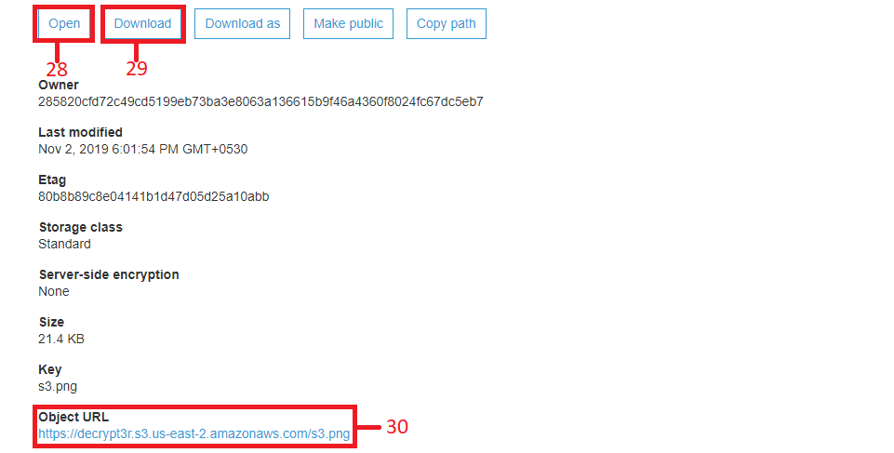

**How to deleted uploaded file:**

1. Click on the bucket name to view all bucket content.

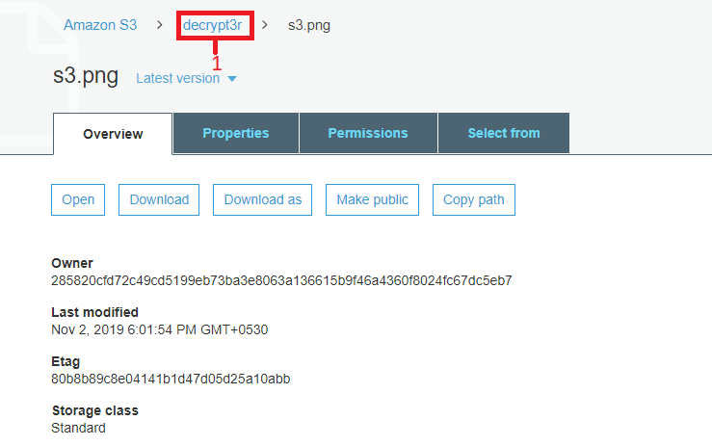

1. Tick on checkbox of the file which you want to delete.
2. Select Actions drop down menu.
3. Click on Delete button and popup window will appear, again confirm delete action.

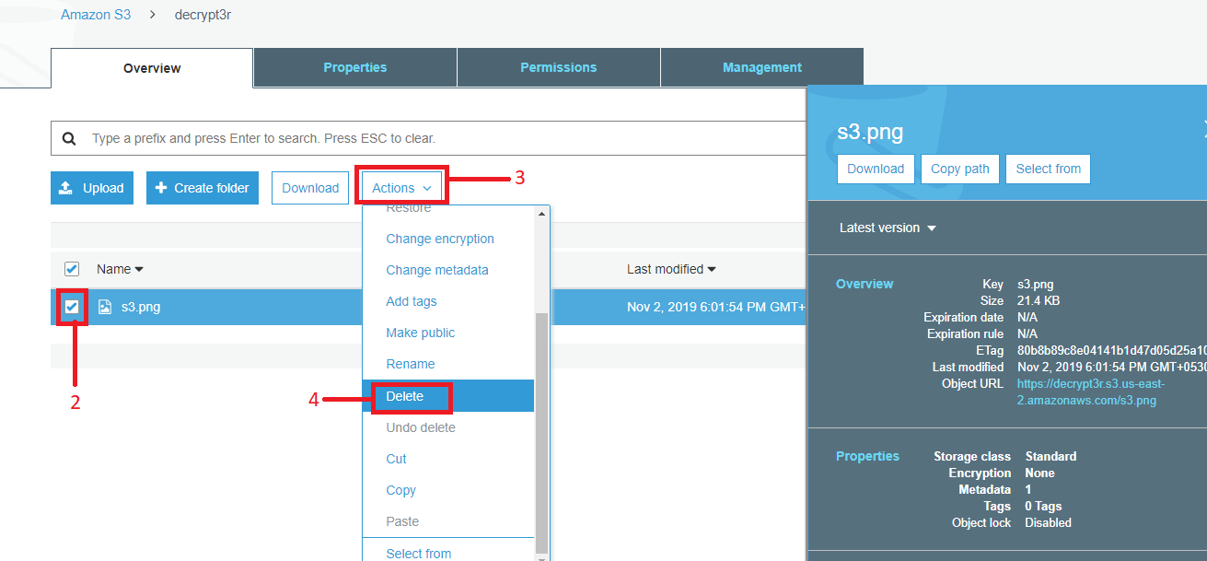

**How to delete the bucket:**

1. Click on **Amazon S3** to view all created buckets.

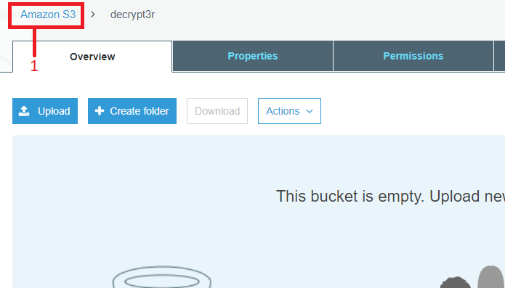

1. Tick on the bucket which you want to delete.
2. Click on **delete** option.

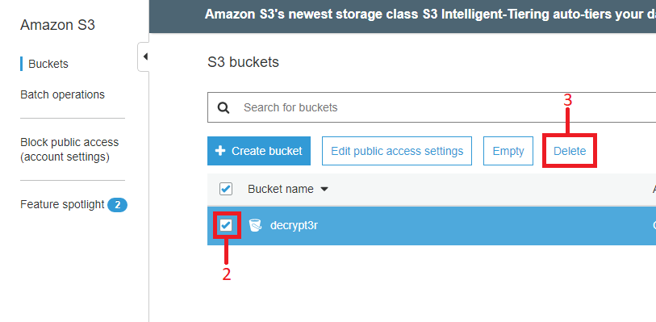

1. To delete the bucket you need to enter its name, if bucket have lengthy name then you can copy bucket name from here.
2. Paste/Enter **Bucket Name**.
3. **Confirm** to delete the bucket.

