1. 1) minimum sampling rate is 8kHz,
2. bit rate is 8kHz \*8bit= 16kbps
3. 45mbps / 16kbps = 2812.5 so it can handle 2812 voice calls.
4. 1million \* 1% \*16kbps = 16mbps
5. the signal power after the transmission is wpsoffice, the noise power after the transmission is wpsoffice ,so the SNR is 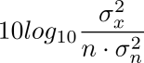.
6. 1)power is twice as the noise: SNR=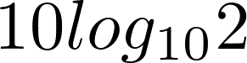=3dB

2) 10 times:SNR=wpsoffice=10\*1=10dB

3) 2^n times:SNR=wpsoffice

4) 10^k times:SNR=10k

4.1)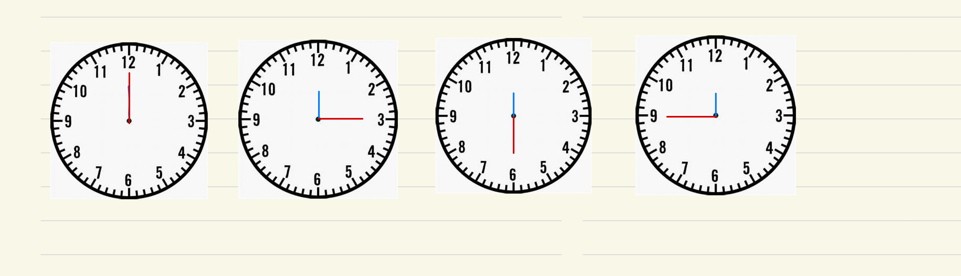

The second hand appears to move forward.

2)30sec The second hand appears not to move. 29 sec The second hand appears to move forward

3)when you sample a little more than twice its frequency you can obtain the variation trend of the signal, same as the clock, only you sample more than twice its frequency can you see the hand is moving forward

4)the sequence is 45 30 15 0 backward

5.44000Hz\*16bits/sample\*20s=14,080,000bits

6.bit rate is 2\*10kHz \*wpsoffice=80kbits/s

1. the SNR is 16 so the max bit rate according to Shannon theory is B\*>2B\*wpsoffice

So 1+16>V^2 the max levels are 4

8.64<3\* so the minimum SNR is approximately equal to 2,642,245

9.1)2\*1MHz \*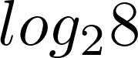=6Mbits/s

2)1Mhz $≈$\*4.39Mbits/s

3)1Mhz $≈$\*5.36Mbits/s