1. the main difference is: each frame sent is individually acknowledged in acknowledged connectionless service, but there is no acknowledgement in unacknowledged connectionless service. Thanks for the acknowledgement, if a frame has not arrived within a specified time interval, it can be sent again.
2. The main difference between Go-Back-N ARQ and Selective Repeat ARQ is the way they handle packet retransmission. Go-Back-N ARQ requires retransmission of multiple packets in a sequence, while Selective Repeat ARQ only retransmits the lost/damaged packet. As a result, Selective Repeat ARQ is more efficient and has better performance when there are multiple packet losses/damages.

3.1) 00111011 01111110 11110000 11110000 01111110 11001110

2)01111110 00111110 11100010 11100000 00111110 11000011 11100010 01111110 01111110

4.

Parity bit 1: 1.

Parity bit 2: 1.

Parity bit 4: 1.

Parity bit 8: 0.

the binary value after encoding "1010101" using an odd-parity Hamming code (11, 7) is "11110100101".

5.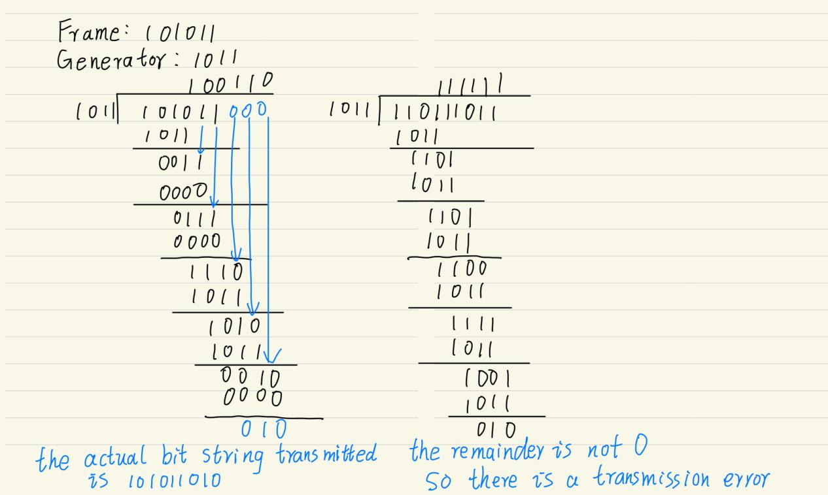

6.The time taken to transmit a 120-bit frame over a channel with a bit rate of 3 kbps is:

t(frame) = (120 bits) / (3 kbps) = 40 ms

The round-trip time (RTT) and is equal to twice the propagation delay:

RTT = 2 \* propagation delay = 2 \* 30 ms = 60 ms

Therefore, the total time taken to transmit one frame and receive the acknowledgement is:

t(total) = t(frame) + RTT = 40 ms + 60 ms = 100 ms

Transmission efficiency = t(frame) / t(total) = 40 ms / 100 ms = 40%

7.PPP has a simpler header structure, does not support multiple addressing, uses a 16-bit CRC for error detection, is more transparent, and is more interoperable than HDLC. HDLC has a more complex header structure, supports multiple addressing, uses a 16- or 32-bit CRC for error detection, is less transparent, and may only be supported by certain devices or operating systems.