1. Pure ALOHA allows devices to transmit at any time, while Slotted ALOHA divides the communication channel into discrete time slots and only allows devices to transmit at the beginning of each slot. Slotted ALOHA reduces the probability of collisions, but may also result in idle time slots.

2.

Carrier Sense: Before transmitting any data, a device checks whether the network is idle. If the network is busy, the device waits until it becomes free.

Multiple Access: When the network is idle, multiple devices can transmit data simultaneously. However, if two devices try to transmit data at the same time, a collision occurs.

Collision Detection: When a collision is detected, both devices stop transmitting and wait for a random amount of time before trying again. The random delay helps to ensure that the two devices don't try to transmit at the same time again.

Re-transmission: After waiting for a random amount of time, the two devices try to transmit their data again. This process continues until the data is successfully transmitted without any collision.

3.

8, 2, 4, 5, 1, 7, 3, 6, 9, 0 will become 8, 3, 4, 5, 2, 7, 0, 6, 9, 1 after 3 transmission.

8, 3, 4, 5, 2, 7, 0, 6, 9, 1 will become 8, 4, 0, 5, 3, 7, 1, 6, 9, 2 after 4 transmission.

8, 4, 0, 5, 3, 7, 1, 6, 9, 2 will become 9, 5, 1, 6, 4, 8, 2, 7, 0, 3 after 9 transmission.

4.

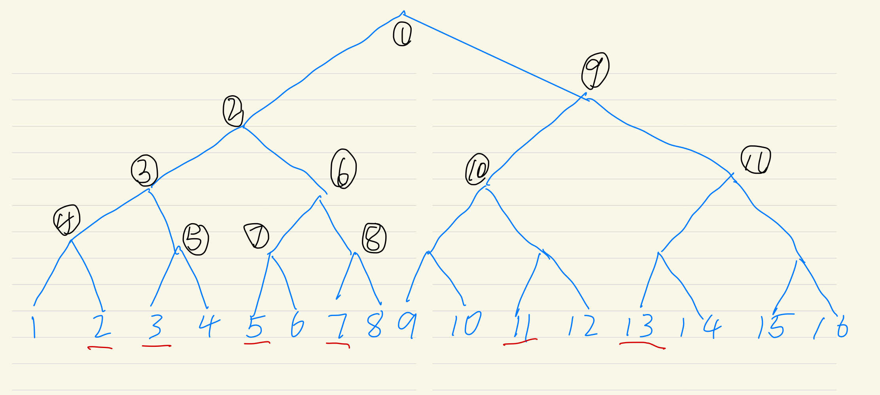

According to the figure shown above, we need 11 bit slots

5.

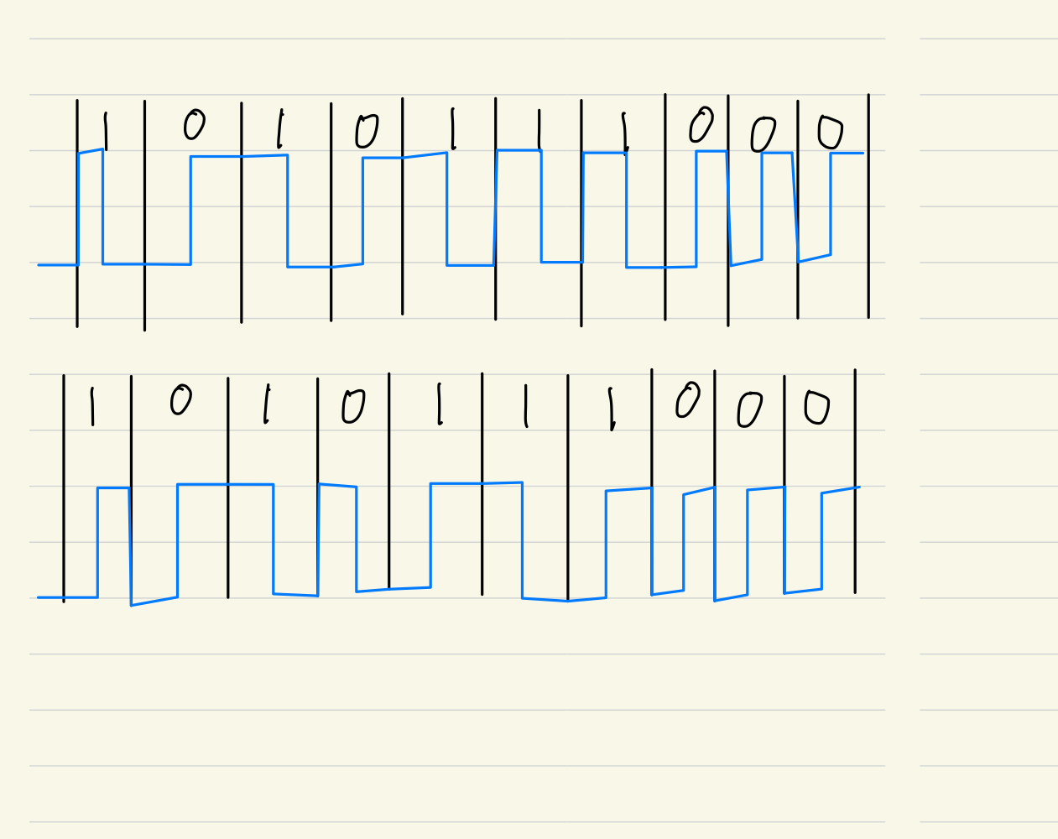

6.I think c is more closer to A, because A first send a RTS and then B send a CTS, C received the RTS and established a NAV, but D hadn’t received the RTS until the CTS reach the D, so I think C is more closer to A than D.