

**B38EM**

**Lab1**

**Lab Report**

**Name: MA XUNCHI**

**HW ID:H00392669 XDU ID:21012100015**

1. **Introduction** After studying the concept of electrostatics, dipole, charged bodies, students are going to observe their properties in the simulation software “CST Studio Suit”.

The lab aims to further understanding of the electrostatic concept of electric fields around dipoles/charged bodies. Participants investigate different configurations and see how field lines are produced by different distributions of charges.

The main experiment involves simulating the electric field around two perfectly conducting, charged spheres with radius R0=1mm that are separated by D=6mm and have charges of q=8nC. The lab explores theory vs. simulation by calculating E-field at different points using Coulomb's Law and the principles of superposition.

Other topics discussed in the lab are electric flux lines, Coulomb's law, and electric force on charged objects. The lab report serves as an assessment of the verification of the theory and indicates what the participants have learned while completing the laboratory activity.

1. **Procedure**launch the CST and create a parameter table that we will use later

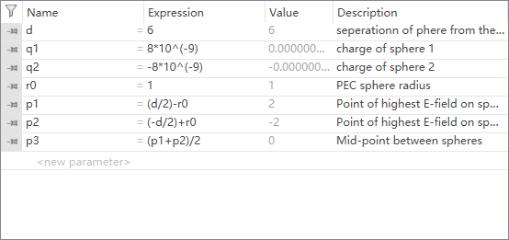

Figure2.1: the parameter table

Then configure all kinds of things to start simulation

And we will get the simulation result

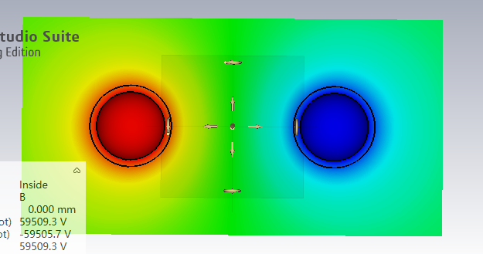

Figure2.2: distribution of potential around the sphere

1. **Exercises**

**Exercises 1**

1)

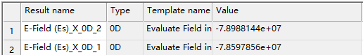

Figure3.1: the value of Emax

2)



Figure3.2: the value of E on the midpoint

It is not the same. As observed from the simulation result, the electric field line is thinner at the midpoint and is dense at the sphere(corresponding to the E)

3)

The Emax is approximately the same as the result calculated from the pre-Lab (7.5*10^7)

**Exercises 2**

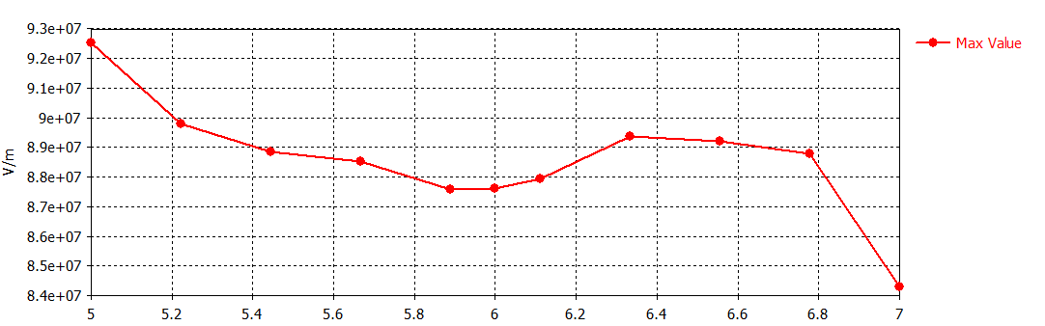

Figure3.3: the diagram of Emax

Comment: with the distance increasing the Emax decreased first reached the minimum value when d approximate equal to 5.9m and then increase

**Exercises 3**

1)

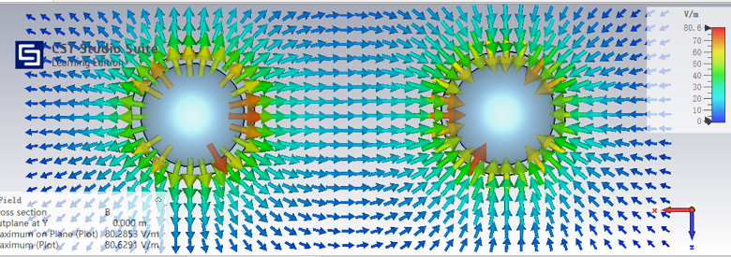

Figure3.4: electric field orientation

The electric field point outwards near the positive charge and point inwards near the negative charge. It is denser near the two particles especially at face to face side.

2)

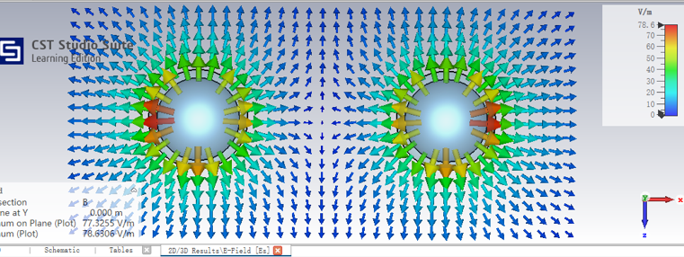

Figure3.5: electric field orientation for two positive charges

It is not the same cause the electric field of two positive particles will repel each other, which lead to the 0 E at the midpoint. The electric field is denser near the two particles especially at back to back side.

**3.Conclusion**

After doing this lab our students are more familiar with the flux distribution around a point charge and dipole. They originate from the charge point outwards when it has positive charge and point inwards when it has negative charge. The density of the flux is represented by E which is proportional with the charge and inversely proportional with the square of the distance.