Xidian University & Heriot-Watt University

**Wireless Local Area Network (LAN) Matching Circuit Design and Test**

(Lab 3)

B39HF

Group 3

2023-11-11

**2.Procedure**

1. Open Keysight *ADS*.

2. Create a new project, and then open a schematic window (Window — New Schematic).

Make sure to specify millimetres and NOT mil in the new Workspace Wizard. Select the

option: “Standard ADS Layers, 0.0001 millimetre layout resolution”.

3. In the schematic window (see Fig. 2), the element bar on the left side of the screen

contains various lumped elements which may be deposited on the schematic. You can try

different items if you want (try a resistor by pressing the resistor button, then drop the

resistor on the schematic using the left mouse button. Hit escape to stop placing

resistors). Double click on the resistor to change its value to 100 Ohm.

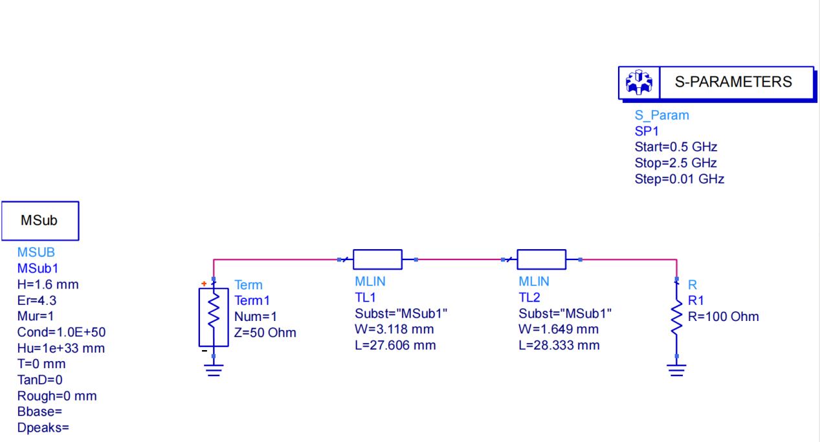

**Figure 2.1** *Schematic Window and Libraries / Elements*

4. As you get more and more comfortable with the user interface, the buttons on the element bar may be changed to other libraries using the selection block right above the element menu (it should, as a default, read “**Lumped – Components**” library). Select **TLines Microstrip** library to get microstrip devices. Deposit two microstrip lines (**MLIN**) and a microstrip substrate (**MSUB**). Double click on the microstrip substrate to set the substrate parameters. ***Set the substrate to FR4 (Er = 4.3, tan(d) = 0.019, thickness = 1.6 mm).*** Keep the other values as default.

5. Change to the **Simulation-S-param** library, and then deposit a port, a terminal (**TERM**), a ground connection (see Fig. 2 to see where to get the port and ground), and an S parameter simulation block (**SP**). Set the start, stop, and step frequencies of the S parameter simulation as you think appropriate. Set ‘Term1’ as 50 ohms, which is telling the software that the reference impedance of the system will be 50 ohms.

6. Use wires to connect the simulation items together using (**Component—Wire** library), or

by pushing the wire button.

7. Using equations given in class and this lab guide, find the required impedance for a

quarter-wave transformer to match a 50 Ω transmission line to a 100 Ω load at 1.5 GHz.

8. Open the LineCalc tool **Tools – LineCalc – Start LineCalc**. LineCalc (see Fig. 3) is used to determine the width and length of transmission lines based on the substrate

parameters and frequency of operation.

9. Use the same method in part 8, to determine the dimensions of the matching section

which has the impedance calculated in part 7. You may put “90” into the E_Eff box to

determine the length of the quarter-wave section. This corresponds to a length of 90˚ long or λ/4.

10. **Save** your design. Simulate the system by selecting **Simulate**, or pressing F7, or clicking the Simulate icon on the toolbox (it looks like a spinning gear).

11. Plot the result by opening a new data display (**Simulate — New Data Display**, or

pressing the graph icon on the toolbox). In the new window that pops up (Fig. 4), select **Insert — Plot**, then insert the square box in the blank display by clicking. Select S11, click “Add”, then chose “dB”. Select “OK”, and the plot of S11 will be displayed. Note the frequencies at which the circuit is matched. Is this what you expected? Explain.

12. Tweak the parameters of the matching network to achieve a match at 1.5 GHz if

necessary. Plot the result. Account for the differences in the predicted and previously

observed results.

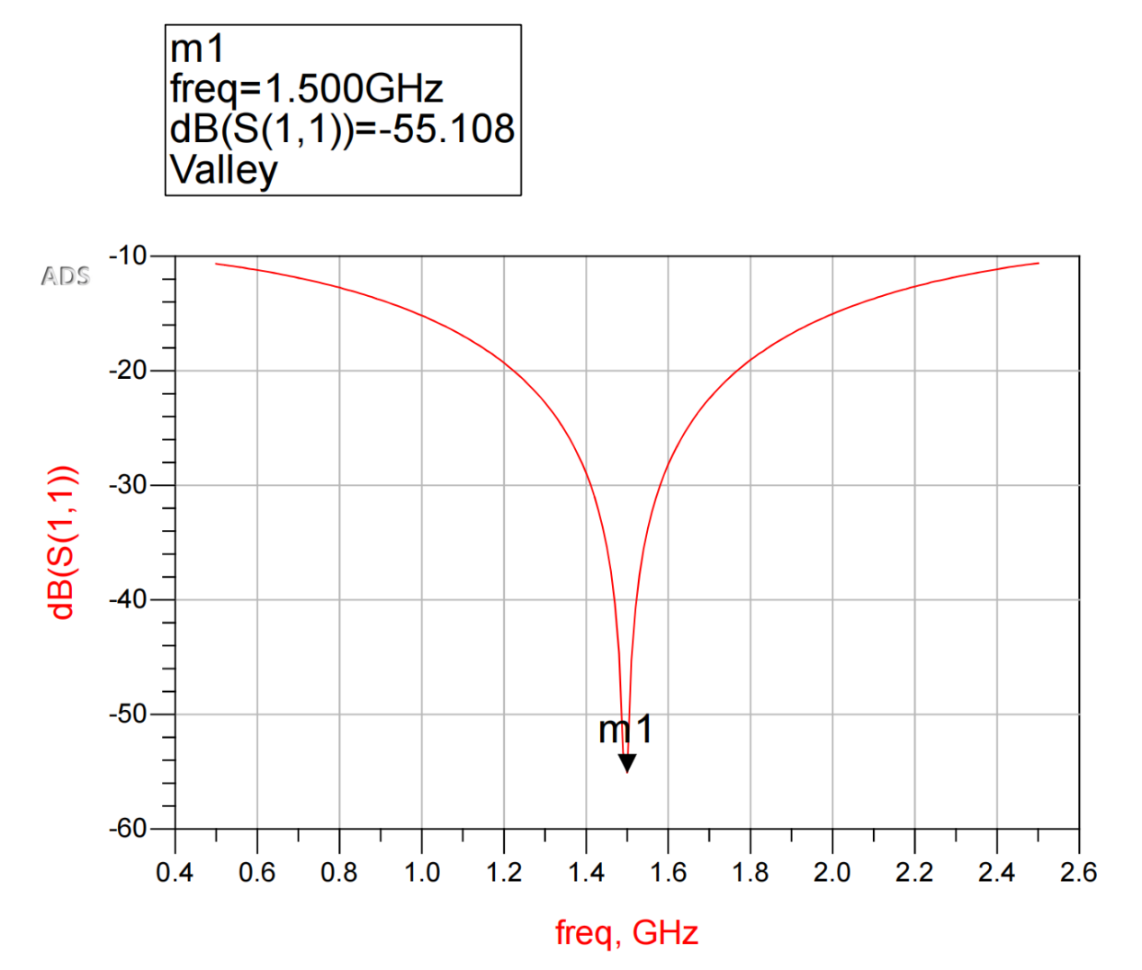

**Figure 2.2** *S-parameter plot*

13. In this part of the lab you are to design a wireless local area network (WLAN)

communication system (see Fig. 5) which use two antennas in parallel. You can model

these antennas using equivalent circuits defined as ZL1 = 82 Ω and ZL2 = 36 Ω. These

loads need to be matched to a transmitter with an internal impedance Zg = Zo = 50 Ω.

• In ADS design a matching network consisting of **2 quarter-wave transformers**

**MLIN**, to achieve Zin= 50 Ω at the input impedance for the transmitter

(represented as Port 1).

• The substrate is to be FR4 as defined above in this lab guide.

• Use the fact that Zin1 and Zin2 are in parallel.

• Design frequency; if you are group #X, your design frequency is 1.X GHz. For

example, for group #3, the design frequency for your circuit is 1.3 GHz.

• Make sure that you have a minimum length of about 3 cm for TL3. This ensures

space for connector soldering at each of the four ports.

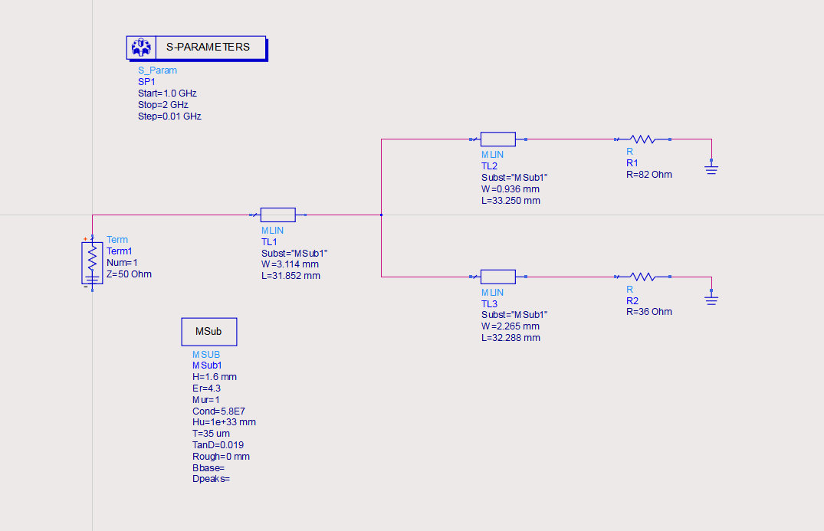

**Figure 2.3** *Representative Wireless Local Area Network (WLAN) Communication System.*

14. Implement the WLAN circuit and simulate its frequency response in terms of S11.

15. The next step in the design process will be to generate the *layout* of your circuit. This consists of the coordinates of the metallization. Basically the physical realization of the matching circuit. The layout will then be sent to another ADS module called

Momentum. During a full-wave simulation, Momentum will solve Maxwell’s equations to determine the physical currents flowing on the circuit. This specialized piece of software uses a numerical technique known as the *method of moments* to solve Maxwell’s equations, which is well beyond the scope of this course. In fact, Momentum will not even be explored extensively in this lab. All you need to know is that Momentum will discretize the metal into a finite number of points, known as a *mesh* and then solve Maxwell’s equations during a full-wave simulation.

16. The first step is to generate a Momentum layout of your schematic by clicking on Layout Generate/Update Layout. Accept any dialogue boxes that may appear. A new

Momentum window will be generated that shows the artwork associated with your

design, as illustrated in Fig. 6.

17. You might notice that the generated layout structure in Fig. 6 looks a little misplaced. This is because improper *physical* connections were included between TL1, TL2, and TL3. This can be corrected by including microstrip T-junction (**MTEE**) and two transmission line corner bends (**MCORN**) as shown in Fig. 6 for the circuit schematic.

18. Re-simulate your design in the schematic window and record your results. You should notice that the S11 minimum might be shifted because of the added transmission line lengths of **MTEE** and **MCORN**. Given this, you need to optimize your structure further such that your required design frequency is still achieved. Thus you need to tweak your circuit in the schematic window. Continue until you are satisfied with the results. You are free to make use of the other transmission line bends, T-section elements, and alike.

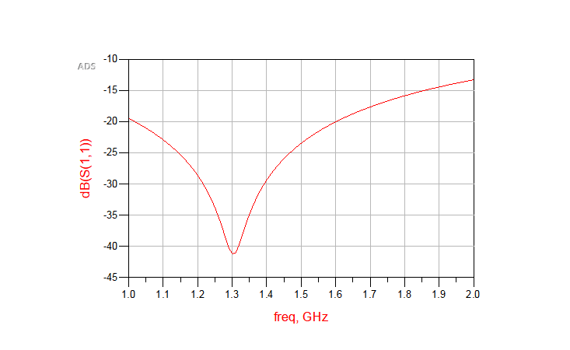

**Figure 2.4** *S-parameter plot after adding the MTEE and MCORN*

19. Once you have completed the previous step, re-generate the momentum layout of your circuit. You will also need to delete and ports, resistors blocks, and ground connections at this stage.

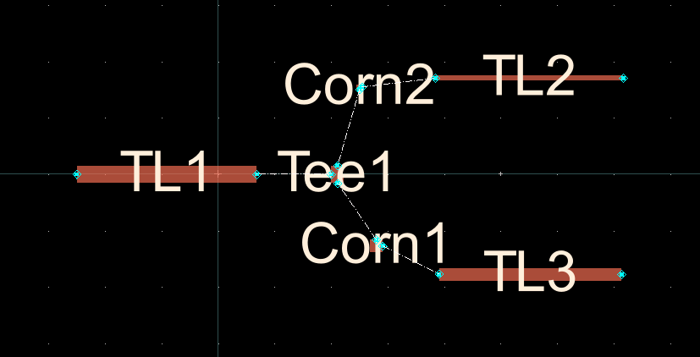

**Figure 2.5** *Momentum layout of the matching circuit.*

**3.Measurement**

Using the provided lab kits, measure the matching circuit and compare with your simulation results. Prior to your measurements, ensure that your VNA has been properly calibrated.

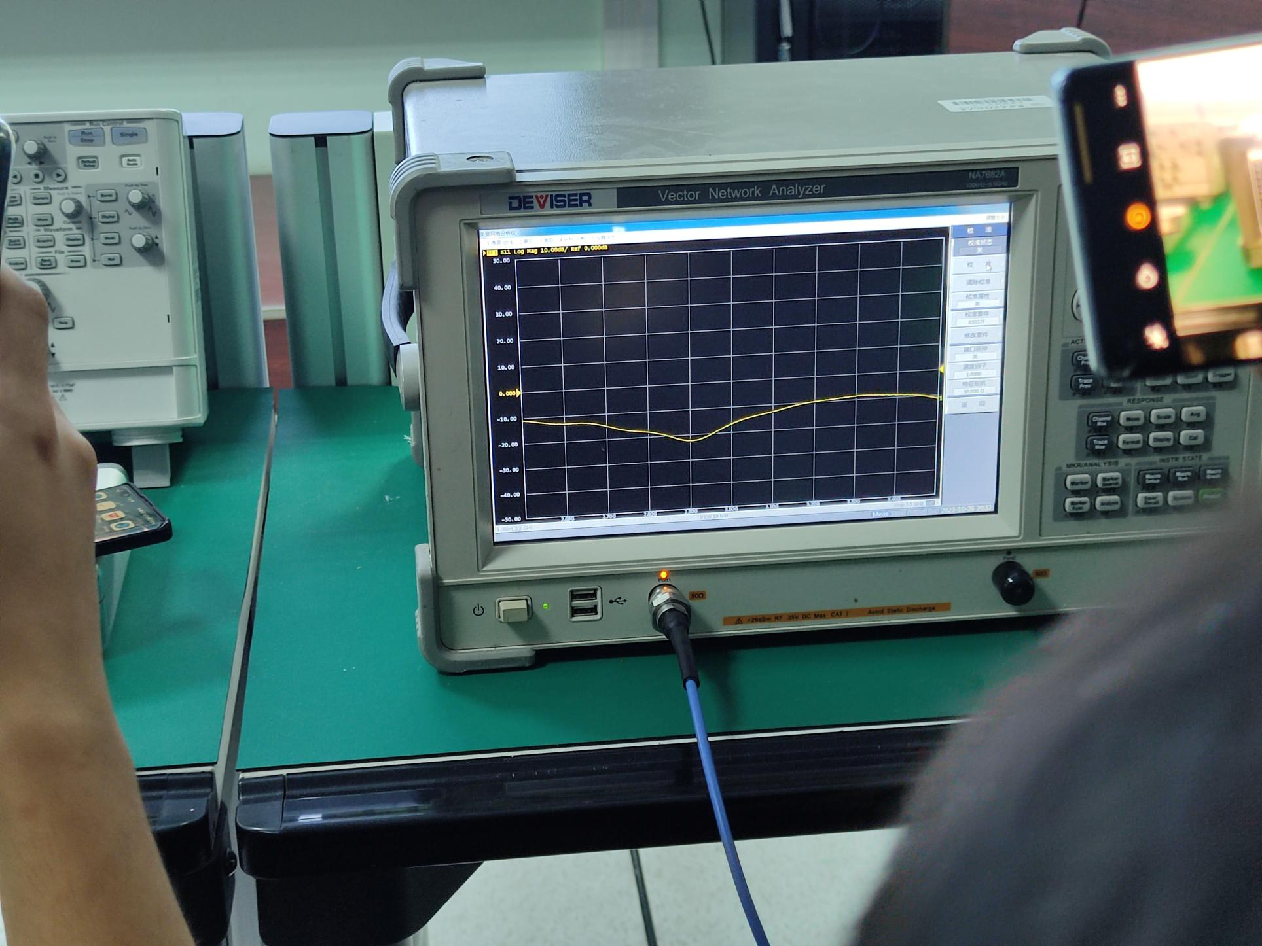

**Figure 3.1** *Observation result*