—
Using the Program Applets to Learn DECtalk Software Basics

This chapter introduces the basic operations involved in DECtalk Software voice and program control. If you are a general user, this chapter gives you the information you need to use the Sample, Speak, and User Dictionary Build Tool program applets. If you are an application programmer, and not familiar with DECtalk Software , this chapter introduces the basic program and voice-control functions used to control DECtalk Software from within an application program. Topics include:
- Starting the sample applet and opening a text file
- Inserting commands and learning command syntax
- Modifying voice characteristics
- Modifying speech from text files
- Controlling pronunciation with the user dictionary
- Using the Speak applet
- Using DECtalk Software with other applications
Starting the Sample Applet and Opening a Text File
The fastest way to start learning about DECtalk Software is by using the Sample program applet to convert an ASCII text file to speech. Once you start the applet and speak a text file, you can then learn more about controlling voice characteristics through voice-control commands and the user dictionary, which are covered later in this chapter.

Table 3-1 — Starting the Sample Applet and Opening a Text File
Task/Location |  | Action | Result
DECtalk Software program Group (1) |  | Double click on the sample applet icon (2) | The sample applet window is displayed. (3)
 |  | Pull down the File menu and select Open. (4) | The Open a File dialog box is displayed. (5)
Open File dialog box (5) |  | Select the file you want DECtalk Software to speak. (6) | The file is displayed in the sample applet window.(3)
Start button (7) |  | Click on the start button. | DECtalk Software starts speaking the file.
Pause and stop buttons(8)(9) |  | Click on the Pause or Stop button as needed. | DECtalk Software pauses or stops the speaking session.
Drag and Drop
File manager with text file name visible (not shown here) |  | Click on the file name, and drag to sample applet window or to the minimized DECtalk Software icon. | The file is spoken.

Figure 3-1 — Starting the Sample Applet and Opening a Text File
t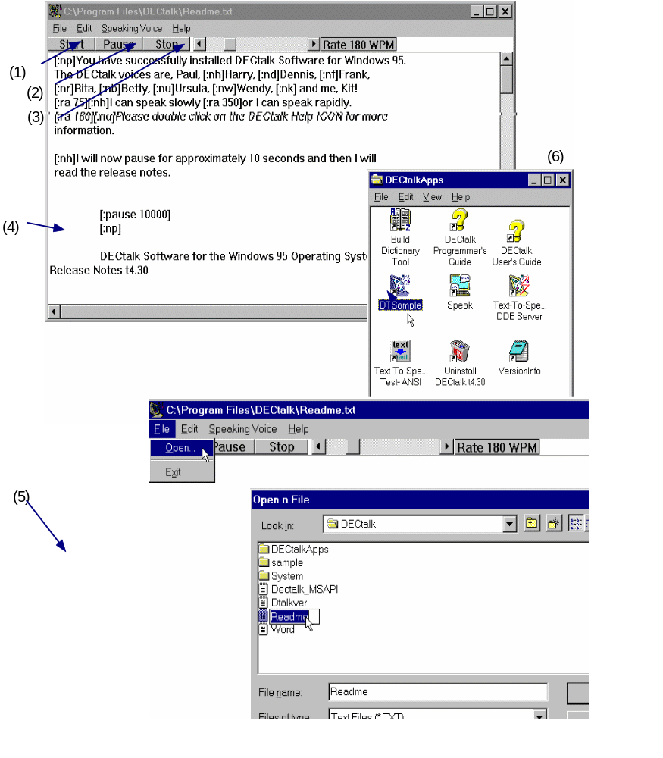
Inserting Voice-Control Commands (Syntax Rules)
Before you can use DECtalk Software commands to modify speech output, you need to know the proper syntax with which to include those commands into a text file. Figure 3-2 illustrates the rules of DECtalk Software command syntax.
Figure 3-2 — Rules for Voice-Control Command Syntax
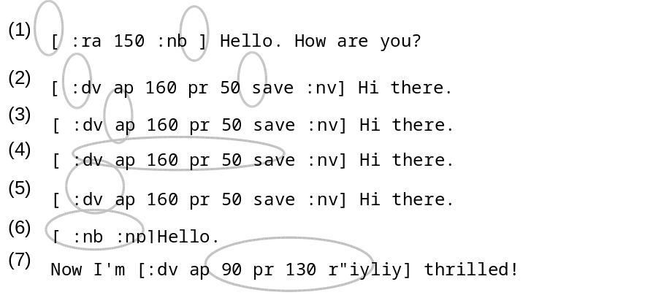

Legend
(1) | Enclose every command in brackets.
(2) | Begin every command with a colon.
(3) | Separate each command and its parameter or parameters from the text by a valid word boundary marker, such as a space, tab, or carriage return. A space is used here.
(4) | You can include several commands within the same brackets.
(5) | Include several parameters within the same brackets if the command allows more than one parameter. If you use several parameters, enter each command’s parameters before you enter a second command in the same bracket. (In this example, the parameter group modifies the [:dv] command.)
(6) | If you give two conflicting parameters or commands, DECtalk Software uses the last command in the sequence. (In this example, DECtalk Software uses Paul’s voice.)
(7) | You can use phonemic symbols within the same brackets with voice commands. In this example, the phonetic spelling of word really (r"iyliy) is included.
Additional Syntax Rules
If the value in a [:dv] command is too low, DECtalk Software uses the minimum valid value. If the value is too high, it uses the maximum valid value.
Once you enter a command, that command applies to the remaining text until it is overridden by another command. For example, the command [:nk] invokes Kit’s voice on all entered text until you enter another voice-selection command.
Invalid commands are ignored. By setting the [:error speak] command, you can receive an audible warning that an invalid command has been entered.
DECtalk Software interprets text between brackets as phonemes only after the [:phoneme arpabet speak on] command has been sent to the application. If [:phoneme arpabet speak on] has not been sent, DECtalk Software interprets the brackets and characters between them literally. The [:phoneme arpabet speak off] command must be sent with literal characters if you want to insert brackets in normal text.
If the command [:phoneme arpabet speak on] is set and you forget the right bracket ( ] ), DECtalk Software attempts to interpret all text following the ASCII text as phonemes, skipping over illegal letter combinations. The resulting text sounds garbled. Enter a right bracket to fix this problem.
Changing Voice Selections
You can change a speaking voice by inserting DECtalk Software commands into the text-collection area displayed in the sample applet window or by selecting text and then selecting a different name from the Voice pull-down menu in the sample applet window. Voice changes made with commands are permanent for the session and remain intact as along as the command remains in the file. Voice changes made from the menu only remain in effect as long as the current DECtalk Software session is running.
Each voice selection is inserted into the command [:n x] where x is a value representing one of the voices. Table 3-2 lists the names and their corresponding values.
You can change voices with a new voice command as in the following example.
[:nb] Hello. I'm Betty.
You can also change voices in the middle of a sentence.
[:np] This is a demo [:nb] of a sudden change in voice.
If a voice-change request occurs in the middle of a sentence, DECtalk Software automatically pauses. The pause is the equivalent of inserting a comma, or about half a second.
[:np] This is a demo, [:nb] of a sudden change in voice.
Table 3-2 — DECtalk Voices and Their Associated Values
Name | Value | Name | Value
Paul | P | Betty | B
Harry | H | Ursula | U
Frank | F | Wendy | W
Dennis | D | Rita | R
Kit | K

Figure 3-3 — Changing DECtalk Software Voices
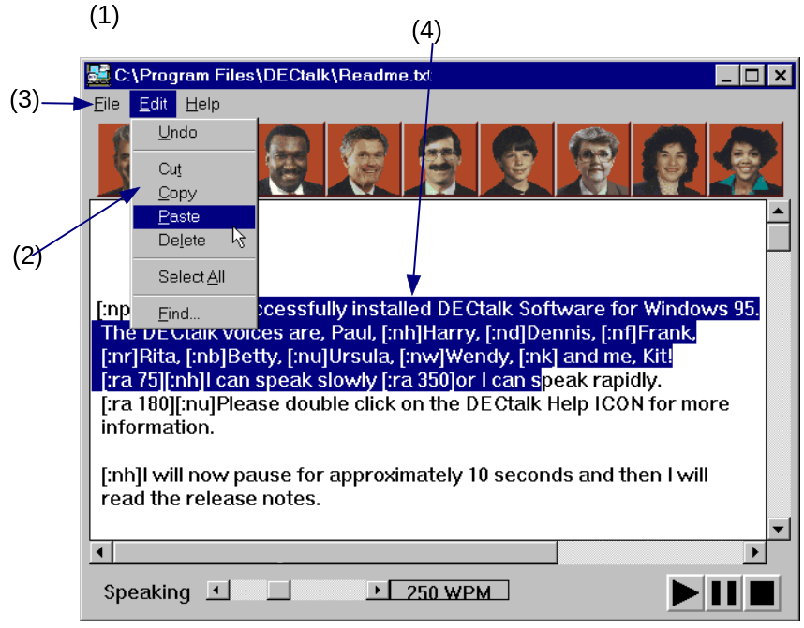

Table 3-3 — Changing Voices
Task/Location |  | Action | Result
Using the Speaking-Voice Menu
Sample applet window (1) |  | Select the desired speaking voice from the Speaking Voice menu. (2)
 |  | Press the start button. (3) | The entire file or selected section is spoken.
Using Voice-Control Commands
Sample applet window (1) |  | Insert voice-definition commands in the text at the points where you want a new voice to take effect.(4) | DECtalk Software changes the speaking voice at the point where you insert commands.

Editing a Text File and Changing the Speaking Rate
DECtalk Software lets you edit text — select, cut, paste, append other text files — that is displayed in the sample applet window and then play segments or all of the edited text.
You can also increase and decrease the rate at which DECtalk Software speaks a file or a section of a file.
Figure 3-4 — Editing a Text File and Changing the Speaking Rate

Table 3-4 — Editing the Input Text File and Changing the Speaking Rate
Task/Location |  |  | Action |  | Result
To Edit the file and play selected segments
DECtalk Software sample applet Window (1) |  |  | Select the range of text you want to edit. To play the selected range, click on the right mouse (MB2 or 3) button (2)
 |  |  | Use cut, copy, paste, delete, and insert selections from the Edit pull-down menu to manipulate the selected text. For example, select a single sentence for DECtalk Software to speak.  Click on the Start button. (3) |  | DECtalk Software speaks the edited file in the new, edited format.
To change the output rate
Sample applet window as DECtalk Software is speaking a file (1) |  |  |  | Use the mouse to position the pointer on the rate slider bar. Press the left mouse (MB1) and drag the slider to the left and wait for the speaking voice change to occur. Then drag the slider to the right (4) |  | The speed at which DECtalk Software speaks the file changes. It increases if you drag to the right and decreases if you drag to the left. The rate in words per minute is displayed to the right of the slider bar. Changes in the speaking rate occur only on a clause boundary after all the previously queued audio has played.

Overview of the User Dictionary Build Tool
The User Dictionary Build Tool creates a loadable dictionary file (.dic) from a list of words and their corresponding pronunciations. The dictionary is loaded with a call to the TextToSpeechLoadUserDictionary() function or from the File menu in the Speak Program applet.
Use the Translate command to create phonemic translations of words or phrases.
Figure 3-5 — Components of the User Dictionary Build Tool
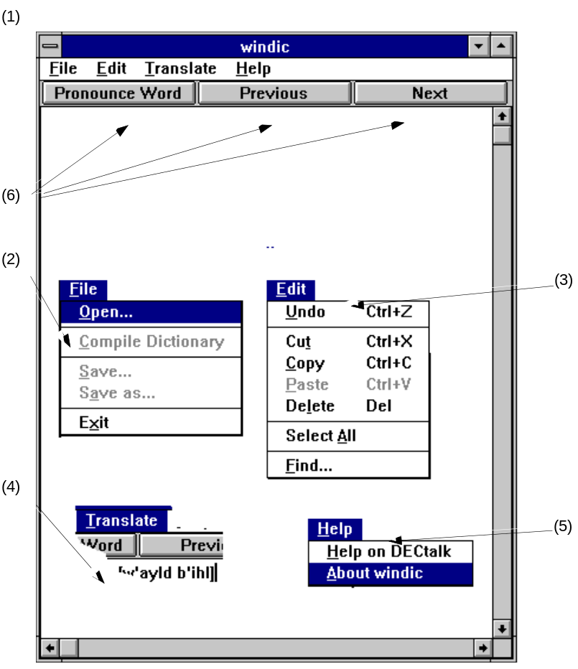
Legend
(1) | Text-collection Area  Enter word-pronunciation pairs in the text window. Word-pronunciation pairs are words that are not predefined or not pronounced as desired in the DECtalk Software user dictionary.
(2) | File pull-down menu  Open... A pop-up dialog box that opens up a dictionary definition file (*.tab).  Save... A pop-up dialog box that saves the file and calls the compiler to create a dictionary file (*.dic).  Save as... A pop-up dialog box that lets the user rename the file. This also calls the compiler to create a dictionary file (*.dic).  Compile Compiles the current file to a .dic file with the same name.  Exit Exits the program and, if the entries in the Text Window have been modified, it pops up the Save dialog box.
(3) | Edit pull-down menu  Undo Undo the previous command.  Cut Cut the selected region.  Copy Copy the selected region.  Paste Paste the selected region.  Delete Delete the selected region.  Select All Select all of the word-pronunciation pairs from the text-collection area.  Find... A pop-up dialog box that prompts you to search for selected text.
(4) | Translate Menu  Translates selected text into phonemic spelling.
(5) | Help pull-down menu  Selects the online help.
 | Pronounce Word, Next, and Previous buttons  When these buttons are pressed, all the phonetic pronunciations that are listed in the text-collection area are spoken. If a range of word-pronunciation pairs is selected, then only the phonetic pronunciation for the corresponding words is pronounced. If only one word is selected, then the Pronounce Word, Next, and Previous buttons force DECtalk to pronounce the highlighted selection.
Building a User Dictionary
Building a user dictionary is a two-step process. First you create a .tab source file with the User Dictionary Build Tool to define the pronunciation of special words you want to place in the dictionary. Then you compile the .tab file to produce a .dic file. This file is loaded into a DECtalk Software session through the Speak applet or an API call.
Figure 3-6 — Building a User Dictionary
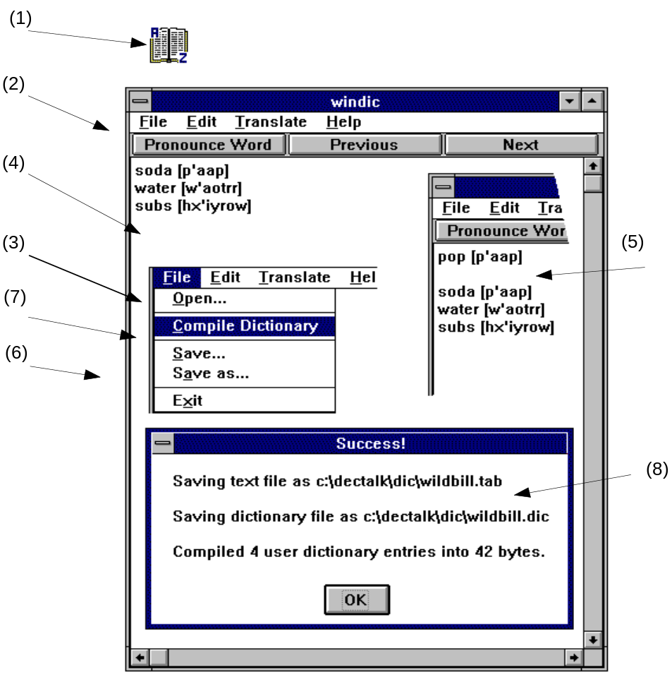

Table 3-5 — Building a User Dictionary
Task/Location |  |  |  |  | Action |  | Result
DECtalk Software program group (1) |  |  |  |  | Double click on the User Dictionary icon. |  |  | The DECtalk Software Help Builder window is displayed. (2)
File pull-down menu (3) |  |  |  |  | Select Open to open a new or existing dictionary file.
Enter word-pronunciation pairs for words that are not predefined or not pronounced as desired in the DECtalk Software user dictionary. A word-pronunciation pair is written in the following format with the pronunciation enclosed in brackets. Note, that each word-pronunciation pair must be on a separate line in the dictionary.
word [pronunciation]
As an example, define the word soda to be equivalent to pop; define water to be pronounced with a New England accent; and take into account the dialectic regional preferences so that the word sub is called a hero. Use the following pronunciation pairs:
soda [p'aap]
water [w'aotrr]
subs [hx'iyrow]
Text window (4) |  |  |  |  | Use the Translate command menu to translate desired words into a proper phonemic spelling .(5)  Refer to Chapter 5 or DECtalk Software online help (the Advanced Topic Index) for a complete list of phonemic, stress, and syntactic symbols. Refer to Chapter 4 for more on modifying and enhancing pronunciation.
To save the Dictionary .tab File
File pull-down menu (3) |  |  |  | Select Save or Save as... to save the .tab file. (6) |  |  |  |  | The Save dialog box is displayed (not shown here).
Save as dialog box |  |  |  | Select the file where you want the dictionary session saved.
To compile the Dictionary
File pull-down menu (3) |  |  |  |  |  | Select Compile (7) to compile the current session.  Click on OK. |  |  |  | The dictionary session is saved and compiled to a .dic file. The Compile dialog box confirms the compile. (9)

Using the DECtalk Software Speak Applet
The Speak applet demonstrates the DECtalk Software voice set. Each picture * displayed in the Speak window represents one of the nine built-in voices. You can select a specific voice by clicking on the picture. DECtalk Software then uses the selected voice to speak the contents of a text file displayed in the text-collection area with the selected voice or from a file you drag and drop from the Windows 95 File Manager into the text-collection area. * Note that the faces are cartoon characters when using VGA 16-color mode.
Figure 3-7 — Using the DECtalk Software Speak Applet
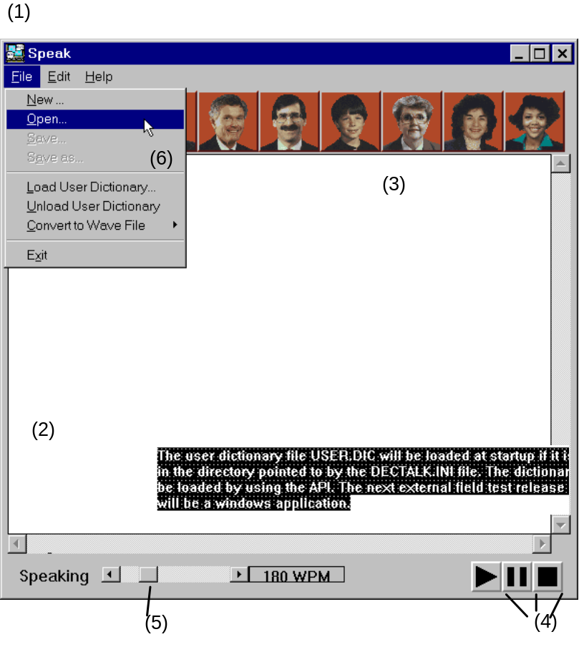
Table 3-6 — Using the DECtalk Speak Application

Task/Location |  | Action | Result
To edit a text file and play selected segments
Speak Applet Window (1) |  | Select the range of text you want to edit or play. (2)
 |  | Use the Cut, Paste, and Insert keys or corresponding commands from the Edit menu to manipulate the selected text. For example, cut and paste a single sentence for DECtalk Software to speak.
 |  | Click on the face of the voice you want to speak the selected text. (3)
Edit menu |  | Use the (MB2 or 3) right mouse button to speak a selected region or press the Play, Pause, and Stop buttons. (4) | The edited file is spoken.
To change the speaking rate
Speak applet window while DECtalk Software is speaking a file |  | Use the mouse to position the pointer on the rate slider button. (5) Press MB1 and drag the slider to the left and wait for the speaking rate to change. Then move the slider to the right. | The rate in words per minute displays to the right of the slider bar. Rate changes occur only at a clause boundary and only after all previously queued audio has played.
To save as a wave file
File pull-down menu (6) |  | Pull down the File menu, select Convert to Wave File. Select the desired format.(6)Select the file into which you want the audio file. | The Save as... dialog box is displayed (not shown here).The text file is saved to the selected file as a standard window .wav file.
To load a user dictionary
File pull-down menu (7) |  | Select Load User Dictionary.(7) Note that the current user dictionary is defined in the dectalk.ini file and is loaded if available. | The Load User Dictionary dialog box is displayed.
 |  | Select the User Dictionary you want to load, and Press Return or click on OK. | That dictionary is loaded and remains in effect until you change the dictionary or end the session.

Running DECtalk Software from Other Applications
You can run DECtalk software via the Text-To-Speech DDE server from any application that supports Dynamic Data Exchange (DDE). When run from such applications, you can have DECtalk speak any selected text associated with the application. For example, DECtalk can be “plugged into” Microsoft Word and then used as a proofing tool to read entire files or selected sections from those files.
The following section is an example of how to set up and then run DECtalk software from within a Microsoft Word document. The steps include:
- Creating a Word macro and associating it with a file or document template (for Word 6.0)
- Associating the macro with a button, menu selection, or hot key
- Launching the DECtalk TTS Server and speaking the text
- Speaking the text from within the document

Step 1 — Creating a Word Macro and Associating it with a File or Document Template (for Word 6.0)
The first step in running DECtalk Software from a Microsoft Word document is creating the Word macro that links Word and DECtalk through DDE. You only have to create this macro once and associate it with a button, hot key, or menu command. If you make the macro part of a permanent .dot (template) file, DECtalk Software will always be available when you edit a document associated with that template.
Figure 3-8 — Creating a Word Macro and Associating it with a File or Document Template

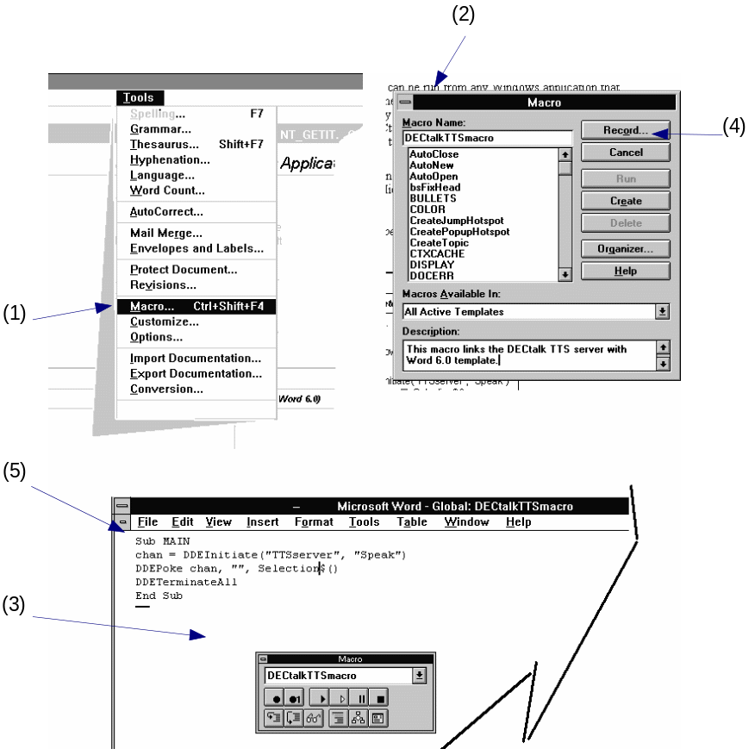

Table 3-7 — Creating a Word Macro and Associating it with a File or Document Template
Task/Location |  |  |  | Action |  |  | Result
Word Window, Tools menu |  |  |  |  |  | Select Macro from the Tools Menu. (1) |  | The Macro dialog box is displayed. (2) 
Macro dialog box (2) |  |  |  |  |  | Enter the name of the macro you are going to create. (3)
Macro dialog box (2) |  |  |  |  |  | Click on the Create button. (4) |  | The Macro creation window is displayed. (5)
Macro creation window (5) |  |  |  |  | Insert the following macro: (Note: you can insert this macro as a text file directly from the word.txt file located in the \DECTALK\ directory)  Sub MAIN  If AppIsRunning("TTSsrv") = 0 Then  Shell "TTSSRV.EXE", 0  rightNow = Now()  diffTime = 0  Print "Starting DECtalk Server"  WaitCursor 1  While diffTime < 0.0000300000000000001  diffTime = Now() - rightNow  Wend  WaitCursor 0  Print " "  If AppIsRunning("TTSsrv") = 0 Then  MsgBox("Cannot find TTSSRV.EXE in the path", "Speak", 0)  Goto FINIS  End If  End If  channel = DDEInitiate("TTSserver", "Speak")  If channel = 0 Then  MsgBox("Unable to connect to TTSSRV.EXE", "Speak", 0)  Goto FINIS  Else  DDEPoke channel, "Speak", Selection$()  DDETerminate channel  FINIS:  End Sub
Macro creation window (5) |  |  |  |  |  | Close macro creation window and return to the main document. |  | The macro is created.
Step 2 — Associating the Macro with a Tool Bar Button
After you create a macro to run DECtalk from within a Microsoft Word document (step 1), you can associate the macro with a button on a tool bar. You can also associate the macro with a menu selection from one of the pull-down menus or with a power-key combination from the keyboard. This section illustrates how to link the macro with a button on a tool bar.
Figure 3-9 — Associating the Macro with aTool Bar Button

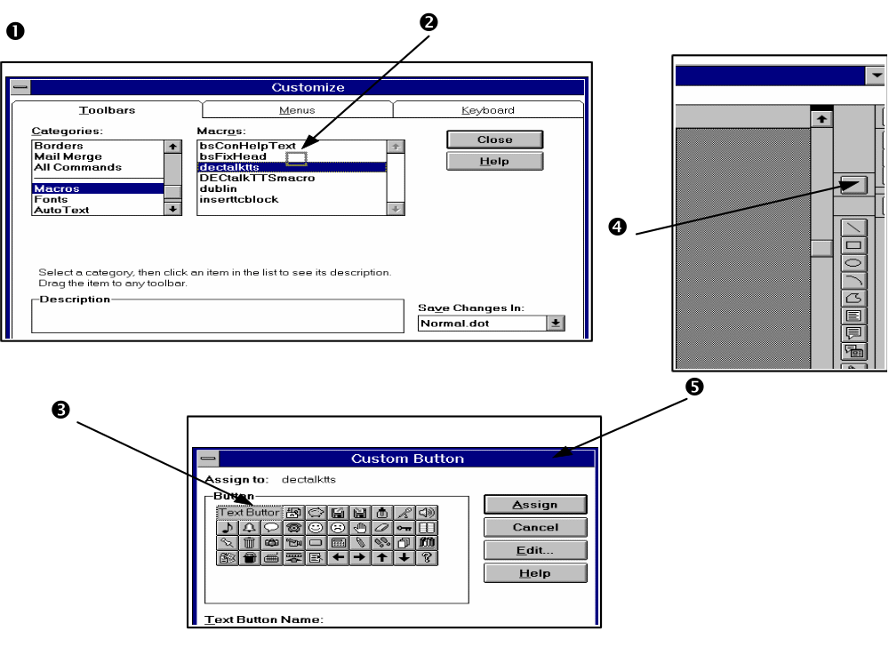
Table 3-8 — Associating the Macro with a Tool Bar Button
Task/Location |  |  | Action |  |  | Result
Associating the macro with a button on a tool bar
Word Window  Tools menu |  |  |  | Select Customize. | The Customize dialog box is displayed. (1)
Customize dialog box. |  |  |  | Select the Toolbars tab and click on Macros.
 |  |  |  | Locate the macro you created and click on the name. (2)
 |  |  |  | Place the cursor (arrow) on the macro name, press and hold MB1 and drag the cursor to the tool bar in which you want the DECtalk macro placed. (3)
 |  |  |  | An outlined box appears where Word will place the new button. (4) | The Custom Button box is displayed. (5)
Custom button dialog box (5) |  |  |  | Click on the button you want to associate with the DECtalk macro. | The new button now appears in the gray outlined box in the toolbar.

Step 3 — Launching and Configuring the DECtalk Software Text-to-Speech Server
Once you have associated the DECtalk macro with a button (step 2), you must have the TTS (text-to-speech) server running before DECtalk will speak selected sections of text from an application. This section outlines how to start the TTS server and configure it for speaker selection, User dictionary selection, and speaking rate.
The TTS Server is launched by the Word macro and is displayed as a small window. You can control the speaking voice and speaking rate from the window pull down menu.
Applications can access the Text-To-Speech DDE server using the service name “TTSserver”. The service topic names are “Speak”, “LoadDictionary”, and “UnloadDictionary”. Each of these topics requires a string that is either text to be spoken (for topic “Speak”) or a dictionary file string.
Figure 3-10 — Launching and Configuring the DECtalk TTS Server
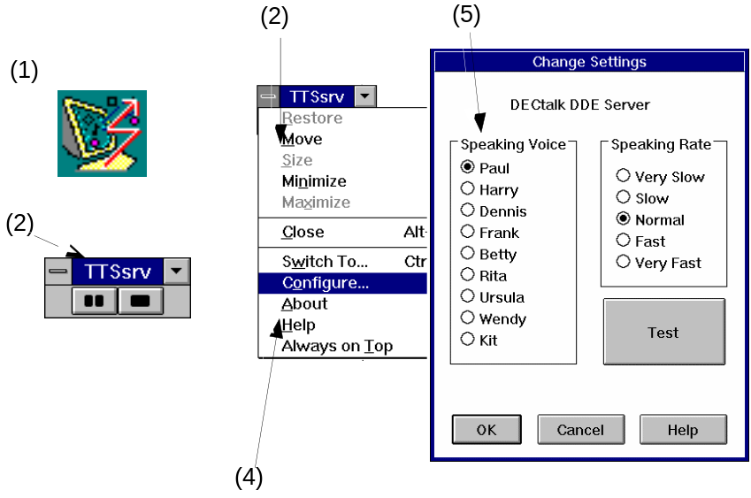
Table 3-9 — Launching and Configuring the DECtalk TTS Server
Task/Location |  |  |  | Action |  | Result
Launching and configuring the DECtalk TTS server
DECtalk Software program group |  |  | Click on the TTS Server icon. (1) |  | The TTS Server window is displayed. (2)
TTS Server window (2) |  |  | Pull down the Window menu (3) and select Configure... (4) |  | The Change Settings dialog box is displayed. (5)
Change Settings dialog box (5) |  |  | Click on the desired speaking voice and speaking rate.
 |  |  | Click on the Test button to preview your selections.
 |  |  | Adjust the settings until you produce the desired result.
 |  |  | Click on OK. |  | The selected settings will remain in effect as the default settings until they are changed.  Note: in-line commands in selected text played through the TTS server will override the defaults.

Step 4 — Speaking Text in a Microsoft Word .doc File with the DECtalk TTS Server
Once the TTS server is launched by the Word macro and you configure it for the desired speaking voice, speaking rate, and with a user dictionary file (step 3), you can have DECtalk speak selected sections of text from an opened file.
Figure 3-11 — Speaking Text in a Microsoft Word .doc File with the DECtalk Software TTS Server

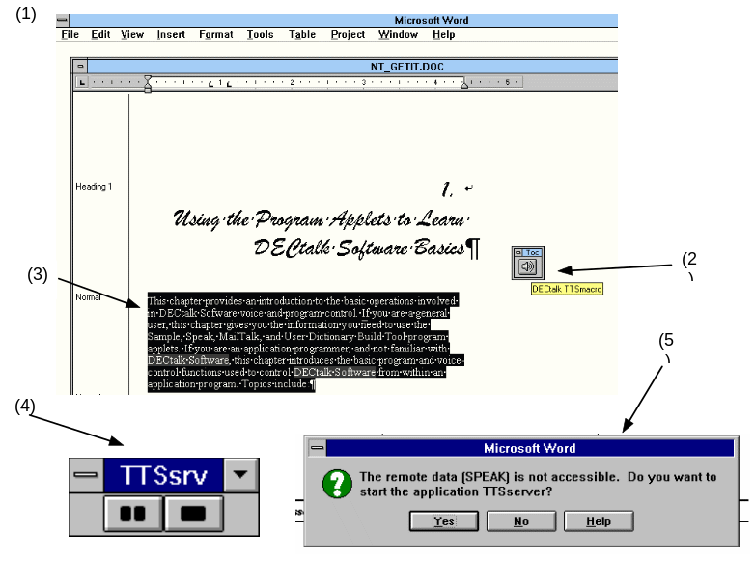
Table 3-10 — Speaking Text in a Microsoft Word .doc file with the DECtalk TTS Server
Task/Location |  |  | Action |  | Result
Microsoft Word window with file opened (1) and the TTS Server button visible (2) |  |  |  | Select a range of text for DECtalk to speak. (3)
 |  |  |  | Click on the TTS Server button (2) |  | DECtalk speaks the selected text.
TTS Server window (4) |  |  |  | Press the Pause or Stop button if you want to pause or stop DECtalk as it is speaking the text.  Note: When you pause the server, all queued text remains queued up even though you deselect it in the Word document. When you stop the server, all queued text is flushed from the DECtalk system. |  | If the server is not accessible, an error is returned. (5)

Say Command-Line Applet
The DECtalk Say command-line applet lets you run DECtalk from the Windows 95 command line. Say provides many of the standard DECtalk input and output options available in the Speak and sample applets and the DECtalk API.
Command syntax:
SAY [options] [text]

Help Options
-h or -? | Outputs this file to the console. This option cancels any others on the command line.
Output Options
-w outFile | Convert text to specified wave file instead of speaking to the sound device.
-l[t] outFile | Turn on text logging, which logs all input text to a file. This text includes any pre- and post- commands as well as commands sent to DECtalk by the Say program itself.  Because this is the default logging mode, the 't' immediately following the '-l' is optional.
-ls outFile | Turn on syllable logging, which logs each syllable to a file.
-lp outFile | Turn on phoneme logging, which converts the input text to phonemes. This is useful if you want to get DECtalk to sing. You convert the text to phonemes and then insert the tone commands into the phoneme file.
-lp outFile (cont.) | If no output options are specified, Say sends its output to the installed sound device, usually a sound card. Only one output option can be specified; if you specify more than one, the last one on the command line is used.
Input Options
-pre preText | Text to be passed to DECtalk before the normal input. The prefix text is "forced" out before the input text is read.
-post postText | Text to be passed to DECtalk after the normal input.  This is useful for passing terminating commands to DECtalk that would normally not be part of the input. If the postfix text has spaces, it must be enclosed in quotes. An example would be "[:phoneme off]" or "The End".  The "normal" input is "forced" out before the postfix text is read.
text | Text appearing on the command line is spoken. The text to be spoken can come either from the standard input or from the command line.  Anything on the command line that is not an option will be interpreted as text, as will anything following it on the command line. In other words, text to be spoken must appear on the command line after all options.  If the *first* word in the text has a dash (-) or slash (/) as its first character, you must precede it with another dash or slash. For example, to tell DECtalk to say the number -123, you would type the command  This is necessary to avoid having SAY interpret the number as a command line option. I  f you embed DECtalk commands into your text, you must enclose them in quotes if they contain spaces.  This is because SAY treats each space-delimited command-line argument as a separate "word", while DECtalk commands must be processed as single "words" by the SAY program.  If no text is specified, SAY will take its input from the standard input. For example, you could have SAY speak a directory listing in Betty's voice by typing  DIR | SAY -pre "[:nb]"  or you could just type the command SAY  and then enter text at the console. In this case, SAY speaks each line after you press Return, and exits after you press ctrl-z. If you want Say to take its input from a file, use file redirection as in the following example, which reads the file foo.txt in Harry's voice:  SAY -pre "[:nh]" < FOO.TXT
Dictionary Options
-d userDict | Loads the specified user dictionary before speaking. This dictionary is loaded in place of any default user dictionary determined by DECtalk.

