—
Installing DECtalk Software

This chapter provides the information needed to install Error: Reference source not found and important information about registering your Error: Reference source not found product.
Specific topics include:
• Preparing for installation
• Installing Error: Reference source not found
• Solving installation problems
Preparing for Installation
Error: Reference source not found is installed from the installation floppy shipped with the product. The installation should take you no longer than ten minutes to complete. You can install Error: Reference source not found from the Windows command line or from within the File Manager.
Before installing Error: Reference source not found, make sure that all prerequisite software and hardware components are installed on your system. Consult the release notes and carefully read the Error: Reference source not found license agreement. Digital recommends that you back up the disk or file system you will be installing Error: Reference source not found on before installing Error: Reference source not found.
Release Notes
Before you install the Error: Reference source not found product, Digital strongly recommends that you read the release notes that are available in the installation kit. The release notes are in the readme.txt file found in the installation directory. These notes contain the latest information about the product.
Software License
The software license is subject to the software agreement enclosed in the product kit containing the installation disks and documentation.
Hardware Requirements
Hardware requirements include a standard PC audio sound card, an Intel PC workstation, and adequate disk space for installation.
Audio Sound Card
Your system must be configured with an MPC (Multimedia PC) compliant audio device that supports 8-bit or 16-bit data format at an 11.025 kHz sample rate. You can install Error: Reference source not found without an audio device present and capture .WAV audio files; however, an audio device must be present to actually have Error: Reference source not found speak text.
Intel PC Workstations
Error: Reference source not found runs on Intel PC workstations. Error: Reference source not found performance is dependent on your system having enough computational power to perform all the computations involved in text-to-speech conversion. Therefore, Error: Reference source not found only should be installed on one of the approved processors. See the Software Product Description or release notes for a list of the latest supported systems.
Note
Error: Reference source not found performance can be affected in a heavily loaded multitasking environment where Error: Reference source not found could become starved for computational power and will not speak continuously. There might be pauses in output for any application running on such an under-powered system.
Required Disk Space and Software
Error: Reference source not foundrequires that you have a minimum of 2.6 MB disk space for proper configuration and installation.
Error: Reference source not foundrequires that you have the Windows Operating System installed and running on your computer.
Installing Error: Reference source not foundError: Reference source not found
You can install Error: Reference source not found from within Windows using the Windows Explorer or from the Windows Operating System Run Window.
If a previous version of Error: Reference source not found exists on your system, the new installation overwrites it.

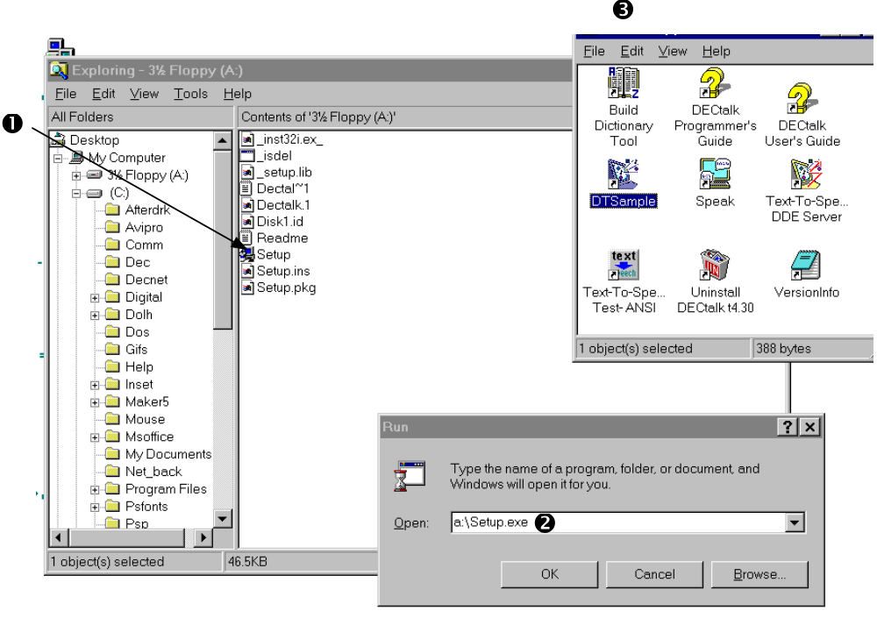
Table 1-1— Installing DECtalk Software
Task/Location | Action | Result
Installing Error: Reference source not found from the Windows Explorer
 | 1. Insert the distribution media in the 3.5-inch floppy drive.
With the File Manager displayed (1) | 2. Display the directory listing for the Error: Reference source not found installation floppy drive.
 | 3. Double click on the setup.exe file. | The Error: Reference source not found installation process begins.
Installing Error: Reference source not found from the Windows Explorer
At the File menu | 1. Select Run. | The Run dialog box is displayed. 
Run dialog box  | 2. Enter a:\setup. (Some machines might have a disk drive letter other than b: for the installation drive.)
 | 3. Click on OK. | Installation begins.
Installing Error: Reference source not found from the Windows Run Window
 | - Insert the distribution media your 3.5-inch floppy drive. | Installation process begins. Error: Reference source not found prompts you for required installation information through a number of screen prompts.
 | - Set the default directory to a:
At the Windows command line prompt with the default directory selected  | - Enter setup and respond to the prompts. | A message is displayed upon successful completion of the installation procedure.

Solving Installation Problems
If errors occur during the installation procedure, Error: Reference source not found returns an error message. Installation errors usually occur if any of the following conditions exist:
- The operating system version is incorrect.
- The prerequisite software and hardware components or version is missing or incorrect.
- There is insufficient disk space.
System files and parameters are not updated to reflect exact file locations and directory naming conventions.
If you have problems while using Error: Reference source not found and you believe the error is caused by the application, do one of the following based on the type of support service your organization has obtained from Digital:
- If you have a Software Product Services Support Agreement, contact your Customer Support Center for advisory and remedial advice.
- Submit a Software Product Report (SPR).
- If you do not have a support agreement with Digital but have purchased Error: Reference source not found within the last 12 months, submit an SPR.

