—
Introduction to DECtalk Software

This chapter provides a general overview of DECtalk Software.
Topics include:
• Features and functions
• Components
• How it works

Overview
Error: Reference source not found extends the capabilities of your personal computer by turning text files into spoken words. It can accurately read ASCII text from a variety of sources, such as electronic mail and word processors, using a standard PC audio sound card for output. Nine different voices are provided and users can control voice pitch, rate of speech, and word or phrase emphasis.

Error: Reference source not found Version 4.3 Features and Functions Error: Reference source not found

Latest Version of Speech-Synthesis Technology from Digital
Error: Reference source not found contains the latest version of Error: Reference source not found speech synthesis. This incorporates a number of improvements from earlier versions of DECtalk and is the a software-only version.

Letter Mode, Word Mode, and Clause Mode
Error: Reference source not found can immediately speak single characters without waiting for an entire clause to be buffered. This feature is useful in applications requiring tactile feedback for what was entered on the keyboard. It also provides normal clause buffering for natural speech. Error: Reference source not found can speak letters, words, phrases, clauses, paragraphs, and whole documents. Error: Reference source not found allows the application to terminate speech immediately instead of waiting for the buffered text to complete processing.

Short Command Strings
Many of the command strings, such as change rate, change voice, start, stop, and index marks can be abbreviated for greater ease of use in applications.

High-Quality Speech and Word Pronunciation Accuracy
Error: Reference source not found speech retains its high quality. In addition, a number of improvements have been made in functionality and acoustic phonetic quality.
The accuracy of word pronunciation is higher than in any previous version of Error: Reference source not found. There have been significant improvements in the accuracy and quality of letter-to-phoneme rules. Also, Error: Reference source not found has a large built-in dictionary that is used in the accurate pronunciation of individual words as well as enhancing their rhythmic naturalness.

Pronunciation Heuristics
Certain heuristics have been improved and made more intelligent. For example, Error: Reference source not found is able to recognize and parse unpronounceable sequences such as uppercase initials (FBI, AAA, and so forth) in addition to the normal unpronounceable sequences such as those with no vowels (CBS, NBC, for example).

Error: Reference source not found Components Error: Reference source not found
Error: Reference source not found components include:
- Sample and Speak program applets (dtsample.exe and speak.exe)
- A command-line program that speaks text (say.exe)
- Programming aids, including the API, voice-control commands, and the User-Dictionary Build Tool
- Text-to-Speech Server
- Sample code for the Sample applet, the command line program, say.exe, and a speech-to-memory sample program.

Sample Program Applet
The sample program applet and components are provided to give you some ideas on how to get started with your application. Both the graphic user interface and source components used to develop that user interface are included as part of the sample program. See Figure 2-1 for a visual overview of the sample Program applet. See the DECtalk Software Programmer’s Guide for a technical description of the sample program.
Figure 2-1 — Visual Overview of the Sample Program Applet
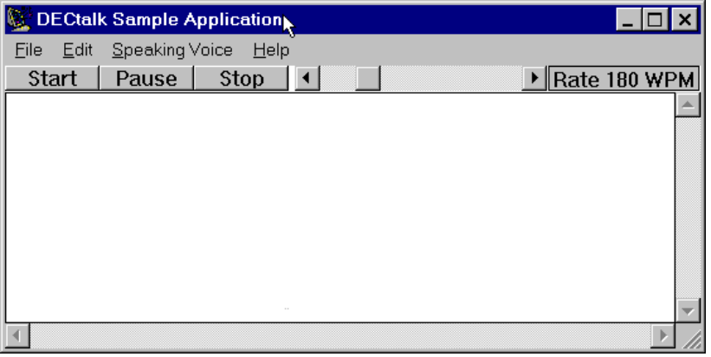

Speak Program Applet
The Speak program applet is included as a practical example of how the Error: Reference source not found API can be used to produce an innovative Text-To-Speech application that maximizes user interaction through a highly graphical interface. Figure 2-2 shows the Speak program applet.
Figure 2-2 — Visual Overview of the Speak Applet
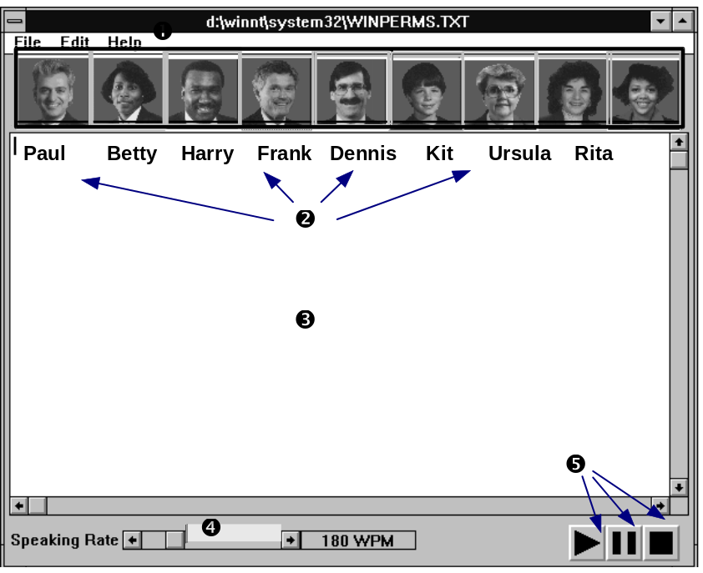

Legend
 | Menu bar: File, Edit, and Help menus |  |  |  |  | Speech speed-control slider
 | Voice-activation buttons |  |  |  |  | Start, pause, and stop push buttons
 |  | Text-collection area
* Note that the faces become cartoon characters when using VGA 16-color mode.

Text-to-Speech Services
DECtalk Software text-to-speech services includes the DDE Text-to-Speech server.

Text-to-Speech DDE Server
The DECtalk Software Text-to-Speech server makes it possible for any Window’s application that can call DDE and that contains ASCII English text to speak that text through DECtalk Software. The server is launched automatically when ever you start Microsoft Mail or manually when ever you click on the Text-to-Speech server icon in the DECtalk Software program group.

Programming Aids
The Error: Reference source not found programming aids include the application programmer’s interface (API), voice-control commands, and user dictionary build tool. Each component is introduced in this section and explained in detail in Chapter 3.

Error: Reference source not found 4.3 APIError: Reference source not found
DECtalk Software contains two APIs. The DECtalk Software API and the Microsoft Text-To-Speech API.
The DECtalk Software Text-To-Speech API is a Digital extension to the MPC (Multimedia PC) API specified by the Windows 95 operating system.
The API function set gives you a flexible method of manipulating various parameters of Error: Reference source not found functionality from within your application. These functions perform a wide range of tasks associated with the Text-To-Speech system. See the DECtalk Software Programmer’s Guide for the complete list of API functions.

Voice-Control Commands
Error: Reference source not found includes Voice-Control commands, also called inline commands. You can use these commands to perform simple voice-control operations, such as changing the speaking rate or speaking voice while Error: Reference source not found is speaking. Commands are inserted into ASCII text files displayed in one of the program applets or directly into the application sources through the API functions.
Error: Reference source not found also has a more complex set of voice-control commands to modify the characteristics of each voice, control intonation and stress within written text, or to create special effects, such as singing.
Commands have special syntax rules and components that you need to use when you insert them into files. A few simple commands and command components are illustrated in Figure 2-3. Refer to Chapters 3 and 4, and online help for more information on voice-control commands.
Figure 2-3 — Command Components

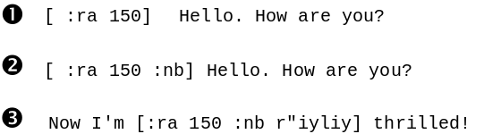

Legend
 | All commands are inserted into ASCII text files, begin with a colon, and are always inserted between brackets. (The command here tells Error: Reference source not found to speak this line at 150 words per minute.) Most commands can have parameters (For example, : ra 150 = rate of 150 words per minute). Commands are usually abbreviated forms of the complete command form (For example, ra = Rate.)
 | Two or more commands can be inserted between a single bracket set. (For example, the rate and voice selection are combined here.)
 | Phonetic spellings of words can be included with commands. (For example, [r"iyliy] for really after you have included a [:phone arapbet on] command)

Error: Reference source not found Dictionaries Error: Reference source not found
Error: Reference source not found has two pronunciation dictionaries — a large internal (built-in) dictionary and a user-defined dictionary. With the large built-in dictionary, you can easily use many proper names and normally unpronounceable sequences, such as uppercase initials, in their applications. With the user dictionary build tool, you can load application-specific words, or cultural or language-specific terms into the user dictionary. A sample user-dictionary file is installed with the software.

Using the Components
Error: Reference source not found applications and application-building components are intended for two specific audiences: the application programmer and the general user of text-to-speech applications developed with the API.

Application Programmer
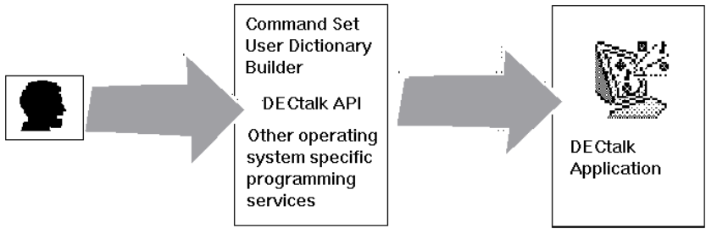
As a Error: Reference source not found application programmer, you can use the Error: Reference source not found programming aids and API components to create Error: Reference source not found applications. These applications can incorporate text files and use embedded Voice-Control commands as permanent parts of the application.

General User
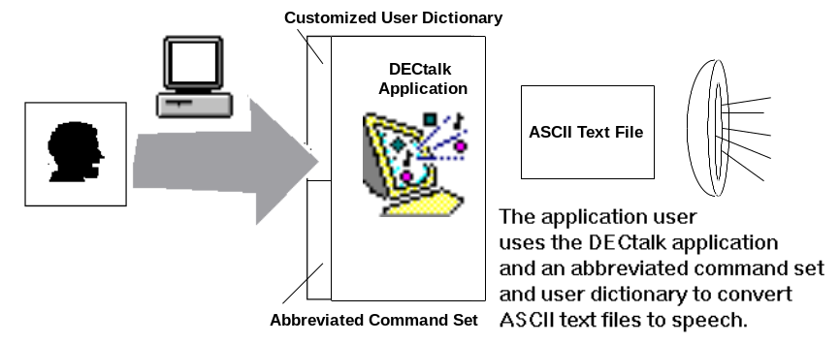
The application’s general user accesses the application through the Windows 95 environment and can use an abbreviated set of voice-control commands and the user dictionary to fine-tune the basic pronunciation and voice characteristics defined in the application.

How It Works
Error: Reference source not found converts ASCII English language text into speech output through a speech synthesizer. There are two ways to feed text into the speech synthesizer: through the user interface or through the API. The flow of the text-to-speech process is shown in Figure 2-4.
Figure 2-4 — Flow of the DECtalk Software Text-to-Speech Conversion Process

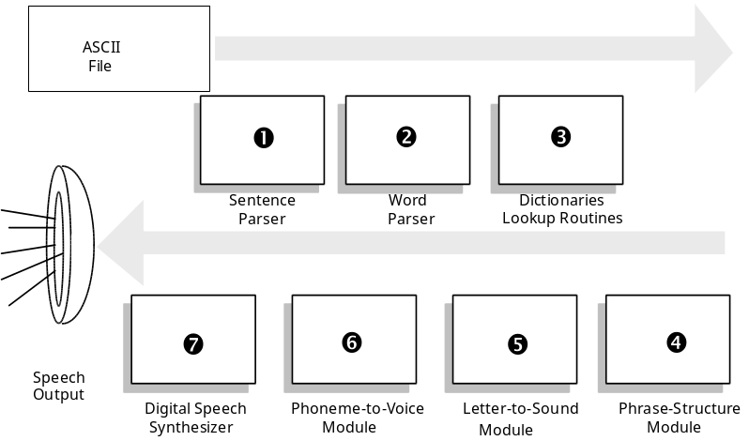

Legend
❶ | A sentence parser breaks the input stream into separate words and locates some clause boundaries (indicated by commas and other punctuation marks as well as by special words loaded in the Error: Reference source not found internal dictionary). The sentence parser also recognizes and deals with phonemic symbols and commands that you might have added to the input text.
❷ | A word parser breaks words into their component parts, dividing words by their final pronounceable form. Strings of text that do not form pronounceable English words are spelled out letter by letter. A number formatter is used if the text contains numerals. The number formatter applies the rules for many common number formats and converts the numbers into English words.
 | The number formatter also recognizes many common abbreviations, such as “lb” for “pound.” Number speaking rules are discussed in the Error: Reference source not found online Help file.
❸ | A dictionary lookup routine searches the pronunciation dictionaries. Error: Reference source not found has a built-in dictionary of many commonly used words. Error: Reference source not found also has a user dictionary for programmers and general users that can be filled with words specific to an application. This dictionary and how to load it are described in Chapter 3. While this version of Error: Reference source not found has greater pronunciation accuracy than its predecessors, it may sometimes be necessary to send Error: Reference source not found the correct phonemes for words important for a particular application. This can be done by using the user dictionary.
❹ | A phrase structure module recombines all phonemic output from the dictionary search and other modules. Durations of phonemes and pitch commands are computed for the clause, and appropriate sound variants are selected for those phonemes that can be pronounced in more than one way.
❺ | A letter-to-sound module uses a set of English pronunciation rules to assign phonemic form and lexical stress patterns to words not found in the dictionary. See Chapter 3 for more information on modifying the phonemic form of words, and see Chapter 4 and Appendix C for enhancing special voice qualities, such as emphasis and singing.
❻ | The phoneme-to-voice module processes clauses passed from the phrase structure module and converts them to control signals for the speech synthesizer. This module modifies the clauses by changing the phonemes/allophones into parameters that determine the natural resonant frequencies of the vocal tract (formants), and sound source amplitudes. The control parameters are sent to the speech synthesizer for output.
❼ | The Digital speech synthesizer computes a speech wave form with acoustic characteristics that are determined by the synthesizer control commands.

