Pure Java Embedded
Graph Database Engine
(Denys Mosiuk, IO-92)

Draft Version

- Graph Database Overview (by neo4j)
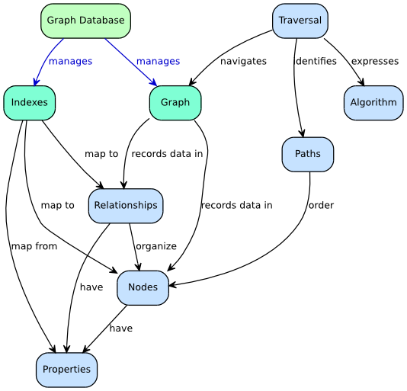

- Project Features
- Store Nodes.
- Store Relationships.
- Define Node Types (peoples, movies etc).
- Define Relationship Types (knows, follows).
- Store Properties for Nodes.
- Store Properties for Relationships.
- Store Indexes for Nodes.
- Store Indexes for Relationships.
- Optimize database storage.
- Store infromation in files.
- Pure Java API (Embedded).
- Server-Client model.
- Find Traversals (in queries).
- Query Result -> Node Set.
  - User defined implementation (Iterative query) [?]
  - Algorithm is selected by some criteria (Task) [?]
- Manage Nodes.
- Manage Relationships.
- Manage Properties.

Legend
- - Kernel/Important feature. Will be realised.
- - Not_Important feature. Will not be realised yet.
- - Uncertain feature. Thinking about “to be realised?”.

- Database and query sample (in development)
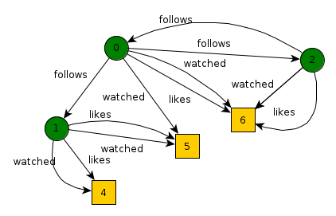
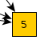 Movie Node
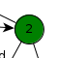 User Node

Task: Find movies people which I follow likes, but I don't watched.

Code Sample (Draft)
Database db = Database.loadDatabase("mydb.gdf");
Node me = db.getNode(0);

. . .

Transaction t = new Transaction();
t.setRootNode(me);
t.addQuery(1, db.getEdgeType(MySchema.EDGE_FOLLOWS));
t.addQuery(1, db.getEdgeType(MySchema.EDGE_LIKE));
t.addQuery(2, db.getEdgeType(MySchema.EDGE_WATCHED));
t.minus(1, 2);
t.execute();

if (t.isSuccessfull()) {
NodeSet result = t.getResultSet(1);
. . .
} else {
System.out.println("Transaction wasn't executed!");
}

. . .
db.close(); // Close database after using
Short Description: This Transaction type means, that Transaction consist of queries. Query result is always Set of Nodes. Each Transaction has query-branches. So, client programmer can execute few queries simultaneously (using different branches) or use Result Set from previous queries as a input data for next query (in same branch). Also, API_User (or just User) can apply discrete math operations for branch Result Sets. User can request Result Set from any branch. Default branch index is 0.

Thinking about another transaction model

Branch visualization for sample:
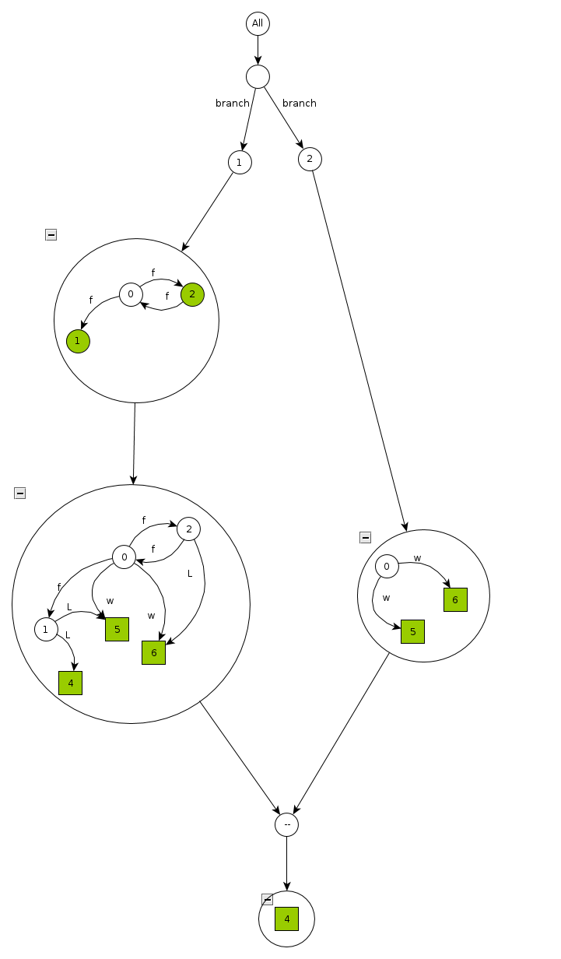
Nodes, which are result of query are highlighted green.
- Object project structure (Draft)
