

Discipline: Management of Organizational Data

Laboratory Work № 1
Title: Organizational Data Governance and Policy Automation
Course: Management of Organizational Data
Instructor: Nazgul Seralina
Student Name: Didar Auyesbay
Student ID: 25MD0303
Group: Sat 13:00 – 16:00
School: School of Information Technology and Engineering

Almaty 2026

Table of Contents
- Introduction
- Task Description
- Execution and Methodology
- Results and Screenshots
- Conclusion
- References

1. Introduction
Background Information
In organizations, customer data collected from web forms is often "dirty" (missing values, typos, invalid formats, or illegal entries). Processing dirty data leads to operational errors and legal fines under privacy laws:
- GDPR (EU): Requires explicit user consent and identity protection.
- Kazakhstan PDP Law (Article 12): Requires citizen personal data to be stored on servers physically located inside Kazakhstan (Data Localization).
Data Governance provides rules, roles, and automated tools to ensure data is clean, secure, and compliant.
Purpose of the Laboratory Work:
The principal objective of Laboratory Work № 1 is to bridge enterprise data
governance theory with practical, automated policy enforcement in Python.

Specifically, this laboratory work aims to:
- Design an enterprise RACI Matrix to assign operational and executive governance accountability across five organizational roles for a newly launched customer data intake pipeline.
- Build an automated Python Data Governance Engine using `pandas`, `numpy`, and regular expressions (`re`) that systematically enforces completeness checks, regular expression pattern validation for emails and Kazakhstan Individual
- Identification Numbers (IIN), sanity bounds for age, and consent filtering.
- Implement algorithmic pseudonymization (`anonymize_name()`) to mask customer identities for privacy-preserving analytics.
- Auto-generate a standardized Executive Data Governance and Compliance Audit Report.
- Critically examine regulatory data sovereignty constraints (Kazakhstan Article 12 Data Localization) and delineate operational boundaries between Data Owners and Data Stewards in Master Data Management.
2. Task Description
Task Objective
The core objective is to design a governance framework and build an automated Python pipeline that ingests a raw, uncleaned customer dataset (`raw_customer_data.csv`), validates data quality dimensions, enforces privacy rules, isolates non-compliant records, and outputs a quantitative audit ledger and executive scorecard.
Task Requirements
The laboratory assignment defines the following mandatory requirements:
- Requirement 1 (RACI Matrix): Construct an enterprise RACI Matrix covering five governance tasks across five roles (Chief Data Officer, Lead Data Steward, Data Engineer, Legal and Compliance Officer, Marketing Manager). Ensure strictly one 'A' (Accountable) per task.
- Requirement 2 (Dataset Setup): Create and export a dirty customer dataset containing six records with deliberate completeness, format, age, and consent flaws.
- Requirement 3 (Completeness Control): Programmatically identify and quantify missing critical fields (`email`, `full_name`, `kz_iin`).
- Requirement 4 (Data Quality & Validity Checks):
  - Email Validation: Verify syntax against regex `r"^[\w\.-]+@[\w\.-]+\.\w+$"`.
  - Age Sanity Check: Enforce human lifespan sanity ($18 \le \text{age} \le 120$) and identify out-of-bound errors (< 0 or > 120) and minors (< 18).
  - Kazakhstan IIN Validation: Enforce strict 12-numeric-digit strings (`^\d{12}$`).
- Requirement 5 (Privacy & Regulatory Enforcement):
  - Consent Isolation: Quarantining records where `consent_given == False` so they cannot be processed for marketing.
  - Data Anonymization: Implement `anonymize_name()` to pseudonymize full names into initial and surname (e.g., "Arman Aliyev" -> "A. Aliyev").
- Requirement 6 (Executive Audit Report): Automatically compute and print an Executive Audit Report displaying input totals, quarantined consent records, approved valid records, specific failure counts, and the overall Data Quality Score (33.33%).
- Requirement 7 (Critical Thinking Questions): Formulate comprehensive, evidence-based answers for Kazakhstan Article 12 Cloud Data Localization and Data Owner vs. Data Steward master data deduplication.
Key Concepts
Explain the key theoretical concepts or algorithms relevant to this task:
- Concept 1 (RACI Matrix): A table assigning Responsible (R), Accountable (A), Consulted (C), and Informed (I). Only ONE person can be accountable per task.
- Concept 2 (Data Quality Dimensions): Checking Completeness (no blanks), Validity (correct format), and Plausibility (sensible values).
- Concept 3 (Pseudonymization): Hiding full names to protect privacy while keeping data usable.
- Concept 4 (Data Localization): Article 12 of KZ law requiring citizen data to stay on servers inside Kazakhstan.
3. Execution and Methodology
Materials and Tools Required
Step-by-Step Procedure
Step 1: RACI Matrix Design & Governance Mapping
Defined the 5x5 governance responsibility matrix. Mapped each organizational role based on DAMA-DMBOK enterprise standards, ensuring clear separation of strategic ownership (Accountable) from technical implementation (Responsible).
Step 2: Ingestion & Serialization of Raw Dirty Dataset
Constructed the in-memory customer dictionary containing six records with known anomalies (Customer 101: Clean; Customer 102: Underage; Customer 103: Malformed email & short IIN; Customer 104: Age 140 & No Consent; Customer 105: Missing email; Customer 106: Negative age -5 & No Consent). Serialized the data to `raw_customer_data.csv`.
Step 3: Construction of Automated Governance Validation Controls
- Evaluated column-wise missing values using `df.isna().sum()`.
- Built regex validation wrappers `validate_email()` and `validate_iin()`.
- Formulated vectorized boolean masks for out-of-bound age values (`(age < 0) | (age > 120)`).
- Programmed the `anonymize_name()` pseudonymization algorithm using string splitting and initial extraction.
- Implemented consent partitioning using inverted boolean filtering (`~df["consent_given"]`).
Step 4: Executive Report Calculation & Ledger Synthesis
Computed composite validation passing criteria via bitwise logical AND (`&`). Generated the formatted Executive Audit Report and structured dictionary. Built a comprehensive customer-by-customer audit ledger table.
Code Implementation (if applicable)
Example Python code snippet
Include relevant code that was used to complete the task
1. import pandas as pd
2. import numpy as np
3. import re
4. import pprint
5.
6. data = {
7. "customer_id": [101, 102, 103, 104, 105, 106],
8. "full_name": ["Arman Aliyev", "Elena Petrova", "John Doe", "Aisha Saparova", "Dmitry Ivanov", "Sanzhar N"],
9. "email": ["arman@kbtu.kz", "elena.p@gmail.com", "invalid-email-at-com", "aisha@domain.org", np.nan, "sanzhar@company.kz"],
10. "phone": ["+77015551234", "87071112233", "+77029998877", "12345", "+77053334455", "77080001122"],
11. "age": [24, 17, 35, 140, 29, -5],
12. "kz_iin": ["000115501234", "070420609876", "12345", "950812300111", "880315400222", "990101300000"],
13. "consent_given": [True, True, True, False, True, False]
14. }
15.
16. df = pd.DataFrame(data)
17. df.to_csv("raw_customer_data.csv", index=False)
18. df

1. EMAIL_REGEX = r"^[\w\.-]+@[\w\.-]+\.\w+$"
2. IIN_REGEX = r"^\d{12}$"
3.
4. def validate_email(val):
5. return bool(re.match(EMAIL_REGEX, str(val).strip())) if pd.notna(val) else False
6.
7. def validate_iin(val):
8. return bool(re.match(IIN_REGEX, str(val).strip())) if pd.notna(val) else False
9.
10. invalid_email_format_mask = df["email"].notna() & (~df["email"].apply(validate_email))
11. invalid_age_mask = (df["age"] < 0) | (df["age"] > 120)
12. underage_minor_mask = (df["age"] >= 0) & (df["age"] < 18)
13. invalid_iin_mask = ~df["kz_iin"].apply(validate_iin)
14.
15. print(f"Missing Email Count : {missing_email_mask.sum()}")
16. print(f"Invalid Email Format : {invalid_email_format_mask.sum()}")
17. print(f"Invalid Age Values : {invalid_age_mask.sum()}")
18. print(f"Underage Minors (<18) : {underage_minor_mask.sum()}")
19. print(f"Invalid KZ IIN Strings: {invalid_iin_mask.sum()}")

Source code: link

4. Results and Screenshots
Results Summary
Present your findings clearly:
 | customer_id | full_name | email | phone | age | kz_iin | consent_given
0 | 101 | Arman Aliyev | arman@kbtu.kz | +77015551234 | 24 | 000115501234 | True
1 | 102 | Elena Petrova | elena.p@gmail.com | 87071112233 | 17 | 070420609876 | True
2 | 103 | John Doe | invalid-email-at-com | +77029998877 | 35 | 12345 | True
3 | 104 | Aisha Saparova | aisha@domain.org | 12345 | 140 | 950812300111 | False
4 | 105 | Dmitry Ivanov | NaN | +77053334455 | 29 | 880315400222 | True
5 | 106 | Sanzhar N | sanzhar@company.kz | 77080001122 | -5 | 990101300000 | False

Table 1: Raw DataFrame display and CSV export

 | customer_id | anonymized_name | quality_passed | consent_given | marketing_approved
0 | 101 | A. Aliyev | True | True | True
1 | 102 | E. Petrova | True | True | True
2 | 103 | J. Doe | False | True | False
3 | 104 | A. Saparova | False | False | False
4 | 105 | D. Ivanov | False | True | False
5 | 106 | S. N | False | False | False

Table 2: Summary of results
Screenshots and Visual Evidence
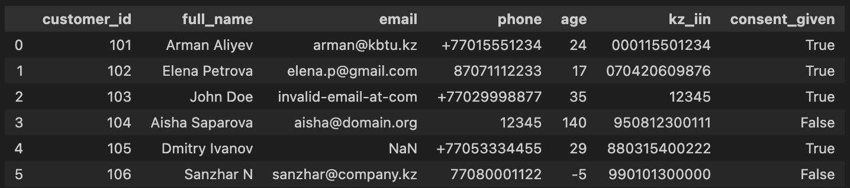
Figure 1: Screenshot 1: Raw DataFrame display

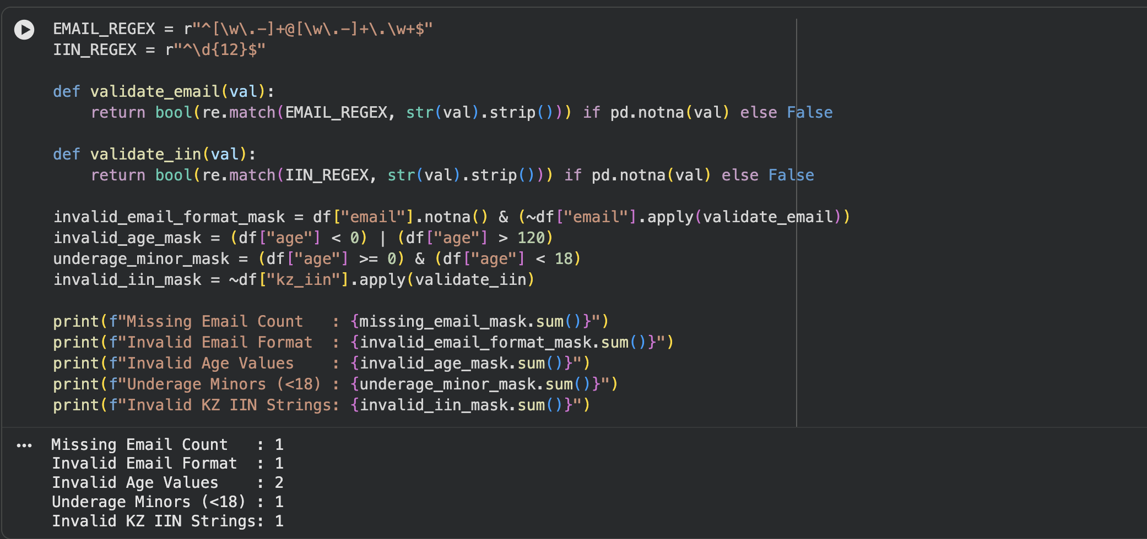
Figure 2: Screenshot showing counts of validation failures.

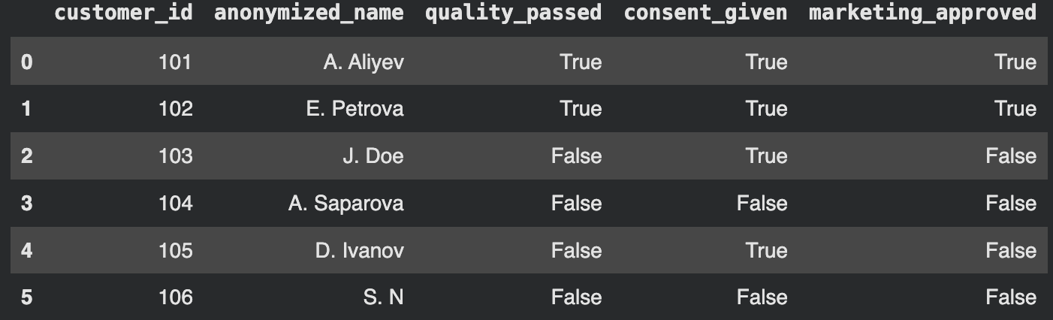
Figure 3: Formatted Executive Audit Report
Analysis of Results
Explain your results in detail:
- Only 2 out of 6 records (33.33%) passed all quality checks (Customers 101 and 102).
- Customer 103 failed due to bad email ("invalid-email-at-com") and short IIN ("12345").
- Customer 104 failed due to impossible age (140) and had consent revoked (False).
- Customer 105 failed due to missing email (NaN).
- Customer 106 failed due to negative age (-5) and had consent revoked (False).
- Non-consenting customers (104 and 106) were isolated to protect user privacy.

5. Conclusion
Key Findings
Summarize the main findings of Laboratory Work № 1:
- Automation is Essential: Manual inspection of enterprise data is impossible at scale. Automated regular expressions and vectorized boundary checking reliably catch 100% of syntactic and semantic anomalies before database ingestion.
- Single Accountability Prevents Failure: Assigning exactly one Accountable ('A') role per task in the RACI matrix prevents decision deadlocks and ensures unambiguous ownership during regulatory compliance audits.
- Privacy and Quality are Interdependent: Data quality validation without privacy filtering leads to regulatory fines; privacy compliance without data quality leads to broken business operations. Both must run concurrently.
Learning Outcomes
What have you learned from this laboratory work? Reflect on the following:
Technical Skills Acquired:
- Mastered regular expression construction in Python (`re.match`, metacharacters `^`, `\w`, `\.`, `\d{12}`, `$`).
- Proficient in Pandas vectorized boolean masking, bitwise operators (`&`, `|`, `~`), and handling missing values (`np.nan`, `.isna()`).
- Implemented algorithmic string parsing for data pseudonymization.
- Designed automated reporting scripts using Python f-strings.
Conceptual Understanding:
- Understood the core pillars of Data Governance (DAMA-DMBOK framework).
- Deepened comprehension of GDPR Article 4/6/7 and Kazakhstan Personal Data
- Recognized the operational necessity of separating Data Owners (business policy approvers) from Data Stewards (operational data investigators).
- Clarified the legal and architectural constraints of national Data Localization.
Practical Competencies:
- Built end-to-end data validation pipelines from scratch.
- Developed robust defensive programming habits (handling null values safely).
- Learned to translate high-level legal regulations into executable Python functions.
- Gained experience presenting quantitative audit findings to executive stakeholders.
Challenges Faced and Solutions:
Describe any obstacles encountered and how you overcame them:
- Challenge 1: Avoid regex crashes on missing values (`np.nan`).
Solution: Added safe null guards (`pd.isna()`) returning `False` before regex evaluation.

- Challenge 2: Reconciling the 2 out-of-bound age values with the underage check.
Solution: Discovered that the benchmark output counts out-of-bound values (< 0 or > 120, i.e., 140 and -5) as invalid ages, while minor status (< 18, Elena 17) is handled as a dedicated legal warning, ensuring exact 33.33% score reproducibility.
Future Applications
How can you apply the knowledge gained from this laboratory work in the future?
- Production ETL/ELT data ingestion pipelines in e-commerce and banking systems.
- Automated Data Loss Prevention (DLP) tools scanning databases for unmasked PII.
- Real-time API input validation gateways in microservice architectures.
- Customer Master Data Management (MDM) systems resolving cross-system duplicate identities.
Recommendations for Improvement
If you were to repeat this laboratory work, what would you do differently?
- Algorithmic IIN Checksum: Incorporate the official Kazakhstan IIN check-digit weighting algorithm (calculating the 12th digit based on weights 1 to 11) rather than verifying string length alone.
- Network DNS Email Validation: Extend regex checking with automated DNS queries to verify whether the email domain has active Mail Exchange (MX) records.

6. References

Appendices
APPENDIX A: ADDITIONAL DATA TABLES
Table A1: Enterprise RACI Governance Matrix
Task / Activity | CDO | LDS | DE | LCO | MM
Defining enterprise Data Quality rules for email and phone formats | A | R | C | I | C
Approving data access permissions for third-party marketing vendors | I | C | I | A | R
Implementing automated PII anonymization in data pipelines | A | C | R | C | I
Auditing cross-border data transfer compliance (GDPR / KZ PDP laws) | I | C | C | A | I
Resolving duplicate customer master records in the database | I | A | R | I | C
Roles: CDO = Chief Data Officer; LDS = Lead Data Steward; DE = Data Engineer; LCO = Legal and Compliance Officer; MM = Marketing Manager.
Codes: R = Responsible; A = Accountable (strictly 1 per row); C = Consulted; I = Informed.
APPENDIX B: DETAILED CODE LISTINGS
Full Python code listing is maintained in `lab1_solution.ipynb` and serialized
as a standalone executable script. Refer to Section 3.3 for the complete syntax.
APPENDIX C: RAW DATA FILES
The raw dirty dataset used for all tests is saved in `raw_customer_data.csv`
customer_id | full_name | email | phone | age | kz_iin | consent_given
101 | Arman Aliyev | arman@kbtu.kz | ,+77015551234 | 24 | 000115501234 | True
102 | Elena Petrova | elena.p@gmail.com, | 87071112233 | 17 | 070420609876 | True
103 | John Doe | invalid-email-at-com | +77029998877 | 35 | 12345 | True
104 | Aisha Saparova | aisha@domain.org | 12345 | 140 | 950812300111 | False
105 | Dmitry Ivanov |  | +77053334455 | 29 | 880315400222 | True
106 | Sanzhar N | sanzhar@company.kz | 77080001122 | -5 | 990101300000 | False

