AVR MINI KIT

User manual

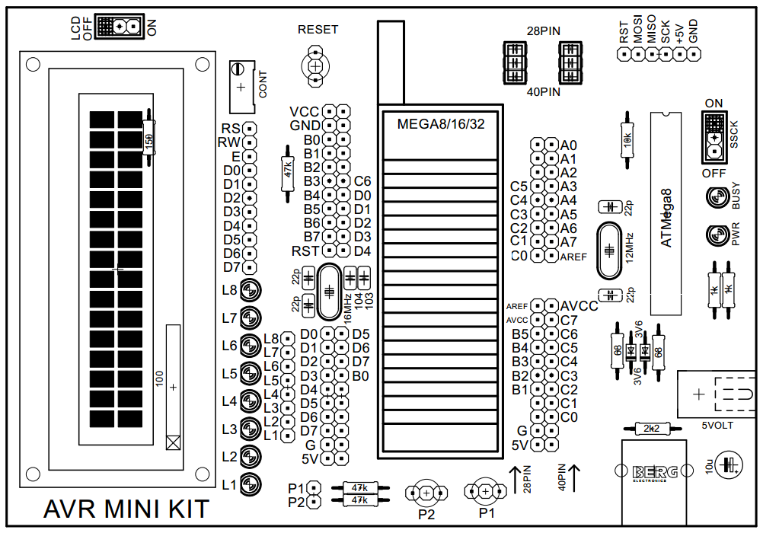

**Contents**

* Introduction ------------------------------------------------------------------------------------------------------------ 3
* Kit contents------------------------------------------------------------------------------------------------------------- 3
* Features ----------------------------------------------------------------------------------------------------------------- 3
* Board Layout ------------------------------------------------------------------------------------------------------------4
* Interfaces ----------------------------------------------------------------------------------------------------------------4
* Chip placements -------------------------------------------------------------------------------------------------------5
* Getting started with the board -------------------------------------------------------------------------------------5
* Driver installation ----------------------------------------------------------------------------------------------------- 6
* Getting the Microcontroller running ------------------------------------------------------------------------------6
* Using sample code-----------------------------------------------------------------------------------------------------7
* Troubleshoots ----------------------------------------------------------------------------------------------------------7

**Introduction**

This AVR Development Board allows you to perform any experiment on Atmega8/16/32 microcontrollers and create any applications based on them with minimum amount of effort and time. It’s easy and fast programming helps debug the programs at a much faster rate, whereas on-board interfaces like LCD and LEDs make it really comfortable to test the programs on the go. Connection of any external hardware is also very handy with I/O extended through pin headers. Programming of the microcontrollers on the board is done directly through USB cable. The board can also be used as a programmer for programming other AVR microcontrollers.

**Kit contents**

* AVR MINI KIT board
* Usb cable
* 5V DC adapter
* CD (required softwares and examples)

**Features**

1. Small size : 137x94 mm
2. Support Atmega8 /16/32 DIP microcontrollers
3. Built-in USBAsp programmer
4. 16MHz crystal for maximum speed
5. Available extra +5V and GND power pin, to handle other circuits or sensors.
6. All ports easily accessible
7. LCD module
8. 8 LED
9. Can be powered via USB or 5 volts adapter
10. 2 pulled up push buttons

**Board Layout**

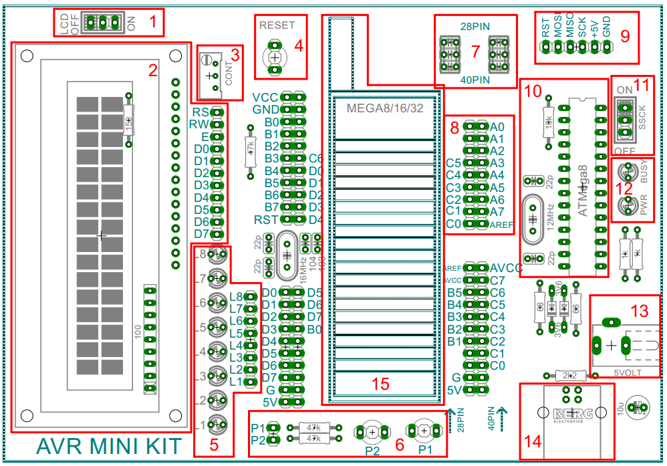

|  |  |  |  |
| --- | --- | --- | --- |
| **AREA** | **DESCRIPTION** | **AREA** | **DESCRIPTION** |
| 1 | LCD power switch | 9 | ISP connector for external circuit |
| 2 | LCD | 10 | USBASP programmer |
| 3 | LCD contrast setting pot | 11 | Slow SCK switch |
| 4 | MCU reset switch | 12 | Status LED |
| 5 | LED | 13 | 5V DC connector |
| 6 | Push button(pulled up) | 14 | USB B-Type connector |
| 7 | 40/28pin MCU selector switches | 15 | Zif socket for microcontroller |
| 8 | MCU pin out header |  |  |

**Interfaces**

**1. I/O**: There are 4 input/output ports that are extended through pin headers for easy interfacing to the external hardware.

**2. LED:** LEDs are provided on the board for quickly debugging simple programs. These can be connected to any Port using jumper cables.  
**3. LCD:** LCD provided in the board can be connected to any Port.  
**4. External programmer:** The ISP connector can be used to program any AVR microcontroller on external hardware.

**Chip placements**

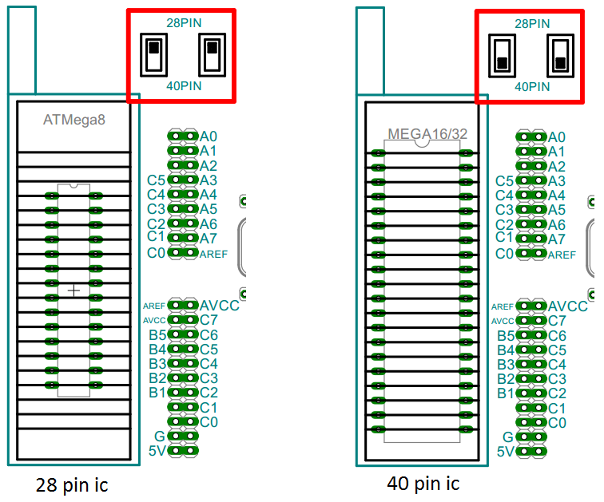

**Getting started with the board:**

1. Connect the board with a pc using the usb cable provided with the board. The LED marked as ‘PWR’ will glow if everything is ok.
2. A driver is needed for the pc to recognize the board’s in-built programmer. The Installation requires multiple steps which are described on the next section

**\*CAUTION: Powering the board with a voltage higher than 5 will permanently damage it.**

**Driver installation**

1. First disable “Signed driver enforcement”. Search Google and find the solution for your OS.
2. Connect the board with your pc.
3. Install eXtreme Burner (included in the cd)
4. If the warning box appears as below, click “Install this driver software anyway”.

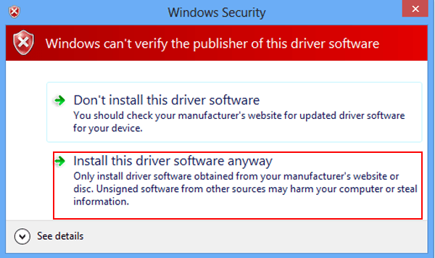

1. Complete the Installation process.
2. After successful installation, device manager will show the board whenever it’s plugged in.

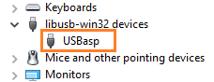

**Getting the Microcontroller running**

Along with the board, two more softwares are needed,

1. **Compiler:** Converts your program to a hex file (CodeVisionAVR) .
2. **Burning software:** Upload the hex file onto the MCU via a programmer (eXtreme Burner ) .

**Slow sck:** Brand new chip comes with a default internal 1 MHz clock frequency. Without slow sck, programming will failed with this kind of chips. After setting the clock to external high frequency crystal by changing fuse bits, high speed programming is possible. You can control the sck frequency via “SSCK” switch.

**\*CAUTION: Programming wrong fuse bit will kill the microcontroller.**

**Using sample codes**

The CD also contains some example codes. CodeVisionAVR C Compiler is used to write and compile the codes. The folder “exe” contains compiled hex file which can be uploaded directly onto the chip using eXtreme Burner.

**Troubleshoots:**

If the eXtreme Burner does not detect the board:

* Check if the board has power
* Check if the pc driver is properly installed
* Check the usb cable

If your programmer does not detect the chip:

* Check if the chip is properly placed in the zif socket
* Check “SSCK” is set properly
* Try changing the chip