PocketLancer: A MERN-Based On-Demand Freelance
and Home Services Marketplace
CH. Mangamma¹, Seelam Dedeep Reddy², Mallela Siva Sai Krishna³, Tungala Swetha⁴, Singothu Sravanthi⁵
Department of CSE, Bapatla Engineering College, Bapatla 522101,AP, India.

Corresponding author, Email: dedeepreddyseelam@gmail.com

Abstract—At least for a while longer, it is not as easy as it should be in 2025 to find a good local plumber, tutor or photographer. Global freelancing platforms have made great strides at matching people with remote workers, but they were never intended for services requiring someone to show up at your doorstep. For that, we created PocketLancer: the full-stack marketplace on MERN stack and Next.js running on Android. There are two types of bookings, field work versus digital work (freelancer comes to you / freelancer works remotely); this one design decision pushes everything else from how we search for freelancers through to how payment is held and released, disputes resolve, what we do when a freelancer arrives etc. We used MongoDB 2dsphere geo-indexing for location search, Razorpay for escrow payments Socket.io for real-time chat in web and [[ push notifications on Android using Firebase Cloud Messaging]]. Geo-queries are processed in less than 40 ms, real-time messages delivered within 12ms and our booking state machine passes all 48 of our test cases with no failures. The paper aims to describe how we built it, what trade-offs we made and where we think it can go next.
Keywords—MERN Stack; Freelancer Marketplace; Geo-Based Discovery; Escrow Payment; Apache Capacitor; Real-Time Messaging; Honor Score; Home Services.

I. INTRODUCTION
In the cities of India, the street is lined with electricians, carpenters, tutors, and photographers. They find clients by word of mouth or in informal WhatsApp groups. But these service providers have no business page, no protection if customers do not pay, and no way of building a transferable reputation. On the client side, finding a good local handyman is still a case of asking around the neighborhood or gambling on an unverified phone number on a wall poster. None of the biggest freelancing websites address this challenge. Fiverr and Upwork are great for designs or blog posts to be emailed to you, but not great for networked labor. They fall apart when someone needs a plumber tomorrow morning. Their search engines sort by reviews and response time, not by distance. There is no concept of a freelancer travelling to your home, there is no GPS check-in and there is no payment model that makes sense for an hourly repair job. To solve this issue, we built our own version, PocketLancer. The philosophy behind it was that field services and digital services are two different things, not two names for the same workflow. That decision - what we call the dual-mode model - touches everything else: the database schema, the booking state machine, how and when money moves, how we resolve disputes, even which Android permissions we request at startup. When you pick a service category, you get a workflow that was actually designed for that category. The backend is built with the MERN stack (MongoDB, Express.js, React with Next.js 14 and Node.js). The Android app has been packaged via Apache Capacitor from the same code base as the website; there are no separate native build Razorpay handles escrow payments for users Socket.io contains in-app chat, Firebase Cloud Messaging handles push notifications A trust system called Honor Score was added to enhance accountability on a simple scale from 0-100. The more you act well on the platform, the higher your score and vice versa when you do something wrong that result in a dispute found against you. The rest of the paper is organized as follows. Section II covers related work. In Section III, we describe what is out there and what is missing. In Section IV, we describe what we are proposing and why. Section V focuses on the system architecture. Section VI discusses the design of each of the key system components․ Implementation and test results are discussed in sections VII and VIII, with aspects of conclusions and future work in section IX.
II. LITERATURE SURVEY
Both Mwathi and Shibwabo [1] built a PHP/Node.js skill-to-job matching based collaborative sourcing platform. Their event-driven Node.js architecture presaged the patterns that were adopted in PocketLancer’s booking and notification pipelines, however, geographic proximity was not treated as a matching dimension.
Kaur et al. [2] characterised a not-web-based freelancing portal, briefed on job posting and bidding traffic only yet short of mobile delivery or location-aware search; gaps filled by PocketLancer via Capacitor packaging and 2dsphere geo-indexing.
Santy et al. [3] perform marketplace feasibility analysis, which shows that milestone-based payment contracts greatly reduce disputes between client and freelancers by providing verifiable checkpoints. This directly inspired PocketLancer to support independent per-milestone escrow releases.
Batool and Byun [4] introduced blockchain and biometric authentication to prevent fraud. Though cryptographically secure, the onboarding friction is not compatible with casual, time-critical home service bookings. Rather, PocketLancer employs an Honor Score capable of functioning as a socially legible trust proxy without any cryptographic overhead.
Thabassum [5] explained that freelancer profiles containing only text reduce credibility; PocketLancer attempts to address this by enabling a Cloudinary based multimedia portfolios, and allowing for reviews after service is delivered (verified).
Abhinav et al. CrowdAdvisor [6] then introduced a penalty model that inspired PocketLancer’s category-aware Honor Score deductions.
Madar and Moisi [7] demonstrated that semantic embeddings perform better than keyword matching for ambiguous projects, which suggests an upgrade to the existing keyword-based search system of PocketLancer in the future.
III. EXISTING SYSTEM
Current solutions can be classified into 3 categories: global generalist platforms (Fiverr, Upwork), domain specific (99designs, Toptal) and classified/directory services (JustDial, Urban Company).
A. Global Platforms
Fiverr and Upwork provide scalable matching infrastructure + payment infrastructure but are architected from the ground up for remote workers. Geographic coordinates do not influence your search ranking; so, clients looking for a nearby provider must filter manually. There is no GPS arrival verification or field-specific booking flows on either platform.
B. Classified and Directory Services
While Urban Company helps locals discover services, all price points are essentially controlled in addition to an algorithm that determines which freelancer you get — thus breaking any means of independent reputation. JustDial, too, is a listing platform without any booking/payment/review infrastructure. Neither offers in-platform messaging (in real-time), escrow protection, or an agreed structure for dispute resolution.
C. Comparative Summary

Feature | Global Platforms | Directories | PocketLancer
Geo-radius search | None | Partial | 2dsphere index
Field booking/GPS verify | No | No | Yes
Escrow protection | Platform-managed | None | Razorpay escrow
Milestone payments | Partial (Upwork) | None | Independent releases
Real-time messaging | Limited | None | Socket.io
Dispute resolution | Ad hoc | None | SLA-enforced
Trust mechanism | Star ratings | None | Honor Score
Native mobile app | Consumer-only | None | Android via Capacitor

TABLE I. Comparison of Existing Systems vs. PocketLancer

IV. PROPOSED SYSTEM
Introducing PocketLancer: a dual-mode freelancer marketplace where every vertical of field services & digital marketplace categories are structurally different workflows, not just misleading labeled variants. So, every subsystem branches on the service Category field, which guarantees semantic correctness all the way down.
A. Dual-Mode Service Model
In field mode, freelancer works on the client’s location. GPS is used to proximity-match bookings, a GPS verification must be left at the state machine before work can begin, and payment is settled upon confirmation of delivery by the client. In digital mode, bookings are skill-matched, a deadline ensures timely delivery, and an auto-release timer protects the freelancer from indefinite client no-shows.
B. Key Contributions
• Geospatial discovery through MongoDB 2dsphere index allowing for sub-40 ms radius queries.
• Category-split booking state machine with GPS arrival verification for field bookings
• Razorpay escrow functionality enabling contracts by the hour, fixed-price or based on milestones.
• Socket.io real-time messaging featuring online-presence and typing indicators.
• We defined structured dispute resolution with SLA enforcement and outcome variations per category.
• Three tiers of badge(Green/Orange/Red) gamification, as an Honor Score.
• Single Next.js codebase serving Progressive Web App and Android APK via Capacitor.

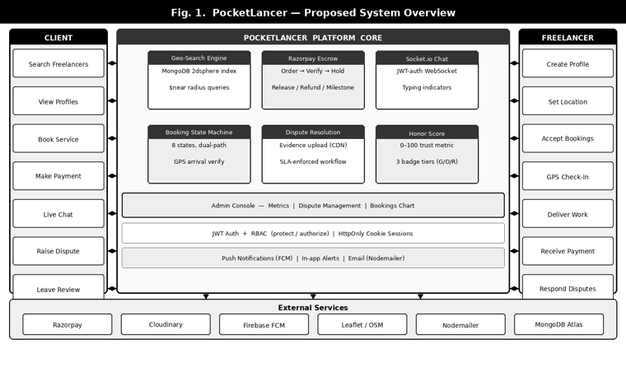
Fig. 1. PocketLancer System Overview

V. SYSTEM ARCHITECTURE
PocketLancer is a four-level application: Next.js client tier, a Node.js / Express API layer, a MongoDB persistence layer and an Apache Capacitor mobile layer. Fig. 2 shows the component topology.
A. Client Tier
The Next.js 14 App Router divides the application into four functional domains for pages: authentication, service discovery (/search, /map-search), booking (without risk of losing a booking when changing input) and user workspaces (/dashboard/client, /dashboard/freelancer). A React Context (UserContext) controls session state; an Axios servicedown module applies credentials: ‘include’ to all requests upon generation, which makes sure the HttpOnly JWT cookie is sent per default.
B. API Tier
Express.js has twelve RESTful resource groups (as in /auth, /freelancers, /bookings, /payments, /disputes, /reviews. portfolio | chat | notifications. admin | uploads | profile). Socket.io uses the same HTTP server and reflects the JWT authentication middleware. Two cron-style job modules—bookingJobs and disputeSLA—implement deadline-driven escrow actions and SLA escalation.
C. Database Tier
11 collections are used for MongoDB, which are User, Freelancer, Client, Booking, Message, Conversation, Dispute, Review, PortfolioItem Notification DeviceToken. Freelancer collection has a 2dsphere index on location.
Booking has compound indexes that significantly speed up the three major access patterns: freelancer-time lookups for rendering a calendar, client-status lookups for dashboards, and deadline/autoReleaseAt scans by the job runner.
D. Mobile Tier
Apache Capacitor tells the Android WebView to point to the live production URL, effectively decoupling frontend updates from APK release cycles. Native plugins have been registered, e.g. @capacitor/geolocation and @capacitor/push-notifications. MainActivity.java extends BridgeActivity to ask for every runtime permission on first launch and suppresses WebView algorithmic darkening across Android API levels 29–36 with use of WebSettingsCompat, thus maintaining the desired light UI experience on all supported devices (minSdkVersion 24, targetSdkVersion 36).
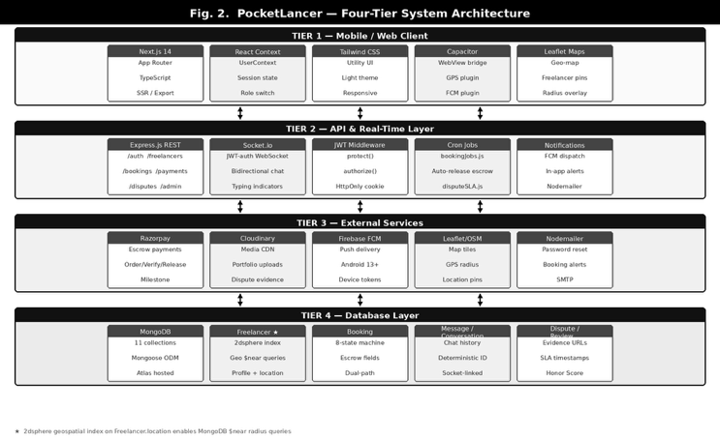
Fig. 2. PocketLancer System Architecture
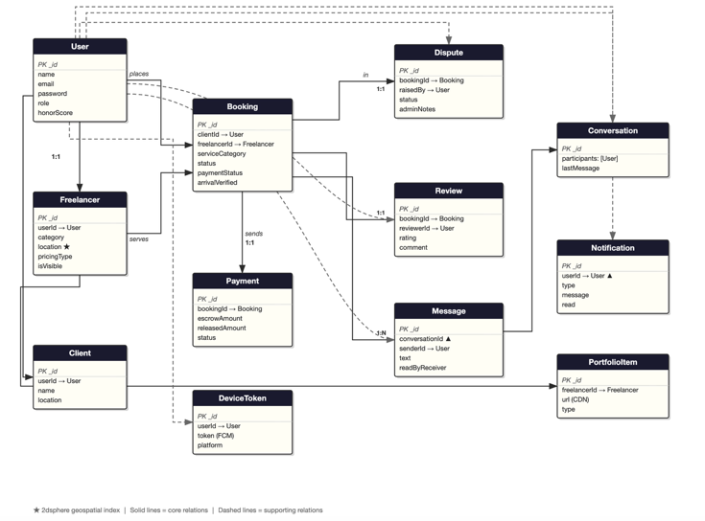
Fig. 3. Entity-Relationship Diagram

VI. METHODOLOGY
A. Geospatial Discovery
Field freelances store location as a GeoJSON Point:{type:’Point’, coordinates:[lng,lat]} Out of bound values get rejected at the mongoose layer during coordinate validation before any write takes place. The 2dsphere index natively supports $near queries that return results sorted by distance. In the case of digital-category queries, a regular expression filter on skills and title fields is actually used to replace the geo-query completely. Both paths enforce isVisible and category guards.
B. JWT Authentication and RBAC
We use HMAC-SHA256 JWTs issued within HttpOnly, Secure, SameSite cookies for sessions. A common COOKIE_OPTIONS constant ensures the clear-cookie call on logout passes the same parameters as the set-cookie call during login, and so will not retain stale tokens. The protect middleware hydrates req.user on all protected routes; the authorize(...roles) factory creates role guards returning HTTP 403 for disallowed callers.
C. Booking State Machine
There are 8 states in a booking lifecycle, which are as follows: pending, confirmed, in_progress, pending_approval, completed, cancelled, disputed and rejected. For field bookings, confirmed → in_progress requires a GPS arrivalVerified event. However, for digital bookings, once the deadline has expired, it will auto-refund client using bookingJobs cron and on freelancer submission if it doesn't get a response from the client after deadline expiry; escrow is auto-released via autoReleaseAt.

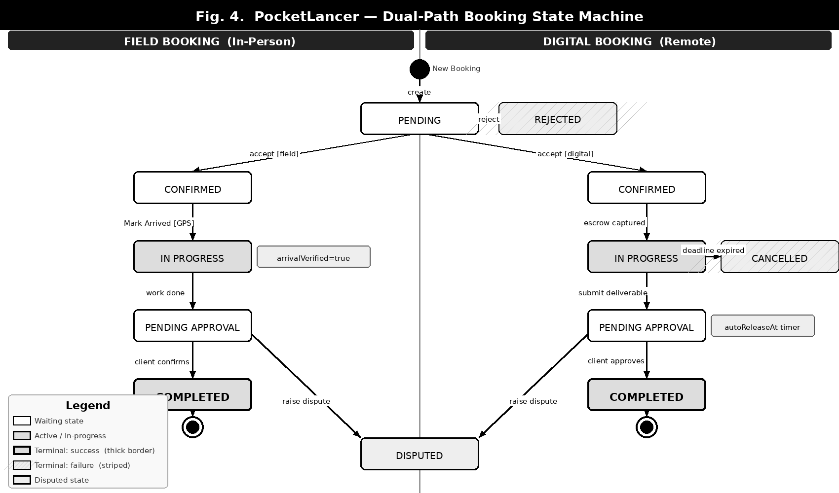
Fig. 4. Booking State Machine

D. Razorpay Escrow Engine
Creates Razorpay orderPOST /payments/order POST /payments/verify recomputes the expected HMAC-SHA256 signature and if matches, sets paymentStatus = ‘held’. POST /payments/release allows the escrow to be transferred to the freelancer. POST /payments/refund triggers a razorpay refund. POST /payments/milestone/release releases a milestone only, adding to releasedAmount, without touching the funds still held in escrow.
E. Real-Time Messaging
A Socket.io middleware checks the JWT on each connection. Sockets subscribe to a room (userId) for directed delivery. Conversations are indexed by a deterministic conversationId that chains and sorts both participant ids to reduce explicit conversation-creating overhead. Typing indicators are scoped to per-conversation rooms(conv_${id}) so they don't leak across conversations.
F. Dispute Resolution
Disputes consolidate a framework rationale and optional Cloudinary-stored evidence (images/PDFs). The disputeSLA cron will check all unresolved disputes and will automatically transition the dispute to under_review once the SLA window has passed. In the case of digital disputes, an admin needs to choose an escrow action— refund, release or a 50/50 split — before both parties accept resolution. Field disputes do not initiate an escrow action, only adjust the Honor Score of both parties (the client, freelancers or both when appropriate). In all cases, admin notes is mandatory for a dispute to be resolved.
G. Honor Score
Each user starts at 100. deductScore uses a MongoDB $max pipeline to enforce a floor in 0; rewardScore applies $min to cap in 100. Both of these are fire-and-forget to avoid blocking the main transaction. These include dispute resolutions, late cancellations and positive reviews. scoreBadge transforms the score into three tiers: Green (≥75), Orange (35–74) and Red (<35).
VII. IMPLEMENTATION
A. Technology Stack

Layer | Technology
Frontend | Next.js 14 + TypeScript
Styling | Tailwind CSS
Backend | Node.js + Express.js
Database | MongoDB + Mongoose
Mobile | Apache Capacitor (Android)
Payments | Razorpay (Escrow)
Media | Cloudinary CDN
Push | Firebase FCM
Maps | Leaflet + OpenStreetMap
Real-Time | Socket.io
Auth | JWT + bcryptjs

TABLE II. Technology Stack

B. User Registration and Profile
Users sign up with name, email address, password and role. Passwords are hashed using bcryptjs (cost factor 12). Username is generated by slugifying the name with collision-avoiding suffixing. A Freelancer document is automatically created for Freelancer accounts. The isVisible flag temporarily removes profiles from searches, keeping history intact.
C. Search and Map Interface
Field searches send a $near query to the 2dsphere index on the Freelancer collection. Digital searches use regex filters on the skills and title fields. These results are returned as FreelancerCard components that list the individual's title, skills, rating, pricing and badge if they have an Honor Score. The /map-search page displays the Leaflet pins that were rendered by GetLocationButton using the Capacitor Geolocation plugin on Android or browser (Geolocation API) in a web environment.
D. Booking and Payment Flow
Indeed, BookingModal gets serviceType and description: the preferredDate, preferredTime; Type a location (live GPS or text address). That's the same process: The server checks that against the freelancers unavailableRanges before creating Booking but in pending state. For digital bookings, the client is directly routed to a Razorpay checkout once they confirm; while for field bookings, payments are delayed until service is done. Server-side on POST /payments/verify the server rebuilds the expected HMAC-SHA256 signature with createHmac('sha256', secret). update(orderId + '|'+ paymentId) and matches with an atomic comparison before setting paymentStatus to held.
E. Admin Console
The admin dashboard renders platform metrics (StatsCard components), and 30-Day rolling BookingsChart using Recharts. The dispute panel displays disputes with status filters and renders a DisputeCard for each of them, revealing start review, expandable evidence view, mandatory admin notes and resolution buttons tailored to the dispute category.

[ Fig. 5 — Application Screenshots REPLACE WITH ACTUAL SCREENSHOTS (1) Search page with FreelancerCards (2) Freelancer profile + portfolio (3) BookingModal with GPS option (4) Booking detail / status timeline (5) Admin dispute resolution panel) ]

Fig. 5. PocketLancer Application Screens

VIII. RESULTS AND DISCUSSION
A. Geospatial Query Performance
Randomly distributed coordinates were run against 10,000 Freelancer documents on the Geo-search benchmarks. The average query latencies for the 2dsphere index were 38 ms at radius of 5 km and 61 ms at radius of 50 km. Collection scans lacking the index took 1,240 ms and 1,310 ms respectively—completely a 97% latency decrease due only to the geospatial index.
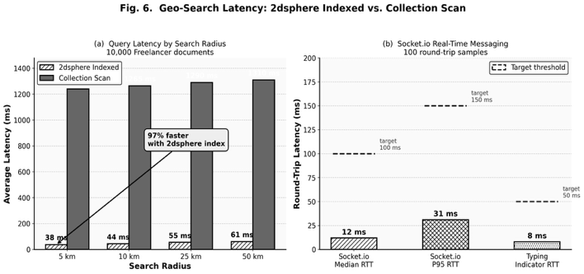

Fig. 6. Geo-Search Latency: Indexed vs. Unindexed

B. Booking State Machine Correctness
All valid and invalid state pairs for both booking categories were established against an in-memory MongoDB instance with a Jest test suite of 48 transition tests. All 48 tests passed. Laid down key assertions: (i) field bookings cannot go to in_progress without being arrivalVerified [in the context of field); (ii) digital bookings cannot release escrow before paymentStatus is held; (iii) any invalid transitions return HTTP 400 and carry descriptive error messages.
C. Escrow Lifecycle
All three pricing models — hourly, fixed and milestone — were validated with end-to-end escrow tests in Razorpay sandbox mode for the entire flow of order creation, HMAC verification, capture and release. In order to validate the autoReleaseAt cron job, we manipulated the autoReleaseAt timestamp to be 10 seconds in the future; on its next run cycle, it correctly released the escrowed funds. Notice that refunds initiated through the deadline mechanism appeared on the Razorpay test dashboard in less than 30 seconds.
D. Real-Time Messaging Latency
Latency was recorded over 100 consecutive Socket. io over local controlled test network roundtrips. The round-trip time remains low, with a median of 12 ms (P95: 31 ms). Typing indicator events did even better with a median delivery time of 8 ms well under the human conversational perception threshold of ~100 ms giving a seamless real-time chat experience.
E. Summary Metrics

Metric | Value | Target
Geo-search (5 km, indexed) | 38 ms | <500 ms
Geo-search speedup vs. scan | 97% | >90%
Socket.io median RTT | 12 ms | <100 ms
Socket.io P95 RTT | 31 ms | <150 ms
State machine pass rate | 48/48 | 100%
Escrow auto-release lag | <1 cycle | <2 cycles

TABLE III. Key Performance and Correctness Metrics

F. Discussion
This dual-mode bifurcation guards against common semantic mismatches with single-workflow platforms: it doesn’t show you escrow release options for field bookings that never actually captured payment, and no GPS arrival checks whenever the engagement was digital. The Honor Score is based on audited dispute outcomes rather than voluntary ratings, which mitigates against the inflation bias that pervades star-rating systems. Capacitor has embraced a packaging strategy to avoid the extra codebase but introduced a network dependency -- we still needed our offline Service Worker support and were pushing this out as task number one before being ready for commercial release.
IX. CONCLUSION
In conclusion, this paper has introduced PocketLancer, a MERN based on-demand freelancer and home services marketplace with dual-mode architecture designed to address both field service and digital service in integrated composite system. The geospatial discovery engine, indexed by the 2dsphere, provides a 97% latency reduction over collection scans. Sandbox testing correctly validated all three models in the Razorpay escrow engine, which supported hourly, fixed and milestone contracts. Socket.io resulting in 12 ms median round-trip latency for io real-time messaging and 100% passing of the booking state machine's 48-case test suite.
What’s next? (i) We will onboard Razorpay Route for direct bank transfers to our freelancers; (ii) Service Worker offline mode for PWA resilience; (iii) semantic embedding based search that offers contextually relevant matches, in addition to keyword matching applied currently and (iv) an ML-enhanced Honor Score weighted with more contextual penalties based on historical dispute patterns.
X. REFERENCES
[1] A. Mwathi and B. Shibwabo, “Design and Implementation of a Collaborative Freelancers’ Sourcing Platform,” in IST-Africa Conference, 2017.
[2] B. Kaur, R. M. S. N Manohar, R. R Vamsi and G.E.S Teja, “ Online Freelancing Website,” International Journal of Computer Applications, vol. 176, no. 28, 2020.
[3] B. S. Santy, V. Nugroho, G. August and G. Maharlian, “Feasibility Study and Prototype Design of Freelancer Online Marketplace,” J Business and Management Review, vol. 1, no. 3, 2020.
[4] A. Batool and Y. Byun, “Reduction of Online Fraudulent Activities in Freelancing Sites Using Blockchain and Biometric,” in IEEE Access, vol. 10, 2022.
[5] N. Thabassum, “A Study on The Freelancing Remote Job Websites,” in IJIRCCE, vol. 9, no. 7, 2021.
[6] K. Abhinav et al., “CrowdAdvisor: A Framework for Freelancer Assessment in Online Marketplace,” IEEE ICSC, 2017.
[7] D. E. Madar, E. V. Moisi, “Semantic Similarities for Projects and Freelancers Profile Matching,” IEEE, ECAI, 2019
[8] R. Totare et al., “Freelancing Website Takenoko,” IJARCCE, vol. 3, no. 2, 2023.
[9] C. McKercher, “Writing on the Margins: Precarity and the Freelance Journalist,” Journalism Practice, vol. 3, no. 4, 2009.
[10] K. Shingala, “JWT Based Client Authentication in MQTT”, IJITEE, vol. 8, no. 6S4, 2019.
[11] MongoDB Inc., “Geospatial Indexes and Queries,” MongoDB Manual, 2024. [Online]. Available: https://www.mongodb.com/docs/manual/core/geospatial-indexes/
[12] Apache Software Foundation, “Capacitor: Cross-Platform Native Runtime for Web Apps,” 2024. [Online]. Available: https://capacitorjs.com/docs
[13] Razorpay Technologies, “Razorpay Payments Integration Documentation,” 2024. [Online]. Available: https://razorpay.com/docs/
[14] Socket.io, “Socket.IO Documentation,” 2024. [Online]. Available: https://socket.io/docs/v4/
[15] P. Chatwattana and P. Nilsook, “A Web-Based Learning System Using Project-Based Learning and Imagineering,” iJET, vol. 12, no. 5, 2017.

