SHRI VISHNU ENGINEERING COLLEGE FOR WOMEN:: BHIMAVARAM
(AUTONOMOUS)
DEPARTMENT OF CSE
Academic Year:: 2020-21 :: II Semester

B.Tech - PROJECT WORK:: ABSTRACT

Name of the Class / Section | IV – CSE / B
Batch Number | B7
Project Domain / Technology | Machine Learning
Project Title | Chronic Kidney Disease Prediction
Guide Name | Mr.K.Bhadrachalam
Students Registered | Registered Number | Student Name | Student  Signature
Students Registered | 17B01A0567 | Kollapudi Lakshmi Naga Pravallika | 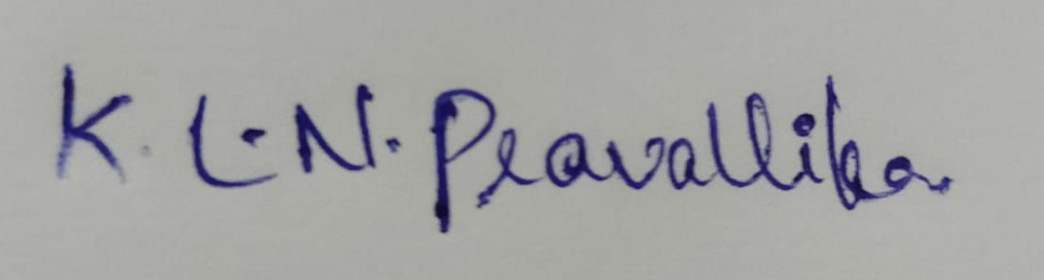
Students Registered | 17B01A0585 | Manne Dedeepya | 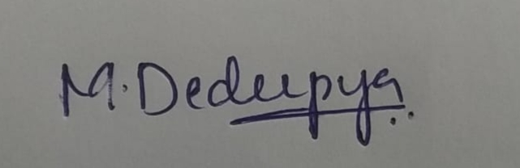
Students Registered | 17B01A0591 | Doddapaneni Srilakshmi | 
Students Registered | 17B01A05A4 | Nandivada Sumedha Lakshmi Meghana | 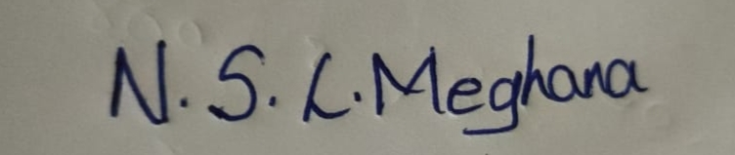

Signature of  Internal Project Guide | Signature of  B.Tech Projects – Coordinator | Signature of  Head of the Department

Abstract of the Project ( In 200 words)
The aim of the project is to detect CKD using machine learning algorithms by considering the least number of tests or features. We approach this by applying machine learning classifiers on a small dataset of 400 records. To remove the null values, we perform Data Cleaning. In order to increase the size of the dataset, we perform data augmentation. In order to reduce the number of features, the association between variables has been studied. Feature selection methods has been applied to the attributes and found that there are some of the attributes which impact mostly to predict the CKD.

Existing System (If any) – Features & Drawbacks
The existing system of diagnosis is based on the examination of urine with the help of serum creatinine level. Many medical methods are used for this purpose such as screening, ultrasound method. In screening, the patients with hypertension, history of cardiovascular disease, disease in the past, and the patients who have relatives who had kidney disease are screened. This technique includes the calculation of the estimated Glomerular Filteration Rate (GFR) from the serum creatinine level.
Drawbacks:
It is more time consuming.
It require lot of features to decide whether a person suffering from CKD or not.

Proposed System – Features
List of objectives/features that are planned to implement.
- It is an approach to predict the Chronic Kidney Disease.
- Preprocessing of the dataset.
  - Outliers
  - Missing Values
  - Data Reduction
- Data Augmentation
- Working on various models to find the more accurate one.
- It gives more efficient results.

(i)Functional Requirements
(ii) Non Functional Requirements
(iii) Software & Hardware Requirements
Functional Requirements
Support Vector Classifier, Random Forest, and other algorithms along with Python programming

Non Functional Requirements

Scalability : As we are performing prediction using various algorithms, we can use large amount of data for making predictions.

Performance : Based on various models, performance increases gradually.

Software Requirements

Operating System : Windows 7/Windows 8/Windows 10
Coding Language : Python
Dataset : MS Excel
Software IDE /
Online Working Toll : Anaconda Navigator(Spyder) / Google Collaboratory
Documentation : Microsoft Office

Hardware Requirements

GPU or any high process power server

 | Literature Survey | Kunwar, et al. entitled “Chronic Kidney Disease Analysis is Using Data Mining Classification Techniques” published in 2016.  Amirgaliyev, et al. entitled “Analysis of Chronic Kidney Disease Dataset by Applying Machine Learning Methods” published in 2015.  Devika, et al. entitled “Comparative Study of Classifier forChronic Kidney Disease Prediction Using Naive Bayes, KNN and Random Forest” published in 2019.  Avci E et al. entitled “Performance Comparison of Some Classifiers on Chronic Kidney Disease Data” published in 2018.
 | Modules | Expected date of completion
 | Understanding and Preprocessing of data | 16-05-2021
 | Visualization of data | 18-05-2021
 | Feature Selection | 23-05-2021
 | Support Vector Classifier, Random Forest Classifier | 26-05-2021
 | Front End | 10-06-2021
 | Testing the project | 12-06-2021
 | Data Augmentation, Naïve Bayes | 19-06-2021
 | Final Testing of Project | 21-06-2021
 | Project Report | 1-07-2021

