MAKALAH

Nama Kelompok:

1. Bita Indriani
2. Dede Meri
3. Indah Purnamasari
4. Rifanjani s.d

Tabel Barang

|  |  |  |  |
| --- | --- | --- | --- |
| Field | Type | Size | Keterangan |
| Kd_brg | char | 5 | Primary key |
| Nm_brg | Char | 20 |  |
| Harga | Int |  |  |
| Stok | Int |  |  |

Tabel Supplier

|  |  |  |  |
| --- | --- | --- | --- |
| Field | Type | Size | Keterangan |
| Kd_supp | char | 5 | Primary key |
| Nm_supp | Char | 20 |  |
| Alamat | char | 40 |  |
| telpon | Char | 15 |  |

Tabel Pemesanan

|  |  |  |  |
| --- | --- | --- | --- |
| Field | Type | Size | Keterangan |
| no_pesan | char | 5 | Primary key |
| Tgl_pesan | Date |  |  |
| Total | Int | 8 |  |
| Kd_supp | varchar | 5 |  |

Tabel detail_pesan

|  |  |  |  |
| --- | --- | --- | --- |
| Field | Type | Size | Keterangan |
| No_pesan | Char | 5 | Foreign key |
| Kd_brg | Char | 8 | Foreign key |
| Qty_pesan | Int | 11 |  |
| Subtotal | Int | 11 |  |

Tabel Penjualan

|  |  |  |  |
| --- | --- | --- | --- |
| Field | Type | Size | Keterangan |
| No_penj | Char | 5 | Primary key |
| Tgl_penj | Date |  |  |
| No_faktur | Char | 10 |  |
| Total_penj | Int | 11 |  |
| No_pesan | Char | 8 | Foreign key |

Tabel detail_penjualan

|  |  |  |  |
| --- | --- | --- | --- |
| Field | Type | Size | Keterangan |
| No_penj | char | 8 | Foreign key |
| Kd_brg | Char | 5 | Foreign key |
| Qty_penj | Int | 11 |  |
| Sub_penj | Int | 11 |  |

Coding Class Barang

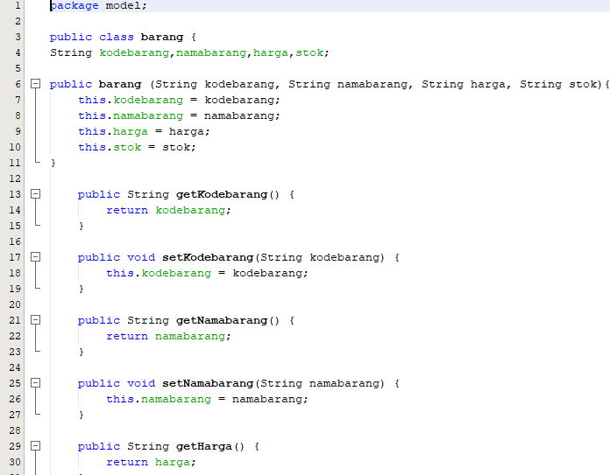

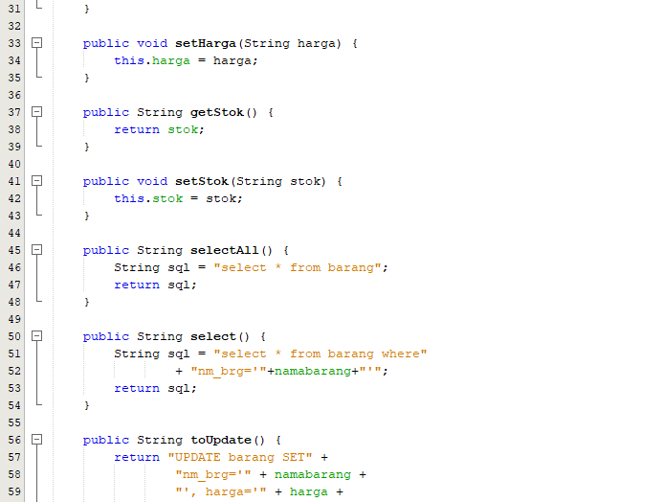

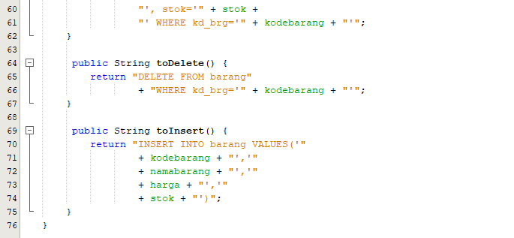

Coding Class Supplier

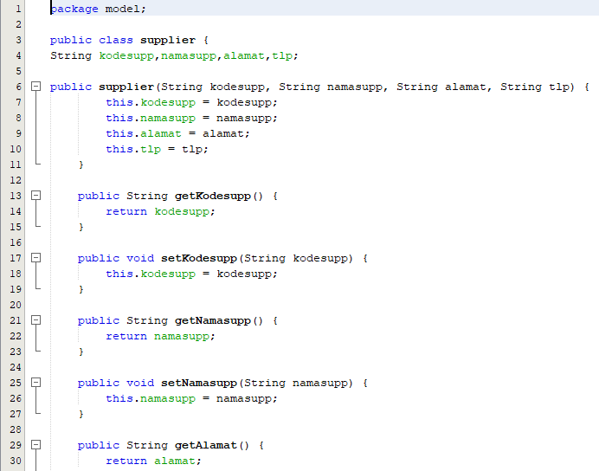

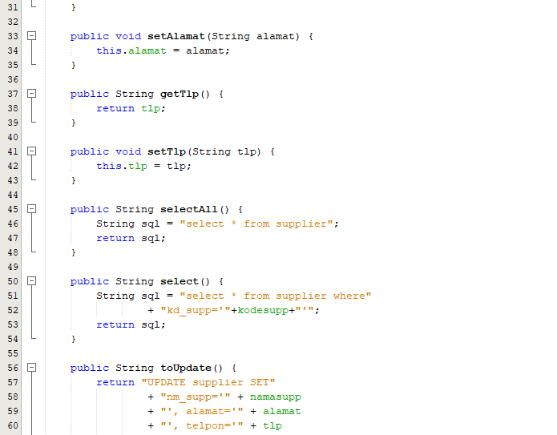

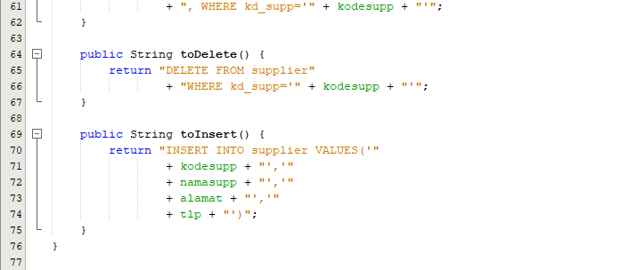

Coding Class pemesanan

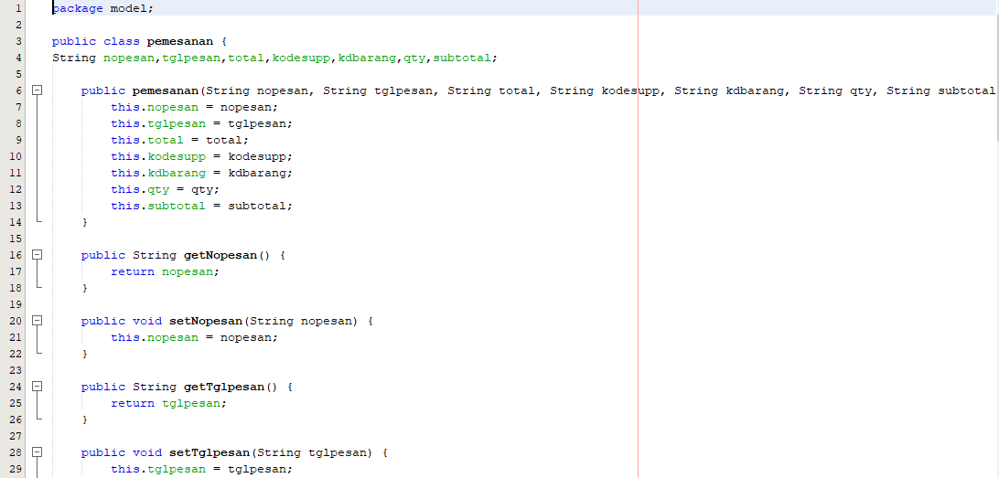

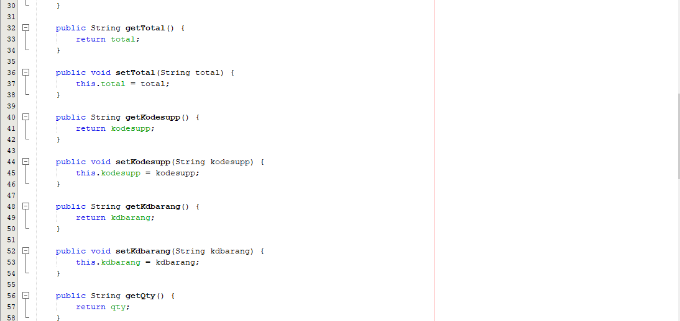

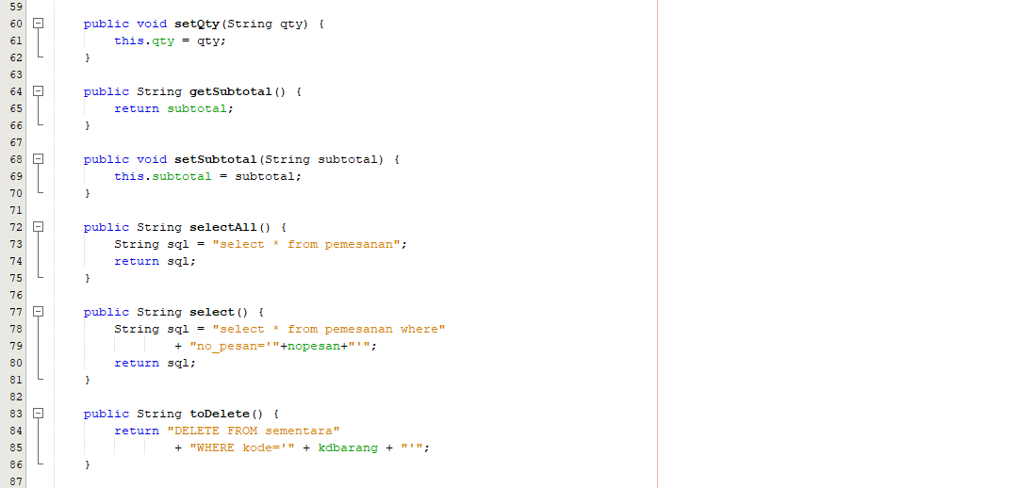

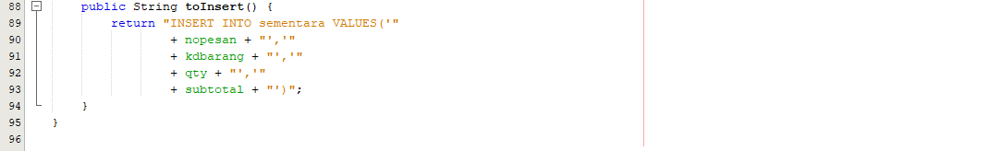

Coding Penjualan

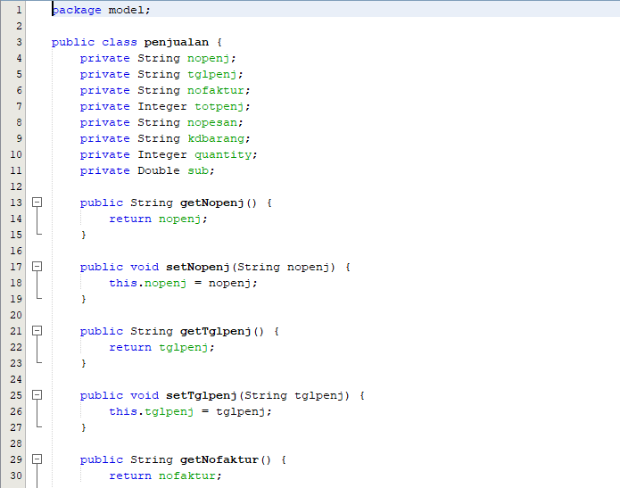

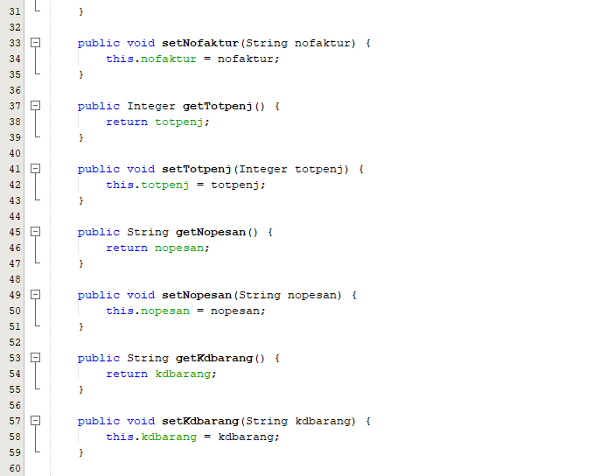

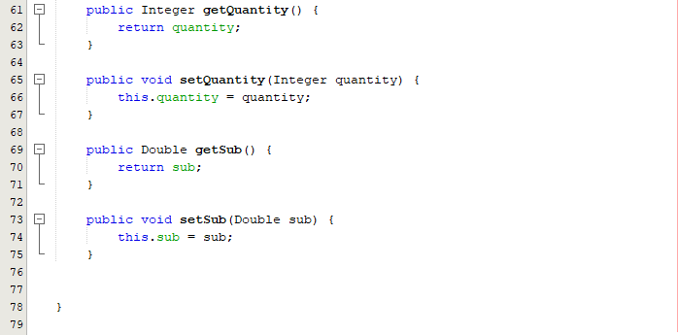

Pembuatan classs pesan (Control)

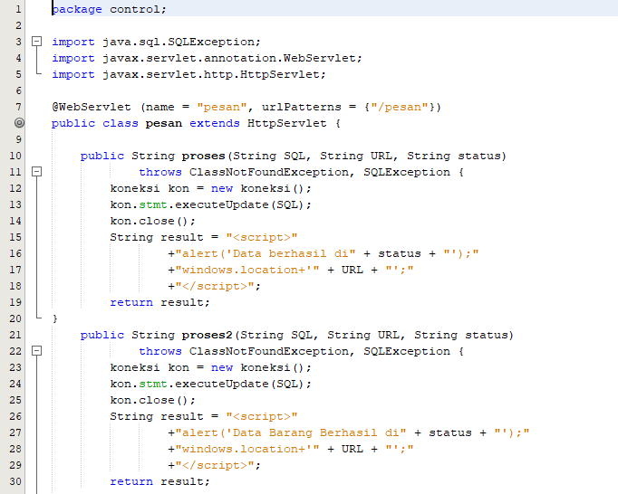

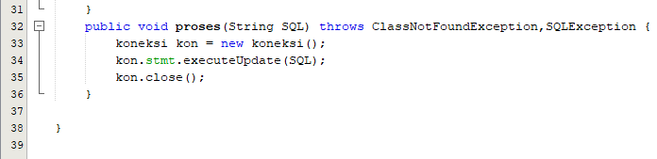

Pembuatan koneksi (Control)

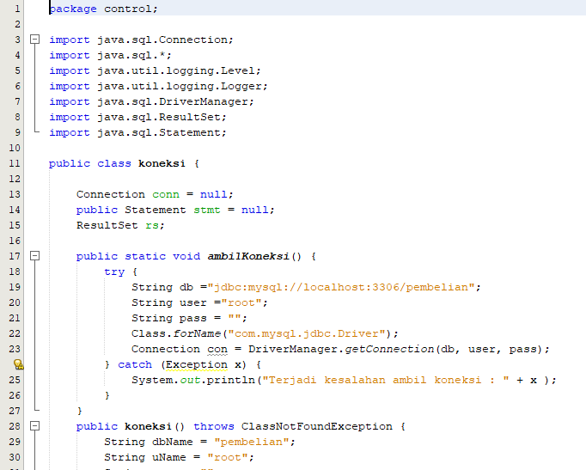

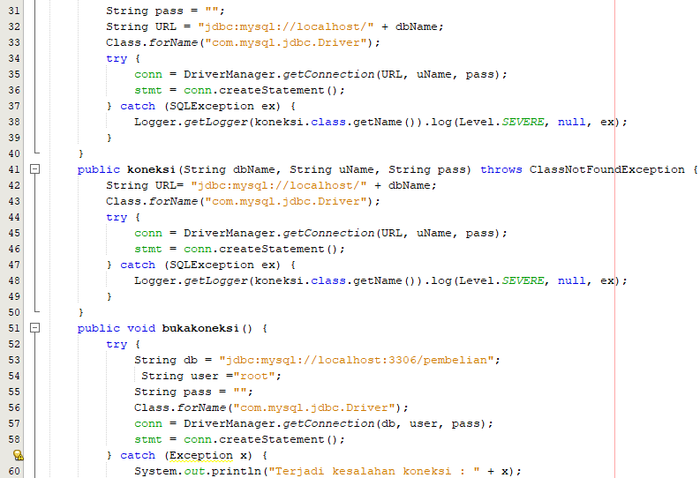

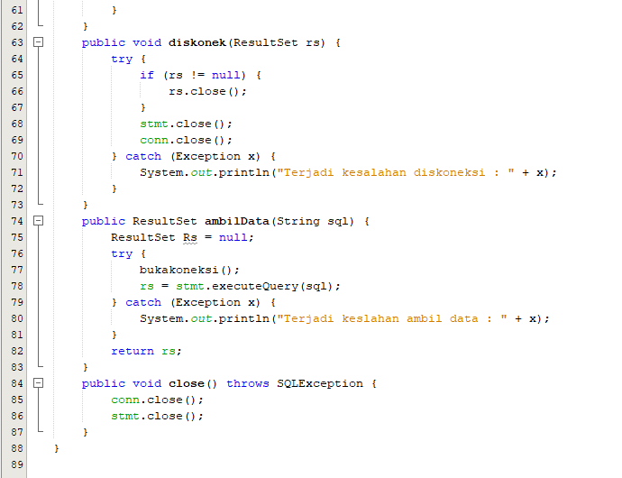

From barang.jsp

Data Master barang

Kode Barang :

Nama Barang :

Harga Barang :

Stok barang :

Simpan

Cari Data Barang : Cari

|  |  |  |  |  |
| --- | --- | --- | --- | --- |
| Kode Barang | Nama Barang | Harga Barang | Stok Barang | Action |
| B01 | Pashmina | 30000 | 20 | Hapus | Edit |
| B02 | Segitiga | 25000 | 20 | Hapus | Edit |
| B03 | Segiempat | 20000 | 20 | Hapus | Edit |

Coding Barang.jsp

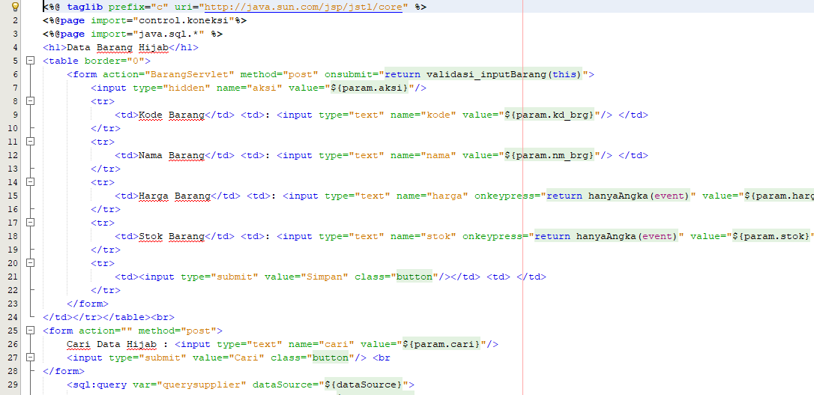

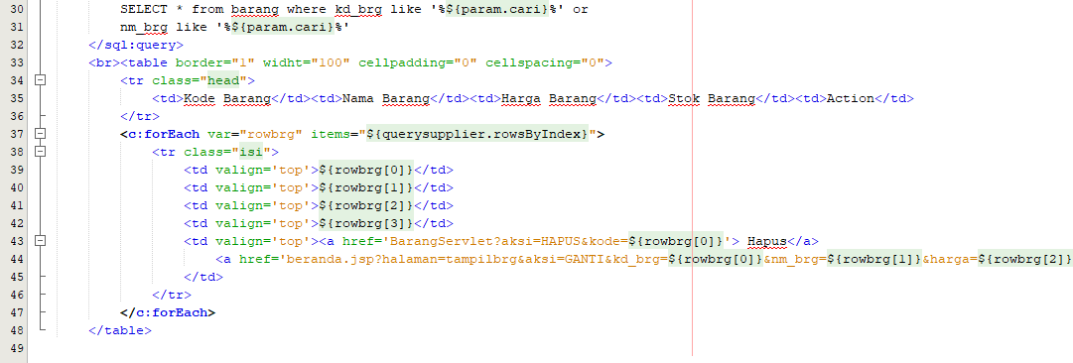

Pembuatan File setting.js

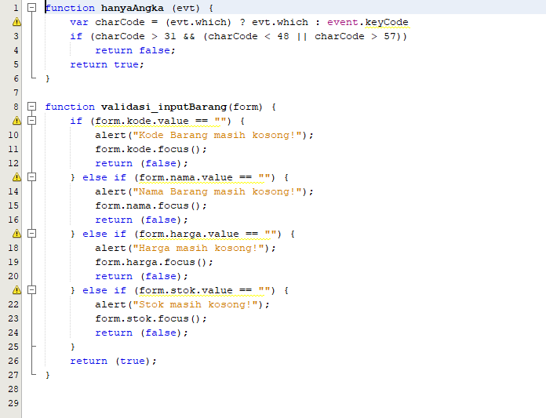

Coding BarangServlet.java

