**Telegram Bot for Alerting**

**Workflow**

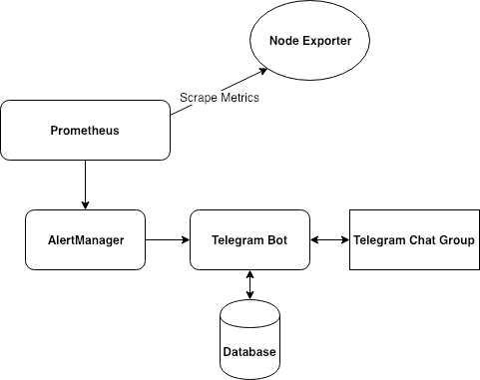

**Requirements:**

* Write your own code to create a Chat Bot that follow the description as below.
* You can use a code base from some open source project, but should show your ability as a software engineer.

**Specifications:**

1. **Node Exporter:**

* Running an exporter agent to collect service/server metrics and show via HTTP/HTTPS endpoint.  
  **Example**: CPU, memory, network, disk utilization of server.

1. **Prometheus:**

* Automatically scrape metrics from Node Exporter after an interval time.
* Set rules for alerting.  
  **Example**: Monitor memory usage of node, if node_memory_Active exceeds 80% then send alert to Alertmanager.

1. **Alertmanager:**

* Receiving signal from Prometheus and forward the alert to Telegram Bot.

1. **Levels of alerting:**

* Define 3 levels of alert
* Level 1: owners of each service (or server)
* Level 2: Tech Manager
* Level 3: SRE
* When alert is sent, each level need to do response in 5 minutes by one of 2 actions:
* **Acknowledge**
* **Forward**
* If there is no any response in 5 minutes, the alert will be sent to next levels.

1. **Database:**

* Storing service/server name, owners with different levels, Telegram ID of each person.

1. **Telegram Chat Group:**

* A Telegram chat group that including all Tech owners. Everyone disable notification of that group by default, but not tagging.

1. **Telegram Bot:**

**Description**: Handle the alerts from Alertmanager and send to Telegram chat group.

* Receiving alert/resolved messages from AlertManager.
* Handling messages:  
  + The alert message will be send to Telegram Group with tag a **TelegramID** for level 1 recipients (ex: **wukong** - owner in below photo) and two buttons: **'Acknowledge'**, **'Forward'**. For example:

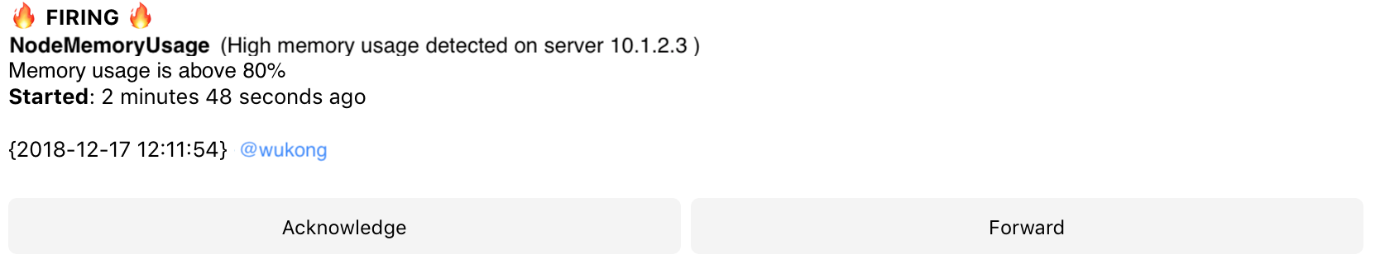  
  
+ If anyone in chat group click to **'Acknowledge'** button, then:

* Hide all buttons
* Show username who did acknowledge the alert
* Stop auto forwarding to next Level recipients.

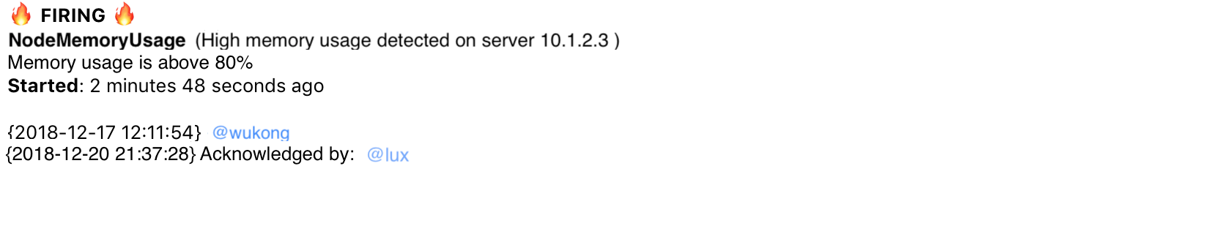

+ If anyone in chat group click to **‘Forward’** button, then:

* Show username that did forward the alert and username of Level 2 of recipients
* Button ‘Forward’ will be hide

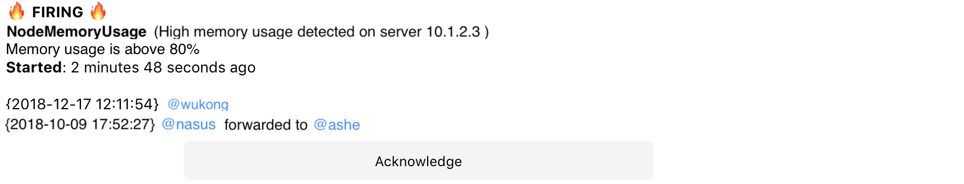

+ If no one action that message in 5 minutes, then:

* The message will be auto forward for next level (Level 2).
* When the highest level was forwarded, the button **‘Forward’** will be hide.

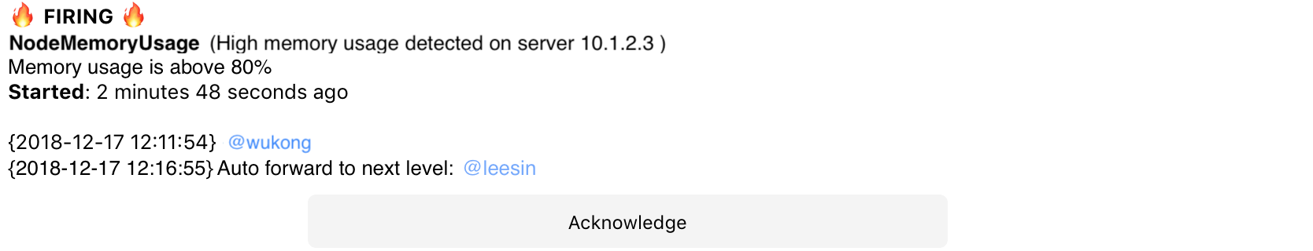

+ If the bot received a resolved message, then:

* Hide all buttons of previous alert message
* Stop auto forward to next Level of previous alert message



