**Algorithm of squared thumbs creation**

1. Get the original image size (original_width, original_height)
2. Calculate the minimum of original_width, original_height .  
   This value is needed to get crop of original image with max possible square
3. Resize to required thumb size (400x400) or (260x260)

Examples:  
  
**Image in portrait orientation**

* width = 720 px
* height = 960

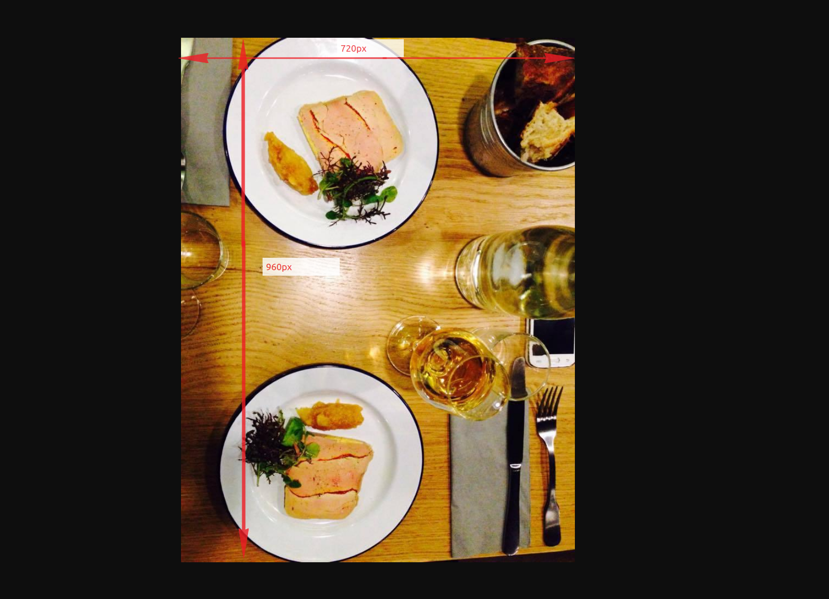

Thumb output image will be 400x400 px

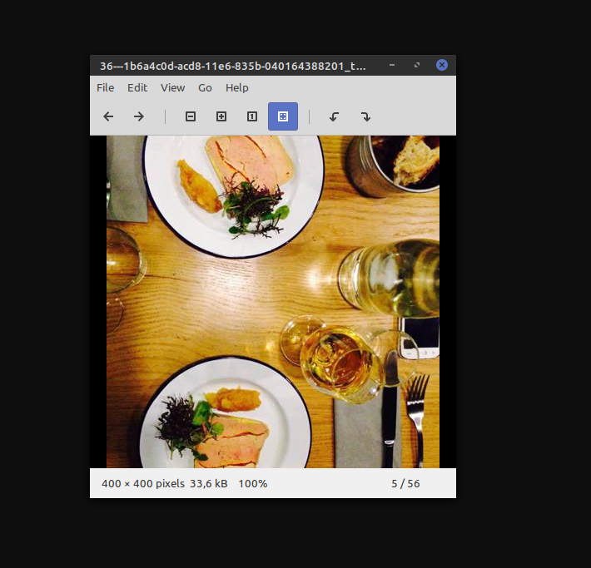

Square output image will be 260x260px

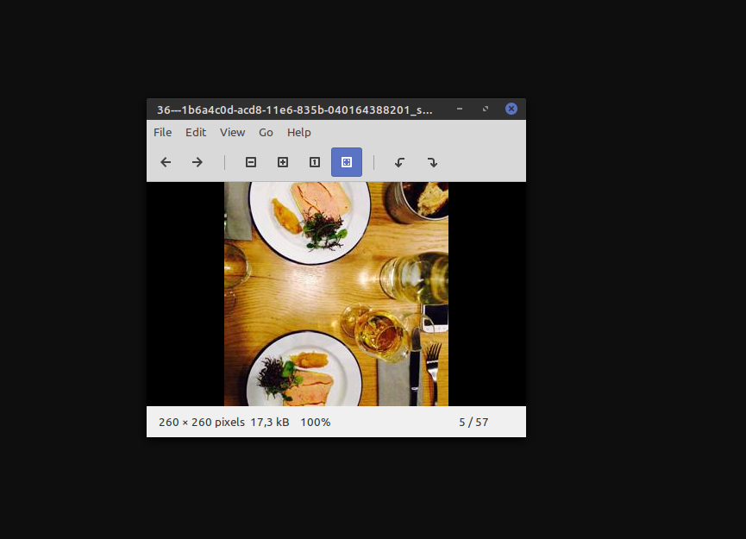

## **Image in landscape orientation**

* width = 750 px
* height = 337

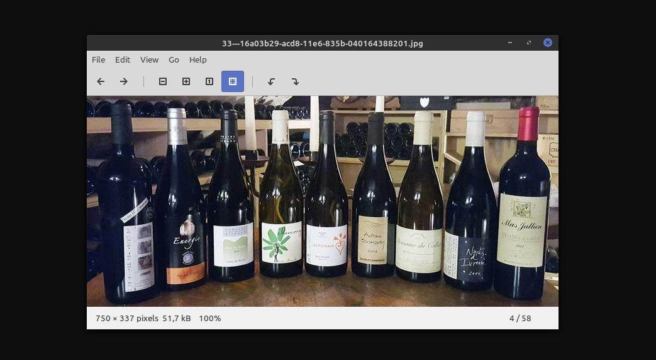

Thumb output image will be 400x400 px

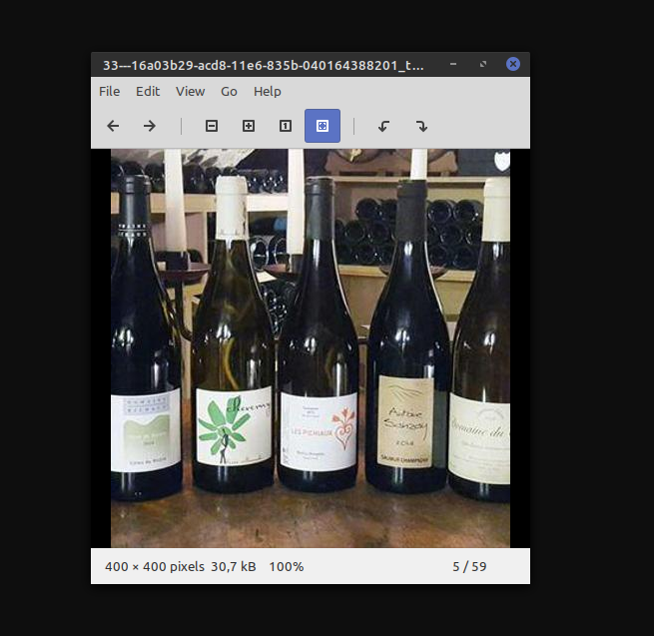

Square output image will be 260x260px

