**Optimization of MRF formulation to generate disparity map using minimum sum Belief propagation**

**Abstract:**

The stereomatching between two images is done by computing disparity of all the points on the object. The process involves identifying the corresponding points and finding the shift. There is no method that finds shift in the corresponding point or points showing corresponding objects. This is mainly due to no procedure that identifies the group of pixel from the same object. The local method either uses window or feature to find shift in stereo image. The issues in local method are size of window or extraction of feature.

The global method uses graph theory and probability theory to find shift efficiently. The Global method are based on Bayesian approach finds disparity as an energy minimization problem. The Global stereo algorithms are Graph cut and belief propagation. The belief propagation algorithm is used as global algorithm expected to offer computationally efficient approach with good results. The method used in this report is “Minimum sum Belief propagation” method as message updates with linear “Quadratic function ". The results with the computational estimations are presented.

Key words:

**Introduction:**

The parallax effect(Ability to see an object at two different views) is present in stereoscopic or stereo pair image. The objects near the camera will represent more to the right in the left image and more left in the right image is due to parallax effect in stereoscopic or stereo pair image.

 

To find the horizontal matching pixel in left and right image for stereo pair image is known as **stereo vision, stereo correspondence or stereo matching.**The horizontal pixel distance for each pixel coordinates is the disparity map or the depth map. The Depth map or Disparity map is a gray scale image which is highly compressed. The Depth map or Disparity map shows distance rather than texture. If shift of pixel between right and left stereo image is more than object looks darker which is located far away from camera and if shift is less than object is bright i.e. object close to the camera. In practice where occluded objects in stereo pair image, finding the corresponding point or points showing corresponding object is a challenging one which is due to there is no procedure to identify the group of pixel from the same object.



Some applications of Depth Map or Disparity Map are used for Image sequence analysis and reconstruct 3D model sequences which can be used either for information transfer or for entertainment.

Depth maps are used for robot application for navigation purpose and for object recognition to separate occluded image components.

Another important scientific application of Depth Map or Disparity Map to extracts information from aerial surveys and for calculation of contour maps and Depth Map is used for Gaze correction for video conferencing.

Stereo matching Algorithm is classified as **Area-based, Feature- based and Global algorithm**. The Area and feature based algorithms are based on intensity profile. The constrains in area- based algorithm is to find the optimal size of the window. The feature-based algorithms are restricted to using only specific feature, that only yield sparse disparity maps. However these techniques had limited success.

The Belief propagation algorithm is one of the possible inference algorithm based on Bayesian approach to finds corresponding point or points in stereo image as an energy minimization problem. The Belief propagation algorithm is iterative process works well and also computationally simple and computationally efficient for occluded objects.

Organization of report

**Chapter-2**

**Literature Survey**

The area based method [1] depends on Gestalt grouping in which support weight is based on similarity and proximity and is proportional to the strength of the grouping. In this method these two values expressed as a single value in an integrated manner. The group of similarity is calculated by means of Euclidean distance whereas group of proximity is by means of Palladian Kernel. The weight adoptive method computationally takes more time than other methods.

The method used in [2] is feature based local method to generate depth map or disparity map. The estimation of Disparity map is by using K-mean square algorithm and hybrid segmentation algorithm. The K means clustering algorithm is used to group the objects based on some criteria. K is a positive integer. The criteria for grouping is by minimizing the distance between data and cluster centroid .Initial set of K, virtual points in the data space randomly selected and every point if data set is assigned nearest centroid. The position of centroid is updated by means of the data points assigned to the cluster. The algorithm is stopped when minimum shift is below threshold. The segmentation algorithm extracts feature by Scale Invariant Feature Transform (SIFT) and Sum of Absolute Difference (SAD).The proposed algorithm is complex and computation time is more.

The major contribution in the field of stereo matching using Random Markov field and inference algorithm like Belief Propagation

**[2003] Comparison of Graph cuts with Belief Propagation for stereo, Using Identical MRF Parameters:**

The disparity image can be achieved by modelling Markov Random Field and by using optimization algorithm such as Graph cut and Belief Propagation. These two algorithm allow fast and approximate solution to MRF which are powerful tools for modelling vision problems.so one system improvement over the other be attributed to its choice of an inference algorithm.

The comparison between Graph cut algorithm with max product Belief Propagation algorithm shows that the solution for energy by Graph cut and Belief Propagation algorithm nearly equal although graph cut consistently returns smaller energy. The solutions produced by Graph cut are smoother while accelerated Belief Propagation algorithm was faster.

Given this situation improving formulation of MRF rather than improving solution (optimization algorithm) for MRF.

The comparisons between inference algorithm such as Graph cut and Belief Propagation depends on the functions of MRF formulation.

The future research can be different functions such as truncated linear or quadratic used for MRF optimizing with any one of the inference algorithm

**[2004] Efficient Belief Propagation for Early Vision:**

The early vision problems such as stereo, optical flow and image restoration can be solved by MRF model by using inference algorithm based on Graph cut and Belief propagation in this paper new algorithm techniques improve the running time of the algorithm.

The inference algorithm used is max product belief propagation.

The three techniques substantiallyreduce time required to compute the message updates.

1. In low level vision problems the label or hidden node is generally based on some difference between two labels rather than on particular pair of labels, this is known as distance transform technique. This technique reduces message computing time.

2. In new message update scheme, here nodes are split into two

Messages are updated alternately, so half of the messages only updated at each iteration.so memory required to store messages are reduced.

3. The third technique uses hierarchical structure to reduce the number of message passing iterations to small constant rather depends on size of the image grid.

**[2007] Low Memory Cost Block Based Belief Propagation for Stereo Correspondence**

The global approaches can handle the texture less and occluded regions well by formulating disparity inference as an energy minimization problem. The energy function usually has smoothness constraint which represents a certain relationship between neighboring pixel pair. This smoothness constraint enforces penalty on the energy function, if the labels (disparity or segments) of neighboring pixel are inconsistent.

The 2D optimization algorithm such as graph cut and Belief Propagation have been applies successfully to optimize energy functions. The BP algorithms construct 2-D graph structures with nodes represent all pixels in the disparity image to find the disparity map with energy closer to the global minima. However, the vast number of nodes in 2-D graph result in extremely high computation complexity too difficulty in real time applications.

The proposed Block based Belief Propagation algorithm directly partitions image into separated independent blocks.so memory size reduces significantly due to block based computation. With block based design, the criterion of convergence becomes important for each block. In general, the criterion of convergence in belief propagation is defined with the saturation of energy functions. The specific threshold is set to terminate the belief propagation process. However it is difficult to find a global threshold for each block. In proposed algorithm find the convergence according to the equivalence of all disparities for each node in a block over successive iterations.

**[2009] Hardware-Efficient Belief Propagation**

Loopy belief propagation is an effective solution for assigning labels to the nodes of a graphical model such as Markov Random Field, but requires high memory, bandwidth and computational costs.

In this paper two techniques are proposed

1. Tile based Belief propagation ,when message is updated data of nodes which are far away are not required, so MRF is divided into

Multiple regions known as tile and iterations are done on those regions. So memory required to store messages are reduced.

1. Fast message construction:

The cost functions serve for measuring the compatibility between the labels and the observations or prior knowledge.

For example in stereo matching that the disparity values vary smoothly between neighboring pixels. However this assumption is valid only when corresponding pixels belong to the same object. Otherwise the difference between their disparity values can be arbitrarily large resulting high cost value. In fast message construction using robust function is used as smoothness cost.

The summary of literature survey is mentioned in table

|  |  |  |
| --- | --- | --- |
| Research paper | Optimization Method | Scope for Research |
| Comparison of Graph cuts with Belief Propagation for stereo, Using Identical MRF Parameters  [2003] | Comparative study of Graph cut &Belief Propagation on same MRF Model | Further study of  Improving formulation of MRF rather than improving solution for MRF |
| Efficient Belief Propagation for Early Vision  [2004] | 1.Distance transform technique(difference between two labels)  2. New message update scheme  3. Hierarchical structure | Further study can be:  These optimization method can be  Applicable to a broad range of more sophisticated cost functions. |
| Low Memory Cost Block Based Belief Propagation for Stereo Correspondence  [2007] | 2D BP Graph is divided into blocks. Optimize each block separately. | The information exchange between Neighboring finished processing block &unfinished processing block can be further investigated |

**2.Chapter**

**Overview of Global Algorithm:**

According to [1]Most stereo algorithm performs 4 basic steps to find disparity map from stereo pair image. Theses 4 steps are

1. Matching cost computation
2. Cost (or support) aggregation
3. Disparity optimization
4. Disparity refinement

Matching cost computation: The Actual disparity of each pixel in the disparity image is a random variable, denoted xp the variable at pixel location p. Each variable can take one of N discrete states, which represent the possible disparities at that point. For each possible disparity value, there is a cost associated with matching the pixel to the corresponding pixel in the other stereo image at that disparity value. Typically, this cost is based on the intensity differences between the two pixels yp. This cost is reflected in the compatibility function(xp , yp) which relates how compatible a disparity value is with the intensity differences observed in the image. Smaller intensity differences will correspond to higher compatibilities and vice-versa.

Cost (or support) aggregation : A pair wise MRF uses another compatibility function(.) which denotes compatibility between neighbouring variables known as smoothing function[comparative study].The pixels in disparity image forms 2D grid ,so that p can also written in terms of its coordinates p(i,j) considering standard 4-connected neighbourhood system, so that smoothness function is the sum of spatially varying horizontal and vertical nearest neighbours. Therefore every ψ(.) is in the form of ψ (xp , xn) Where location n is adjacent to p.

Disparity optimization : The joint probability between two compatibility function as defined in above which optimize the disparity.[pearl]The product rule or chain rule formula states than for set of events ,then the probability of joint event can be written as a product of number of conditional probabilities.

According to Bayesian technique[pearl book]

P(X/Y) = P(Y/X).P(X) / P(Y)

Where

P(X/Y) is posterior probability :

P(Y/X) is likelihood probability:

P(X) is priori probability;

P(Y) is normalisation can be considered as 1.

Disparity refinement :

The disparity image for stereo pair image can be obtained by maximize the posterior probability. The disparity Refinement is done by Maximum A Posterior (MAP) estimation .

**2.1 Markov Random Field (MRF) Formation**

The global methods use MRF formulation as an objective function. The MRF are undirected graphical model consists of nodes and links which encodes spatial dependencies in stereo images. The nodes in MRF are observed nodes and hidden nodes.

The observed nodes (Y) represents pixel intensity values whereas hidden node(X) represents disparity value in stereo pair image. The link (markov assumption) between these nodes represents dependencies. The markov assumption is such that it depends on its immediate neighbours.

MRF formulation in terms of energy function which gives link between observed node and hidden node. The figure 1 describes about MRF formation for 4 by 4 node where blue node represent observed node and yellow represent hidden node.

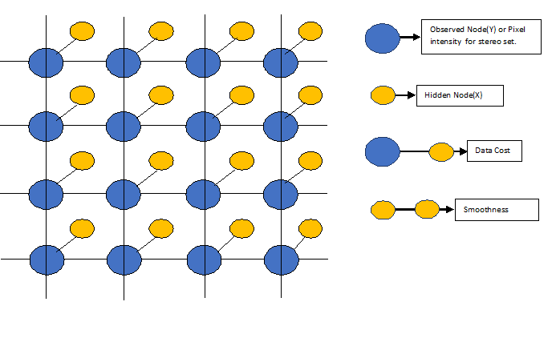

Figure1: MRF Formulation for 4by4 node

The data cost function (U) is based on the intensity differences between the two pixels. The smoothness cost (V) sometimes referred as the pair wise term which compares adjacent pixels.

E (f) = + ………………………… (1)

Where U is data cost function: V is smoothness cost function , i is pixel index, j is the neighbouring index.

The energy function adds all the cost at each link given in observed node Y with some disparity for each corresponding pixel in the hidden node x. The aim is to find the disparity from the hidden node which produces lowest energy. To find lowest energy in Markov network is NP hard means, to get a solution for such problem takes unthinkably long time which is because each pixel (node) in disparity map can take any value in disparity space (state).

The brute force method straight forward method checks all disparities for pixels but it is huge computations .For example for Aloevera plant stereo image size of 427x 370 pixel and for 64 disparity levels, which gives combinations of 157990^ 64 so computational time will more in brute force method.

**Belief Propagation:**

The loopy belief propagation (LBP) algorithm is one of many algorithms that can find an approximate solution for a MRF.The belief propagation algorithm was proposed by Pearl [24] in 1988 for finding exact marginal’s on graphs known as trees that contain no loops. The Belief Propagation can be applied to graph which contains loops .The Loopy belief propagation is an approximate inference algorithm which keep passing the messages around markov state or node until stable belief state is reached, so the Loopy belief propagation algorithm is an iterative algorithm, messages will converge on doing iterations.

**In terms of Probabilistic theory:**

* After t iterations M (t)i→j& M^ (t)j→I are two messages
* The Messages takes values in the space of Probability distributions over a single variable space χ
* M (t)i→I = { M (t)i→j (xi) : xiЄχ}, with M (t)i→j (xi) > 0

∑ M(t)i→j (xi) =1

The characteristic feature of Belief propagation or message passing algorithm is that for a given node updates outgoing messages on the basis of incoming ones at previous iteration.[]

The messages are updated in three different ways in Belief Propagation which are known as Sum product BP, Max product BP and Minimum sum BP.

**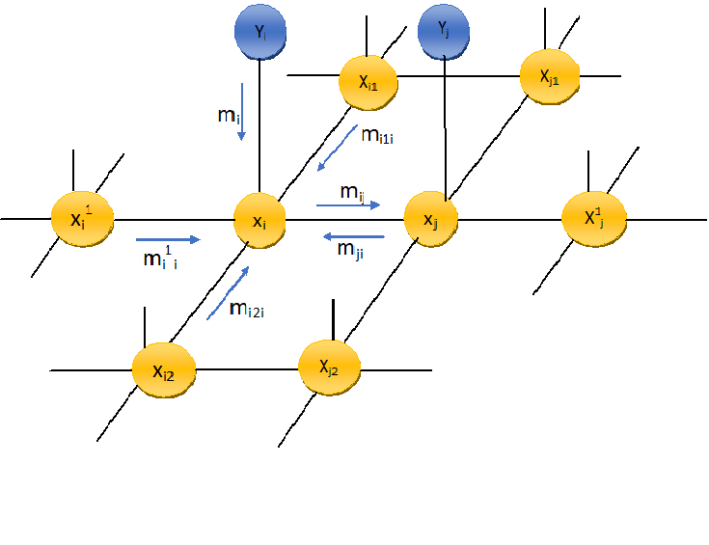**

Figure2: Description of Belief propagation

The yellow nodes with respect to above diagram are hidden nodes. The belief propagation is applied to hidden nodes only. The blue nodes are observed node. The minimum sum message updates are given below.

m i, jis message passing from node i to node j: The message sent from node xi to xj is givenbelow:

mi,j ← Minxi + Vij(xi ,xj) +mi1i + mi + mi2i + mi1i

The belief at xi is computed as:

b1 ←mi1i + mi + mi2i + mi1i +m ji

**2.2.2. The method used for simulation results:**

The method used forour experimentin this paper is Minimum Sum Belief propagation [8]. The minimum sum BP algorithm finds max marginal at each node in log space. The minimum sum messages are defined to overall additive constant. The Message initialization, Message updatesrule and finding beliefs are the main steps in Belief Propagation algorithm.

The messages in minimum sum BP algorithm are initialized to zero. The normalization of message is not required for minimum sum BP because it operates in log space.

The message update rule

Msgi→j(d) = min l’ { U(y i ,d) + V( d ,d’) + ∑ kϵ i\jMsg k→ i (d’) }……………………………….(2)

Where Yi is intensity value at pixel index. Msgi→j(d) messages from node i to j for disparity d, d is disparity range or level, d’ is disparity values belong to all disparity range or level. The disparity range or level is a variable of the form d = 24 or 25 or 26or 2x?

U is data cost function, V is smoothness cost function

The best assignment of disparity can be obtained by finding the belief which gives smallest value.

belief( xi,=d) = U(y i ,d) + ∑ k ϵ Ꞑ (xi)Msg k→i (d) ……………………………………. (3)

**2.2.3.The models used:**

The data cost function is sum of absolute difference function used.

Data cost function (U) = ∑x ,y { | I x ,y – J x-d, y| }

Where I x ,y is left image: J x ,y is right image , d is disparity range or level

The four connected grid is used for smoothness cost function. The linear model shown in figure 3 is used as smoothness cost function.

Smoothness cost function (V):

f (v) = w x min (|f | , t)

Where w is tuneable variable: t is truncation value:

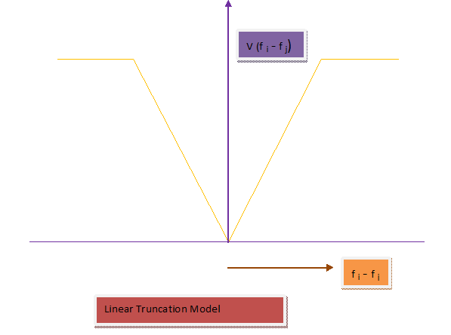

Figue3: Linear Model as smoothness cost function

**3. Results and discussion:**

Results:

The test stereo input images are from vision .middlebury.edu .The test stereo images are rectified and radial distortion is removed. The input stereo images alovera ,baby ,pot are from datasets of 2006 where asSukuba is from dataset of 2001.The ground truth image for each test stereo image is used for comparing performance of disparity map.[1].The system used for testing is Intel(R) Core(TM) i5-4200M CPU @2.5GH. and software used for programming is MATLAB version 15.

In the first Method of evaluation process the linear model is used as a smoothness cost function for minimum sum BP .The tunable variable parameter (w) is at 20 and truncation parameter (t) which restrict the maximum value or as a threshold value is kept at 2..The disparity map generated for three different disparity range (16,32 ,64) for each test stereo image are shown below for 10 iterations. The various performance parameters like PSNR (Peak Signal to Noise Ratio), MSE (Mean Square Error) and runtime of the Belief Propagation algorithm for Alovera , Baby ,Pot and Tsukuba are shown below in table 1,2,3,4.The graphical representation for computational parameters as well as Run time for each test stereo images are shown below.

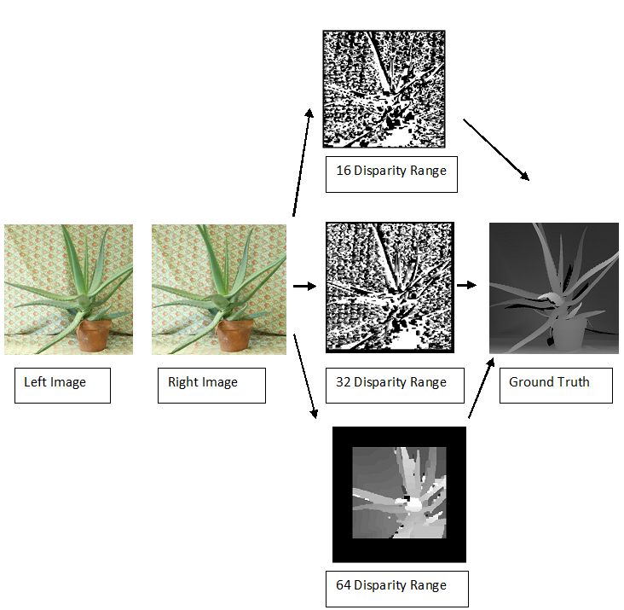

Tabel1: Computational Estimations for Alovera

|  |  |  |  |  |
| --- | --- | --- | --- | --- |
| Disparity Range | PSNR  (db) | Efficiency in % | MSE  (per total no of pixel) | Run time  (seconds) |
| 16 | 6.1 | 51 | 0.1 | 8.7 |
| 32 | 6.3 | 52 | 0.097 | 22 |
| 64 | 10.2 | 85 | 0.039 | 75.5 |

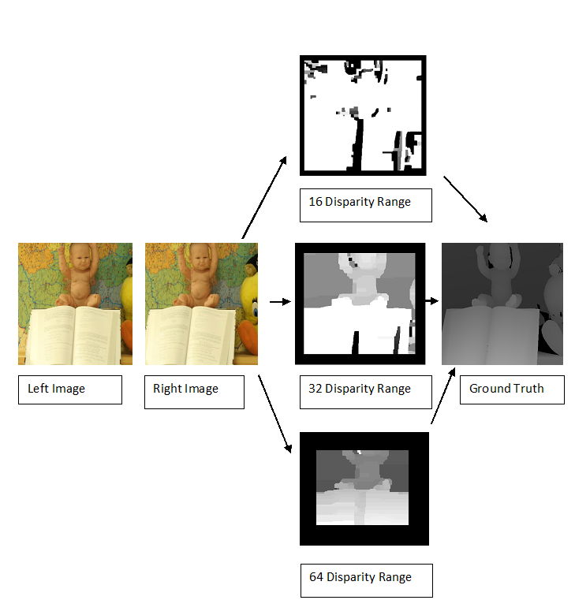

Tabel2: Computational Estimations for Baby

|  |  |  |  |  |
| --- | --- | --- | --- | --- |
| Disparity Range | PSNR  (db) | Efficiency in % | MSE  (per total no of pixel) | Run time  (seconds) |
| 16 | 4.3 | 43 | 0.15 | 8.7 |
| 32 | 6.7 | 67 | 0.09 | 18.8 |
| 64 | 8.7 | 87 | 0.06 | 72.6 |

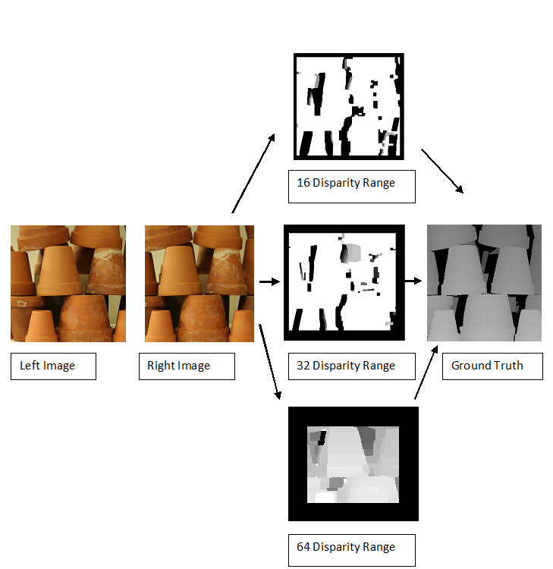

Tabel3: Computational Estimations for Pot

|  |  |  |  |  |
| --- | --- | --- | --- | --- |
| Disparity Range | PSNR  (db) | Efficiency in % | MSE  (per total no of pixel) | Run time  (seconds) |
| 16 | 5.3 | 66 | 0.12 | 6.01 |
| 32 | 5.3 | 66 | 0.12 | 26 |
| 64 | 6.6 | 82 | 0.09 | 76.6 |

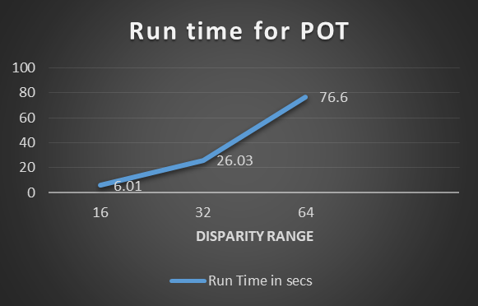

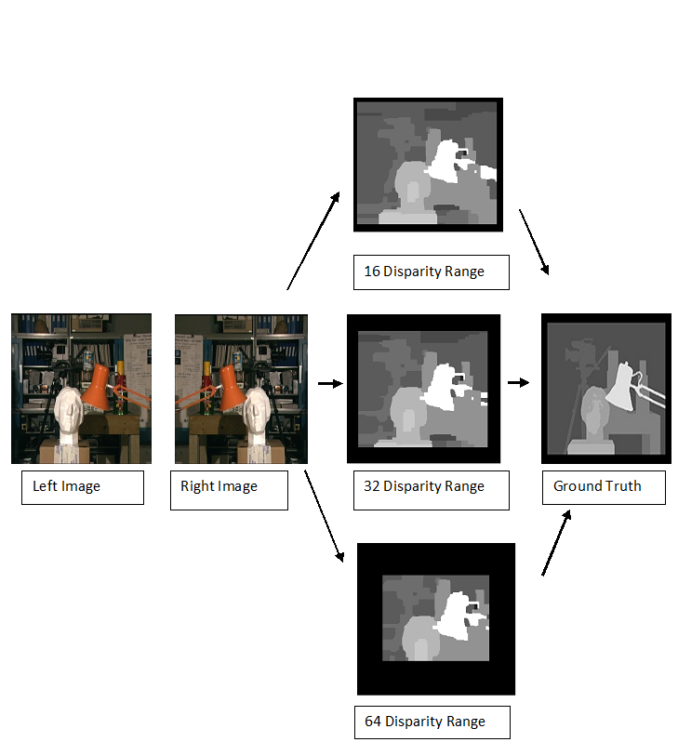

Tabel2: Computational Estimations for Tsukuba

|  |  |  |  |  |
| --- | --- | --- | --- | --- |
| Disparity Range | PSNR  (db) | Efficiency in % | MSE  (per total no of pixel) | Run time  (seconds) |
| 16 | 11.4 | 76 | 0.043 | 6.01 |
| 32 | 13.1 | 88 | 0.03 | 26.03 |
| 64 | 9.9 | 67 | 0.06 | 76.6 |

In second experimental process, The truncation parameter (t) is kept at constant one .The algorithm is tested for various values of tunable parameter(w) such as 0.1,0.2,1,5,10.The sharpness of the disparity map for all test stereo images are depend on these values. The disparity map for various values of tunable parameter are shown below.

Pot

Tsukuba

Alovera

Baby

|  |  |  |  |  |
| --- | --- | --- | --- | --- |
| C:\Users\Mahe\Desktop\CS\aloe_.5lam1sk .png  1 | C:\Users\Mahe\Desktop\CS\aloe_.1lam1sk .png  2 | 3 | C:\Users\Mahe\Desktop\CS\aloe_1lam1sk .png  4 | C:\Users\Mahe\Downloads\aloe_10lam1sk (1).png  5 |
| C:\Users\Mahe\Desktop\CS\ba_.1lam1sk.png  1 | C:\Users\Mahe\Desktop\CS\ba_10lam1sk.png  2 | C:\Users\Mahe\Downloads\Untitled.png  3 | C:\Users\Mahe\Desktop\CS\ba_5lam1sk.png  4 | C:\Users\Mahe\Desktop\CS\ba_.5lam1sk.png  5 |
| C:\Users\Mahe\Desktop\CS\pot_.1lam_1sk.png  1 | C:\Users\Mahe\Desktop\CS\pot_.5lam_1sk.png  2 | C:\Users\Mahe\Desktop\CS\pot_1lam_1sk.png  3 | C:\Users\Mahe\Desktop\CS\pot_5lam_1sk.png  4 | C:\Users\Mahe\Desktop\CS\pot_10lam_1sk.png  5 |
| C:\Users\Mahe\Desktop\CS\stu_.5lam_sk1.png  1 | C:\Users\Mahe\Desktop\CS\stu_.1lam_sk1.png  2 | C:\Users\Mahe\Desktop\CS\stu_10lam_sk1.png  3 | C:\Users\Mahe\Desktop\CS\stu_5lam_sk1.png  4 | C:\Users\Mahe\Desktop\CS\stu_1lam_sk1.png  5 |

Figure : Disparity maps for various tunable parameter(w) 1 : 0.1…2:0….3:1...4:5…5:10

The graphical representation for efficiency as well as mean square error for all test stereo images are shown below.

Discussion:

The first method of experimental analysis is for different disparity range. The subjective analysis of comparison of disparity map with ground truth was by human perception for all test stereo images are shown in figure………….The computational estimation given in table……….with respective graphical representation given in ……..

The optimal disparity map is obtained for alovera at disparity range 64 with less MSE 0.039 and high efficiency 85% compare to other disparity map. The optimal disparity map for baby as well as pot test stereo image obtained at disparity range 64 with high efficiency(87% for baby and 82% for pot) and low MSE(0.06 for baby and 0.09 for pot).For Tsukuba test stereo image, optimal disparity map is obtained at disparity range 32 for high efficiency 88% with low MSE 0.03.

The graphical representation for all test stereo images shown in figure………….shows that run time increases with disparity range. The run time to get optimal disparity maps for Alovera , baby ,pot and Tsukuba are at 76sec,73sec,77sec and 15 sec respectively.

The subjective analysis for second experimental results are shown in figure……..and the computational analysis are in graphical representation shown in figure…….The result analysis for all test stereo images are given below

The disparity map obtained for alovera with highest efficiency 68% is obtained for tunable parameter( w) 10 with less MSE 0.032 ,For baby, the highest efficiency 63% for tunable parameter( w)1,5,10 but less MSE 0.043 is at w =5.Simillarly for pot 43% efficiency at w=0.1with MSE 0.09.For Tsukuba highest efficiency 89% with less MSE 0.022 at w=5.The results of second method shows that, sharpness of disparity map depends on tunable parameter , The results of analyzing second method shows that , best disparity map for alovera is at tunable parameter(w)=10:for baby at tunable parameter(w)=5 :for pot tunable parameter

**5. Conclusion:**

The disparity maps computed by our method are ascommensurableto ground truth. Our result shows that the performance analysis like Peak Signal to Noise Ratio (PSNR) and Mean Square Error (MSE) are at acceptable level. The truncation and tuneable are parameters in linear model, the sharpness of the disparity map depends upon these values. Further study is required on model used as well as on its parameters.

**References:**

1. L.kuk-JinYoon,InSokweon,”Adaptivesupport-weightapproachforcorrespondencesearch”.IEEETrans- actions on pattern analysis and machine Intelligence, Vol. 28,no.4,April 2006,pp650-651.
2. PatrikKamencay,MartinaZachariasova,MartinBrezman,RomanJarina,RobertHudec,MiroslavBenco,SlavomirMatuska, ”A New Approach for Disparity Map Estimation from stereo Image Sequences using Hybrid Segmentation Algorithm”, International Journal of Modern Engineering Research,Vol.2,Issue 5,Sep-Oct 2012 ,pp3201-3206
3. Tappen,M.F.andFreeman,W.T.,“ComparisionofgraphcutswithBPforstereo,using identicalMRFparameters”,*InIEEEInternationalconferenceoncomputervision*.
4. PedroF.Felzenszwalb,DanielP.Huttenlocher,“AEﬃcientBeliefPropagationFor EarlyVision”,*InternationalJournalOfComputerScience*,Vol.41-54,No.2,Febru- ary,pp,2006.
5. Yu-ChangAndnelsonChang,“LowMemoryCostBlock-BasedBeliefPropagationForStereoCorrespondence”,*IEEETransisition*,1-4244-1017-718
6. Chia-KaiLiang,Chao-ChungCheng,Yen-CheiehLai,“AHardware-EﬃcientBeliefPropagation”,*IEEETransactionsOnCircuitsAndSystemsForVideoTechnology*,Vol;21,No.5,May,pp,2011.
7. LiZhou,TaoSun,YuanzhiZhanandJiaWang,“SoftwareandHardwareImplemen- tationsofStereoMatching,”,*InternationalJournalofElectronicsandInformatics*, Vol.7,No.4(2014),pp.37-562,No.1,2014.
8. http://nghiaho.com/notes/MarkovRandomField,LoopyBeliefPropagation,stereovision.
9. AndersOlofsson,”ModernStereoCorrespondenceAlgorithms:Investigationandeva- lution”,*DepartmentofElectrocalEngineering,LinkopingUniversity,s-58183Linkoping,Sweden*,17June2010
10. J.Sun,N.N.ZhengandH.Y.Shum,”StereoMatchingUsingBeliefPropagation”, IEEETrans.PatternAnalysisandMachineIntelligence,vol.7,no.25,(2003),pp.787-800.
11. R.Szeliski,R.Zabih,D.Scharstein,O.Veksler,V.Kolmogorov,A.Agarwala,M.F.TappenandC.Rother,”AComparativeStudyofEnergyMinimizationMethods forMarkovRandomFields”,IEEETrans.PatternAnal.Mach.Intell.,vol.6,no.30, (2008),pp.1068-1080.
12. WFreeman,E.C.,PasztorandO.T.Carmichal,“LearningLowlevelVision”,*InIn- ternationaljournelofcomputervision*,40(1);25-47,2000
13. JianguoDing,“ProbabilisticInferencesInBayesianNetworks”,*InternationalJournalOfComputerScience,Arxiv:1011.0935V2,*,5November2010
14. DanYuan,“UnderstandingBeliefPropagationAndItsApplicatons”,*DepartmentOfComputerEngineering,UniversityOf California.*
15. Erik.B.SudderthAndWilliamT.Freeman,“SignalAndImageProcessingWithBeliefPropagation”,*AcceptedToAppearInIEEESignalProcessingMagazine*,
16. FrankR.Kschischang,BrendanJ.Frey,HansAndreaLoeliger,“FactorGraphandThe SumProductAlgorithm”,*IEEETranscationsOnInformationTheory*,Vol47.No.2, Feb,2001.
17. http:MarlLLrieg,“TutorialonBayesianBeliefNetworks”,*ElectronicsandSurveil- lanceResearchLaboratory*,Australia,December,2001.
18. P.F.FelzenszwalbandD.P.Huttenlocher.Eﬃcientbeliefpropa-gationforearly vision.IJCV,70(1):41-54,2006.
19. J.S.Yedidia,W.T.Freeman,andY.Weiss,”Generalizedbeliefpropagation,”in

Proc.NIPS,1998,pp.689-695.

20, https://github.com/daviddoria/Tutorials/blob/master/BeliefPropagation/- BeliefPropagation.pdf?raw=true

21.[http://www.cedar.buﬀalo.edu/srihari/CSE574/Chap8/Ch8- GraphicalModelInference/Ch8.3.3-Max-SumAlg.pdf](http://www.cedar.buﬀalo.edu/srihari/CSE574/Chap8/Ch8-)

22MarlLLrieg,“TutorialonBayesianBeliefNetworks”,*ElectronicsandSurveillanceResearchLaboratory*,Australia,December,2001.

23.20.J.S.Yeddia,W.T.Freeman,andY.Weiss,”Generalizedbeliefpropagation,”in Proc.NIPS,1998,pp.689-695.bibitemr22D.ScharsteinandR.Szeliski.,”Ataxonomy andevaluationofdensetwo-framestereocorrespondencealgorithms”.IJCV,2002.

24..JudeaPearl,“ProbabilisticReasoninginIntelligentSystems”,*KaufmannMorgannPublishers*, SecondRevisedAndupdatedEdition,SanFrancisco,California,1998