Publishing and Subscribing using python code from aws console

STEP 1. Import the python SDK which can be accessed from the following url

URL to get python SDK : https://github.com/aws/aws-iot-device-sdk-python

STEP 2. Getting the device registered on the console

On the Welcome to the AWS IoT Console page, in the left navigation pane, choose Manage to expand the choices, and then choose Things.

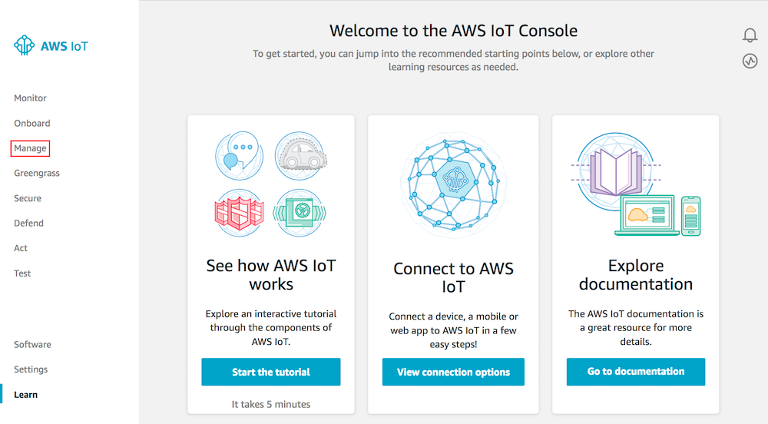
On the page that says You don't have any things yet, choose Register a thing.

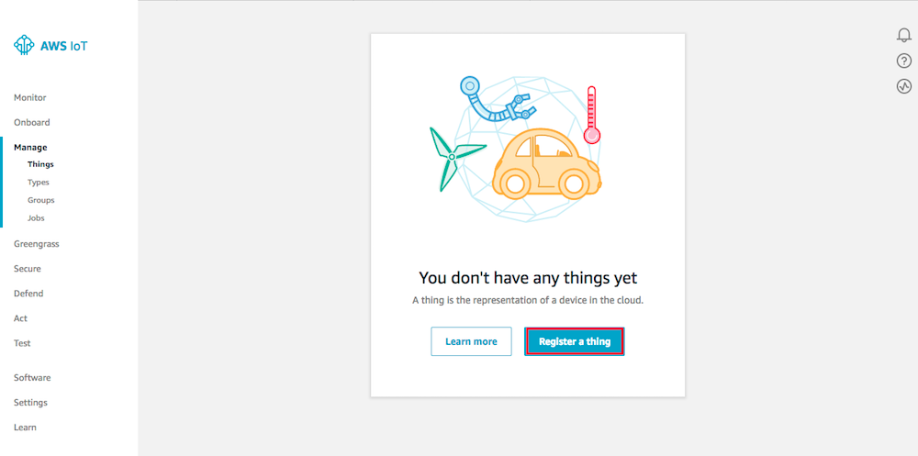
On the Creating AWS IoT things page, choose Create a single thing.

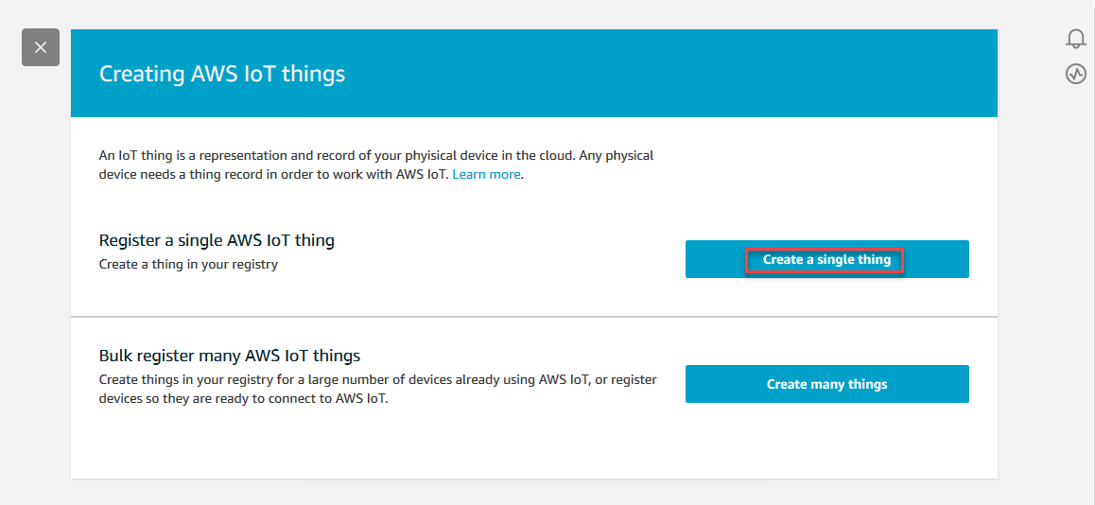

On the Create a thing page, in the Name field, type a name for your device
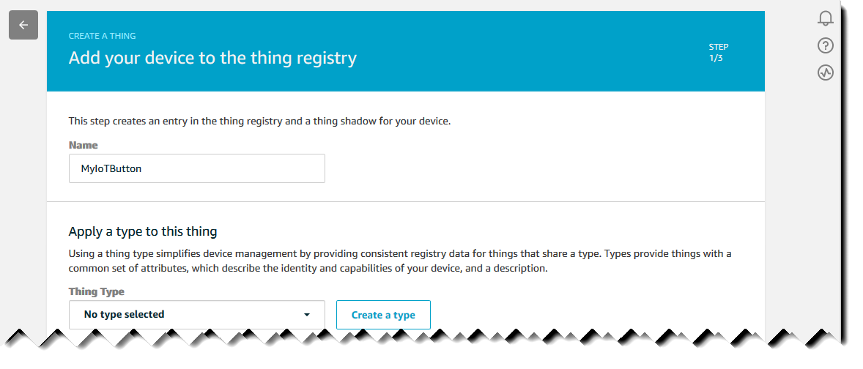

Click on next to finish the registration procedure
Now to add certificates and policies to the thing we just created
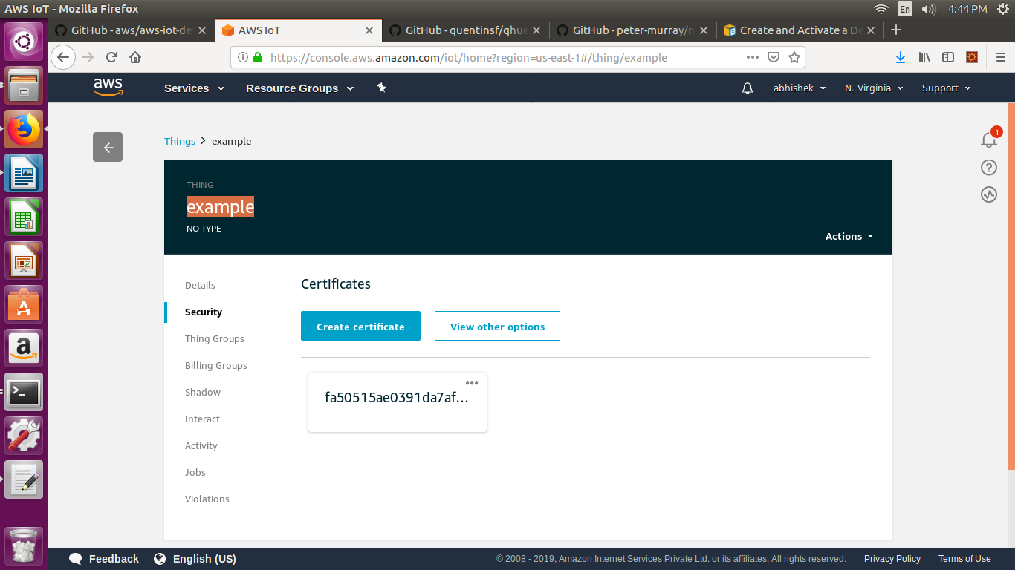
Click create certificate if u don’t have a existing certificate.Choose Create certificate to make a
new certificate
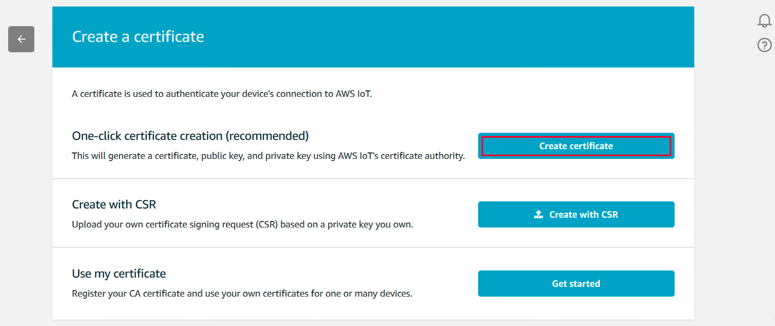

On the Certificate created! page, choose Download for the certificate, private key, and the root CA for AWS IoT (the public key need not be downloaded). Save each of them to your computer, and then choose Activate to continue.
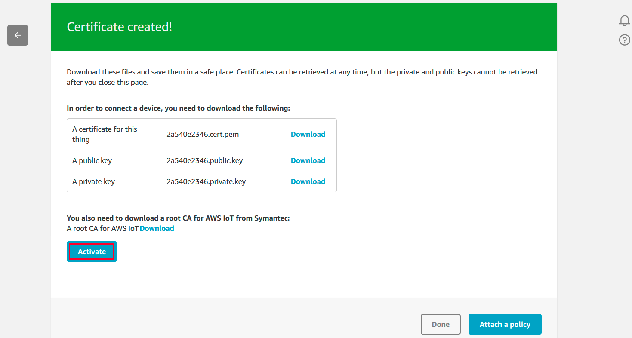

Choose the back arrow until you have returned to the main AWS IoT console screen.
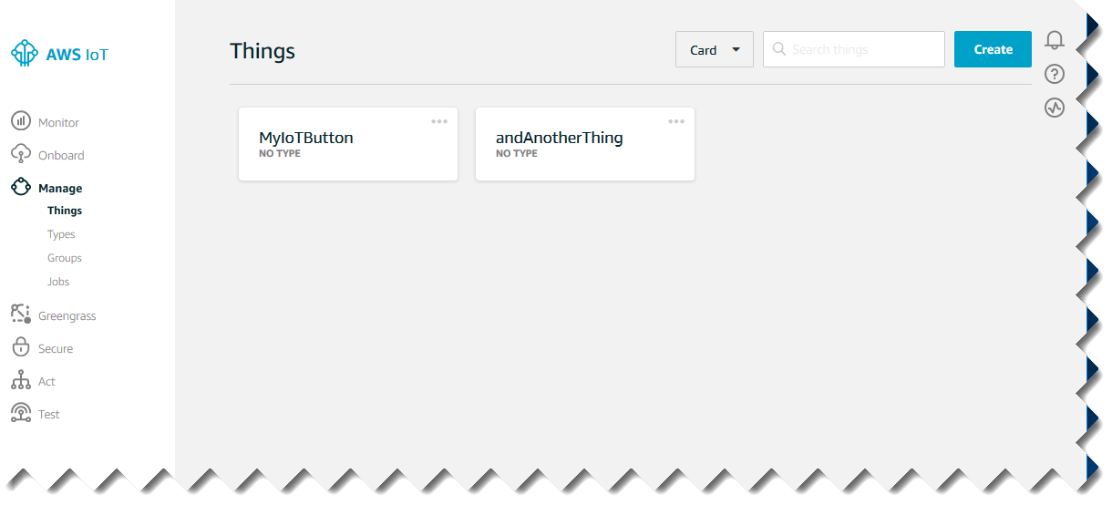
Now your thing is configured with a proper certificate.Now to create a policy to authorize the user device.
In the left navigation pane, choose Secure, and then Policies. On the You don't have a policy yet page, choose Create a policy.
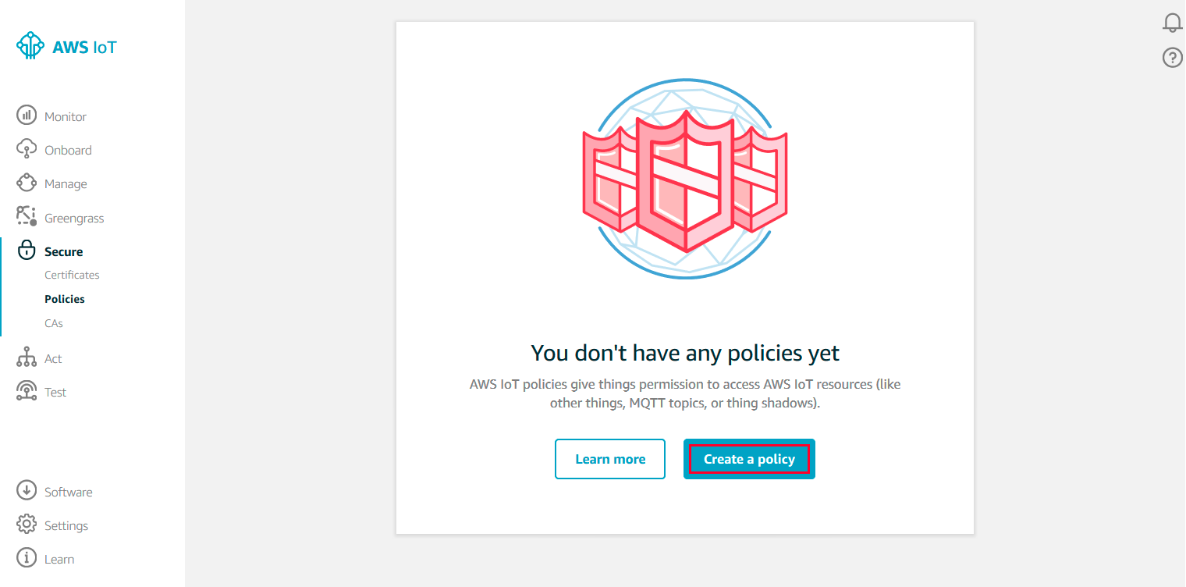

On the Create a policy page, in the Name field, type a name for the policy (for example, MyIoTButtonPolicy). In the Action field, type iot:Connect. In the Resource ARN field, type *.
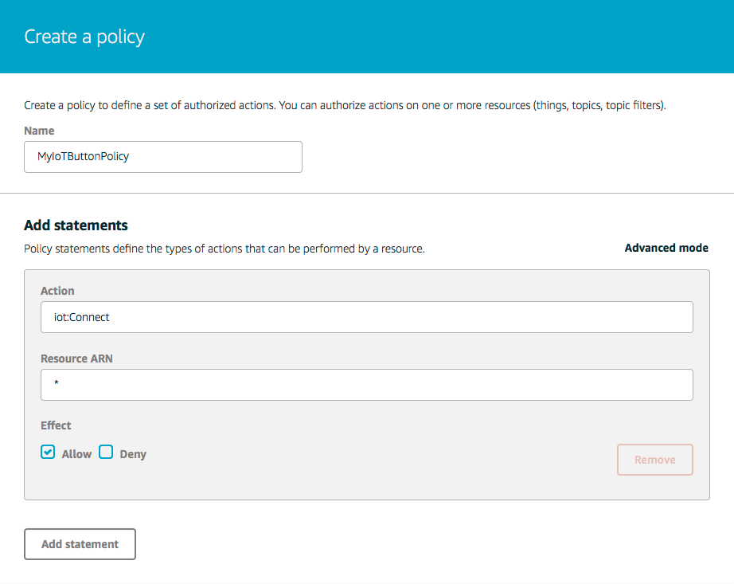

After you have entered the information for your policy, choose Create.
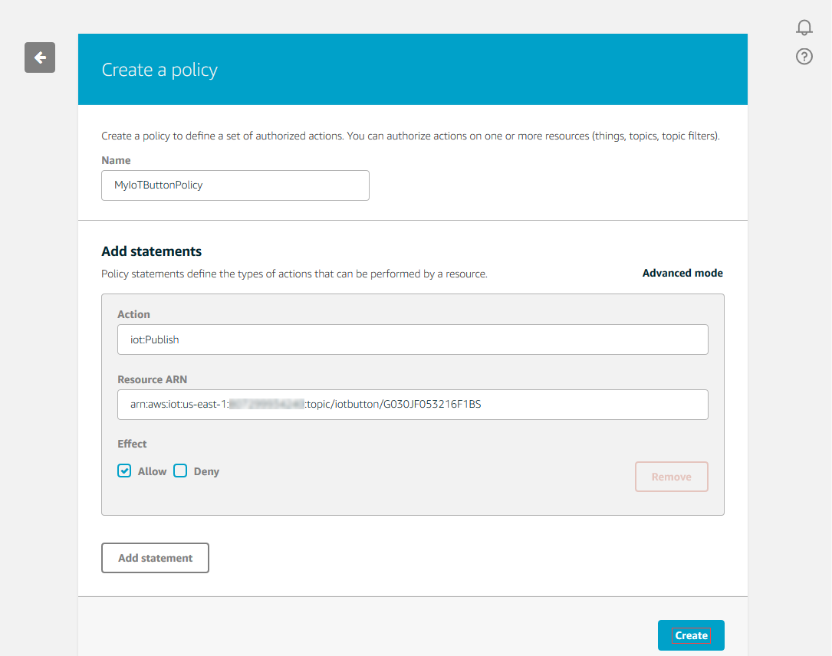

So the policy is created for your thing.

All thats left is to attach the created cerificate and policy to your thing.
In the left navigation pane, choose Secure, and then Certificates.
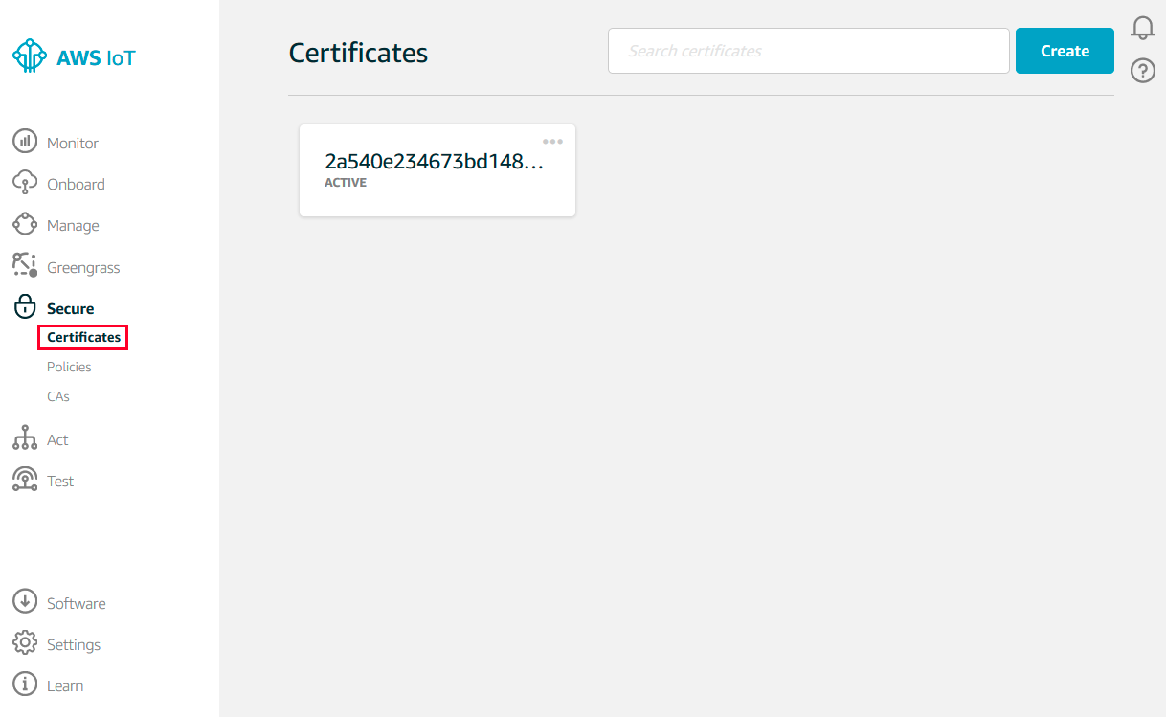

In the box for the certificate you created, choose ... to open a drop-down menu, and then choose Attach policy.
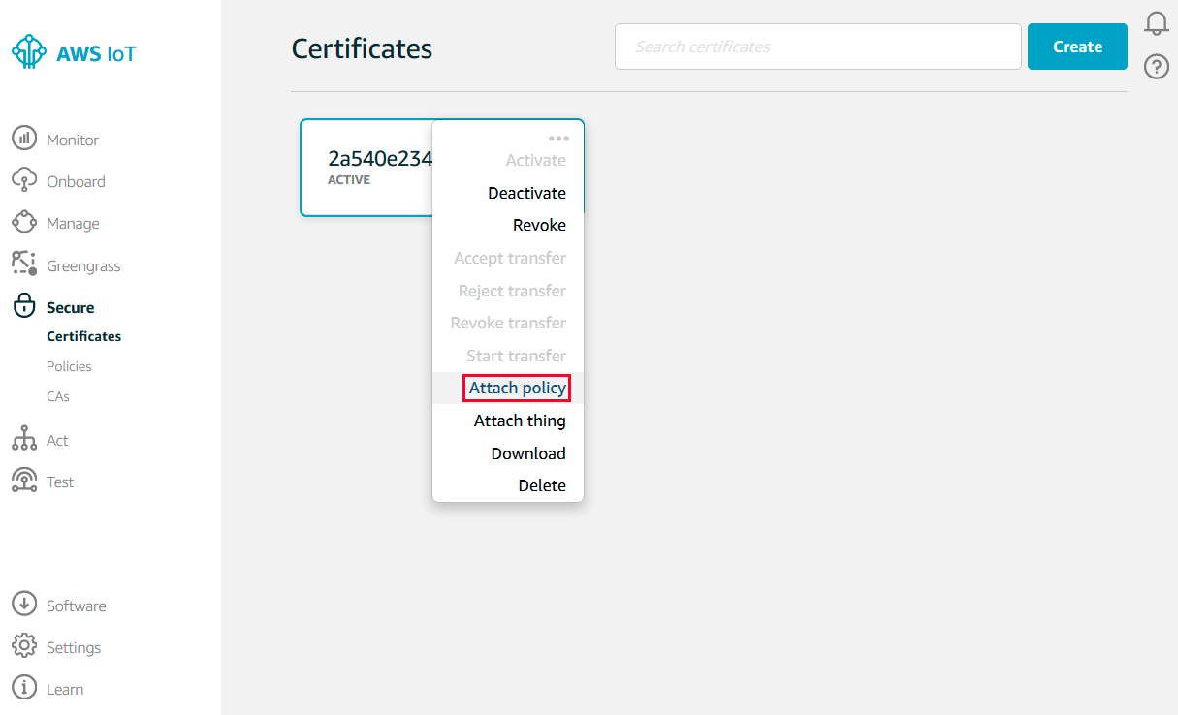
In the Attach policies to certificate(s) dialog box, select the check box next to the policy you created in the previous step, and then choose Attach.
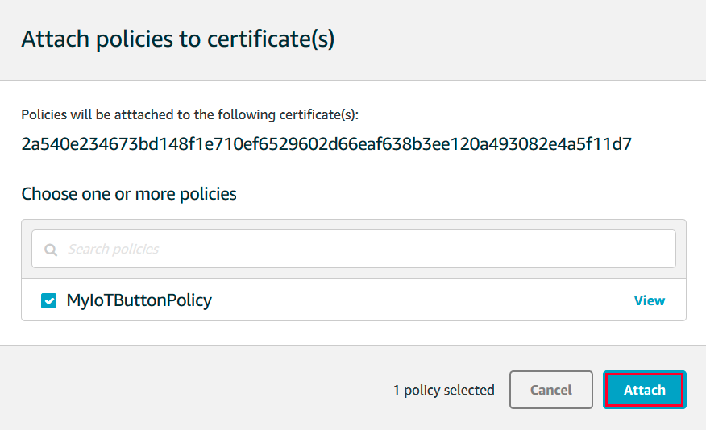

Next task is to attach a certificate to your device
In the box for the certificate you created, choose ... to open a drop-down menu, and then choose Attach thing.
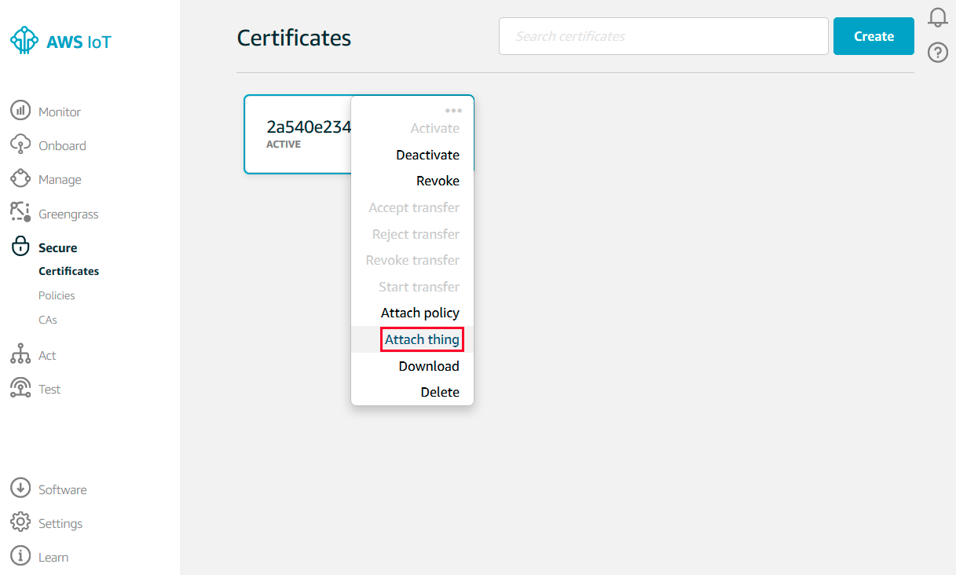

In the Attach things to certificate(s) dialog box, select the check box next to the thing you registered, and then choose Attach.
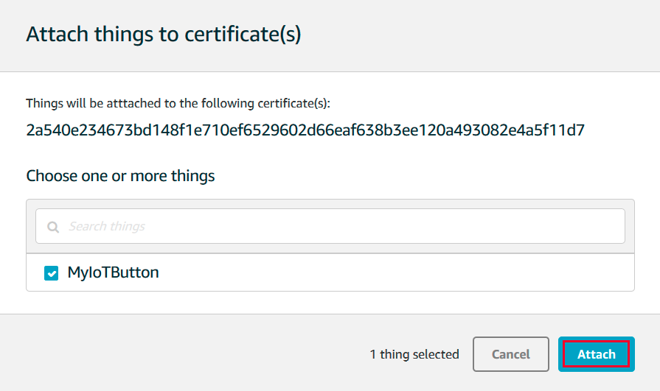

To verify the thing is attached, select the box representing the certificate.
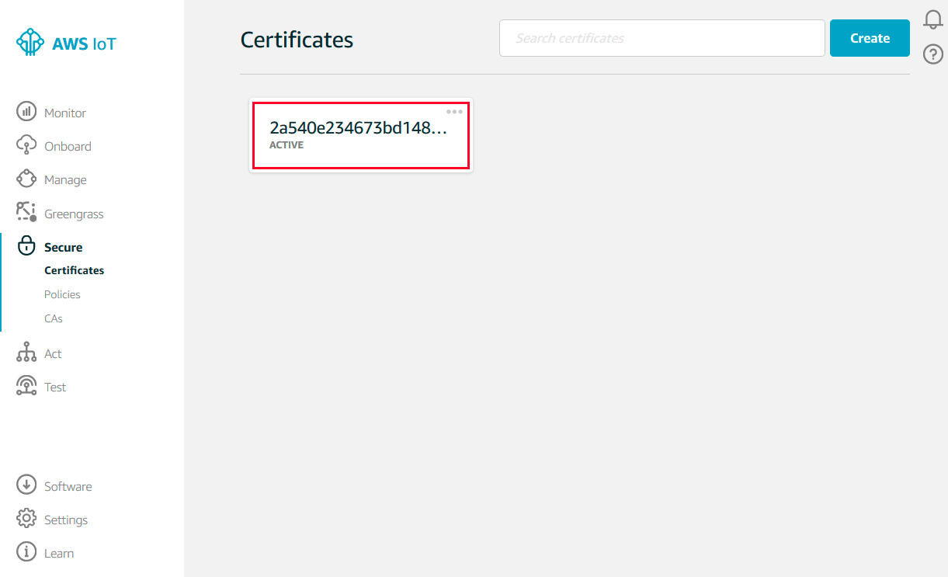

On the Details page for the certificate, in the left navigation pane, choose Things.
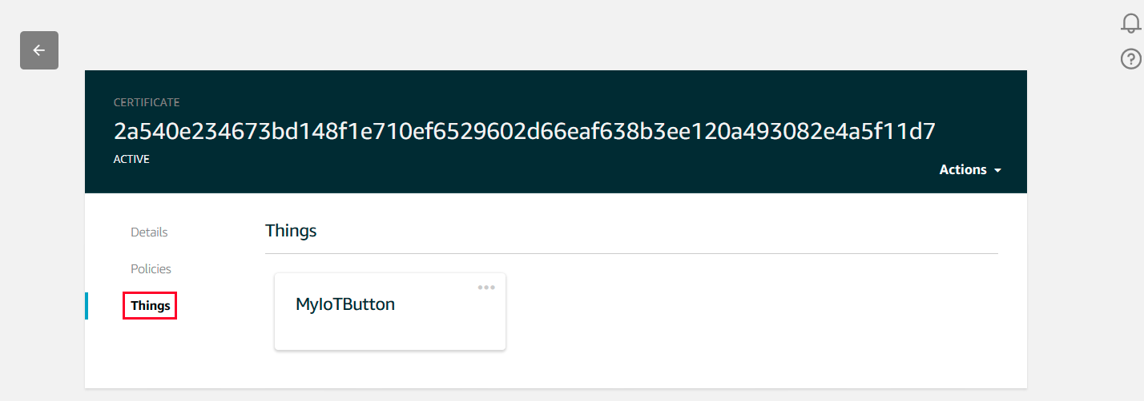

To verify the policy is attached, on the Details page for the certificate, in the left navigation pane, choose Policies.
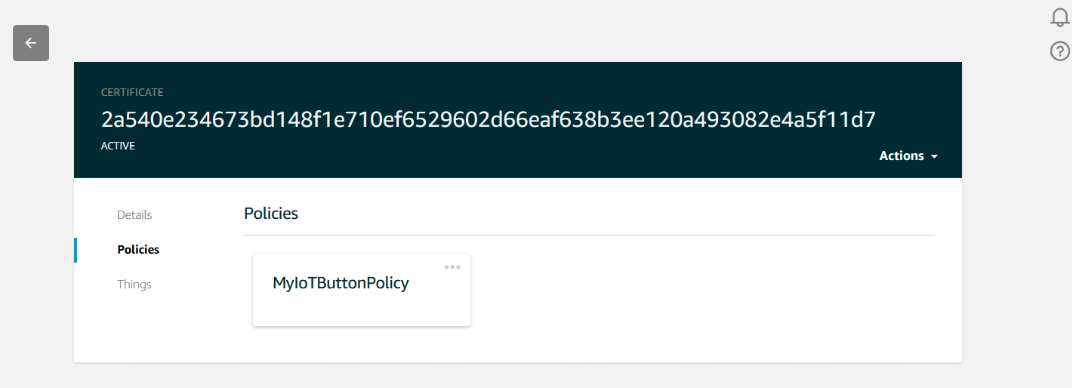

Now to Test your mqtt client code
In the AWS IoT console, in the left navigation pane, choose Test.

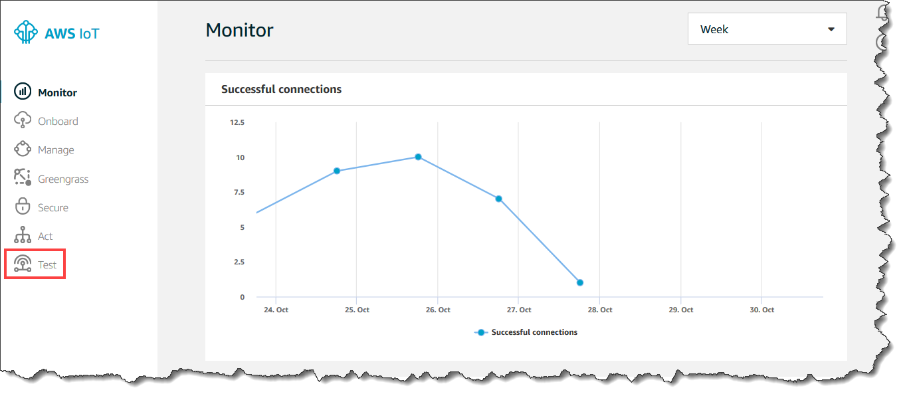

Press your AWS IoT button, and then view the resulting message in the AWS IoT MQTT client. If you do not have a button, you will simulate a button press in the next step.

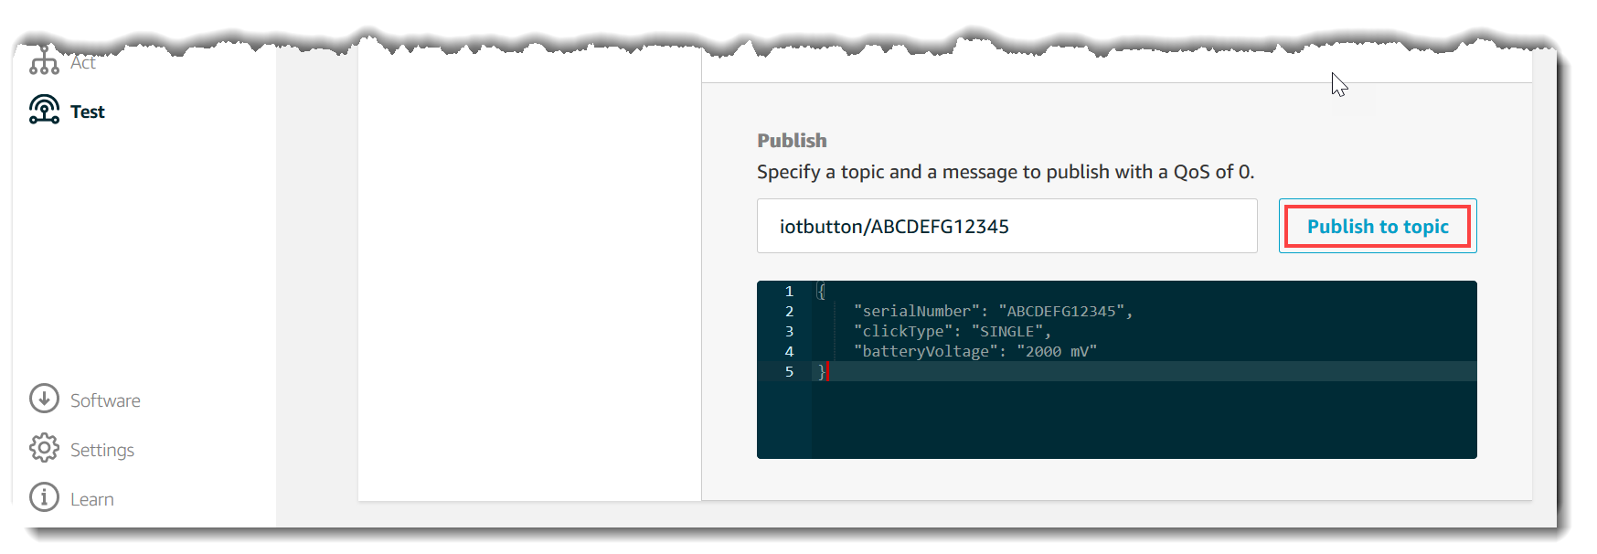
Publishing to a topic

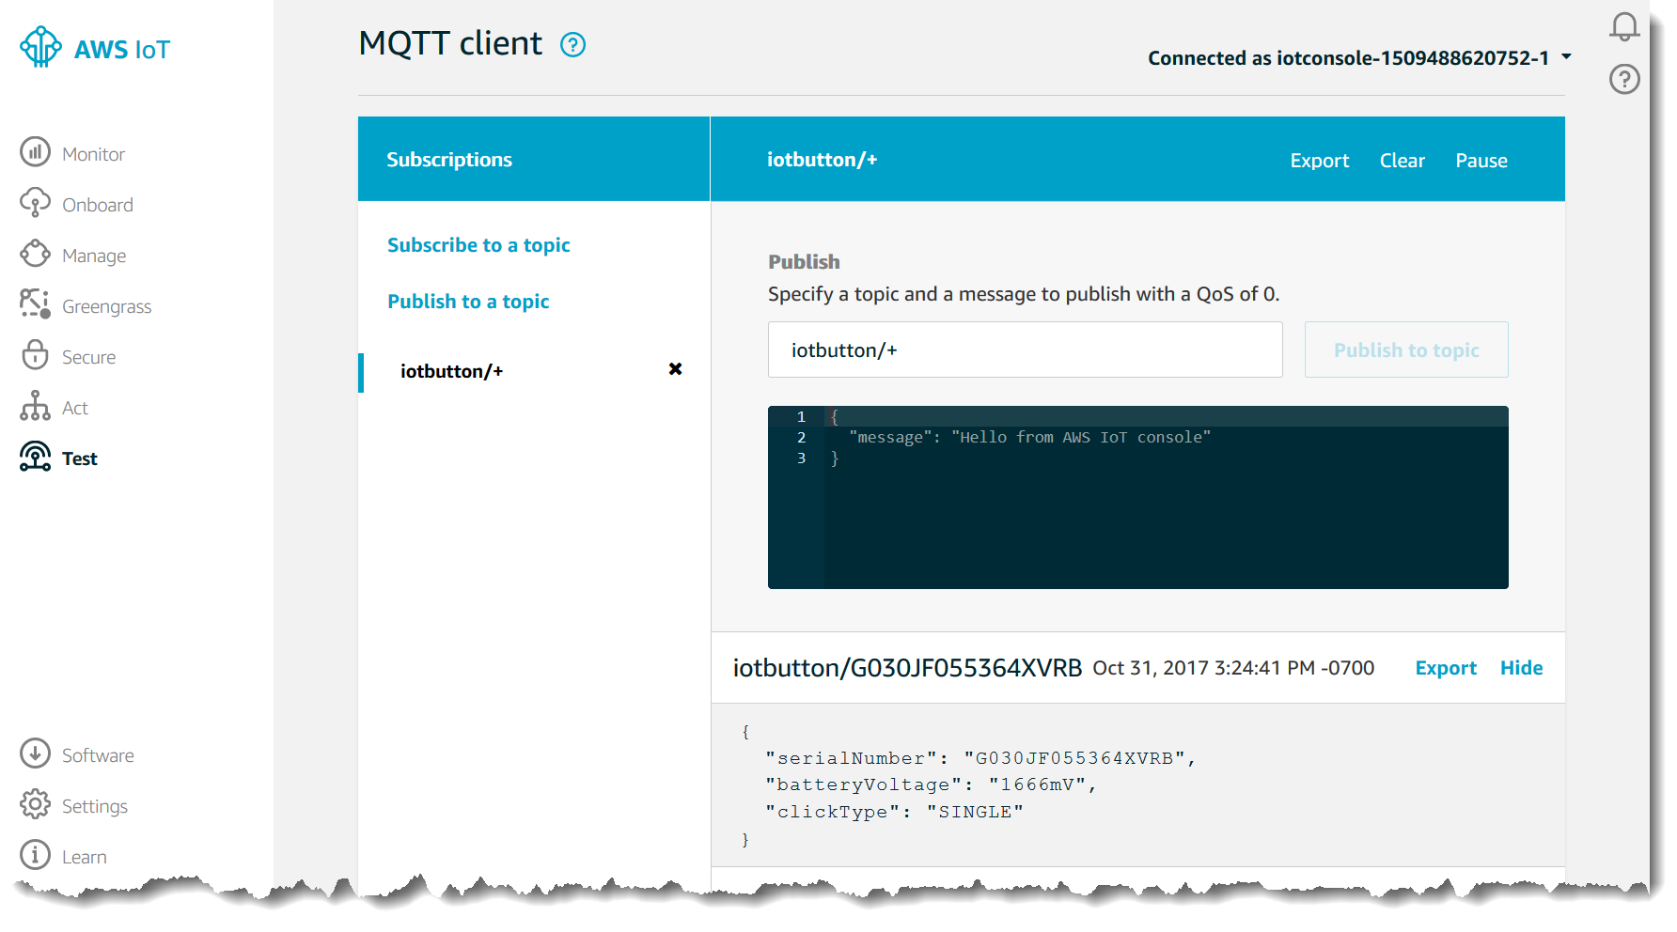
Subscribing from the topic.

So the publishing and subscribing of the topic is done using the following steps
The publish and subscribe we did till now was using the aws console.

We use the below code to publish and subscibe to aws console

from AWSIoTPythonSDK.MQTTLib import AWSIoTMQTTClient
import time
import json

#clientID=XXXX
#rootCAPath=XYZ.crt # change values to your root-ca filename
#privateKeyPath=ABC.private.key #change values to your private key
#certificatePath=XYZ.cert.pem #change values to your pem file
#port = 8883
#host=XXXXXXXX #define your endpoint here

# Custom MQTT message callback
def customCallback(client, userdata, message):
print("Received a new message: ")
print(message.payload) #this prints the payload
print("from topic: ")
print(message.topic) #this prints the topic being subscribed to
print("--------------\n\n")

# Init AWSIoTMQTTClient
myAWSIoTMQTTClient = None
myAWSIoTMQTTClient = AWSIoTMQTTClient('ClientID')
myAWSIoTMQTTClient.configureEndpoint('host', 8883)
myAWSIoTMQTTClient.configureCredentials('rootCA_path', 'privatekeypath', 'certificatepath')

# AWSIoTMQTTClient connection configuration

#the parameters of the below autoreconnect are
#syntax configureAutoReconnectBackoffTime(Starttime,maxiumwait, reset)
#further information refer URL=https://s3.amazonaws.com/aws-iot-device-sdk-python-docs/sphinx/html/index.html

myAWSIoTMQTTClient.configureAutoReconnectBackoffTime(1, 32, 20)

myAWSIoTMQTTClient.configureOfflinePublishQueueing(-1) # Infinite offline Publish queueing
myAWSIoTMQTTClient.configureDrainingFrequency(2) # Draining: 2 Hz
myAWSIoTMQTTClient.configureConnectDisconnectTimeout(10) # 10 sec
myAWSIoTMQTTClient.configureMQTTOperationTimeout(5) # 5 sec
myAWSIoTMQTTClient.connect()
myAWSIoTMQTTClient.subscribe("TOPIC",1, customCallback)
time.sleep(2)
loopCount=1
while True:

messageJson = "" #type any message to send to console
myAWSIoTMQTTClient.publish("TOPIC", messageJson, 1)

time.sleep(1)

