Controlling the smarter coffee machine programmtically using aws console and python

STEP 1: got to url to to access the samples of the client code
URL: https://github.com/evilsocket/coffee/blob/master/coffee

STEP 2:
Open the blog url to understand how the packet syntax is done

BLOG URL :https://www.evilsocket.net/2016/10/09/IoCOFFEE-Reversing-the-Smarter-Coffee-IoT-machine-protocol-to-make-coffee-using-terminal/

Each of these “packets” is sent to tcp port 2081 of the machine, the protocol is very simple.
- First byte: the command number.
- Second byte to N: optional data ( depending on the command code ).
- Last byte: always 0x7e which indicates the end of the packet.

STEP 3:
To understand the packet formation and the fuctions to send data to the client

Responses can vary, but for most of the commands they are:
- First byte: response size
- Second byte: status ( 0 = success otherwise error code )
- Last byte: always 0x7e.
An example command and response, the one to keep the coffee warm for 5 minutes for instance, would be:
COMMAND : 0x3e 0x05 0x7e
RESPONSE : 0x03 0x00 0x7e
STEP 4:
Run the sample code using the following commands
1. Python XXX.py
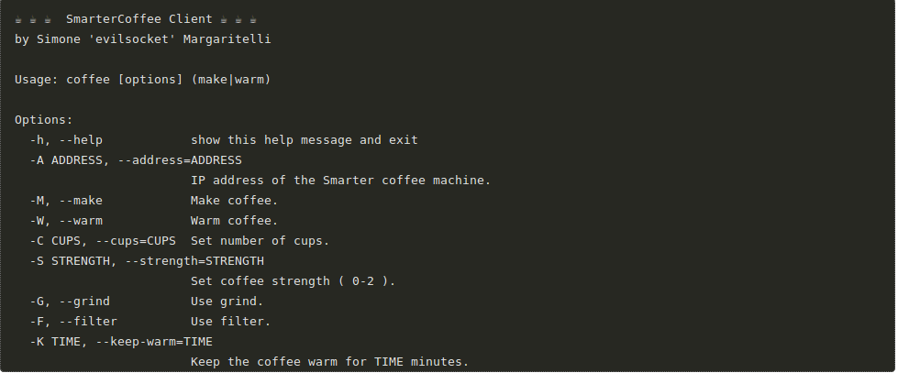
2.
Specify the function for the coffee machine to run
for example:
python coffee make -A XXXX #specify the IP address to connect
then

use

coffee warm –keep-warm=10 #to warm the coffee for 10 min

3.Now u can run the coffee machine using the sample code

To run the coffee machine programmtically use the below code

from AWSIoTPythonSDK.MQTTLib import AWSIoTMQTTClient
import socket
import json
import time
STATUS_OK = 0x00

def customCallback(client, userdata, message):
print("Received a new message: ")
print(message.payload)
print("from topic: ")
print(message.topic)
print("--------------\n\n")
STATUS_OK = 0x00
string = message.payload
JSON=json.loads(string)
print(JSON["config"])
sock =socket.socket( socket.AF_INET, socket.SOCK_STREAM )
sock.connect((address,port))
sock.settimeout(5)
data=bytearray([JSON["config"],JSON["cups"],JSON["strength"],JSON["grind"],JSON["warm"],JSON["end"]])
sock.send(data)
status=ord(sock.recv(1))
print(status)
if status!=STATUS_OK:
print("failed")
else:
print("succeeded")

#coffeemaker
address='192.168.0.54'
port = 2081

CMD_GET_WIFI_APS = 13
CMD_START_BREWING = 51
CMD_SET_STRENGTH = 53
CMD_SET_CUPS = 54
CMD_SET_CONFIG = 56
CMD_ENABLE_WARMING = 62
CMD_DISABLE_WARMING = 74
CMD_END = 126

#mqttclientcode
myAWSIoTMQTTClient = None
myAWSIoTMQTTClient = AWSIoTMQTTClient('example')
myAWSIoTMQTTClient.configureEndpoint('a21rlh0j8rhw6m-ats.iot.us-east-1.amazonaws.com', 8883)
myAWSIoTMQTTClient.configureCredentials('/home/inteldk300/Downloads/ex/root-CA.crt', '/home/inteldk300/Downloads/ex/example.private.key', '/home/inteldk300/Downloads/ex/example.cert.pem')
myAWSIoTMQTTClient.configureAutoReconnectBackoffTime(1, 32, 20)
myAWSIoTMQTTClient.configureOfflinePublishQueueing(-1) # Infinite offline Publish queueing
myAWSIoTMQTTClient.configureDrainingFrequency(2) # Draining: 2 Hz
myAWSIoTMQTTClient.configureConnectDisconnectTimeout(10) # 10 sec
myAWSIoTMQTTClient.configureMQTTOperationTimeout(5) # 5 sec
myAWSIoTMQTTClient.connect()
#start={"start"}
#start = json.dumps(start)
#myAWSIoTMQTTClient.publish("XXXXX",start,1) #publish topic

myAWSIoTMQTTClient.subscribe("XXXXX",1,customCallback)#sub topic
time.sleep(10)

#myAWSIoTMQTTClient.unsubscribe("sdk/test/Python")
#myAWSIoTMQTTClient.disconnect()

