Documentation of running huelights with python and aws mqtt client

STEP 1.

access URL: https://github.com/quentinsf/qhue

STEP 2. installing qhue

pip install qhue

using command line
screenshot attached below
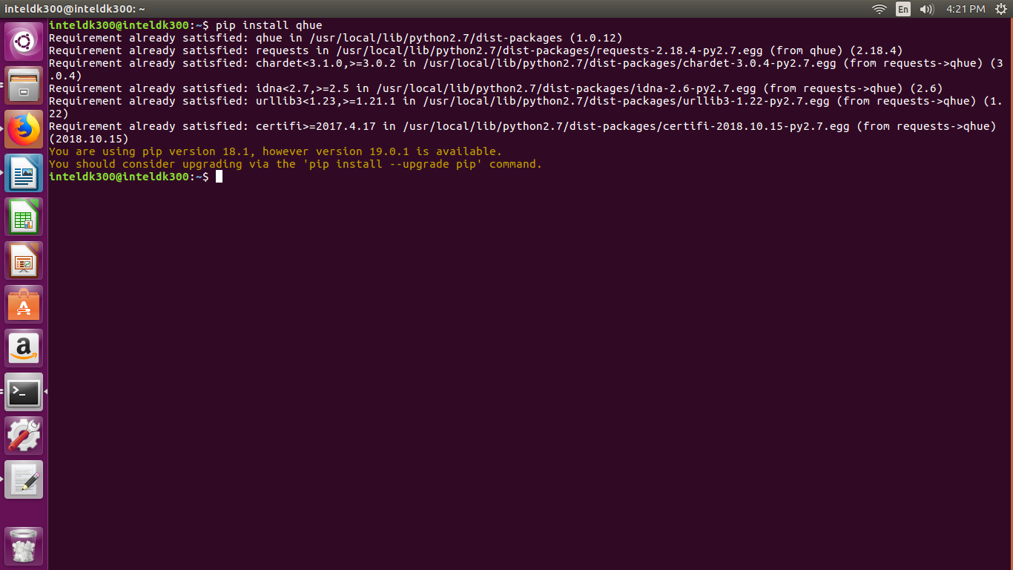

STEP 3. codin in python

import libraires

from qhue import Bridge
from AWSIoTPythonSDK.MQTTLib import AWSIoTMQTTClient
import time
import json

you need AWSIoTPythonSDK.MQTTLib to access the mqtt client

STEP 4.

