Hasil Running – Latihan Micronaut JPA MyBatis

Cara testing :

dedi@dedi-HP-Notebook:~/Tugas/praxis-academy/novice/04-05/latihan/latihanMicronautJPAMyBatis/complete$ gradlew test

BUILD SUCCESSFUL in 5s

4 actionable tasks: 2 executed, 2 up-to-date

dedi@dedi-HP-Notebook:~/Tugas/praxis-academy/novice/04-05/latihan/latihanMicronautJPAMyBatis/complete$

Hasil Tesing :

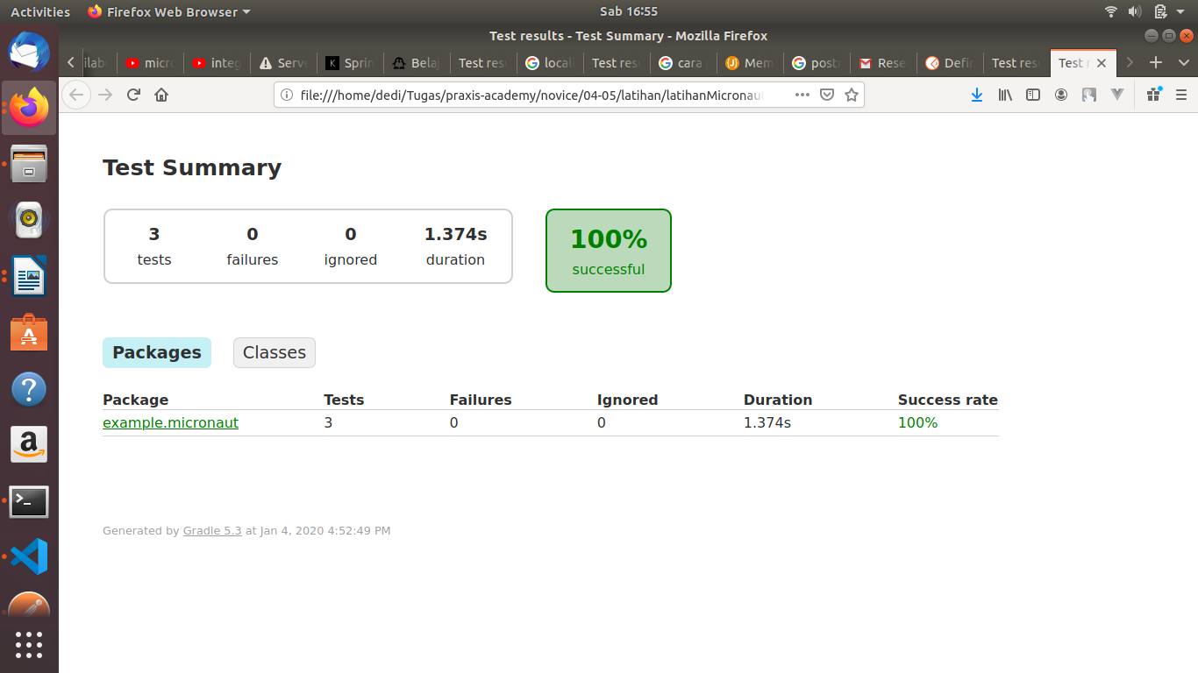

Hasil Running Application :

dedi@dedi-HP-Notebook:~/Tugas/praxis-academy/novice/04-05/latihan/latihanMicronautJPAMyBatis/complete$ gradle run

Starting a Gradle Daemon, 2 busy and 1 incompatible Daemons could not be reused, use --status for details

> Task :compileJava

Note: Creating bean classes for 5 type elements

> Task :run

16:58:32.955 [main] INFO com.zaxxer.hikari.HikariDataSource - HikariPool-1 - Starting...

16:58:33.034 [main] INFO com.zaxxer.hikari.HikariDataSource - HikariPool-1 - Start completed.16:58:33.040 [main] INFO o.f.c.i.license.VersionPrinter - Flyway Community Edition 5.2.4 by Boxfuse

16:58:33.044 [main] INFO o.f.c.i.database.DatabaseFactory - Database: jdbc:h2:mem:default (H2 1.4)

16:58:33.055 [main] WARN o.f.c.i.database.base.Database - Flyway upgrade recommended: H2 1.4.199 is newer than this version of Flyway and support has not been tested.

16:58:33.095 [main] INFO o.f.core.internal.command.DbValidate - Succes

sfully validated 1 migration (execution time 00:00.013s)

16:58:33.108 [main] INFO o.f.c.i.s.JdbcTableSchemaHistory - Creating Schema History table: "PUBLIC"."flyway_schema_history"

16:58:33.125 [main] INFO o.f.core.internal.command.DbMigrate - Current version of schema "PUBLIC": << Empty Schema >>

16:58:33.126 [main] INFO o.f.core.internal.command.DbMigrate - Migrating schema "PUBLIC" to version 1 - schema

16:58:33.146 [main] INFO o.f.core.internal.command.DbMigrate - Successfully applied 1 migration to schema "PUBLIC" (execution time 00:00.042s)

16:58:33.485 [main] INFO io.micronaut.runtime.Micronaut - Startup comp

leted in 1887ms. Server Running: http://localhost:8089

<=========----> 75% EXECUTING [29s]

Menambahkan 1 record “DevOps” pada genre

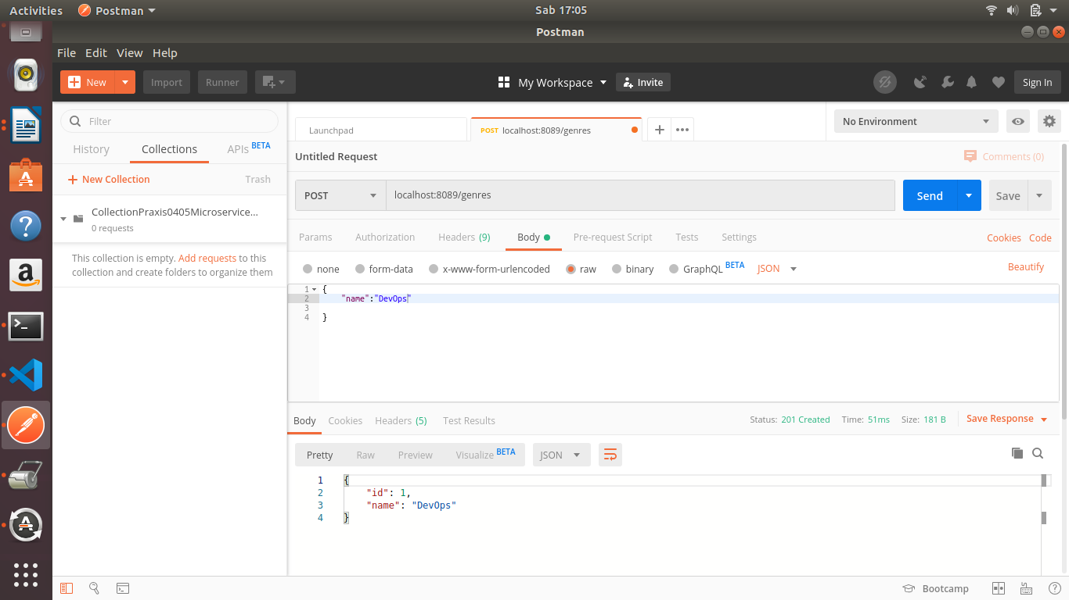

Menambahkan 1 record “Micro-Service” pada genre

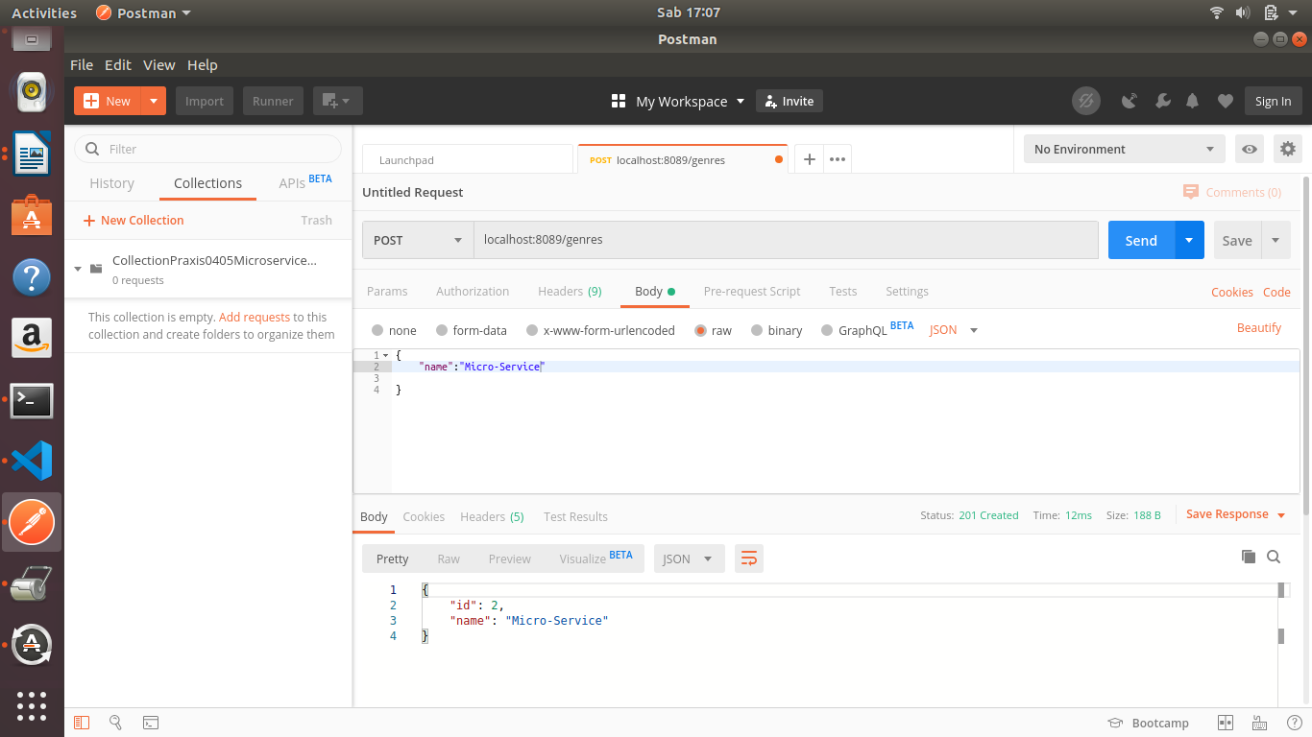

Menampilkan semua record pada genre :

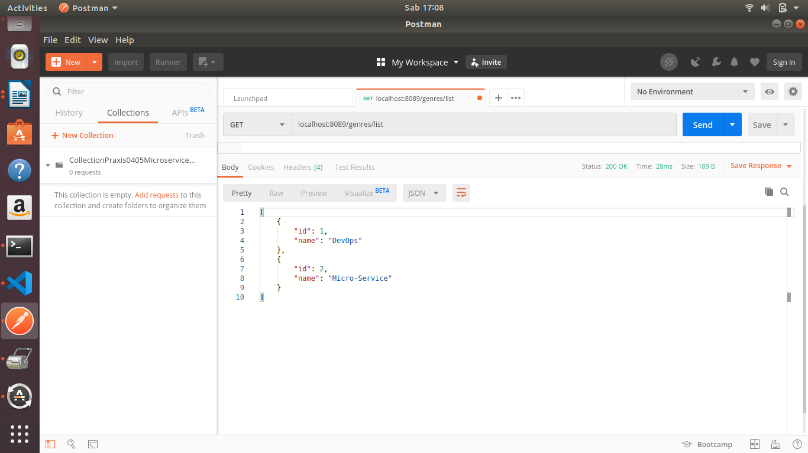

Menampilkan max 1 record :

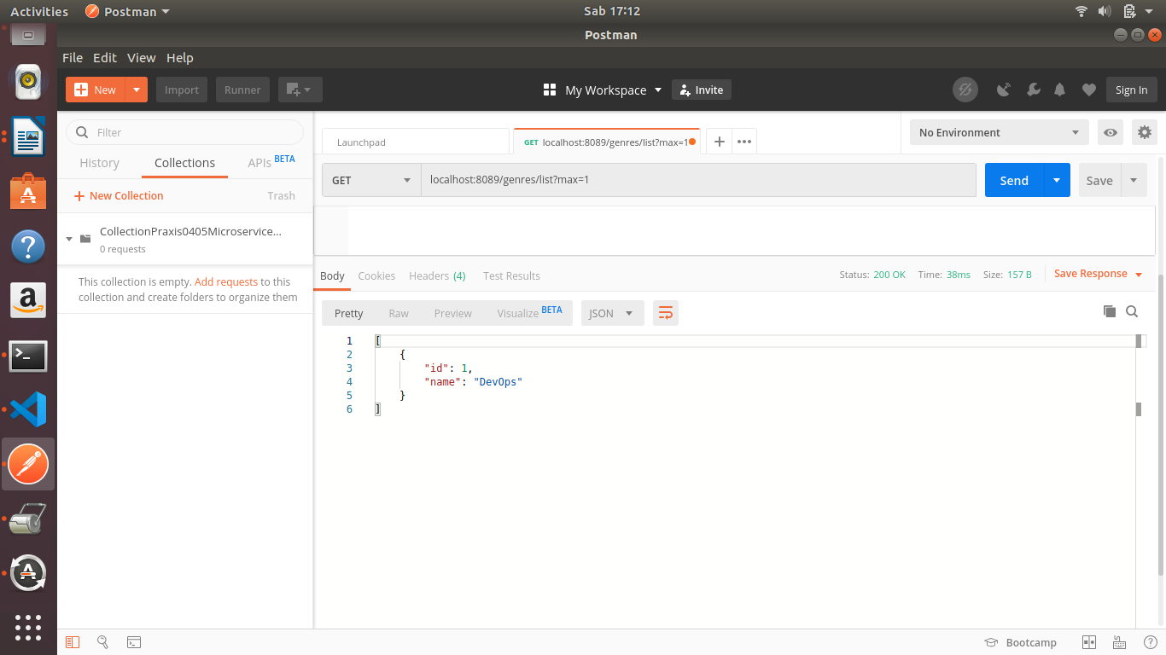

Menampilkan max 2 record pada genre :

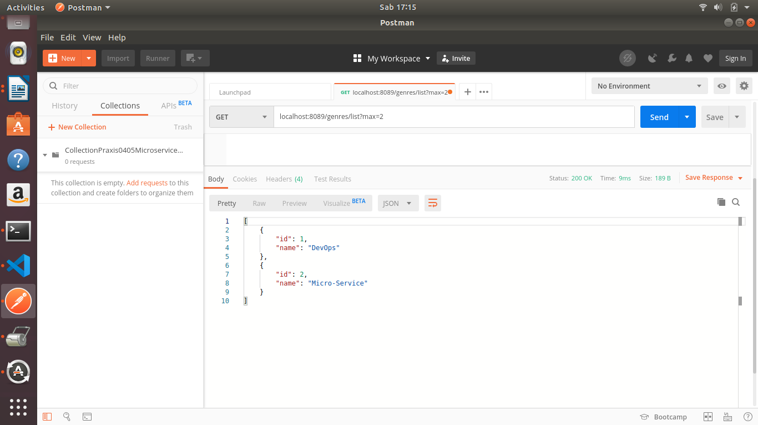

Menampilkan max 2 record, yang di order berdasarkan descending dan di urutkan berdasarkan name :

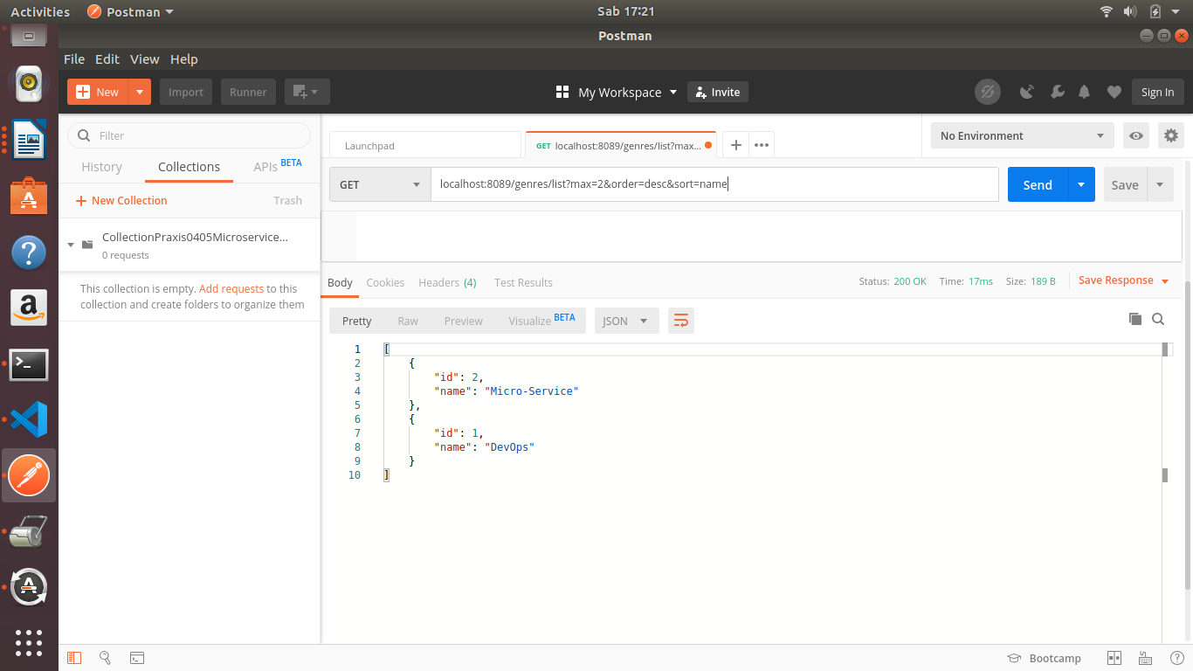

Menampilkan 2 record max, dan offset 10

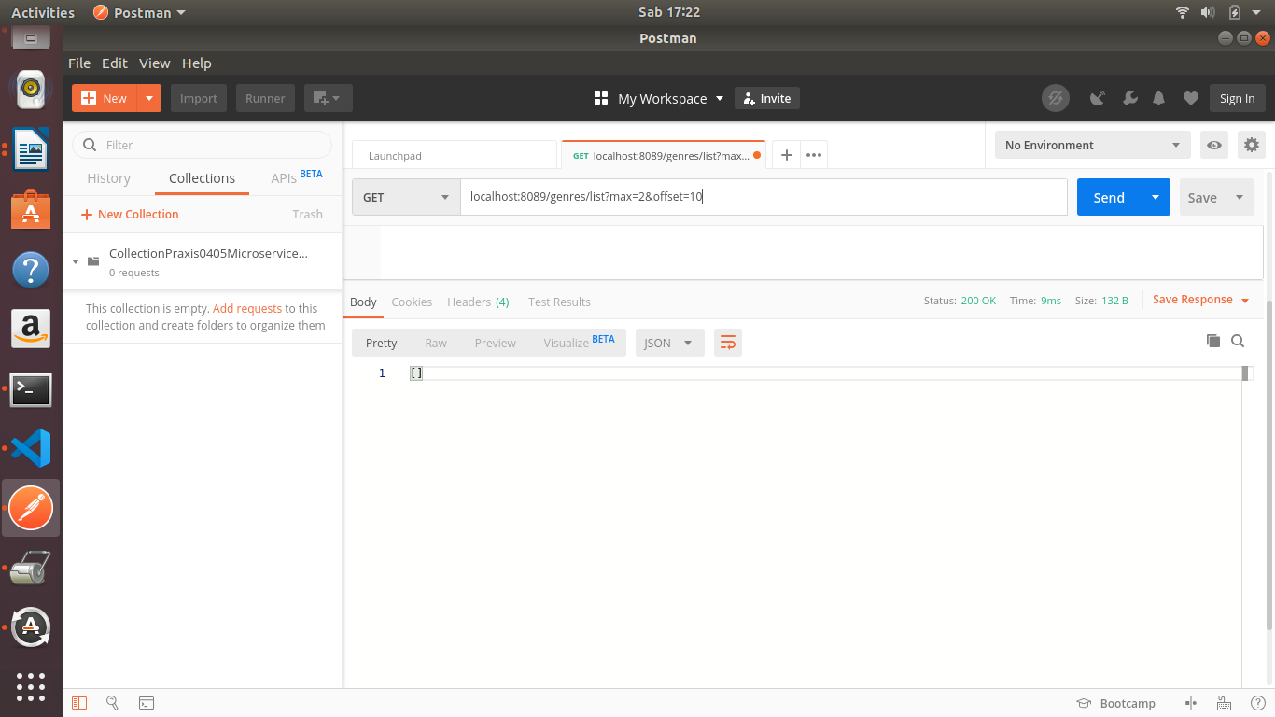

Menampilkan record dengan id = 2

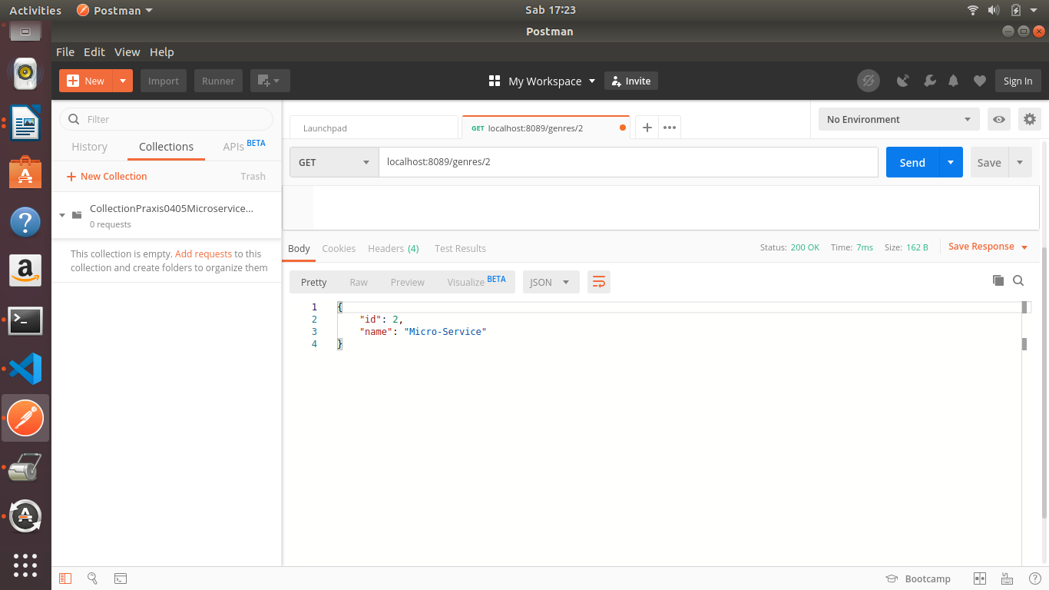

Mengupdate record ke 2 dari “Micro-Service” menjadi “Microservice”

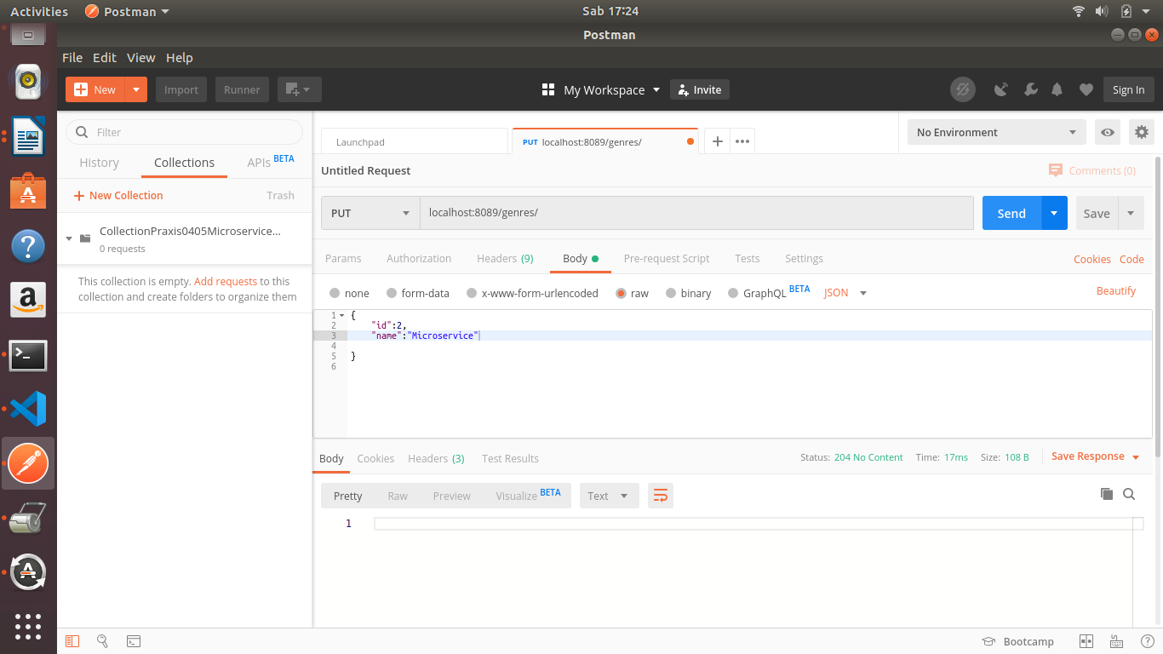

Menampilkan semua record yang ada :

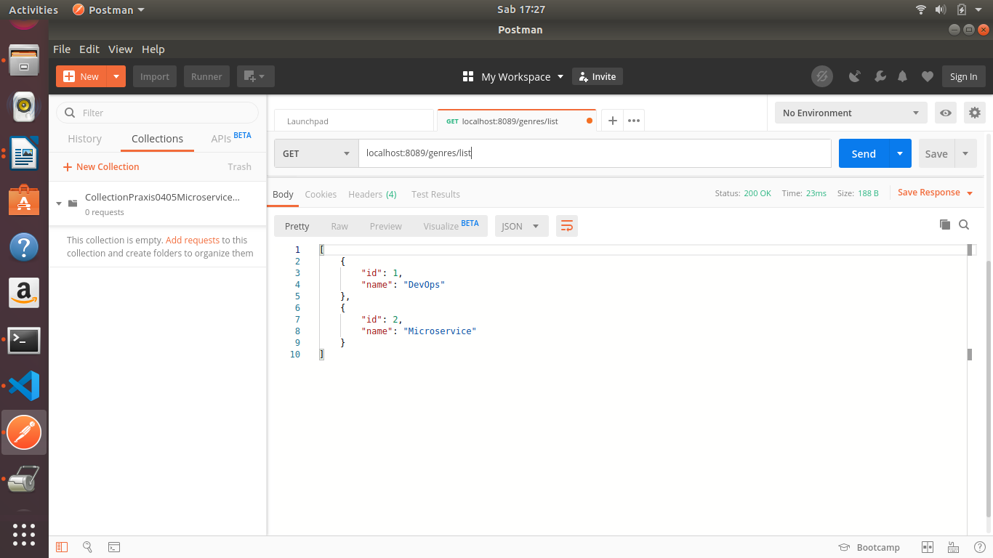

Mendelete 1 record, yaitu record dengan id = 2

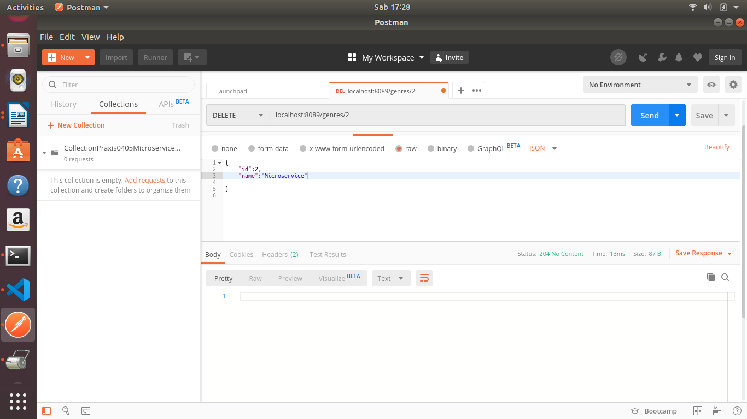

Menampilkan semua record setelah 1 record di delete terlihat record =2 tidak ada :

