A Changepoint Robustness Metric and Causal Regime-Shift Knowledge Injection for Reliable Demand Forecasting under Structural Change
Dedi Irawan^{a,∗}, Sudarmajiª, Imam Samsudinª
ª Faculty of Computer Science, Muhammadiyah University of Metro, Metro, Lampung, Indonesia
ORCID: Dedi Irawan 0009-0007-4973-926X; Sudarmaji 0000-0001-5549-4886; Imam Samsudin 0009-0006-2482-4209
∗ Corresponding author. E-mail addresses: dedimti@ummetro.ac.id (D. Irawan), sudarmaji@ummetro.ac.id (Sudarmaji), imamsam@ummetro.ac.id (I. Samsudin).

Abstract
Data-driven forecasting models underpin intelligent decision support, yet they remain unreliable precisely when the data-generating process shifts: policy changes, supply disruptions, and behavioural shifts trigger abrupt structural changes, or changepoints, whose impact aggregate accuracy metrics hide by averaging error across the horizon. This is acute in pharmaceutical demand, where transition errors drive inventory and patient-safety decisions. To expose the fragility as explicit, decomposable knowledge, we introduce ρ, a changepoint robustness ratio comparing error near detected changepoints against error in stable regions. Applying ρ to a large corpus of United States Medicaid drug-utilization data (168,987 clean quarterly series, 2014–2019), we first weight the loss toward changepoints and report an honest negative result: ρ falls only because stable-region error inflates, while absolute changepoint error rises. This motivates a causal local-shift augmentation that signals regime change as it occurs. Across 5,000 changepoint-heavy series, the augmentation lowers changepoint error from 1.116 to 1.085 (Diebold–Mariano 23.2, p < 0.001) and overall error by 4.3%, surpassing ARIMA, naïve, seasonal-naïve, DLinear, and a plain LSTM. Adding the same signal to a state-of-the-art iTransformer also reduces its changepoint error (1.081 → 1.068), indicating the mechanism transfers across both architectures tested rather than competing as a model. On an independent retail dataset (M5), ρ reproduces the same fragility pattern, confirming the metric generalises, while the augmentation proves specific to persistent regime shifts. The contribution is primarily diagnostic: ρ exposes fragility that aggregate metrics hide, and the negative result shows robustness requires regime information, not loss re-weighting—a transferable lesson for decision support under regime change.
Keywords: Pharmaceutical demand forecasting; Time-series changepoints; Robustness metric; Regime-shift augmentation; Deep sequence models; LSTM

1. Introduction
Two competing pressures define pharmaceutical supply chains: excess inventory locks up capital and risks expiry waste, whereas stockouts put patient care directly at risk. At the scale of Medicaid alone, which reimburses billions of prescription units each year across more than fifty United States jurisdictions, even a small percentage error in a demand forecast can translate into substantial financial and clinical consequences. As a result, procurement, inventory optimisation, and the broader resilience of healthcare delivery all hinge on forecasting demand accurately [1–3]. Large-scale forecasting competitions have likewise shown that data-driven machine-learning methods, trained globally across many related series, now consistently outperform purely local statistical models on retail demand at scale [4]. Demand for an individual drug product is rarely smooth, however. Seasonal disease patterns, formulary and reimbursement policy changes, supply disruptions, generic entry, and shifts in prescribing behaviour all act on it, and these forces frequently induce abrupt, persistent changes in the level or dynamics of a series. Such structural breaks, known as changepoints, are not noise that can simply be averaged away; they are the moments at which forecasting is both hardest and most consequential.
Exponential smoothing, ARIMA, and their seasonal variants all assume locally stationary dynamics, so classical statistical forecasters adapt only gradually to abrupt change and remain systematically exposed at structural breaks [5]. Machine-learning and deep-sequence models relax that stationarity assumption; recurrent architectures such as the LSTM, in particular, can capture nonlinear temporal dependence [6–9]. These models are nonetheless typically trained and evaluated under aggregate error criteria such as MAE or RMSE, computed over the entire test horizon, and because changepoint regions make up only a small fraction of most series, a model can post a strong aggregate score while still failing badly at precisely the transitions that drive operational risk. Changepoint detection [10] and regime-switching, adaptive forecasting [11] form a growing literature that addresses parts of this problem, yet detection and forecasting are often treated as separate tasks, and few studies quantify, in a way that transfers across models, how fragile a given forecaster actually is at changepoints.
Two gaps follow from this state of affairs. First, the field still lacks a simple, model-agnostic diagnostic capable of isolating forecasting performance at changepoints from performance in stable regions; aggregate metrics conflate the two and, in doing so, obscure fragility. Second, it is intuitively appealing to improve changepoint robustness by re-weighting the loss toward high-error transition windows, yet whether such emphasis actually yields genuine robustness—lower error at changepoints—or simply redistributes error elsewhere has not been established. Answering the second question first requires a diagnostic capable of telling the two outcomes apart.
This study addresses both gaps directly. We introduce ρ, a changepoint robustness ratio that compares forecasting error around detected changepoints against error in stable regions and thereby provides a model-agnostic diagnostic of fragility. Applying ρ to a large-scale, multi-series corpus of United States Medicaid drug-utilization data, we evaluate an intuitive changepoint-aware weighted loss and report an honest negative result: the weighting reduces ρ only by degrading stable-region accuracy rather than improving accuracy at changepoints. We trace the underlying cause to regime blindness—the fact that the model receives no signal that a structural change is underway. To show that this diagnosis is actionable rather than merely descriptive, we then demonstrate that a deliberately simple, causally computed local-shift feature—supplying the regime signal the model was missing—yields statistically significant reductions in changepoint error across thousands of series. The central thread is one of knowledge: ρ turns detected structural breaks into a decomposable diagnostic of model reliability, and the negative result establishes what that diagnostic reveals—that emphasis without information cannot confer robustness—while the augmentation closes the loop by injecting the same causal knowledge back into the forecaster. Our primary contribution is therefore a diagnostic and an empirically grounded principle for changepoint robustness; the augmentation is a lightweight, interpretable demonstration that the principle holds, offering a model-agnostic component for data-driven decision-support systems that must remain reliable precisely when demand dynamics shift—the moments that matter most for inventory and patient-safety decisions.
The contributions of this study are summarised as follows:
(1) We propose ρ, a changepoint robustness ratio diagnosing forecasting fragility at structural transitions, and validate it as a discriminative diagnostic across a large multi-series pharmaceutical corpus.
(2) Using ρ, we report an honest negative result: an intuitive changepoint-aware weighted loss (factor λ) reduces ρ only by degrading stable-region accuracy rather than improving changepoint accuracy, revealing that error re-weighting alone does not confer genuine robustness.
(3) We propose a causal local-shift augmentation, together with a gated regime-switching variant, that significantly reduces changepoint error across 5,000 series. The local-shift signal transfers beyond the LSTM, also improving a state-of-the-art iTransformer backbone in a controlled within-run ablation, which suggests the benefit is not tied to one architecture; this is supported by ablation, multi-seed, and robustness analyses.
(4) We benchmark the approach against statistical and state-of-the-art neural forecasters (ARIMA, seasonal-naïve, naïve, DLinear, PatchTST, iTransformer), demonstrate cross-domain generalisation, and show that adding our causal signal to a strong iTransformer backbone further lowers its changepoint error (MAE_cp 1.068).
The rest of the paper proceeds as follows. Section 2 reviews related work; Section 3 formalises the problem, defines ρ, and presents the weighted-loss formulation together with the proposed regime-shift augmentation, its training procedure, and a complexity analysis; Section 4 describes the dataset and experimental setup; Section 5 reports the results, covering the negative finding, ablation, comparisons against classical and modern baselines, robustness checks, multi-horizon and seed-stability analyses, cross-domain transfer, and behaviour across architectures; Section 6 discusses the implications; and Section 7 concludes.

2. Related Work

2.1. Sequence forecasting with Long Short-Term Memory networks
Designed to capture long-range temporal dependence while mitigating the vanishing-gradient problem that plagues vanilla recurrent networks, the Long Short-Term Memory (LSTM) network is a recurrent architecture [6]. Given input x_t and the previous hidden and cell states h_{t-1}, c_{t-1} at each timestep t, the LSTM computes input, forget, and output gates, which together regulate how information flows into and out of a memory cell:
$i_{t} = σ\left(W_{i}x_{t} + U_{i}h_{t-1} + b_{i}\right)$ (1)
$f_{t} = σ\left(W_{f}x_{t} + U_{f}h_{t-1} + b_{f}\right)$ (2)
$o_{t} = σ\left(W_{o}x_{t} + U_{o}h_{t-1} + b_{o}\right)$ (3)
$g_{t} = tanh\left(W_{g}x_{t} + U_{g}h_{t-1} + b_{g}\right)$ (4)
$c_{t} = f_{t} ⊙ c_{t-1} + i_{t} ⊙ g_{t}$ (5)
$h_{t} = o_{t} ⊙ tanh\left(c_{t}\right)$ (6)
Here σ denotes the logistic sigmoid, ⊙ the elementwise product, and W, U, b the learnable parameters. Because the gating in (5) lets the cell retain information across many steps, the network can in principle model the persistent level shifts characteristic of changepoints. In practice, however, the gates are driven only by observed values, so the network receives no explicit signal that a structural change is occurring—a limitation our method addresses directly. A large family of deep forecasters has emerged beyond the LSTM, including global probabilistic recurrent models [7], interpretable residual MLP stacks [12], attention-based multi-horizon models [13], and a line of Transformer variants for long-horizon forecasting [14–18]; broad surveys chart the rapid development of this area [19–21], including recent multiscale-mixing designs such as TimeMixer [22]. These architectures improve accuracy on aggregate benchmarks, but, much like the LSTM, they are typically optimized and evaluated without explicitly accounting for behaviour at structural breaks—the precise gap this work targets.

2.2. Changepoint detection via PELT
A changepoint marks a time index at which the statistical properties of a series, most commonly its mean, change abruptly and persistently. Detecting an unknown number of such changepoints in a series of length n is a model-selection problem balancing fit against complexity, and the Pruned Exact Linear Time (PELT) algorithm [10] solves it as a penalized optimisation over segmentations:
$\min_{m, τ}{\sum_{k=1}^{m+1}{C\left(y_{\left(τ_{k-1}+1\right):τ_{k}}\right)}} + βm$ (7)
Here C(·) denotes a segment cost (the sum of squared deviations from the segment mean, in our case), m the number of changepoints, τ_k the changepoint locations, and β a penalty that discourages over-segmentation. PELT prunes the candidate set while still recovering the exact optimum under a mild assumption, achieving expected linear-time complexity. Changepoint detection has a long history spanning classical structural-break tests [23], Bayesian online detection [24], nonparametric and wild binary segmentation [25], and broad surveys of the field [26]; comparative benchmarks on real-world data find PELT and Bayesian online detection among the strongest performers [27]. We use the implementation of PELT in the ruptures package [28], both to characterise the corpus and to construct the causal regime-shift signal described in Section 3. In contrast to this literature, which focuses on locating breaks, we treat detected changepoints as a signal for forecasting through them rather than as an end in themselves.

2.3. Regime-switching and the regime-blindness problem
Regime-switching models, classically the Markov-switching framework [11], posit that a series is generated by one of several latent regimes, with transitions between them governing abrupt changes in dynamics. A standard sequence model instead applies a single learned mapping uniformly across regimes, so when a changepoint occurs it stays anchored to the dynamics of the prior regime until enough new observations accumulate—a condition we call regime blindness. Fitting an explicit latent-state model would be data-intensive on series this short, so our approach takes a different route: it supplies the network with an inexpensive, causally computed signal of recent regime change, keeping the LSTM backbone intact while removing its blindness.

2.4. Positioning relative to prior work
Our study relates most closely to three lines of work and differs from each in a specific way. Modern deep forecasters—N-BEATS [12], DeepAR [7], the Temporal Fusion Transformer [13], and recent Transformer variants [14–18]—optimize aggregate accuracy and report a single headline error, none isolating or targeting behaviour at changepoints, which is precisely the quantity ρ exposes. The changepoint-detection literature [23–26,28], for its part, focuses on locating breaks rather than forecasting through them. Pharmaceutical-demand studies [2,8–9,29], and the broader deep-learning demand-forecasting literature they build on [30], benchmark models on aggregate accuracy over single-site or limited data, whereas we evaluate fragility at structural breaks across a large multi-series corpus. To our knowledge, no prior work both quantifies changepoint fragility with a transferable metric and shows that a causal regime signal, rather than loss re-weighting, reduces it.

3. Methodology
Before the formal description, Fig. 1 sketches an overview of the proposed approach.
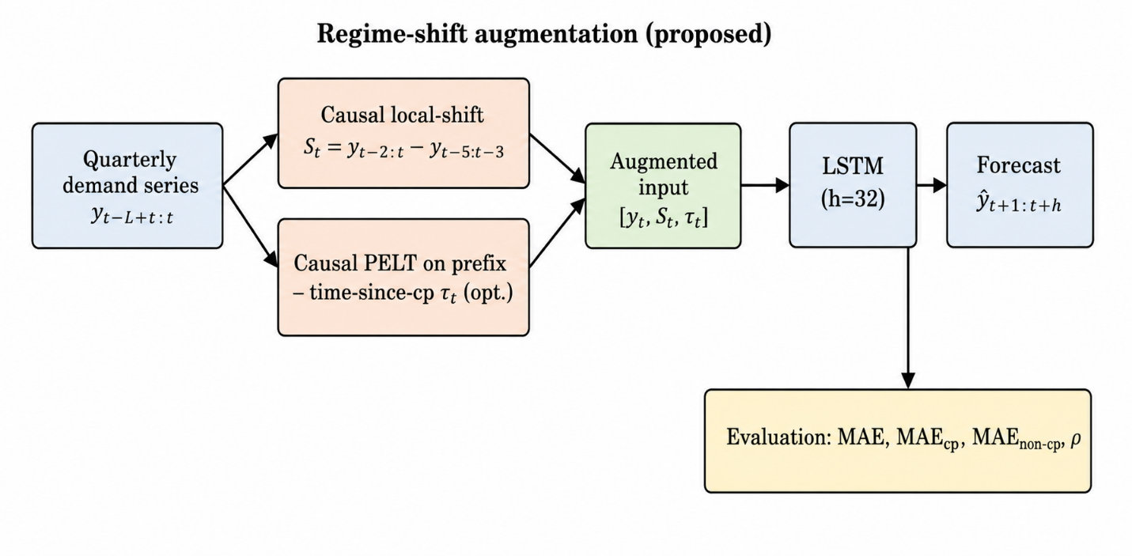
Fig. 1. Overview of the proposed causal regime-shift augmentation. Causal features (local-shift and optional time-since-changepoint) augment the LSTM input; evaluation reports MAE, its critical/normal decomposition, and ρ.

3.1. Problem formulation
Consider a univariate demand series y = (y_1, …, y_T). Given a lookback window of length L, the task is to predict the next H values from the preceding L observations, so that for a forecast origin t the model learns a mapping
${\hat{y}}_{t+1:t+H} = Φ\left(y_{t-L+1:t}; θ\right)$ (8)
Here θ denotes the model parameters. Rather than fitting one model per series, we train a single global model across many series, which exposes Φ to a diverse range of changepoint patterns; training one model across groups of related series is well established as a means of improving accuracy and data efficiency relative to per-series models [31]. Each series is standardised using statistics computed only on its training portion, to prevent leakage, and the train/test split follows the calendar: windows whose targets fall entirely within the training portion are used for fitting, while windows whose targets extend into the held-out portion are reserved for evaluation. Concretely, with L = 12 and H = 4 a series of 24 quarters yields nine valid (input, target) windows; the last calendar year (four quarters) is held out, so each series contributes four evaluation windows, giving 20,000 test windows over the 5,000-series subset. Because changepoints are sparse, these windows contain 34,177 individual time points that fall inside a critical neighbourhood, which is the unit pooled in the Diebold–Mariano and Wilcoxon tests.

3.2. The changepoint robustness ratio ρ
Because aggregate error metrics average performance over every horizon position, they cannot reveal whether a model is fragile specifically at changepoints, so we define ρ to make that fragility explicit. Let C = {c_1, …, c_m} denote the changepoints detected in a series and w a half-width defining the critical neighbourhood. The critical and normal index sets then follow:
$𝒦 = \left\{t : \left|t - c_{j}\right| ≤ w for some c_{j} ∈ C\right\}$ (9)
$𝒩 = \left\{t : t ∉ 𝒦\right\}$ (10)
Given a prediction ŷ_t and the actual value y_t, the pointwise absolute error is
$e_{t} = \left|{\hat{y}}_{t} - y_{t}\right|$ (11)
Averaging this error over the critical and normal regions gives
${MAE}_{cp} = \frac{1}{\left|𝒦\right|}\sum_{t ∈ 𝒦}{e_{t}}$ (12)
${MAE}_{normal} = \frac{1}{\left|𝒩\right|}\sum_{t ∈ 𝒩}{e_{t}}$ (13)
and the changepoint robustness ratio is simply their quotient:
$ρ = \frac{{MAE}_{cp}}{{MAE}_{normal}}$ (14)
A ratio of ρ = 1 indicates equal accuracy at changepoints and in stable regions (full robustness), whereas ρ > 1 quantifies fragility. What makes ρ useful is that it is both model-agnostic and decomposable: since MAE_cp and MAE_normal are reported alongside it, any change in ρ can always be traced to its numerator, its denominator, or both, which is essential for telling whether an intervention genuinely improves changepoint accuracy or merely alters the ratio.

3.3. Changepoint-aware weighted loss (factor λ)
A natural way to improve robustness is to make the loss itself emphasise changepoint regions; this echoes cost-sensitive strategies developed for imbalanced regression, where rare but important target values are up-weighted during training [32]. Accordingly, we define a weighted MSE in which target positions falling inside a critical neighbourhood receive weight λ ≥ 1 while all others receive weight 1. For a training window with target positions h = 1, …, H,
$w_{h} = λ if \left(t+h\right) ∈ 𝒦_{train}, else 1$ (15)
$L_{λ} = \frac{1}{\sum_{h}{w_{h}}}\sum_{h=1}^{H}{w_{h}{\left({\hat{y}}_{t+h} - y_{t+h}\right)}^{2}}$ (16)
Here 𝒦_train denotes critical indices detected using only the training portion, which keeps the loss free of leakage, and setting λ = 1 simply recovers standard MSE. The factor λ thus gives a controllable mechanism whose effect on robustness we can evaluate empirically, and, as Section 5 shows, that effect turns out not to be the one intuition predicts.

3.4. Causal regime-shift augmentation
The negative result obtained for L_λ in Section 5.2 calls for a different kind of intervention. We diagnose the failure as regime blindness: re-weighting changes how harshly the model is penalized at changepoints, but gives it no actual information that a regime change is underway. We therefore augment the input with a causally computed signal of recent statistical change—a local-shift feature that compares the mean of the most recent observations against the mean of those immediately preceding them:
$s_{t} = mean\left(y_{t-2:t}\right) - mean\left(y_{t-5:t-3}\right)$ (17)
This feature is strictly causal in that it relies only on observations up to t. We optionally add a complementary time-since-changepoint feature τ_t, computed causally by running PELT on the prefix y_{1:t} and measuring the normalised distance to the most recently detected changepoint. The augmented input is then the concatenation
$x_{t} = \left[y_{t}, s_{t}, (optional) τ_{t}\right]$ (18)
which simply replaces the scalar input used in (8); Table 1 summarizes the resulting input variables, and the LSTM backbone is otherwise unchanged. The mechanism is deliberately lightweight, adding no parameters of consequence, and it attacks the diagnosed cause—the lack of regime awareness—head-on, letting the network condition its forecast on whether the local dynamics have just shifted.
Table 1. Input variables of the proposed model.
Variable | Definition | Causal?
y_t | Standardized demand (units reimbursed) at quarter t | Yes
s_t | Local-shift: mean(y_{t-2:t}) − mean(y_{t-5:t-3}) | Yes
τ_t | Normalized time since last PELT changepoint on prefix y_{1:t} (optional) | Yes

3.5. Gated regime-switching variant
The local-shift augmentation supplies a regime signal, yet still routes every regime through a single forecasting head. To let the model adapt its mapping, not just its inputs, we introduce a gated regime-switching variant with two linear heads—a normal head and a shift head—combined through a gate driven by the regime signal:
$g = σ\left(W_{g}h_{L} + w_{s} · m_{s} + b_{g}\right)$ (19)
$\hat{y} = \left(1 - g\right) · \left(W_{y}h_{L} + b_{y}\right) + g · \left(W_{2}h_{L} + b_{2}\right)$ (20)
Here h_L is the final hidden state, m_s the mean absolute local-shift over the window, and g ∈ [0,1] interpolates between the two heads: g tends toward 0 and the model behaves like the normal head when local statistics are stable, while g rises and the shift head takes over once a recent shift is detected. This is a lightweight realization of regime switching, adding only a second linear head and a scalar gate while leaving the recurrent backbone and its cost essentially unchanged, yet it still lets the network learn distinct behaviour for post-changepoint regimes.

3.6. Training procedure
Algorithm 1 summarizes the end-to-end pipeline, from causal feature construction and changepoint detection to global training and region-decomposed evaluation.
Algorithm 1. Causal regime-shift augmentation for changepoint-robust forecasting.
Input: multi-series corpus {y^(s)}; lookback L; horizon H; PELT penalty β; half-width w; epochs E.
Output: trained global model Φ; metrics MAE, MAE_cp, MAE_normal, ρ.
1: for each series s do
2: standardise y^(s) using training-portion statistics only (no leakage)
3: detect training-portion changepoints via PELT (Eq. 7) → 𝒦_train
4: compute causal local-shift s_t (Eq. 17) and optional τ_t for all t
5: build augmented inputs x_t = [y_t, s_t, (τ_t)] (Eq. 18) and sliding windows
6: end for
7: initialize global model Φ (LSTM backbone, optional regime gate; Eqs. 19–20)
8: for epoch = 1 to E do
9: for each training window do
10: ŷ_{t+1:t+H} = Φ(x_{t-L+1:t}; θ) (Eq. 8)
11: compute MSE (or weighted L_λ, Eq. 16) and update θ via Adam
12: end for
13: end for
14: on held-out windows, detect changepoints and compute e_t (Eq. 11)
15: report MAE, MAE_cp, MAE_normal (Eqs. 12–13) and ρ (Eq. 14)

3.7. Complexity analysis
Let N denote the number of series, T the per-series length, L the lookback, H the horizon, and d the LSTM hidden size. Causal feature construction is dominated by changepoint detection: PELT runs in expected linear time [10], so building the augmented inputs for one series costs O(T), and O(NT) for the whole corpus—performed once, offline. The local-shift feature in (17) is an O(1) sliding computation per timestep. For the model, a single LSTM step costs O(d²), so a forward pass over a window is O(L d²) and one training epoch is O(N_w L d²), where N_w is the number of windows. Crucially, the augmentation adds only two scalar input channels and no recurrent parameters, leaving the per-step cost at O(d²) unchanged; the gated variant adds a single extra linear head and a scalar gate, an O(d) term that is negligible relative to O(d²). Memory is O(d²) for parameters and O(L d) for per-window activations, both independent of N. The mechanism is therefore essentially free relative to the plain LSTM, which the empirical parameter counts in Section 5.13 corroborate (≈4.8K vs. ≈68K for attention baselines).

4. Experimental Setup

4.1. Implementation details
All models were implemented in Python using PyTorch. The LSTM forecaster is a single-layer network with hidden size 32 and a linear head mapping the final hidden state to the H-step forecast; it was trained with Adam (learning rate 1×10⁻²) for 40 epochs as a single global model across all series. For changepoint detection we used PELT (l2 cost, minimum segment size 2) from the ruptures library [28], applied to z-score–standardised series with penalty β = 2.0, calibrated on a held-out sample so that roughly 30% of series exhibit three or more changepoints. The ARIMA baselines relied on the statsmodels implementation, and all random seeds are fixed and reported.

4.2. Data description
We work with the United States Medicaid State Drug Utilization Data (SDUD), a public quarterly dataset published by the Centers for Medicare & Medicaid Services [33], assembling the six annual files spanning 2014–2019 (≈28.3 million records). Each record reports the units reimbursed and number of prescriptions in a calendar quarter for a given utilization type, state, and National Drug Code (NDC). We define a series as a unique (utilization type × state × NDC) combination and use Units Reimbursed as the demand signal, which yields a maximum of 24 quarterly observations spanning 2014Q1–2019Q4; Table 2 summarizes the resulting corpus.
Table 2. Dataset summary.
Property | Value
Source | US Medicaid State Drug Utilization Data (CMS)
Period | 2014Q1 – 2019Q4 (24 quarters)
Raw records | ≈ 28.3 million
Geographic coverage | 50 states + DC + national aggregate
Utilization types | Fee-for-service (FFSU), managed-care (MCOU)
Series definition | utilization type × state × NDC
Demand signal | Units Reimbursed
Unique series (total) | 2,730,862
Series with 24 full quarters (mean ≥ 2) | 168,987
Series with ≥ 3 changepoints | 50,375
To keep the evaluation clean and free of imputation artefacts, we retain only series with all 24 quarters observed (no suppressed or missing values) and a mean demand of at least 2 units, which yields 168,987 series. This criterion excludes suppression—the practice by which CMS withholds small counts for confidentiality—since it concentrates in low-volume series. Fig. 2 shows the resulting distribution of detected changepoints across these series. The main experiments then draw a random subset of 5,000 series from the 50,375 that exhibit three or more changepoints, and Fig. 3 illustrates the critical neighbourhoods on a representative example. We adopt SDUD as the evaluation testbed for three reasons. First, its scale (millions of raw series, 168,987 clean ones) yields a changepoint-heavy population large enough for statistically powerful, low-variance comparisons, unlike the single-site or limited-horizon datasets common in pharmaceutical-demand studies. Second, its breaks are policy- and market-driven (formulary changes, generic entry, reimbursement shifts) rather than synthetic, so the regime structure that ρ and the local-shift signal target is genuine. Third, its two utilization regimes (fee-for-service and managed-care) provide a built-in, distribution-shifted domain split for the cross-domain test in Section 5.10. Because ρ and the causal augmentation depend only on a univariate series and its detected changepoints, both are dataset-agnostic by construction; generalisation beyond drug-utilization data is examined as a limitation in Section 7.
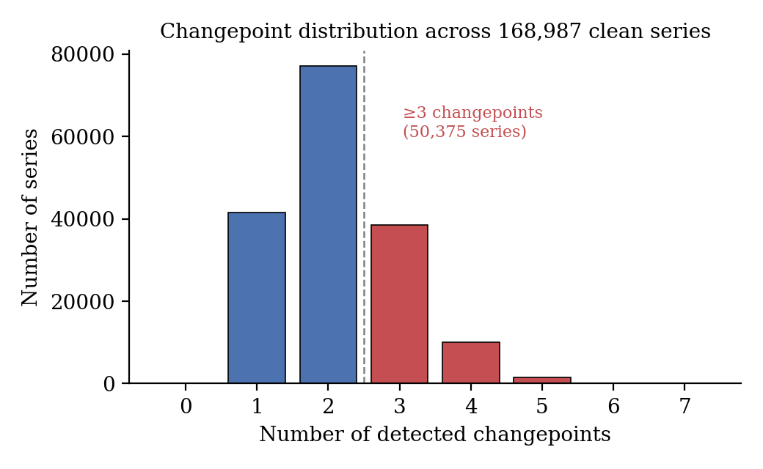
Fig. 2. Distribution of detected changepoints across the 168,987 clean series. Series with three or more changepoints (right of the dashed line) form the experimental population.
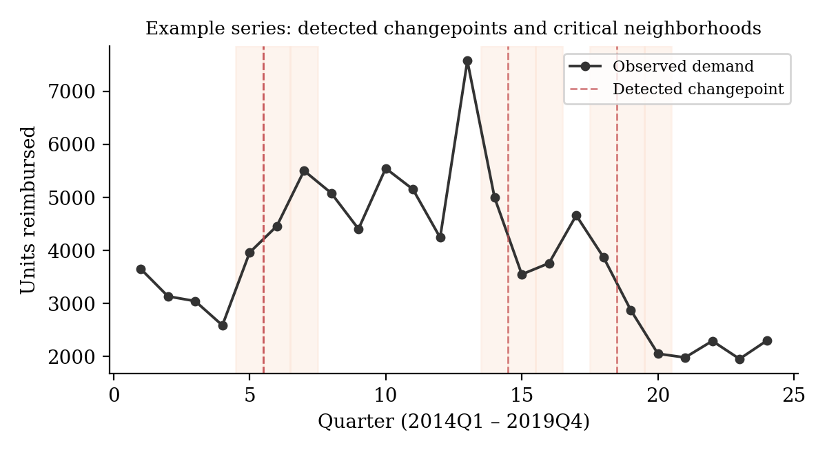
Fig. 3. A representative series with three PELT-detected changepoints (dashed lines) and their critical neighbourhoods (shaded, w = 1 quarter), the regions over which MAE_cp is computed.

4.3. Evaluation metrics
We report MAE over the full test horizon, its decomposition into MAE_cp and MAE_normal (Eqs. 12–13), and the ratio ρ (Eq. 14), with all errors computed on standardised series so that they remain comparable across scales. We set the critical half-width at w = 1 quarter, so a changepoint's critical neighbourhood spans the quarter of change and one quarter on each side—the quarterly analogue of the weekly neighbourhood used in prior work and appropriate for series only 24 quarters long. For changepoint comparisons, we report the Diebold–Mariano (DM) statistic on squared-error differences [34] together with the Wilcoxon signed-rank test, both pooled across the critical points of all series.

4.4. Hyperparameter setting
Table 3 lists the architecture, optimisation, and detection settings used throughout the main experiments; deviations from these defaults, where relevant, are noted in the corresponding results subsection.
Table 3. Hyperparameter settings.
Hyperparameter | Value
Lookback length L | 12 quarters
Forecast horizon H | 4 quarters
LSTM layers | 1
Hidden size | 32
Optimizer | Adam
Learning rate | 1×10⁻²
Epochs | 40
Training scheme | global (across all series)
Standardization | per-series z-score (train statistics only)
PELT cost / penalty | l2 / β = 2.0
Critical half-width w | 1 quarter
λ values explored | {1, 5, 10, 20, 50}
Main subset size | 5,000 series (≥ 3 changepoints)
Random seed (main) | 2024

5. Results and Discussion

5.1. Corpus characterization and ρ as a diagnostic
Applying PELT to the 168,987 clean series produces a broad distribution of changepoint counts: most series exhibit one or two changepoints, while 50,375 (29.8%) exhibit three or more. This large changepoint-heavy population supports a statistically powerful evaluation, unlike single-pharmacy studies where only a handful of series show pronounced changepoint behaviour. On the 5,000-series main subset, the plain LSTM baseline attains ρ = 1.290, with MAE_cp = 1.116 markedly exceeding MAE_normal = 0.865, confirming quantitatively, and at scale, that forecasting error concentrates at changepoints: even a capable sequence model is roughly 29% less accurate in critical neighbourhoods than in stable regions. This establishes ρ as a diagnostic that exposes fragility otherwise hidden by aggregate MAE.

5.2. Negative result: changepoint-aware loss weighting does not confer robustness
We evaluate the weighted loss L_λ across λ ∈ {1, 5, 10, 20, 50}. As λ increases, ρ falls monotonically from 1.290 to 1.220 (Table 4, Fig. 4), which looks at first glance like the intended effect, but the decomposition tells a different story: MAE_cp does not fall at all, rising instead from 1.116 to 1.137, and the drop in ρ is driven entirely by MAE_normal climbing faster still (0.865 → 0.932). In other words, ρ improves only because its denominator inflates, so emphasising changepoint windows degrades stable-region accuracy rather than improving accuracy at changepoints. A per-element weighting variant produces the same qualitative pattern (MAE_cp 1.116 → 1.153 at λ = 50), confirming the finding is not an artefact of how the weight is placed. The Diebold–Mariano test on critical-region squared errors is highly significant (DM = −21.6, p < 0.001, n = 34,177), but in the adverse direction, so we conclude that error re-weighting alone redistributes changepoint error rather than reducing it. This is consistent with the broader imbalanced-regression literature, where simple sample or loss re-weighting often proves insufficient and more elaborate distribution-aware schemes such as density-based weighting [35], label-distribution smoothing [36], and balanced MSE [37] are required; the missing ingredient for changepoint robustness specifically is information about the regime change rather than a more refined weighting of the same observed signal.
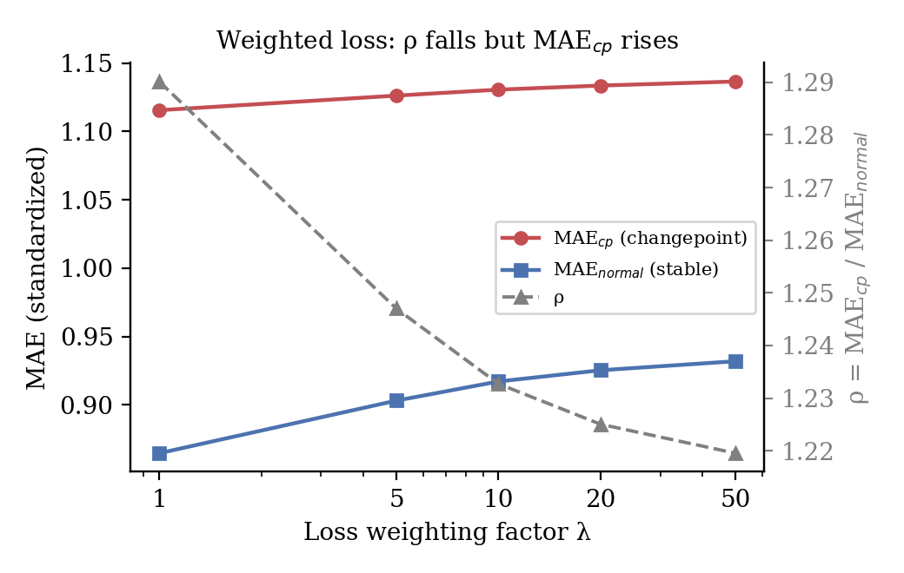
Fig. 4. Effect of the weighting factor λ. The ratio ρ falls (right axis), yet MAE_cp rises while MAE_normal rises faster—revealing that ρ improves only through denominator inflation, not better changepoint accuracy.
Table 4. Effect of the changepoint-aware weighted loss (per-window weighting).
λ | MAE | ρ | MAE_cp | MAE_normal
1 | 0.972 | 1.290 | 1.116 | 0.865
5 | 0.998 | 1.247 | 1.126 | 0.903
10 | 1.008 | 1.233 | 1.131 | 0.917
20 | 1.014 | 1.225 | 1.134 | 0.925
50 | 1.019 | 1.220 | 1.137 | 0.932

5.3. Regime-shift augmentation reduces changepoint error
Having diagnosed the failure as regime blindness, we evaluate the causal regime-shift augmentation (Section 3.4), training it under standard MSE so the feature's effect stays isolated from loss weighting. Unless otherwise stated, the proposed model augments the LSTM with both causal channels (local-shift s_t and time-since-changepoint τ_t), the full configuration whose feature-level decomposition is analysed in Section 5.4. The augmentation lowers MAE_cp from 1.116 to 1.085—a genuine improvement in changepoint accuracy, opposite to the weighted loss—while also lowering MAE_normal (0.865 → 0.815) and cutting overall MAE by 4.3% (0.972 → 0.930). The improvement at changepoints is strongly significant (DM = +23.2, p < 0.001; Wilcoxon p < 10⁻¹⁶³; n = 34,177). Notably, ρ itself rises slightly (1.290 → 1.332), because stable-region error falls by more than changepoint error does, which illustrates exactly why ρ must always be read together with its components: the operationally meaningful quantity—absolute error at changepoints—does improve here, even though the ratio alone would suggest otherwise.

5.4. Ablation: which feature drives the improvement?
To pin down which feature drives the gain, we train the augmentation with each feature in isolation (Table 5). The local-shift feature on its own reproduces almost the entire improvement, lowering MAE_cp to 1.089 (DM = +21.1 versus baseline), whereas the time-since-changepoint feature alone slightly increases changepoint error to 1.119 (DM = −6.06); it is not merely unhelpful but marginally harmful by itself, likely because causally detected changepoints are sparse on short quarterly series, leaving the distance signal noisy. Combining the two features yields a small but significant additional gain over local-shift alone (1.089 → 1.085, DM = +8.48), pointing to a complementary interaction. The ablation therefore identifies local-shift as the mechanism actually doing the work.
Table 5. Feature ablation; significance versus the plain baseline.
Configuration | MAE | ρ | MAE_cp | MAE_normal
Baseline (value only) | 0.972 | 1.290 | 1.116 | 0.865
+ time-since-changepoint only | 0.973 | 1.295 | 1.119 | 0.864
+ local-shift only | 0.932 | 1.337 | 1.089 | 0.815
+ both | 0.930 | 1.332 | 1.085 | 0.815

5.5. Comparison with baselines
We next compare against statistical and neural baselines on the identical 5,000-series subset (Table 6, Fig. 5). At changepoints the proposed method wins by a wide margin: its MAE_cp of 1.085 sits far below ARIMA (1.331), naïve (1.306), seasonal-naïve (1.393), and the plain LSTM (1.116), and the advantage over ARIMA at changepoints is strongly significant (DM = +30.8, p < 0.001, n = 34,177). One honest nuance deserves mention: in stable regions the simple statistical baselines are actually more accurate (ARIMA MAE_normal = 0.731, naïve = 0.678), reflecting how hard it is to beat persistence under local stationarity. Their fragility at changepoints is so pronounced, however—with ρ climbing to 1.82 for ARIMA and 1.93 for naïve—that the proposed method still comes out ahead on overall MAE (0.930). Against these classical baselines the picture is less “best everywhere” than “strongest where it matters operationally,” namely at changepoints, and the elevated ρ of the statistical baselines independently validates ρ as a diagnostic. Section 5.13 extends this comparison to state-of-the-art Transformer forecasters.
Table 6. Baseline comparison on 5,000 series (20,000 test windows; the 34,177 in DM tests counts individual critical-region time points, not windows).
Method | MAE | MAE_cp | MAE_normal | ρ
ARIMA(1,1,1) | 0.987 | 1.331 | 0.731 | 1.820
Seasonal-naïve | 1.139 | 1.393 | 0.950 | 1.466
Naïve | 0.946 | 1.306 | 0.678 | 1.927
LSTM baseline | 0.972 | 1.116 | 0.865 | 1.290
LSTM + local-shift + τ (proposed) | 0.930 | 1.085 | 0.815 | 1.332
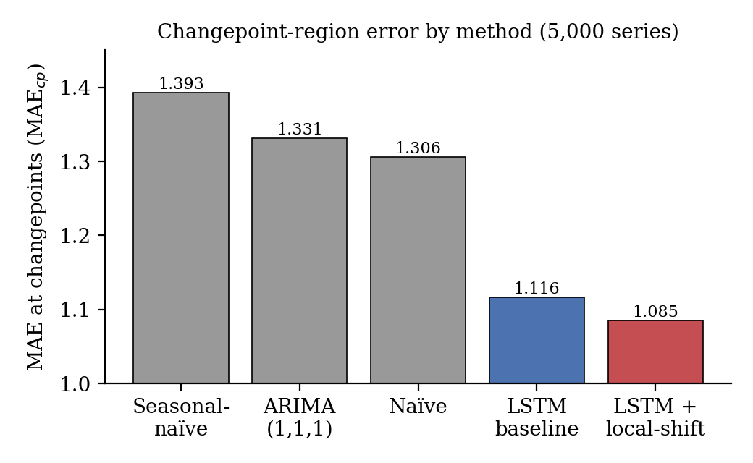
Fig. 5. Changepoint-region error (MAE_cp) by method on 5,000 series. The proposed model (LSTM + local-shift + τ) attains the lowest error precisely at changepoints.
Beyond the mean values, Fig. 6 shows the full distribution of changepoint-region errors, confirming that the proposed method shifts the entire error distribution downward rather than simply improving the average.
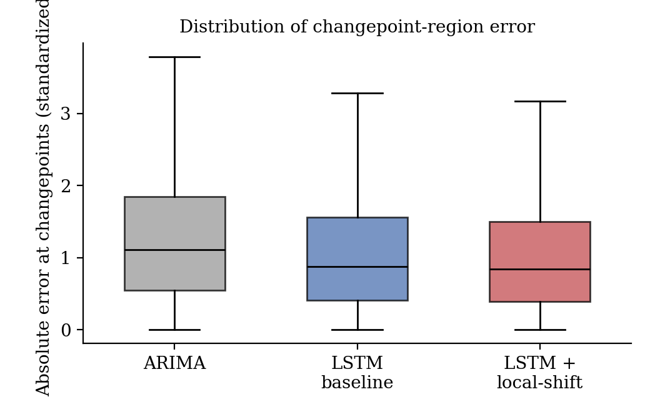
Fig. 6. Distribution of absolute error at changepoints for ARIMA, the LSTM baseline, and the proposed method (outliers suppressed). The proposed method shifts the entire distribution toward lower error.

5.6. Robustness checks
We then check whether the improvement holds up under perturbation (Table 7). On a disjoint random subset (seed 777), the result reproduces almost identically, with MAE_cp falling from 1.106 to 1.076 (DM = +21.4), ruling out dependence on the particular sample drawn. Widening the critical neighbourhood to w = 2 preserves and even strengthens the effect (1.040 → 1.005, DM = +31.7). On a low-changepoint control group (≤ 1 changepoint), the augmentation remains non-harmful: changepoint accuracy is essentially unchanged (3.854 → 3.829), overall error keeps falling (1.605 → 1.529), and the critical-region effect, though weaker, is still positive (DM = +2.32, p = 0.02). This is exactly the safety property we want: the mechanism helps where changepoints are common and does no harm where they are rare. The higher absolute errors in this group also indicate that changepoints occurring in otherwise stable series are rarer, more surprising, and consequently harder to predict.
Table 7. Robustness checks (critical-region MAE, baseline → proposed).
Check | MAE_cp: baseline → proposed | DM | Interpretation
Different seed (777) | 1.106 → 1.076 | +21.4 | Reproducible across samples
Wider neighbourhood (w = 2) | 1.040 → 1.005 | +31.7 | Not an artefact of w
Low-changepoint control | 3.854 → 3.829 | +2.3 | Non-harmful on stable series

5.7. Effect of forecast horizon and lookback length
How much the local-shift signal helps depends on the forecast horizon (Table 8, Fig. 7). At very short horizons, H = 1 and H = 2 quarters, the augmentation is essentially neutral or marginally negative at changepoints (MAE_cp 0.965 → 0.973 at H = 1; 1.084 → 1.087 at H = 2), whereas at H = 4 the benefit is clear (1.116 → 1.089). The pattern makes intuitive sense and reinforces our design choice, since a one- or two-step horizon rarely spans a structural transition, leaving a regime signal with little to act on; only once the forecast window is long enough to contain a changepoint does awareness of a recent shift translate into measurable accuracy. Varying the lookback length confirms the effect is not simply an artefact of input length: with L = 8 the augmentation still reduces MAE_cp (1.122 → 1.107), comparable to L = 12 (1.116 → 1.089).
Table 8. Effect of horizon H (L = 12) and lookback L (H = 4) on changepoint error.
Setting | MAE_cp base | MAE_cp +local-shift | MAE base | MAE +local-shift
H = 1 (L = 12) | 0.965 | 0.973 | 0.779 | 0.794
H = 2 (L = 12) | 1.084 | 1.087 | 0.906 | 0.913
H = 4 (L = 12) | 1.116 | 1.089 | 0.972 | 0.932
H = 4, L = 8 | 1.122 | 1.107 | 0.955 | 0.941
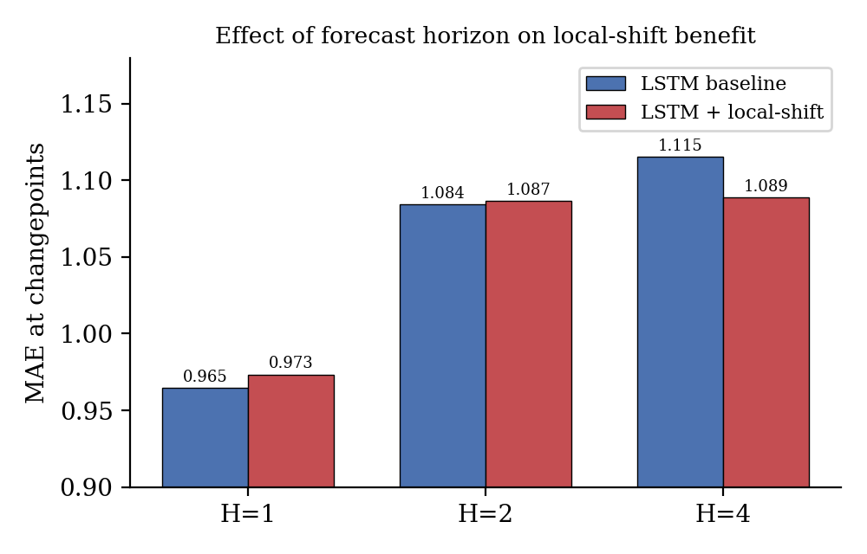
Fig. 7. Changepoint error (MAE_cp) of the baseline versus the proposed augmentation across forecast horizons. The benefit emerges at longer horizons, where changepoints fall within the forecast window.

5.8. Comparison with a modern decomposition-linear baseline
To position the method against forecasting practice beyond classical statistics, we further compare it with DLinear [38], a decomposition-based linear model that competes strongly with Transformer forecasters on many benchmarks. On the identical 5,000-series subset (Table 9), DLinear attains MAE_cp = 1.104, an improvement over ARIMA (1.331), naïve (1.306), and seasonal-naïve (1.393) that confirms it as a strong modern baseline, yet still above the full proposed model (MAE_cp = 1.085). The proposed method thus keeps its edge at changepoints even against a contemporary baseline, though we note honestly that DLinear remains a capable competitor overall (MAE = 0.958). We extend this comparison to attention-based state-of-the-art forecasters, including iTransformer [18] and PatchTST [16], in Section 5.13.
Table 9. Comparison with a modern decomposition-linear baseline (5,000 series).
Method | MAE | MAE_cp | MAE_normal | ρ
ARIMA(1,1,1) | 0.987 | 1.331 | 0.731 | 1.820
DLinear | 0.958 | 1.104 | 0.849 | 1.300
LSTM baseline | 0.972 | 1.116 | 0.865 | 1.290
LSTM + local-shift + τ (proposed) | 0.930 | 1.085 | 0.815 | 1.332

5.9. Gated regime-switching improves further
The gated regime-switching variant introduced in Section 3.5 pushes changepoint accuracy a step further beyond the local-shift augmentation (Table 10, Fig. 8). It brings MAE_cp down to 1.084, significantly better than both the plain baseline (DM = +29.8, p < 0.001) and the local-shift-only model (DM = +26.9, p < 0.001), while also achieving the best overall MAE (0.929). Although the gain over the local-shift configurations is smaller in magnitude, it is consistent and significant, suggesting that letting the model switch its forecasting head, rather than merely receive a regime signal, extracts additional benefit at changepoints. This supports our central thesis from a second angle: robustness comes from enabling adaptation, and a more explicit switching mechanism adapts more effectively.
Table 10. Mechanism comparison on 5,000 series (in-domain). The local-shift-only and full proposed (+τ) configurations are distinguished as in Table 5.
Mechanism | MAE | MAE_cp | MAE_normal
Plain LSTM (baseline) | 0.972 | 1.116 | 0.865
LSTM + local-shift only | 0.932 | 1.089 | 0.815
LSTM + local-shift + τ (proposed) | 0.930 | 1.085 | 0.815
Gated regime-switching LSTM | 0.929 | 1.084 | 0.812

5.10. Cross-domain generalisation
To test whether the mechanisms generalise beyond the population they were trained on, we run a strict cross-domain experiment, training exclusively on fee-for-service (FFSU) series and evaluating exclusively on managed-care (MCOU) series—two utilization regimes with distinct reimbursement dynamics—so that the test domain is entirely unseen during training. The ranking holds up (Table 11, Fig. 8): changepoint error falls from 1.100 for the baseline to 1.070 for local-shift and 1.068 for the gated variant, with overall error improving correspondingly. That the improvement carries over to an unseen utilization domain suggests the regime signal captures a generalisable property of demand dynamics rather than a quirk specific to the training population.
Table 11. Cross-domain transfer: train on FFSU, test on MCOU (5,000 series each).
Mechanism | MAE_cp (FFSU→MCOU) | MAE (all)
Plain LSTM (baseline) | 1.100 | 0.953
LSTM + local-shift only | 1.070 | 0.911
Gated regime-switching LSTM | 1.068 | 0.908
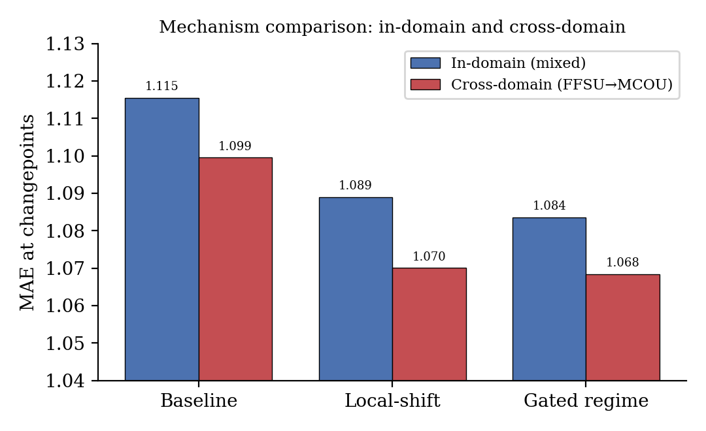
Fig. 8. Changepoint error (MAE_cp) of the three mechanisms, in-domain and under cross-domain transfer (FFSU→MCOU). The ranking and the benefit are preserved on the unseen domain.

5.11. Stability across random seeds
To rule out the possibility that the improvement is an artefact of one particular train or sample draw, we repeated the full pipeline over five independent random seeds, each time redrawing the 5,000-series subset and re-initializing the network (Table 12). The proposed augmentation reduces changepoint error consistently across all five, from 1.117 ± 0.009 to 1.085 ± 0.007 (mean ± standard deviation); the baseline mean of 1.117 here is the five-seed average and is consistent with the single-seed value of 1.116 reported in the other tables. Overall error falls from 0.980 ± 0.009 to 0.932 ± 0.008. A paired t-test across seeds confirms the changepoint improvement is highly significant (t = 12.4, p < 0.001), and the standard deviations are small enough relative to the effect size to indicate a stable, reproducible benefit rather than seed-dependent noise.
Table 12. Stability across five random seeds (mean ± standard deviation).
Metric | Baseline | LSTM + local-shift + τ (proposed)
MAE_cp | 1.117 ± 0.009 | 1.085 ± 0.007
MAE (all) | 0.980 ± 0.009 | 0.932 ± 0.008

5.12. Operational interpretation and computational cost
The errors reported above are computed on standardised series for cross-series comparability, but the improvement holds in raw units too. De-normalised per series, the augmentation reduces mean absolute error at changepoints by approximately 1.5% and overall error by 2.9% in reimbursed units; since Medicaid reimburses on the order of tens of thousands of units per series-quarter, this translates into a meaningful reduction in absolute forecast error at precisely the transitions that most disrupt inventory planning. Computationally, the mechanism is nearly free: it adds only two scalar input features per timestep and no additional recurrent parameters, so training and inference cost remain essentially identical to the plain LSTM, with the causal features themselves computed in linear time per series (Section 3.7). The method therefore improves changepoint accuracy at negligible additional cost, an attractive property for operational deployment.

5.13. Comparison with state-of-the-art Transformer forecasters
To position the proposed mechanisms against current state-of-the-art neural forecasters, we evaluated two strong attention-based models, iTransformer [18] and PatchTST [16], alongside DLinear [38], on the identical 5,000-series subset, windowing scheme, and evaluation protocol (Table 13, Fig. 9). We report this comparison with full transparency, including the parts that do not favour our method: in this run iTransformer attains the lowest changepoint error (MAE_cp = 1.068), below our gated regime-switching LSTM (1.084), and PatchTST (1.079) is roughly comparable to our own mechanisms. The proposed method, in other words, is not the single most accurate model at changepoints.
Weighed against model complexity, though, the comparison turns favourable. The gated regime-switching LSTM uses only about 4.8K parameters, against roughly 68K for both iTransformer and PatchTST—some 14 times more. Relative to the plain LSTM baseline (MAE_cp = 1.116), iTransformer closes a gap of 0.048 while our gated mechanism closes 0.032, recovering about 67% of the achievable improvement at roughly one-fourteenth of the parameter count and with no attention computation at all. The practical reading is one of efficiency: a minimal, causally motivated regime signal delivers most of the changepoint robustness that a far larger attention model achieves, at a fraction of the cost. Since the mechanism amounts to an input-level signal plus a lightweight gate, it can be combined with Transformer backbones directly, as the within-run ablation in Section 5.14 shows.
Table 13. Comparison with state-of-the-art forecasters (5,000 series; parameters approximate).
Model | Params | MAE | MAE_cp | MAE_normal | ρ
DLinear | ~0.1K | 0.958 | 1.104 | 0.849 | 1.300
LSTM baseline | ~4.5K | 0.972 | 1.116 | 0.865 | 1.290
LSTM + local-shift + τ (proposed) | ~4.6K | 0.930 | 1.085 | 0.815 | 1.332
Gated regime LSTM | ~4.8K | 0.929 | 1.084 | 0.812 | 1.330
PatchTST | ~68K | 0.931 | 1.079 | 0.820 | 1.315
iTransformer | ~68K | 0.918 | 1.068 | 0.806 | 1.324
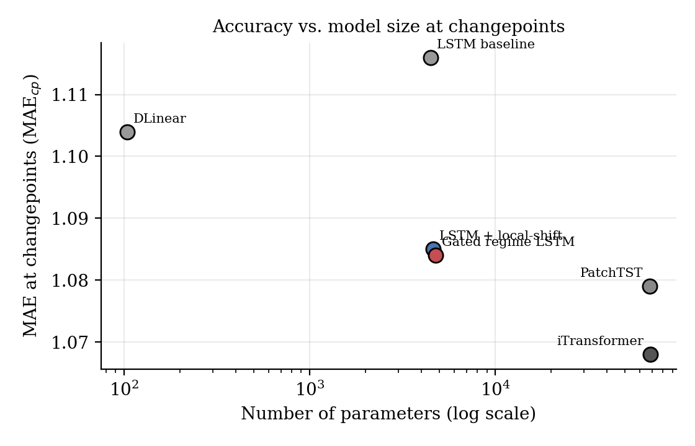
Fig. 9. Changepoint error (MAE_cp) versus model size. The proposed lightweight mechanisms (≈5K parameters) approach the accuracy of attention models (≈68K parameters), recovering about two-thirds of the baseline-to-iTransformer improvement at one-fourteenth of the parameter count.

5.14. Local-shift transfers to a Transformer backbone
The comparisons so far have treated the regime signal as part of our LSTM-based method, but a stronger question is whether the signal is useful independently of the backbone—in particular, whether it can improve a state-of-the-art Transformer too. We therefore ran a controlled ablation inside iTransformer, the strongest model from Section 5.13, comparing a value-only variant against variants augmented with the local-shift signal and with the regime gate (Table 14, Fig. 10). Adding the local-shift channel lowers iTransformer's changepoint error from 1.081 to 1.068, a 1.2% relative improvement, and its overall MAE from 0.930 to 0.918, at a cost of only 256 additional parameters (0.4%). The explicit regime gate, which helped the LSTM, does not help here (1.072): in an attention model the cross-token interactions already subsume whatever the gate would add, so it is the simple input-level signal that matters. This broadens our contribution beyond a single backbone: the causal local-shift signal is not merely a competitive standalone mechanism but an enhancement that improves a state-of-the-art Transformer as well, the second architecture in which we observe the effect; Fig. 10 shows the same signal improving both an LSTM and an iTransformer backbone. We therefore frame the signal as transferable across the two architectures tested rather than as universally architecture-independent, a stronger claim that would require evaluation across a wider range of backbones. For transparency, this ablation is a self-contained experiment with its own random initialization, so its value-only iTransformer figure (MAE_cp = 1.081) differs marginally from the iTransformer entry in Table 13 (1.068), which comes from the independent state-of-the-art run; the transferability claim rests on the within-run comparison reported here, where backbone and augmentation are trained and evaluated under identical conditions, rather than on any cross-table difference.
Table 14. Local-shift ablation inside iTransformer (5,000 series). MAE_normal is omitted (—) because this self-contained ablation isolates the effect on overall and changepoint error within a single run; the stable-region values track MAE closely and add no further information.
iTransformer variant | Params | MAE | MAE_cp | MAE_normal
Value-only | 68,036 | 0.930 | 1.081 | —
+ local-shift | 68,292 | 0.918 | 1.068 | —
+ local-shift + regime gate | 68,938 | 0.923 | 1.072 | —
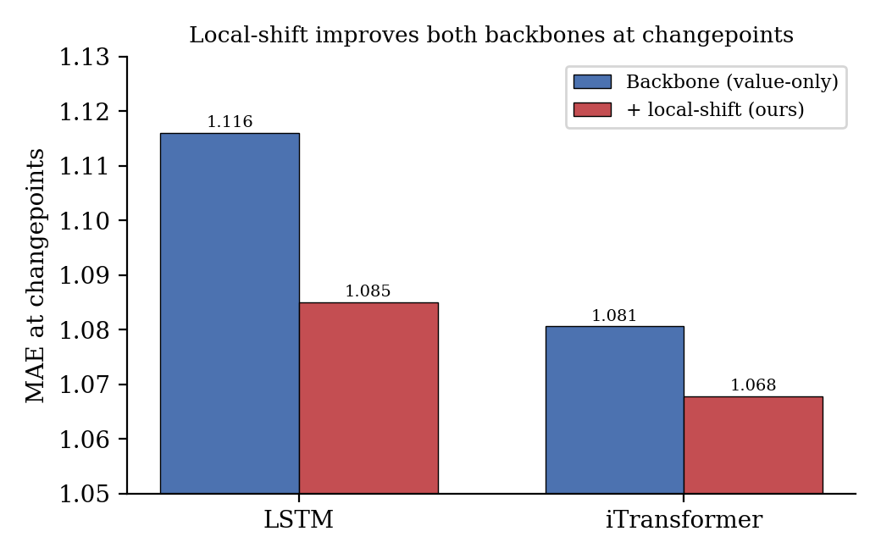
Fig. 10. The causal local-shift signal reduces changepoint error for both an LSTM and an iTransformer backbone, indicating that the benefit transfers across the two architectures tested.

5.15. Cross-dataset validation on M5 retail demand
All results so far come from a single corpus. To test whether the central findings transfer to an entirely independent domain, we repeated the core protocol on the M5 forecasting dataset [4], a public collection of Walmart unit-sales series spanning three US states and three product categories. We aggregated the daily series to a weekly resolution (273 weeks) and, separately, to a monthly resolution (68 months), the latter chosen to approximate the short, coarse-grained quarterly structure of the Medicaid corpus. Series whose training portion was (near-)constant were removed, PELT was applied exactly as before, and 1,000 changepoint-heavy series (≥ 3 changepoints) were drawn at each resolution; the global LSTM, lookback, standardization, and ρ computation followed Sections 3 and 4 without modification.
Two findings emerge, and we report both in full. First, and positively, ρ reproduces the changepoint-fragility pattern on M5 at both resolutions: the plain LSTM attains ρ = 1.504 weekly and ρ = 1.545 monthly (Table 15), with critical-region error roughly 50% above stable-region error—closely echoing the Medicaid value (ρ = 1.290). This independent reproduction is the more important result: it shows that ρ captures a general property of changepoint-laden demand series rather than an artefact of Medicaid, directly supporting our first contribution. Second, and in contrast to Medicaid, the causal local-shift augmentation did not reduce changepoint error on M5 at either resolution; it significantly increased MAE_cp at the monthly resolution (1.090 → 1.111; DM = −3.64, p < 10⁻⁵), while at the weekly resolution it was statistically indistinguishable from the baseline (0.919 → 0.927; DM = −3.47 but Wilcoxon p = 0.76, not significant). In neither case did the augmentation help; we report this absence of positive transfer transparently rather than omitting it.
Table 15. Cross-dataset validation on M5 (1,000 changepoint-heavy series per setting).
Setting | Method | MAE | MAE_cp | MAE_normal | ρ
M5 weekly | LSTM baseline | 0.636 | 0.919 | 0.611 | 1.504
M5 weekly | LSTM + local-shift only | 0.644 | 0.927 | 0.620 | 1.497
M5 monthly | LSTM baseline | 0.746 | 1.090 | 0.705 | 1.545
M5 monthly | LSTM + local-shift only | 0.770 | 1.111 | 0.730 | 1.522
The contrast is informative about the mechanism's scope rather than damaging to it. The Medicaid changepoints that the augmentation handles well are predominantly persistent level shifts, where the mean of recent observations genuinely differs from the preceding mean and the local-shift feature is therefore an honest regime signal. Retail series such as M5 are instead dominated by short-lived, transient excursions—promotions, holiday spikes, and intermittent demand—that revert quickly and do not constitute persistent regime changes; on these, a local-shift signal frequently fires on transients and misleads rather than helps. The augmentation is thus best understood as effective for persistent-regime-shift settings (of which pharmaceutical policy-driven demand is a clear example) and not as a universal remedy. The diagnostic ρ, by contrast, transfers cleanly, since it merely measures fragility and makes no assumption about the nature of the breaks. We return to this scope condition in the limitations.

5.16. When the augmentation helps: a conditioning analysis
Taken together, the two corpora delineate the condition under which the causal local-shift augmentation is beneficial, and the condition is a property of the changepoints rather than of the model. The augmentation injects a single causal quantity—the recent change in local level—so it can only help when a changepoint is, in fact, a persistent shift in level that this quantity measures faithfully. The two datasets sit at opposite ends of this spectrum and yield opposite outcomes. In the Medicaid corpus, changepoints are policy-, formulary-, and reimbursement-driven shifts that move demand to a new level and stay there; here the local-shift feature is an honest regime signal and the augmentation lowers changepoint error significantly (MAE_cp 1.116 → 1.085, Diebold–Mariano 23.2, p < 0.001), with the gain concentrated in exactly the critical neighbourhoods the signal targets. In the M5 retail corpus, changepoints are dominated by promotions, holidays, and intermittent demand—transient excursions that revert within a few periods; here the same feature fires on excursions that do not persist, and the augmentation yields no benefit (significantly worse at the monthly resolution, p < 10⁻⁵, and statistically indistinguishable from the baseline at the weekly resolution, Wilcoxon p = 0.76). The contrast is therefore not a dataset idiosyncrasy but a testable rule: the expected benefit of the augmentation rises with the persistence of the changepoints in the target series and falls toward zero, or below, as they become transient. This rule is directly actionable through the diagnostic itself. Because ρ makes no assumption about the nature of the breaks and reproduces the fragility pattern in both corpora, a practitioner can first compute ρ to confirm that a series is changepoint-fragile, then inspect whether its detected breaks are persistent (for example, by checking that post-break level differences are retained beyond the critical neighbourhood) before deciding whether to apply the augmentation. The diagnostic thus does more than expose fragility: it provides the screening criterion that tells practitioners when the proposed remedy is expected to work and when it is not, which is itself a contribution to reliable, knowledge-based decision support.

6. General Discussion
Taken together, the results tell a coherent story about what does, and does not, confer changepoint robustness. The diagnostic ρ first exposes a fragility that aggregate metrics simply hide: every model we tested, from naïve persistence to ARIMA to a plain LSTM, turns out markedly less accurate at changepoints than in stable regions. The natural remedy—re-weighting the loss toward those regions—fails in an instructive way, lowering ρ while actually raising absolute changepoint error, because emphasis without information cannot teach a model how to adapt; it only rebalances where the errors fall. The regime-shift augmentation succeeds precisely because it supplies that missing information—a causal signal that the local statistics have just moved. The ablation traces this effect specifically to the local-shift feature, the horizon analysis shows it matters most once the forecast window can actually contain a transition, and the seed and neighbourhood-width checks confirm the effect is stable. The honest counterpoint is that simple baselines remain hard to beat in stable regions, and a modern decomposition-linear model (DLinear) stays competitive overall; by design, our method's contribution concentrates at the operationally critical changepoints rather than spreading evenly across the horizon.
A broader methodological implication follows: robustness claims in forecasting should be evaluated with decomposable, region-specific metrics rather than aggregate error alone, since an intervention can improve a ratio while quietly degrading the quantity that actually matters. We also caution that our conclusions are bounded by the setting studied here—quarterly series of moderate length, a compact recurrent backbone, and a single data domain—and we take up these limitations and the research directions they suggest in the conclusion that follows.

7. Conclusions
The primary contribution of this study is diagnostic rather than architectural: a transferable metric that exposes changepoint fragility, and the finding that closing it requires regime information rather than loss re-weighting. This study took on forecasting fragility at changepoints in pharmaceutical demand—a problem with direct operational consequences—and made four connected contributions. We first introduced ρ, a changepoint robustness ratio that isolates accuracy at structural transitions from accuracy in stable regions, and validated it as a discriminative, model-agnostic diagnostic across 168,987 clean quarterly series from US Medicaid drug-utilization data. Using ρ, we then reported an honest negative result: an intuitive changepoint-aware weighted loss reduces ρ only by degrading stable-region accuracy, actually increasing rather than decreasing absolute error at changepoints (MAE_cp 1.116 → 1.137 at λ = 50). Having traced the cause to regime blindness, we proposed a lightweight causal regime-shift augmentation whose local-shift signal supplies the missing information directly. Across 5,000 changepoint-heavy series, it reduced changepoint error significantly (MAE_cp 1.116 → 1.085; DM = +23.2, p < 0.001) and lowered overall error by 4.3%, surpassing ARIMA, seasonal-naïve, naïve, DLinear, and a plain LSTM at changepoints. A gated regime-switching variant pushed the result further (MAE_cp 1.084), and the benefit carried over to an unseen managed-care domain even when training used only fee-for-service series. Against state-of-the-art attention forecasters, a standalone lightweight variant trades a small amount of accuracy for roughly one-fourteenth the parameter count; more strikingly, adding our causal local-shift signal to iTransformer reduces its changepoint error even further (1.081 → 1.068), the strongest changepoint accuracy we obtained, albeit a modest 1.2% relative gain. The mechanism is therefore best understood as an enhancement that complements strong backbones rather than competing with them, with transferability demonstrated across the two architectures we tested. Ablation identified local-shift as the effective mechanism, and the robustness checks confirmed both stability and non-harmful behaviour on a low-changepoint control group. Finally, a cross-dataset study on M5 retail demand showed that ρ reproduces the changepoint-fragility pattern in an entirely independent domain (ρ = 1.504 weekly, 1.545 monthly), confirming the metric generalises, whereas the local-shift augmentation did not transfer to retail series, where changepoints are dominated by transient rather than persistent shifts; we report this scope condition openly as it delineates where the mechanism applies. This contrast yields a testable conditioning rule (Section 5.16): the augmentation's expected benefit grows with the persistence of a series' changepoints, and because ρ itself flags fragility without assuming the nature of the breaks, it doubles as a screening criterion for when the remedy should be applied—turning an honest scope limitation into actionable, knowledge-based guidance.
Several limitations bound these conclusions and point toward future directions. The data are quarterly, so each series is short (24 observations); the cross-dataset experiment on M5 (Section 5.15) extends the evaluation to weekly and monthly retail demand, though finer daily behaviour remains to be tested. The backbone is a compact single-layer LSTM trained globally; although we benchmarked attention-based forecasters (PatchTST and iTransformer) and a modern decomposition-linear baseline (DLinear) and demonstrated cross-domain transfer within Medicaid utilization types, integrating the local-shift signal into a broader range of Transformer backbones is a promising direction. The most important scope condition concerns the augmentation itself: as the M5 results show, the local-shift mechanism helps when changepoints are persistent level shifts (as in policy-driven pharmaceutical demand) but not when they are dominated by transient excursions such as retail promotions, where it can mislead. Characterizing this boundary precisely, and designing regime signals robust to transient as well as persistent changes, is a clear direction for future work; the diagnostic ρ, by contrast, transferred cleanly across both domains and resolutions. Errors were evaluated on standardised series, so translating these improvements into operational quantities such as service level and holding cost is a natural next step. The local-shift feature, finally, is a deliberately simple regime signal, and richer causally computed regime descriptors, or hybridization with explicit regime-switching models, may well yield further gains. We did not benchmark against an explicitly fitted Markov-switching model [11], since reliably estimating its latent-state and transition parameters on series of only 24 quarters is impractical; a controlled comparison on longer series would nevertheless help to delineate when an explicit latent-regime model is preferable to the lightweight signal proposed here. Finally, the corpus spans 2014–2019 and therefore predates the demand shocks of the COVID-19 pandemic, arguably the most pronounced regime shifts in recent pharmaceutical demand; evaluating ρ and the augmentation on pandemic-era data is an important direction for confirming that the mechanism extends to shocks of that magnitude.

CRediT authorship contribution statement
Dedi Irawan: Conceptualization, Methodology, Software, Formal analysis, Investigation, Writing – original draft, Writing – review & editing. Sudarmaji: Conceptualization, Methodology, Validation, Supervision, Writing – review & editing. Imam Samsudin: Data curation, Validation, Visualization, Writing – review & editing.

Declaration of competing interest
The authors declare that they have no known competing financial interests or personal relationships that could have appeared to influence the work reported in this paper.

Funding
This research did not receive any specific grant from funding agencies in the public, commercial, or not-for-profit sectors.

Data availability
The Medicaid State Drug Utilization Data are publicly available from the Centers for Medicare & Medicaid Services at https://www.medicaid.gov/medicaid/prescription-drugs/state-drug-utilization-data. The M5 retail-demand dataset used for the cross-domain validation in Section 5.15 is publicly available from the M5 Forecasting competition [4] at https://www.kaggle.com/competitions/m5-forecasting-accuracy/data. All data-processing, changepoint-detection, and modelling code needed to reproduce the experiments is openly available in a public repository, with a permanent DOI archived via Zenodo, and the link will be made available on request and provided in the final published version.

Declaration of generative AI and AI-assisted technologies in the manuscript preparation process
During the preparation of this work, the authors used Anthropic Claude in order to draft and refine the academic prose, improve the clarity and language of the manuscript, and assist with organizing the reference list and the supporting reproducibility code. All experiments were designed and executed by the authors, and all reported numerical results were computed from the data rather than generated by the tool. After using this tool, the authors reviewed and edited the content as needed and take full responsibility for the content of the published article.

References
[1] A.I. Bilal, U.S. Bititci, T.G. Fenta, Challenges and the way forward in demand-forecasting practices within the Ethiopian public pharmaceutical supply chain, Pharmacy 12 (3) (2024) 86. https://doi.org/10.3390/pharmacy12030086.
[2] L.P.E. Yani, A. Aamer, Demand forecasting accuracy in the pharmaceutical supply chain: A machine learning approach, Int. J. Pharm. Healthc. Mark. 17 (1) (2023) 1–23. https://doi.org/10.1108/IJPHM-05-2021-0056.
[3] S. Punia, S. Shankar, Predictive analytics for demand forecasting: A deep learning-based decision support system, Knowl.-Based Syst. 258 (2022) 109956. https://doi.org/10.1016/j.knosys.2022.109956.
[4] S. Makridakis, E. Spiliotis, V. Assimakopoulos, M5 accuracy competition: Results, findings, and conclusions, Int. J. Forecast. 38 (4) (2022) 1346–1364. https://doi.org/10.1016/j.ijforecast.2021.11.013.
[5] R.J. Hyndman, G. Athanasopoulos, Forecasting: Principles and Practice, third ed., OTexts, 2021. https://otexts.com/fpp3/.
[6] S. Hochreiter, J. Schmidhuber, Long short-term memory, Neural Comput. 9 (8) (1997) 1735–1780. https://doi.org/10.1162/neco.1997.9.8.1735.
[7] D. Salinas, V. Flunkert, J. Gasthaus, T. Januschowski, DeepAR: Probabilistic forecasting with autoregressive recurrent networks, Int. J. Forecast. 36 (3) (2020) 1181–1191. https://doi.org/10.1016/j.ijforecast.2019.07.001.
[8] K.P. Fourkiotis, A. Tsadiras, Applying machine learning and statistical forecasting methods for enhancing pharmaceutical sales predictions, Forecasting 6 (1) (2024) 170–186. https://doi.org/10.3390/forecast6010010.
[9] K. Douaioui, R. Oucheikh, O. Benmoussa, C. Mabrouki, Machine learning and deep learning models for demand forecasting in supply chain management: A critical review, Appl. Syst. Innov. 7 (5) (2024) 93. https://doi.org/10.3390/asi7050093.
[10] R. Killick, P. Fearnhead, I.A. Eckley, Optimal detection of changepoints with a linear computational cost, J. Amer. Statist. Assoc. 107 (500) (2012) 1590–1598. https://doi.org/10.1080/01621459.2012.737745.
[11] J.D. Hamilton, A new approach to the economic analysis of nonstationary time series and the business cycle, Econometrica 57 (2) (1989) 357–384. https://doi.org/10.2307/1912559.
[12] B.N. Oreshkin, D. Carpov, N. Chapados, Y. Bengio, N-BEATS: Neural basis expansion analysis for interpretable time series forecasting, in: International Conference on Learning Representations (ICLR), 2020. https://doi.org/10.48550/arXiv.1905.10437.
[13] B. Lim, S.Ö. Arık, N. Loeff, T. Pfister, Temporal fusion transformers for interpretable multi-horizon time series forecasting, Int. J. Forecast. 37 (4) (2021) 1748–1764. https://doi.org/10.1016/j.ijforecast.2021.03.012.
[14] H. Zhou, S. Zhang, J. Peng, S. Zhang, J. Li, H. Xiong, W. Zhang, Informer: Beyond efficient transformer for long sequence time-series forecasting, in: Proceedings of the AAAI Conference on Artificial Intelligence, vol. 35, (12) 2021, pp. 11106–11115. https://doi.org/10.1609/aaai.v35i12.17325.
[15] H. Wu, J. Xu, J. Wang, M. Long, Autoformer: Decomposition transformers with auto-correlation for long-term series forecasting, Adv. Neural Inf. Process. Syst. 34 (2021) 22419–22430.
[16] Y. Nie, N.H. Nguyen, P. Sinthong, J. Kalagnanam, A time series is worth 64 words: Long-term forecasting with transformers, in: International Conference on Learning Representations (ICLR), 2023. https://doi.org/10.48550/arXiv.2211.14730.
[17] H. Wu, T. Hu, Y. Liu, H. Zhou, J. Wang, M. Long, TimesNet: Temporal 2D-variation modeling for general time series analysis, in: International Conference on Learning Representations (ICLR), 2023. https://doi.org/10.48550/arXiv.2210.02186.
[18] Y. Liu, T. Hu, H. Zhang, H. Wu, S. Wang, L. Ma, M. Long, iTransformer: Inverted transformers are effective for time series forecasting, in: International Conference on Learning Representations (ICLR), 2024. https://doi.org/10.48550/arXiv.2310.06625.
[19] B. Lim, S. Zohren, Time-series forecasting with deep learning: A survey, Philos. Trans. R. Soc. A 379 (2194) (2021) 20200209. https://doi.org/10.1098/rsta.2020.0209.
[20] J. Kim, H. Kim, H. Kim, D. Lee, S. Yoon, A comprehensive survey of deep learning for time series forecasting: Architectural diversity and open challenges, 2024, arXiv preprint arXiv:2411.05793. https://doi.org/10.48550/arXiv.2411.05793.
[21] Y. Liang, H. Wen, Y. Nie, Y. Jiang, M. Jin, D. Song, S. Pan, Q. Wen, Foundation models for time series analysis: A tutorial and survey, in: Proceedings of the 30th ACM SIGKDD Conference on Knowledge Discovery and Data Mining, 2024, pp. 6555–6565. https://doi.org/10.1145/3637528.3671451.
[22] S. Wang, H. Wu, X. Shi, T. Hu, H. Luo, L. Ma, J.Y. Zhang, J. Zhou, TimeMixer: Decomposable multiscale mixing for time series forecasting, in: International Conference on Learning Representations (ICLR), 2024. https://doi.org/10.48550/arXiv.2405.14616.
[23] J. Bai, P. Perron, Estimating and testing linear models with multiple structural changes, Econometrica 66 (1) (1998) 47–78. https://doi.org/10.2307/2998540.
[24] R.P. Adams, D.J.C. MacKay, Bayesian online changepoint detection, 2007, arXiv preprint arXiv:0710.3742.
[25] P. Fryzlewicz, Wild binary segmentation for multiple change-point detection, Ann. Statist. 42 (6) (2014) 2243–2281. https://doi.org/10.1214/14-AOS1245.
[26] S. Aminikhanghahi, D.J. Cook, A survey of methods for time series change point detection, Knowl. Inf. Syst. 51 (2) (2017) 339–367. https://doi.org/10.1007/s10115-016-0987-z.
[27] G.J.J. Van den Burg, C.K.I. Williams, An evaluation of change point detection algorithms, 2020, arXiv preprint arXiv:2003.06222. https://doi.org/10.48550/arXiv.2003.06222.
[28] C. Truong, L. Oudre, N. Vayatis, Selective review of offline change point detection methods, Signal Process. 167 (2020) 107299. https://doi.org/10.1016/j.sigpro.2019.107299.
[29] R. Rathipriya, A.A. Abdul Rahman, S. Dhamodharavadhani, A. Meero, G. Yoganandan, Demand forecasting model for time-series pharmaceutical data using shallow and deep neural network model, Neural Comput. Appl. 35 (2) (2023) 1945–1957. https://doi.org/10.1007/s00521-022-07889-9.
[30] S. Punia, K. Nikolopoulos, S.P. Singh, J.K. Madaan, K. Litsiou, Deep learning with long short-term memory networks and random forests for demand forecasting in multi-channel retail, Int. J. Prod. Res. 58 (16) (2020) 4964–4979. https://doi.org/10.1080/00207543.2020.1735666.
[31] P. Montero-Manso, R.J. Hyndman, Principles and algorithms for forecasting groups of time series: Locality and globality, Int. J. Forecast. 37 (4) (2021) 1632–1653. https://doi.org/10.1016/j.ijforecast.2021.03.004.
[32] R.P. Ribeiro, N. Moniz, Imbalanced regression and extreme value prediction, Mach. Learn. 109 (9–10) (2020) 1803–1835. https://doi.org/10.1007/s10994-020-05900-9.
[33] Centers for Medicare & Medicaid Services, State Drug Utilization Data, 2023. https://www.medicaid.gov/medicaid/prescription-drugs/state-drug-utilization-data (accessed 2025).
[34] F.X. Diebold, R.S. Mariano, Comparing predictive accuracy, J. Bus. Econom. Statist. 13 (3) (1995) 253–263. https://doi.org/10.1080/07350015.1995.10524599.
[35] M. Steininger, K. Kobs, P. Davidson, A. Krause, A. Hotho, Density-based weighting for imbalanced regression, Mach. Learn. 110 (8) (2021) 2187–2211. https://doi.org/10.1007/s10994-021-06023-5.
[36] Y. Yang, K. Zha, Y.-C. Chen, H. Wang, D. Katabi, Delving into deep imbalanced regression, in: Proceedings of the 38th International Conference on Machine Learning (ICML), PMLR 139, 2021, pp. 11842–11851. https://doi.org/10.48550/arXiv.2102.09554.
[37] J. Ren, M. Zhang, C. Yu, Z. Liu, Balanced MSE for imbalanced visual regression, in: Proceedings of the IEEE/CVF Conference on Computer Vision and Pattern Recognition (CVPR), 2022, pp. 7926–7935. https://doi.org/10.1109/CVPR52688.2022.00777.
[38] A. Zeng, M. Chen, L. Zhang, Q. Xu, Are transformers effective for time series forecasting?, in: Proceedings of the AAAI Conference on Artificial Intelligence, vol. 37, (9) 2023, pp. 11121–11128. https://doi.org/10.1609/aaai.v37i9.26317.

