Dedipya Goswami

AP21110010650

BTECH CSE-J

COMPUTER ORGANIZATION AND ARCHITECTURE LAB

PRACTICAL PROGRAMS

**1. Print a single character on screen**

.model small

org 100h

.data

.code

main proc

mov dl,'A'

mov ah,2

int 21h

mov ah,4ch

int 21h

main endp

end main

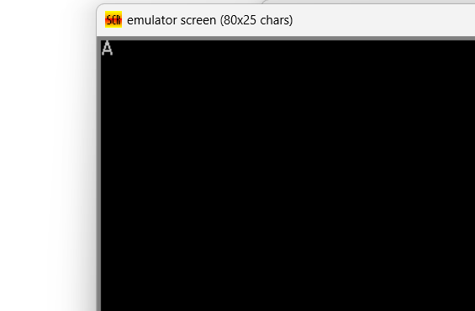

2.Write a program to write Hello World

org 100h

mov dx,offset message

mov ah,09h

int 21h

endp

message db "Hello World$"

end main

ret

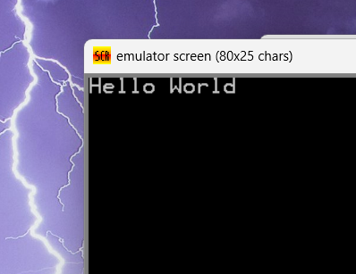

3. Write a program to print single charater and multiple charaters on screen

.model small

.data

.code

main proc

mov dl,"s"

mov ah,2

mov ah,4ch

int 21h

main endp

end main

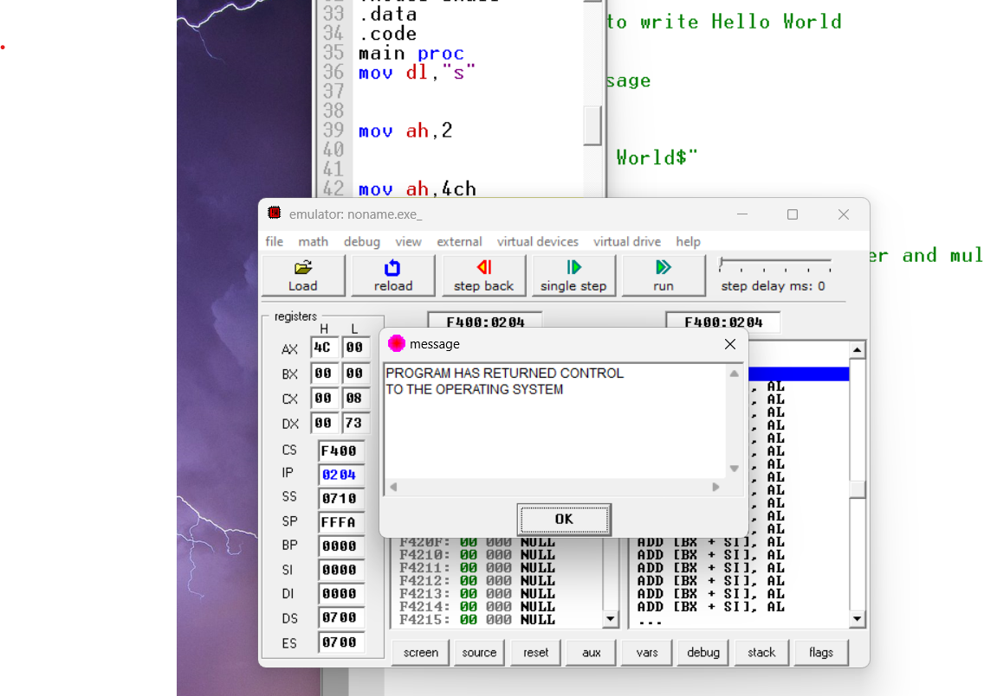

4.Multiple characters using naive method

.model small

.data

.code

main proc

mov dl,"p"

mov ah,2

int 21h

mov dl,"i"

mov ah,2

int 21h

mov dl,"n"

mov ah,2

int 21h

mov dl,"k"

mov ah,2

int 21h

mov dl,"m"

mov ah,2

int 21h

mov dl,"n"

mov ah,2

int 21h

mov ah,4ch

int 21h

main endp

end main

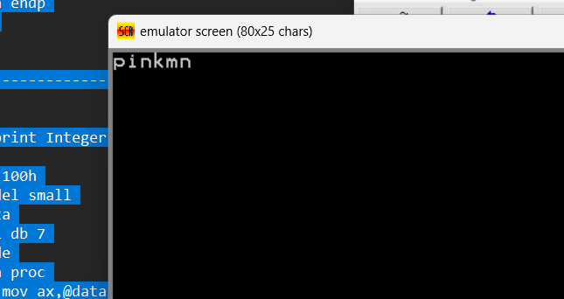

5.Write an Assembly program to Print a String or Message

org 100h

.model small

.data

var1 db "Dedipyaa is a good boy$"

.code

main proc

mov ax,@data

mov ds,ax

mov dx,offset var1

lea dx,var1

mov ah,9

int 21h

main endp

ret

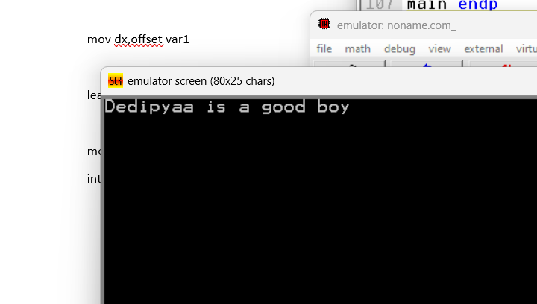

6.Write an Assembly program to print Integer Variable

org 100h

.model small

.data

var1 db 7

.code

main proc

mov ax,@data

mov ds,ax

mov dl,var1

add dl,48

mov ah,2

int 21h

main endp

ret

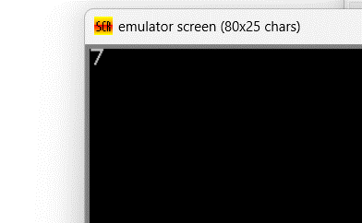

7.Write an assembly language program to input two numbers from the user and add them

org 100h

.model small

.data

.code

main proc

mov ah,1

int 21h

mov bl,al .

mov ah,1

int 21h

add bl,al

sub bl,48

mov dl,bl

mov ah,2

int 21h

main endp

end main

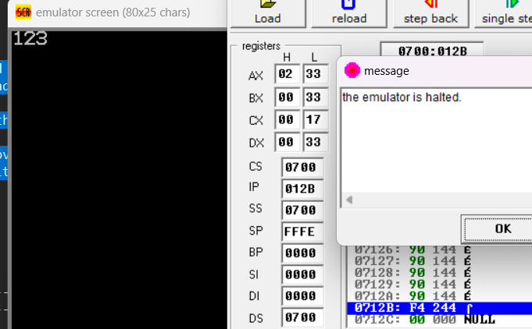

8.Write an Assembly program to print numbers from 0 to 9

org 100h

.model small

.data

a db 0,1,2,3,4,5,6,7,8,9

.code

main proc

mov ax,@data

mov ds,ax

mov cx,10

mov si,0

loop1:

mov al,a[si]

mov dl,al

add dl,48

mov ah,2

int 21h

mov dl,00

mov ah,2

int 21h

inc si

loop loop1

ret

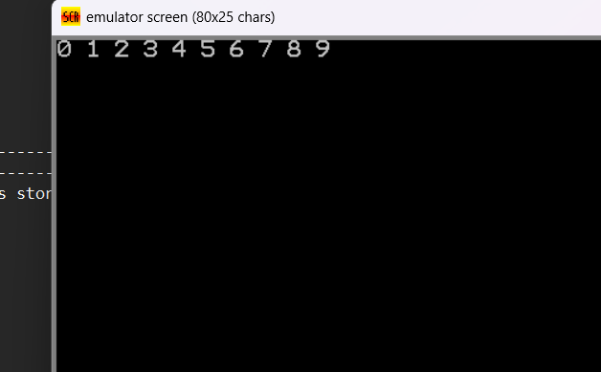

9.Write an Assembly program to print average of numbers stored in an array

org 100h

.data

a db 1,2,3,4,5

avg db ?

.code

mov ax,@data

mov ds,ax

mov cx,5

mov si,0

mov bl,5

mov ax,0

loop1:

add al,a[si]

inc si

loop loop1

div bl

mov avg,al

mov dl,avg

add dl,48

mov ah,2

int 21h

ret

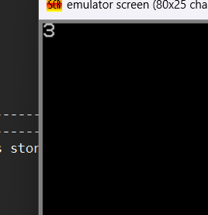

10.Write an Assembly program to find the largest number in an array

org 100h

.model small

.data

a db 1,5,7,2,9

.code

main proc

mov ax,@data

mov ds,ax

mov cx, 4

mov si,0

mov bh,a[si]

loop1:

inc si

cmp bh,a[si]

jg l1

mov bh,a[si]

l1:

mov dl,bh

loop loop1

add dl,48

mov ah,2

int 21h

ret

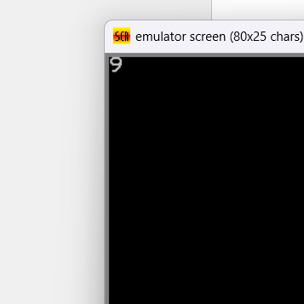

11.Write an assembly program to print factorial of a number

org 100h

.data

n dw 7

fact dw 1

.code

mov ax,@data

mov ds,ax

mov ax,fact

mov bx,n

cmp bx,0

je zero

cmp bx,1

je zero

jg more

zero:

mov fact,1

jmp exit

more:

mul bx

sub bx,1

cmp bx,1

jg more

je exit

exit:

mov fact,ax

ret

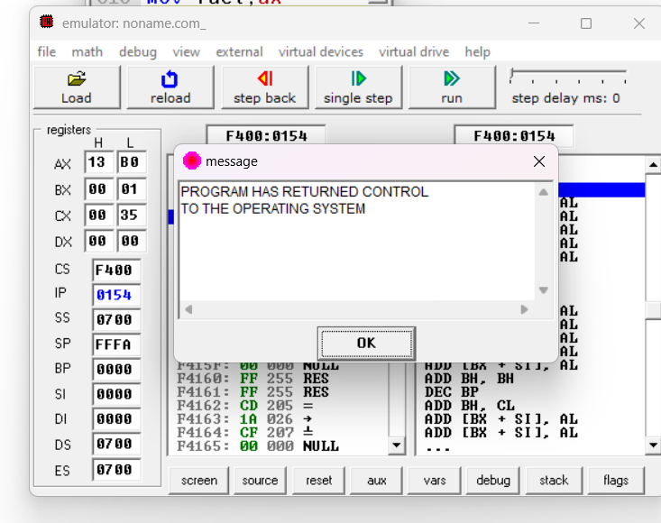

12.Write an Assembly program to print english alphabets (A to Z) in capital case

org 100h

.model small

.data

.code

main proc

mov cx,26

mov ah,2

mov dx,41h

l1:

int 21h

inc dl

loop l1

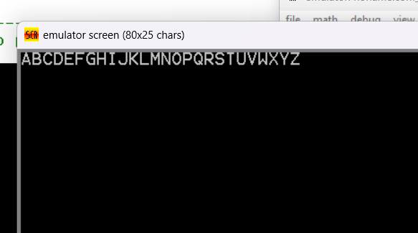

13.Write an Assembly program to Print A to Z in lowercase

org 100h

.model small

.data

.code

main proc

mov cx,26

mov ah,2

mov dx,61h

l1:

int 21h

inc dl

loop l1

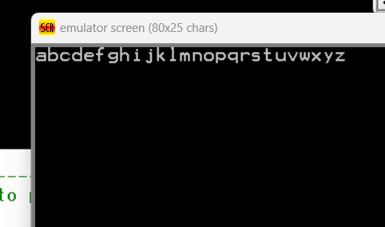

14.To print nth Fibonacci number

org 100h

.data

z 10 dup(?)

b db 0

c db 1

fib db ?

.code

mov ax,@data

mov ds,ax

mov si,0

mov cx,6

mov al,b ;Output is OD which is 13 in unsigned

mov bl,c

mov z[si],al

mov z[si+1],bl

l1:

add al,bl

mov bh,al

mov al,bl

mov bl,bh

mov z[si+2],bh

inc si

loop l1

mov fib,bl

ret

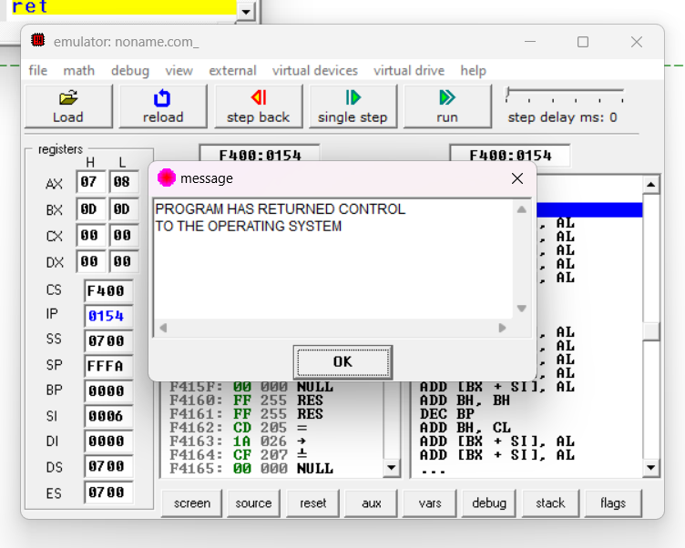

15.Using 3 numbers as sum in Fibonacci

org 100h

.data

z 10 dup(?)

b db 0

c db 1

d db 2

fib db ?

.code

main proc

mov ax,@data

mov dx,ax

mov si,0

mov cx,3

mov al,b

mov bl,c

; mov ah,d

mov z[si],al

mov z[si+1],bl

mov z[si+2],cl

loop1:

add al,bl

add al,ah

mov bh,al

mov al,bl

mov bl,ah

mov ah,bh

mov z[si+3],bh

inc si

loop loop1

mov fib,bl

main endp

end main

ret

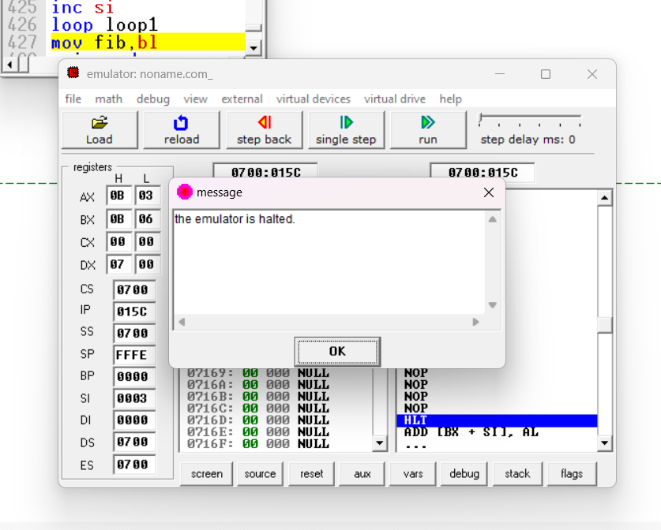

16. Program to check whether a number is odd or even

org 100h

include 'emu8086.inc'

.code

mov al,6

mov bl,2

div bl

mov bx,ax

cmp bh,0

je s1

jg s2

jl s2

s1:

print 'EVEN'

jmp exit

s2:

print 'ODD'

exit:

ret

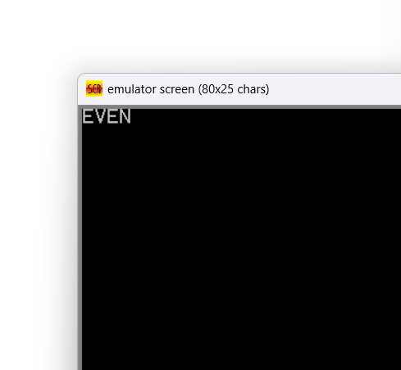

17.Write a program to print if a number is EVEN or ODD

include 'emu8086.inc'

.code

mov al,7

mov bl,2

div bl

mov bx,ax

print 'R:'

mov dl,bh

add dl,48

mov ah,2

int 21h

mov dl,10

mov ah,2

int 21h

mov dl,13

mov ah,2

int 21h

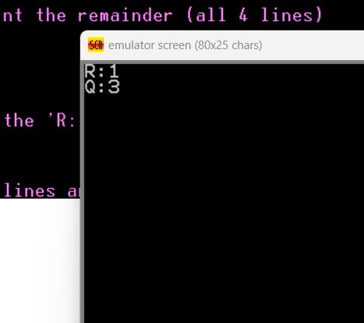

18.Write an Assembly program to implement Bubble Sort

include 'emu8086.inc'

org 100h

.model small

.data

arr db 5 dup(?)

.code

main proc

mov ax,@data

mov ds,ax

print "Enter 5 numbers of the array"

mov cx,5

mov bx,offset arr

mov ah,1

inputs:

int 21h

mov [bx],al

inc bx

loop inputs

mov cx,5

dec cx

outerloop:

mov bx,cx

mov si,0

comploop:

mov al,arr[si]

mov dl,arr[si+1]

cmp al,dl

jnc noswap

mov arr[si],dl

mov arr[si+1],al

noswap:

inc si

dec bx

jnz comploop ; jump if not 0

loop outerloop

mov ah,2

mov dl,10

int 21h

mov dl,13

int 21h

print "After sorting Array"

mov cx,5

mov bx,offset arr

;this loop to display elements on the screen

outputs:

mov dl,[bx]

mov ah,2

int 21h

mov dl,32

mov ah,2

int 21h

inc bx

loop outputs

main endp

ret

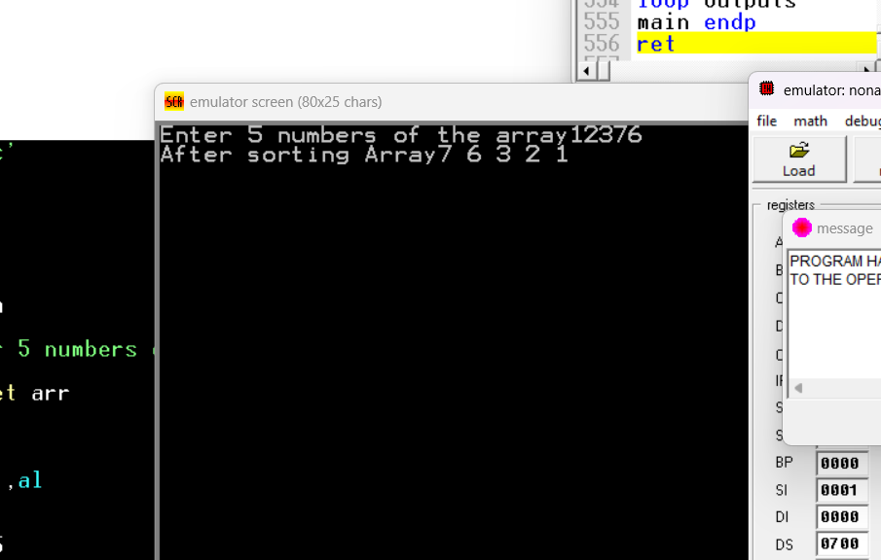

19.Write a Program to implement a stack

.model small

.stack 100h

.data

.code

main proc

mov ax,2

push ax

pop ax

mov dx,ax

mov ah,2

int 21h

mov ah,4ch

int 21h

main endp

end main

