Supplementary Material – Hybrid Anomaly Detection in SAMSAT Banten PKB Data
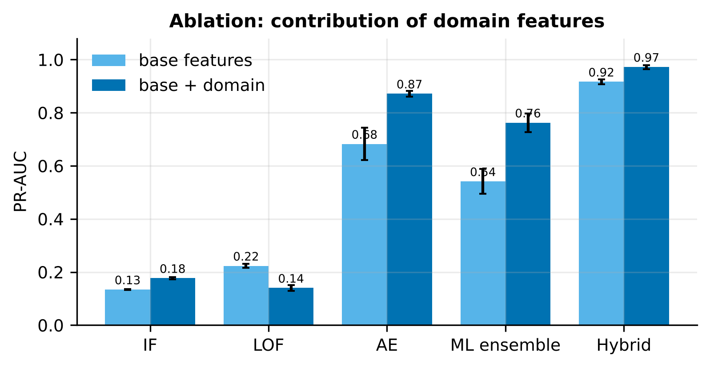
Figure S1: Ablation of domain-feature contribution to PR-AUC (5 runs)
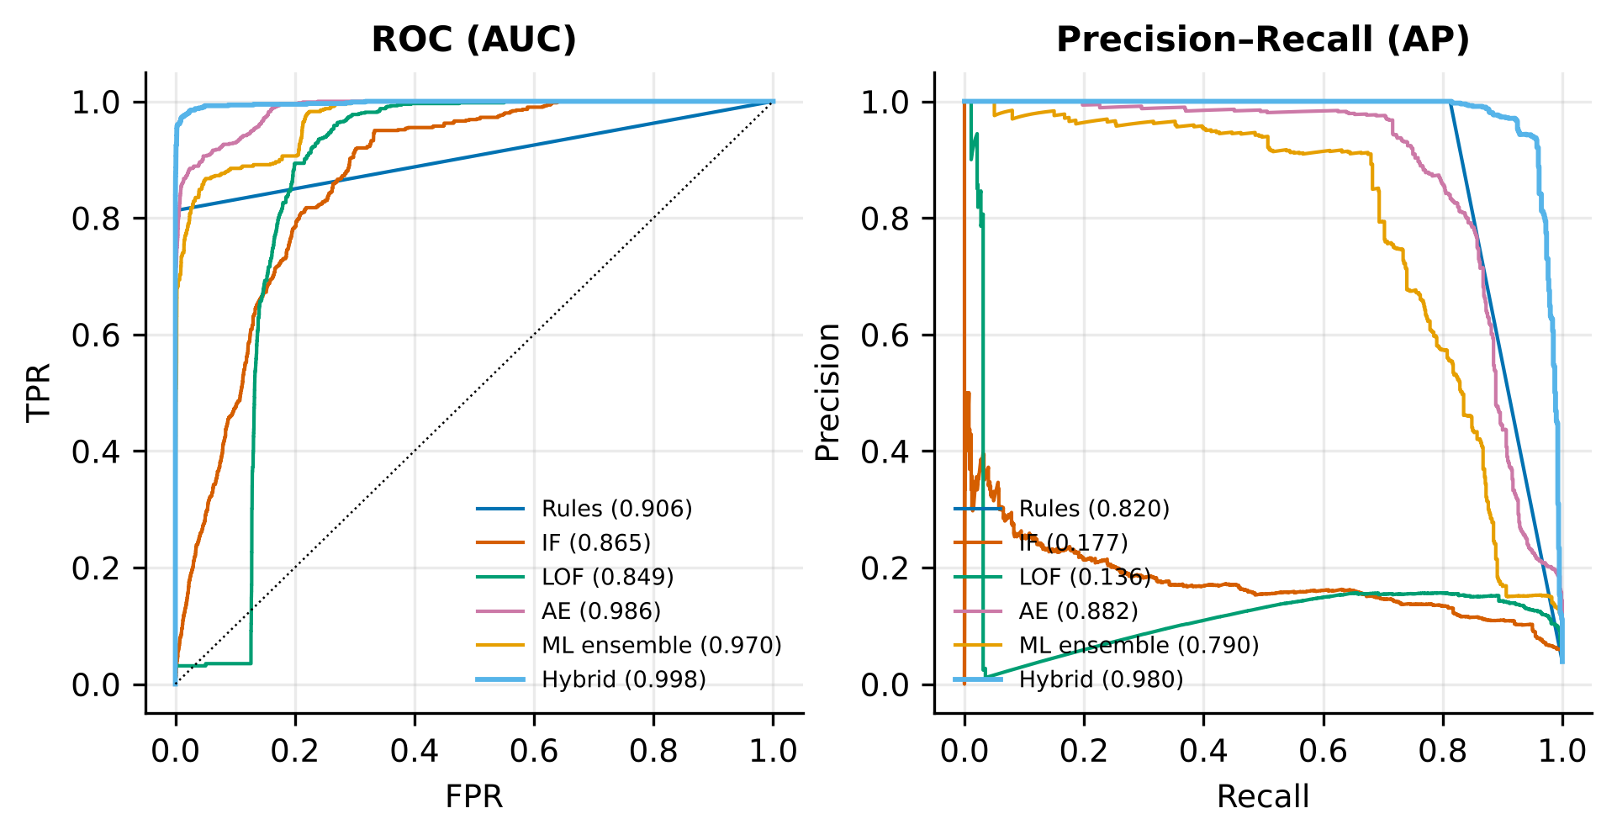
Figure S2: ROC and precision–recall curves (first run)
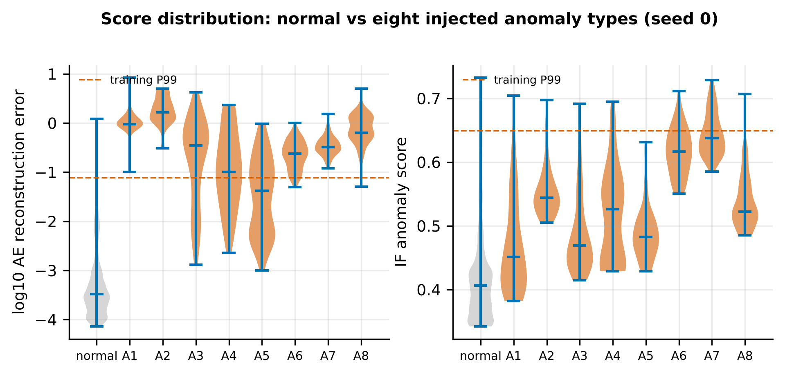
Figure S3: AE and IF score distributions: normal vs anomaly types
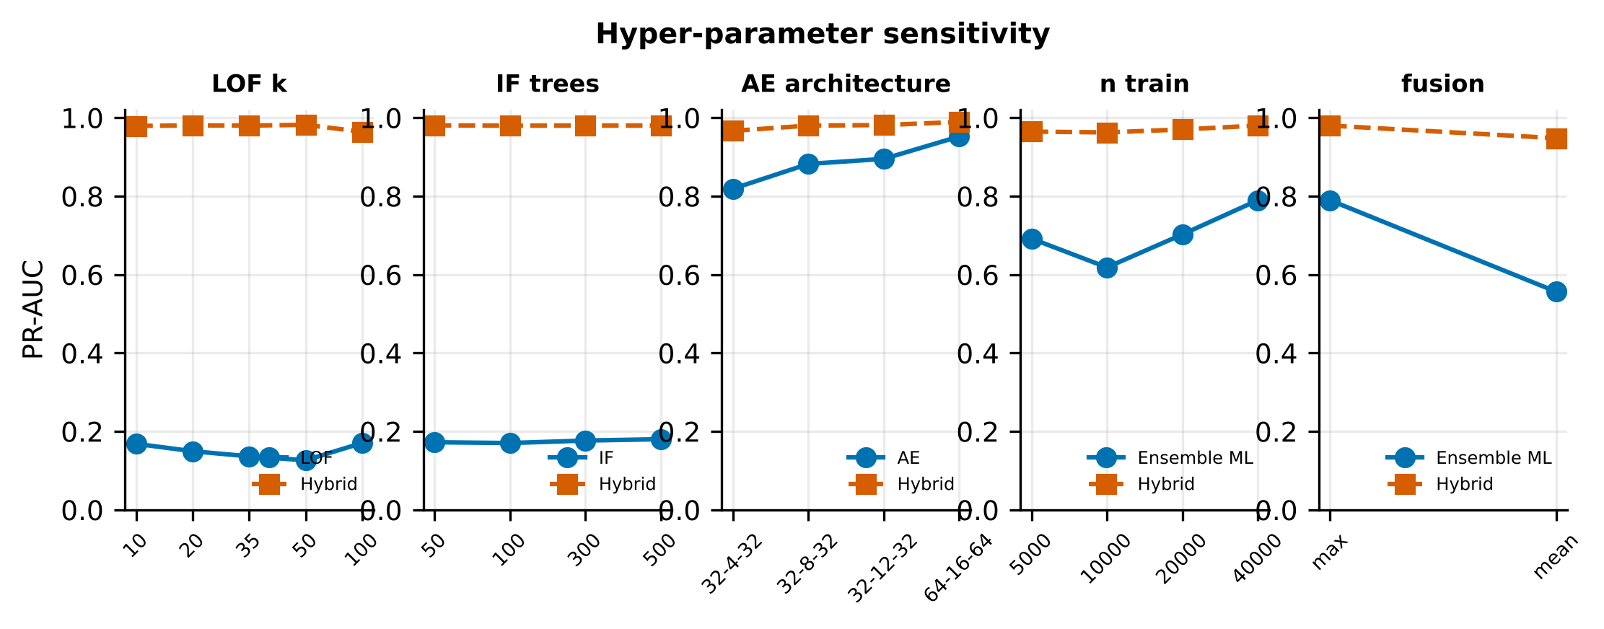
Figure S4: Hyper-parameter and fusion-strategy sensitivity
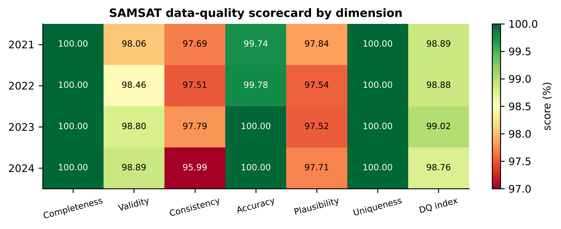
Figure S5: Data-quality scorecard by dimension
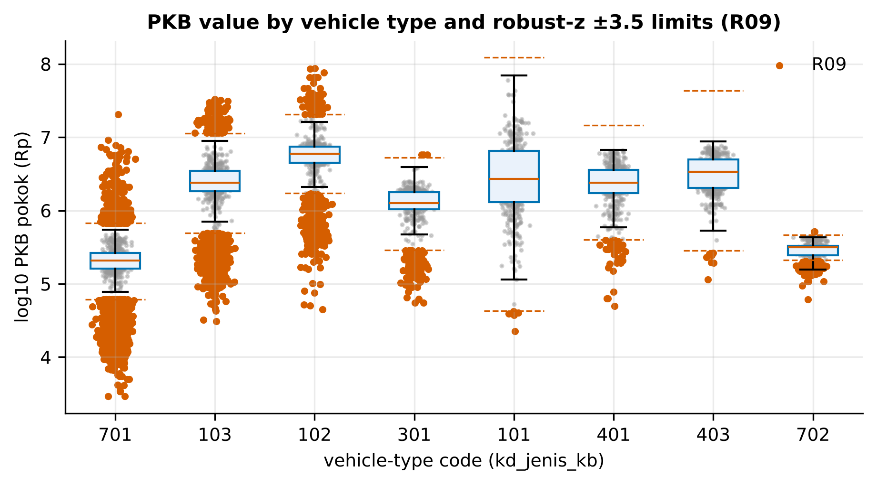
Figure S6: PKB value per vehicle type and R09 limits
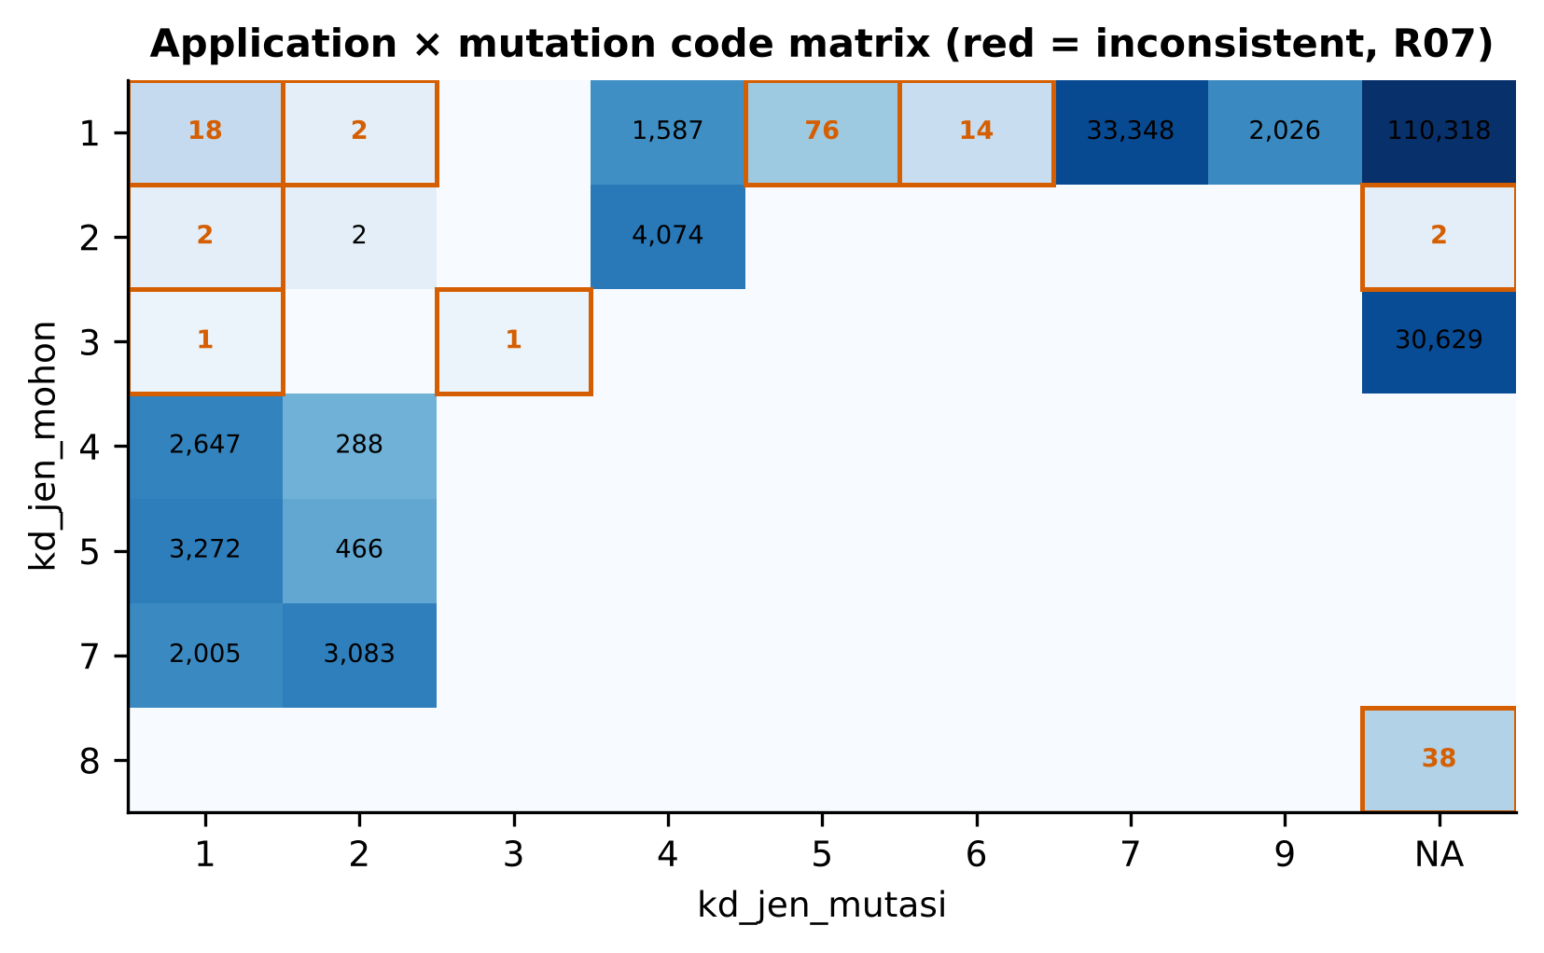
Figure S7: Application × mutation code matrix (after harmonisation)
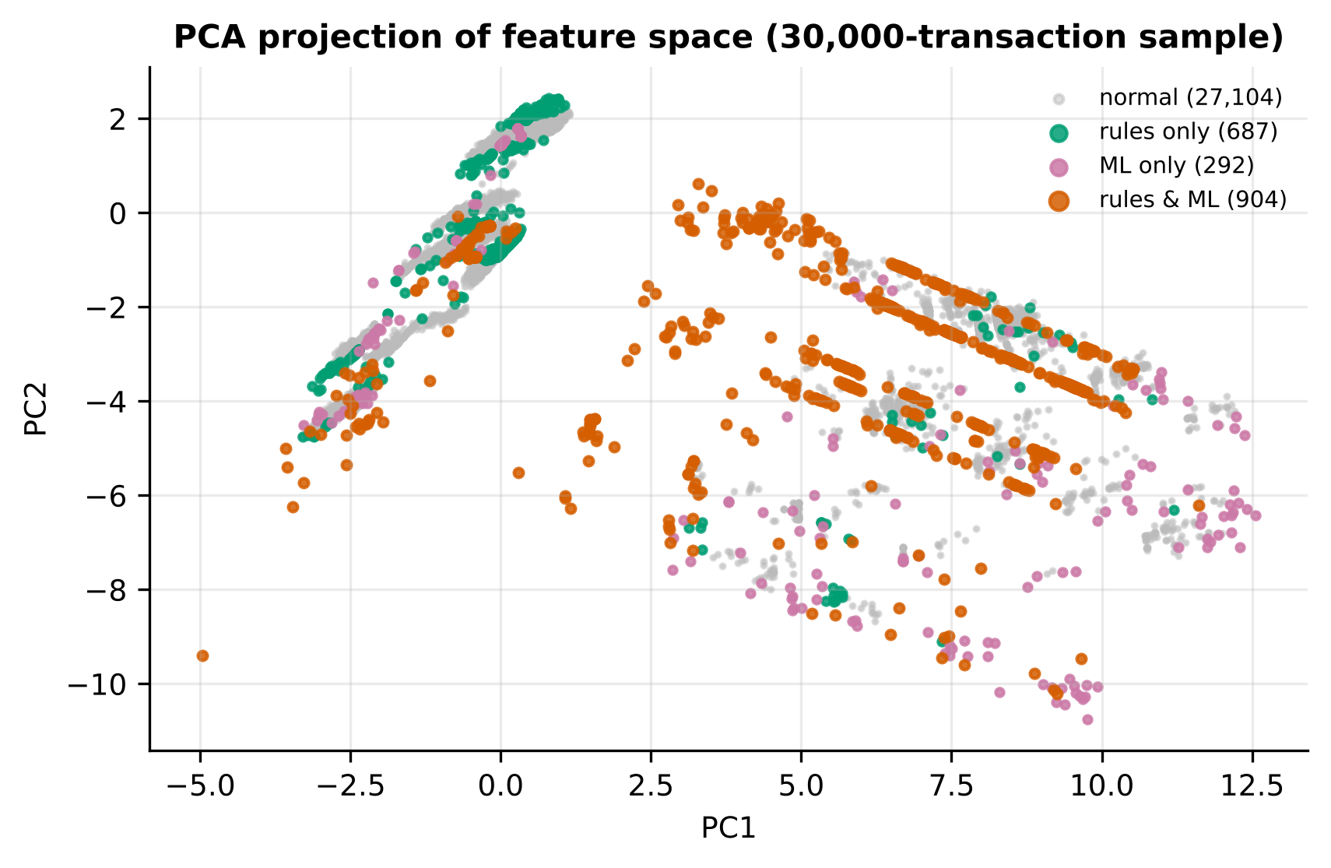
Figure S8: PCA projection of the feature space by finding category
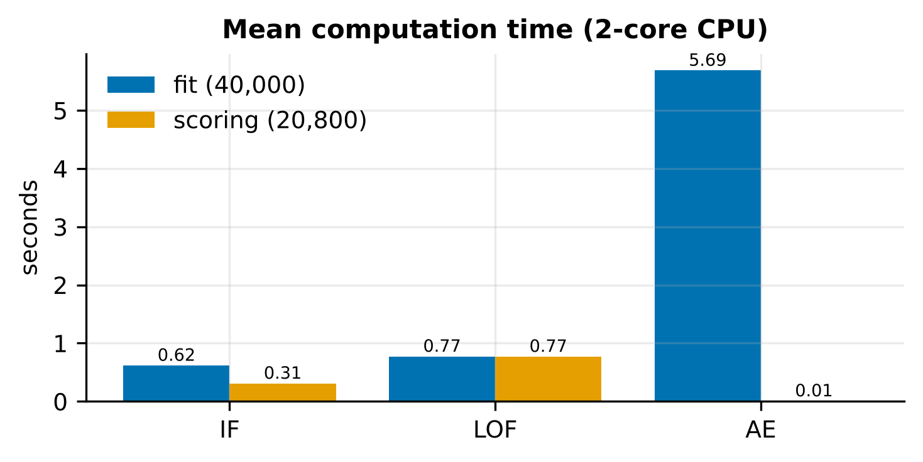
Figure S9: Mean computation time
Table S1: Wilcoxon (hybrid vs competitors, PR-AUC) and Friedman tests
pembanding | selisih_PR_AUC_rerata | W | p | menang/seri/kalah | p_holm | Friedman_chi2 | Friedman_p
Aturan | 0.1564 | 0 | 0.00195 | 10/0/0 | 0.00977 | 50 | 0
IF | 0.7954 | 0 | 0.00195 | 10/0/0 | 0.00977 | 50 | 0
LOF | 0.8401 | 0 | 0.00195 | 10/0/0 | 0.00977 | 50 | 0
AE | 0.1108 | 0 | 0.00195 | 10/0/0 | 0.00977 | 50 | 0
Ensemble ML | 0.2251 | 0 | 0.00195 | 10/0/0 | 0.00977 | 50 | 0

Table S2: Sensitivity analysis
parameter | nilai | metode | PR_AUC | PR_AUC_hibrida
LOF n_neighbors | 10 | LOF | 0.1683 | 0.9791
LOF n_neighbors | 20 | LOF | 0.1494 | 0.9805
LOF n_neighbors | 35 | LOF | 0.1364 | 0.98
LOF n_neighbors | 50 | LOF | 0.1263 | 0.9819
LOF n_neighbors | 100 | LOF | 0.1706 | 0.9642
IF n_estimators | 50 | IF | 0.1723 | 0.9804
IF n_estimators | 100 | IF | 0.1703 | 0.9798
IF n_estimators | 300 | IF | 0.1766 | 0.98
IF n_estimators | 500 | IF | 0.1801 | 0.98
AE arsitektur | 32-4-32 | AE | 0.8191 | 0.9666
AE arsitektur | 32-8-32 | AE | 0.8822 | 0.98
AE arsitektur | 32-12-32 | AE | 0.8951 | 0.9813
AE arsitektur | 64-16-64 | AE | 0.9522 | 0.9893
Ukuran data latih | 5000 | Ensemble ML | 0.6916 | 0.9646
Ukuran data latih | 10000 | Ensemble ML | 0.6183 | 0.9626
Ukuran data latih | 20000 | Ensemble ML | 0.7024 | 0.9701
Ukuran data latih | 40000 | Ensemble ML | 0.7895 | 0.98
Strategi fusi | max persentil (dipakai) | Ensemble ML | 0.7895 | 0.98
Strategi fusi | rerata persentil | Ensemble ML | 0.5563 | 0.9479

Table S3: Code drift per field and year (JSD)
field | tahun | JSD_mentah | JSD_harmonisasi | kode_baru | kode_hilang
kd_status | 2021 | 0.0012 | 0.0012 | - | -
kd_status | 2022 | 0.0012 | 0.0012 | - | -
kd_status | 2023 | 0.0042 | 0.0042 | - | -
kd_status | 2024 | 1 | 0.0007 | 5,6 | 3,4
kd_jen_mohon|kd_jen_mutasi | 2021 | 0.0011 | 0.0011 | 2|9 | 1|2,2|1,2|NA,3|1
kd_jen_mohon|kd_jen_mutasi | 2022 | 0.0043 | 0.0043 | 2|1,2|NA,3|1 | 1|2,2|9
kd_jen_mohon|kd_jen_mutasi | 2023 | 0.006 | 0.006 | 1|2 | 2|1,2|9,2|NA,3|1
kd_jen_mohon|kd_jen_mutasi | 2024 | 0.1886 | 0.007 | 2|2,2|5,2|6,2|7,3|3 | 1|1,1|2,1|4,1|5,1|6,1|7,1|9,2|NA,3|1
kd_jenis_kb | 2021 | 0.0015 | 0.0015 | 304,428,527,580,703 | 308,335,410,416,424,429,433,441,443,504,512,526,551,557,566,567,579,583,586,587,704
kd_jenis_kb | 2022 | 0.0008 | 0.0008 | 308,504,526,587 | 304,410,416,424,428,443,512,527,534,565,566,567,580,583,586,703,704
kd_jenis_kb | 2023 | 0.0014 | 0.0014 | 410,416,424,443,512,566,567,583,586,704 | 304,308,428,504,510,526,527,580,587,703
kd_jenis_kb | 2024 | 0.0008 | 0.0008 | 439 | 304,308,428,433,510,512,526,527,534,566,583,587
kd_lokasi | 2021 | 0.0043 | 0.0043 | - | -
kd_lokasi | 2022 | 0.0021 | 0.0021 | - | -
kd_lokasi | 2023 | 0.0027 | 0.0027 | - | -
kd_lokasi | 2024 | 0.0022 | 0.0022 | - | -
kd_dati2 | 2021 | 0.0025 | 0.0025 | - | -
kd_dati2 | 2022 | 0.0009 | 0.0009 | - | -
kd_dati2 | 2023 | 0.0009 | 0.0009 | - | -
kd_dati2 | 2024 | 0.0001 | 0.0001 | - | -

Table S4: Application–mutation code-pair profile (2021–2023)
kd_jen_mohon | pair | n | bbn_rate | share_in_mohon | status
1 | 1|NA | 80679 | 0 | 0.7439 | lazim
1 | 1|7 | 24621 | 0 | 0.227 | lazim
1 | 1|4 | 1587 | 0 | 0.01463 | lazim
1 | 1|9 | 1474 | 0 | 0.01359 | lazim
1 | 1|5 | 55 | 0 | 0.0005072 | langka/tidak konsisten
1 | 1|1 | 18 | 0 | 0.000166 | langka/tidak konsisten
1 | 1|6 | 12 | 0 | 0.0001107 | langka/tidak konsisten
1 | 1|2 | 2 | 0 | 1.844e-05 | langka/tidak konsisten
2 | 2|4 | 2765 | 1 | 0.9989 | lazim
2 | 2|NA | 2 | 1 | 0.0007225 | langka/tidak konsisten
2 | 2|1 | 1 | 0 | 0.0003613 | langka/tidak konsisten
3 | 3|NA | 21656 | 0.997 | 1 | lazim
3 | 3|1 | 1 | 1 | 4.617e-05 | langka/tidak konsisten
4 | 4|1 | 2035 | 1 | 0.8973 | lazim
4 | 4|2 | 233 | 0 | 0.1027 | lazim
5 | 5|1 | 2485 | 0.6414 | 0.8837 | lazim
5 | 5|2 | 327 | 0 | 0.1163 | lazim
7 | 7|2 | 2378 | 0 | 0.6029 | lazim
7 | 7|1 | 1566 | 0 | 0.3971 | lazim
8 | 8|NA | 36 | 0.25 | 1 | lazim

