Pharmaverse Review
Dashboard
- Only four training modes to be shown
- Tip of the day to be placed on the top or somewhere visible — not at the bottom, as users may have to scroll down every time
- Each tab like hospital should have a picture at the background imparting a better look or we can make it look like if the questioning is happening inside the hospital or industry to increase realism
Training Modes
- Rx and OTC to be merged
- In Rx, realistic prescriptions in scribbled handwriting are needed to make it more challenging
- In Rx, the option that appears after selecting the prescribed drug is positioned at the bottom — this took time to find; needs to be more visible
- Hospital mode to be added
- Oncology and cosmetics to be removed
- Time tickling on the upper tab should be little more visible
- Industry: the master formula is too complex to absorb at a glance — consider displaying it alongside the training modes for better understanding
- Warehouse needs more complex cases
- Streak management like snapchat
- Remove the hard easy specification over the training
Fix bugs here what is the issue here I opened hospital pharmacy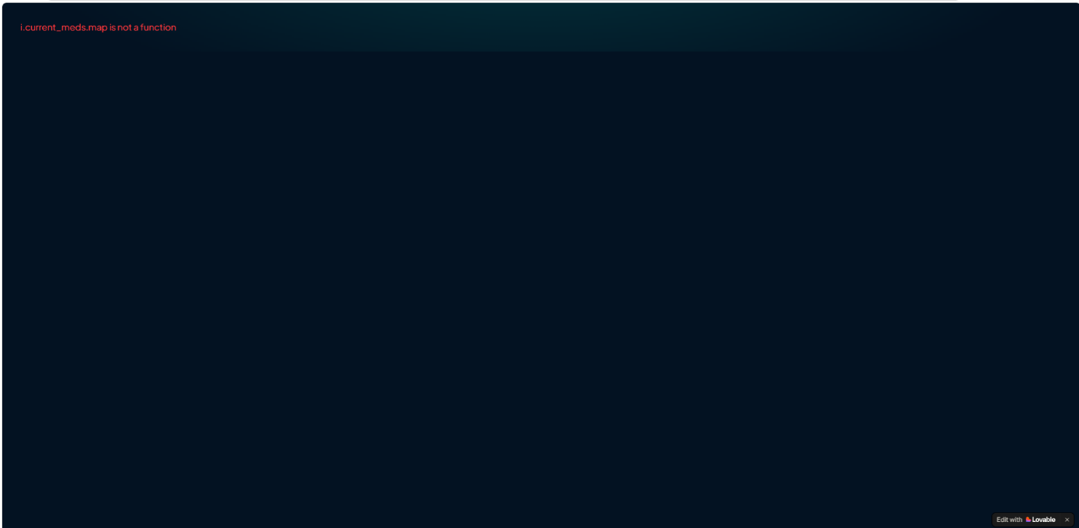

What Is the issue here, in the prescription bar why proper prescription is not available.

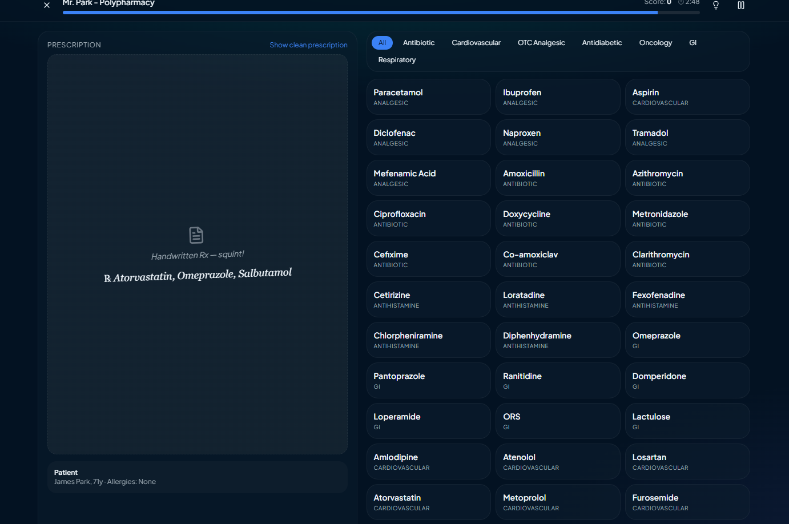

- Add vaccination in community as well, that will include reviewing of vaccination charts of kids or maybe associated symptoms of vaccination.
- Compounding of topical dosage form (lotions ,creams, gels) ,sterile intravenous preparations, TPN , antibiotic dilutions. Under community pharmacy

Profile & Leaderboard
Profile is perfect, and so is the leaderboard.
Other
Consider changing the name To pharmulation.
2. only 2 options of student occupation in sign up
3. Tip of the day at the top
4. Prescription sahi krna hai
5. Ticking clock
6. Har mode ka apna aik difficulty level
7. Rx cases main meds category wali cheez beech main laani Jahan meds likhi hui hain
8. First in industry ask about tablet,syrup etc then their types
9. Back button
10. Batch size change krny ka freedom
11. Tutorial wala bot at front and at each mode
12. neon lime green color theme overall

