Band-Gap Correction and §II.4 Reconciliation
Proposed manuscript wording — June 2026
Draft prose to slot into the manuscript, matching the implemented code and validation. NOTE markers flag editorial decisions. All deviations are vs the experimental (IAEA)/PSTAR references through the Bragg-peak region (~30–300 keV protons).

A. §II.4 reconciliation (plasmon shift / local-field term)
Issue. The current §II.4 writes the shifted plasma frequency as ω̃ₚ² = ωₚ² + γ²ωₚ² with a fixed γ² = 0.75. The code no longer uses a single γ²; the bound/valence “binding” correction is applied through the energy-dependent parameters xepa, xepb (defaults 1.0, 1.1) in vlhfit (and xepc/xepd/xepe in the strong-collision and Barkas cutoffs).
Proposed text (sketch — confirm physics intent before finalizing):
The bound-electron contribution to the dielectric response is incorporated through a local binding-energy shift rather than a single global plasmon-broadening constant. The shift is applied to the average-atom binding-energy density [c10 column] with an energy-dependent weight that turns the correction off above a cutoff set by the local binding scale (parameters xepa, xepb); this replaces the earlier fixed γ² = 0.75 form, which is recovered approximately in the low-energy limit.
NOTE — I’m not fully certain of the exact analytic relationship between the old γ² form and the xepa/xepb weighting — this paragraph needs your confirmation. If γ² = 0.75 is still what you want to publish as the canonical model, then the code defaults should be documented as the operative values instead.

B. Band-gap correction for cold insulators (Levine–Louie)
NOTE — This is scoped deliberately as a cold-insulator correction, consistent with what the validation supports. Dial the emphasis up/down to taste.

B.1 Motivation
For cold ionic insulators the average-atom eRPA-LDA model overshoots the measured electronic stopping through the Bragg peak (Fig. 17). The cause is that the model’s valence electrons are given a gapless free-electron-gas response: low-frequency excitations that are forbidden by the material’s band gap are spuriously allowed, inflating the stopping at low projectile velocity.

B.2 Method
We impose a Levine–Louie band gap on the dielectric response: the energy-loss function Im[−1/ε] is zeroed below a threshold E_g and the oscillator strength is shifted upward, preserving the f-sum rule by construction. Rather than a fixed material gap, the threshold is tied to a local average-atom binding frequency,
E_g(r) = κ · ω_b(r),
where ω_b(r) is obtained from the average-atom geometric-mean binding energy [Eq. (7); in the code, ω_b(r) = c10(r)/r² from the .den output], and κ is a single dimensionless calibration constant. Because ω_b derives from the AA occupations, it evolves continuously with temperature and density. The correction is implemented by tabulating the gapped loss function on a grid of gap frequencies and interpolating at the local E_g(r) during the radial stopping integral.

B.3 Results
A single κ ≈ 0.9 (κ < 1, as expected since the orbital binding ω_b exceeds the optical gap) removes the cold overshoot for the materials where the LDA overshoots:
target | gapless dev. | κ=0.9 dev. | optical gap
LiF | +16 % | −3 % | ~14 eV
SiO₂ | +12 % | +2 % | ~9 eV

The gap effect scales with the material gap (largest for LiF), emerging automatically from ω_b with no per-material tuning (Fig. 1).
NOTE — Honesty point, recommend keeping: For several other wide-gap insulators (Al₂O₃, CaF₂, KCl) the gapless model already agrees with the data to within a few percent; there the correction is small or mildly over-corrects. This is the expected and correct behavior — the gap only matters where sub-threshold excitation is being spuriously allowed — but it means a single κ is an approximation, and the experimental spread (±10–20 % between datasets) precludes a tighter calibration. We therefore present κ ≈ 0.9 as a representative value, not a precisely determined constant.

B.4 Scope and limitations
- Cold condensed regime only. The correction targets the cold-insulator overshoot and is not active for the plasma/WDM targets that are the model’s primary application; for those the band-gap concept dissolves as the material ionizes.
- Liquid water excluded. Water’s stopping is anomalous (breakdown of Bragg additivity by 10–20 % near the peak, hydrogen-bond-modified dielectric response, phase effects) and lies outside an average-atom, Bragg-additive framework; we exclude it from the gap calibration and note it as a separate, known limitation.
- Self-extinction in WDM is incomplete in the present form. Tying E_g to the geometric-mean binding ω_b = c10/r² does not fully vanish at partial ionization (the surviving deep-bound electrons keep ω_b large), so the correction does not yet smoothly disappear across the warm-dense regime. A bound-fraction-weighted threshold (e.g. ω_b ∝ c10/(c06+c07)) is the natural extension and is left to future work.
NOTE — Include the WDM bullet only if you discuss the WDM limit; otherwise the first bullet suffices.

C. Figures
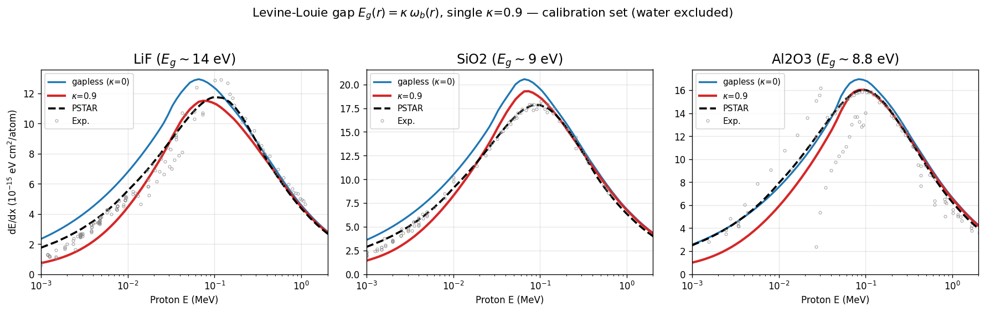
Figure 1. LiF / SiO₂ / Al₂O₃: gapless vs κ = 0.9 vs reference. The gap correction removes the cold overshoot, scaling with the material gap, with a single κ.
Optional counterexample (gapless already matches): CaF₂ and KCl, where the uncorrected model is already within a few percent of the data.
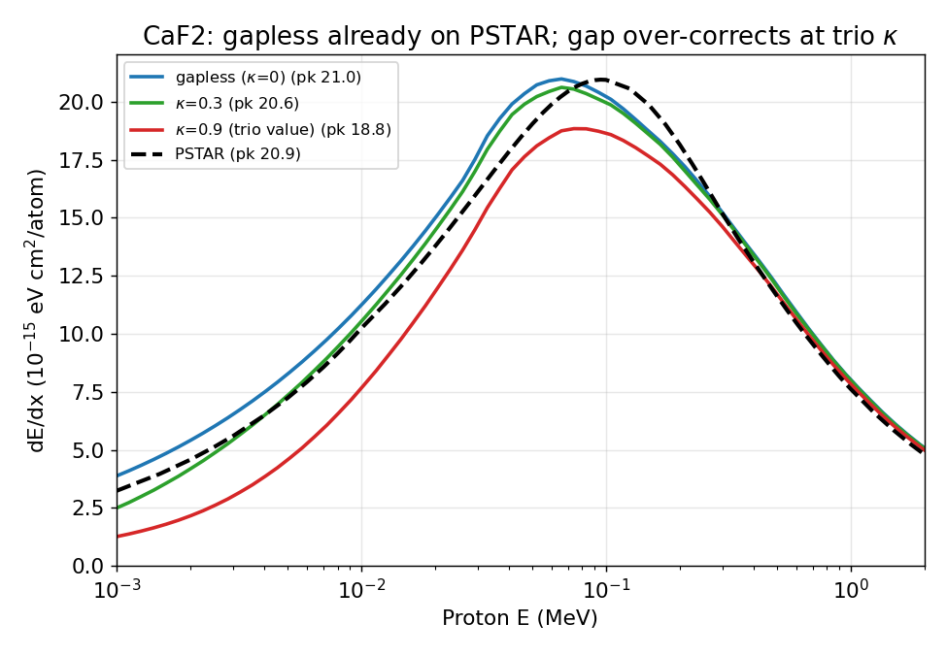
Figure 2 (optional). CaF₂: the gapless model already agrees with the reference; the gap correction is small or mildly over-corrects — the expected behavior for a material whose gap is not driving a spurious overshoot.
Optional (only if the WDM limit is discussed): the temperature fade-out of the correction as the material ionizes.
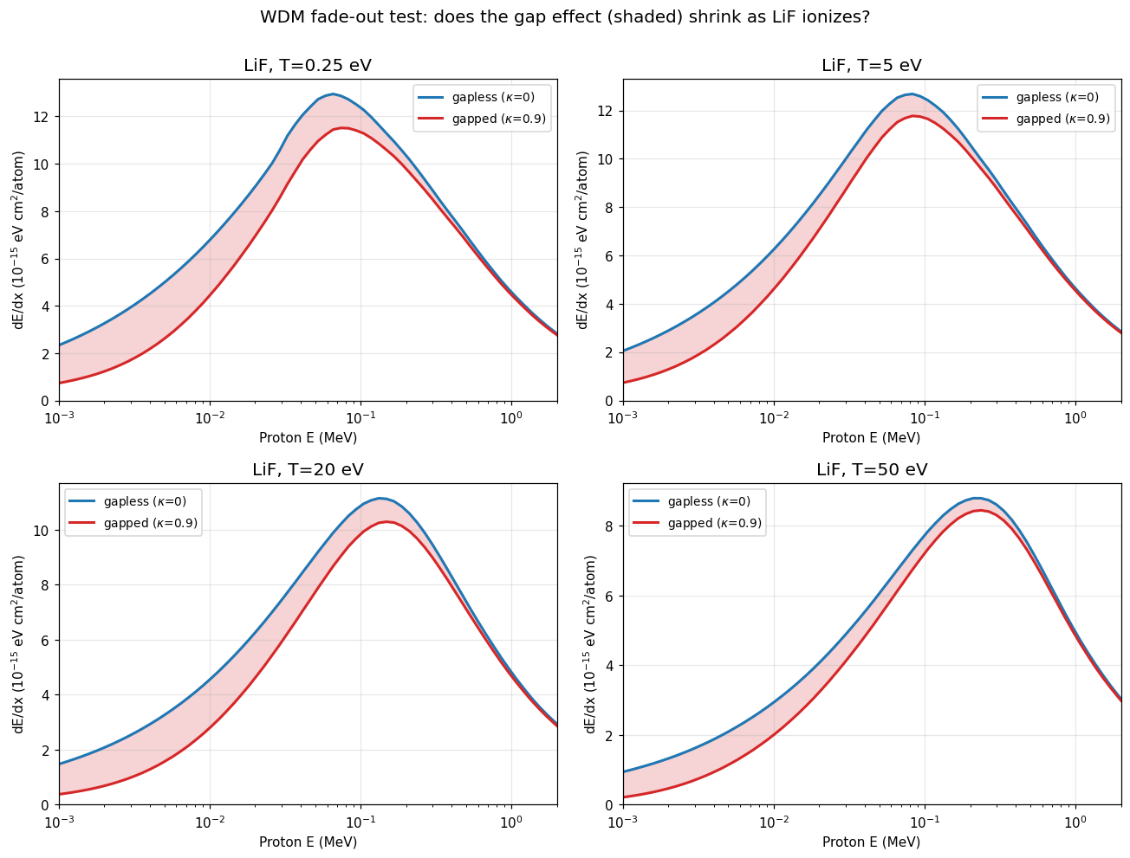
Figure 3 (optional). LiF stopping across the warm-dense regime, illustrating the (incomplete) self-extinction of the gap correction with increasing temperature.

