Total Stopping Power in the eRPA Average-Atom Model:
Nuclear/Ion Stopping and Verification
Draft manuscript sections — June 2026
Companion to the band-gap correction draft. NOTE markers flag editorial decisions.

A. Motivation — a total stopping power from cold solids to fusion plasmas
The eRPA average-atom model gives the electronic stopping power. The energy a projectile loses to the target ions is a separate channel that the electronic model does not capture: at low temperature it is the classical elastic ion–ion (“nuclear”) stopping familiar from cold-matter range tables; at finite temperature it becomes the projectile-ion/target-ion drag of the Fokker–Planck slowing-down (the ion term of Mehlhorn 1981). We add this channel so that the package returns a total stopping power — electronic plus nuclear/ionic — that is consistent from cold solids, through warm and hot dense matter, and on to fully ionized fusion plasmas. The two contributions are returned in the same units (10⁻¹⁵ eV cm²/atom) and add directly.
NOTE — Framing for Tom: present this as “completing the total stopping power” of the existing eRPA model, or as a standalone nuclear/ion-stopping capability. The text is written for the former.

B. Method — nuclear/ion stopping
We follow the classical two-body model of Faussurier, Blancard & Gauthier (Phys. Plasmas 20, 012705, 2013), whose electronic component is the same eRPA model used here (their Ref. 6 is Wang–Mehlhorn–MacFarlane 1998), so the two channels are mutually consistent.
Scattering integral. The per-atom nuclear stopping cross section is obtained from the classical deflection of the projectile in an effective screened ion–ion pair potential U(R), integrated over impact parameter. At zero ion temperature, εₙ(E) = 2π γ E ∫ sin²(θ/2) p dp with γ = 4M₀Mₜ/(M₀+Mₜ)². The turning-point integral uses a substitution that removes the inverse-sqrt singularity; the implementation reproduces the analytic Rutherford cross section to better than 10⁻⁶.
Effective pair potentials. Three potentials are provided. Two are analytic and screen with the free electrons only: an ion-sphere form and a Yukawa/Debye–Hückel form with a finite-temperature Thomas–Fermi screening length. The recommended, default potential is the finite-temperature Gordon–Kim electron-gas potential, built from the real average-atom electron density (bound + free), U_GK(R) = U_es(R) + ΔT(R) + ΔE_x(R) + ΔE_c(R): the electrostatic interaction of the neutral target atom with the projectile, plus the kinetic (Thomas–Fermi), exchange (Dirac), and correlation (PW92 LDA) overlap energies of the frozen densities, with the Faussurier/Stein volume-conservation scaling. Because U_es is built from the full average-atom density, R·U → Z₀′Zₜ (the bare nuclear product) at small R, so Gordon–Kim recovers the unscreened nucleus–nucleus interaction at close approach — which is why it reproduces the cold-matter reference data while the free-electron-screened analytic potentials fall below it.
NOTE — Including the kinetic/exchange/correlation overlap (not just the electrostatic term) is the same modelling choice, in spirit, as going from RPA to eRPA in the electronic stopping: retain the full electron-gas physics.
Average-atom density boundary (eRPA-consistent). The Gordon–Kim overlap requires the target density beyond the Wigner–Seitz cell. We use the muffin-tin interstitial free-electron sea n₀ = qe(R_WS), consistent with the eRPA electronic treatment, with a background-subtracted (embedded) overlap so that U → 0 at large R. This differs from an isolated-neutral-atom truncation by less than 0.5% in cold matter and by up to ~5% in hot dense matter.
Finite ion temperature. The target ions carry a Maxwellian velocity distribution, over which the energy exchange is averaged. Below a threshold E* the projectile is slower than the thermal ions and the net ion–ion energy exchange becomes a gain — the projectile is heated toward equilibrium (it thermalizes). This signed energy exchange is physical, but it is distinct from a stopping power, which is an energy-loss rate (≥ 0); in the stopping-power output we therefore floor the nuclear term at zero below E* (the total returns to the electronic value where the projectile has thermalized). The signed exchange is retained internally and bounds the alpha thermalization range in §E.

C. Correction — low-velocity electronic stopping (LSS/Chandrasekhar limit)
NOTE — This is a correction to the electronic model; place it wherever the electronic stopping is described.
Below the lowest tabulated projectile energy (≈ 1 keV/amu) the table-based electronic modes previously clamped the RPA stopping number to the grid-edge value, producing a spurious dE/dx ∝ 1/E rise in warm/hot matter (the curve turned up at low energy). The correct low-velocity limit is the Lindhard/LSS friction L ∝ v³, i.e. dE/dx ∝ v ∝ √E. We impose this scaling below the table edge; the change is confined to E < 1 keV/amu (every validated energy is unchanged — cold-Al protons vs PSTAR are byte-identical), and the warm-matter low-energy slope d(ln dE/dx)/d(ln E) goes from −1.0 to the correct +0.50, matching the analytic stopping-number path.

D. Verification — nuclear stopping and the Fokker–Planck ion drag
Cold-matter reference (Fig. 1). For protons in cold solid-density aluminum the Gordon–Kim nuclear stopping reproduces the NIST/ICRU-49 (ZBL) nuclear stopping to within ~7% across keV–MeV (the residual is consistent with the known frozen-density over-repulsion of Gordon–Kim and within ZBL’s own ~10% fit uncertainty). The analytic ion-sphere and Yukawa potentials fall below the reference, as in the source paper, because they screen with the free electrons only.
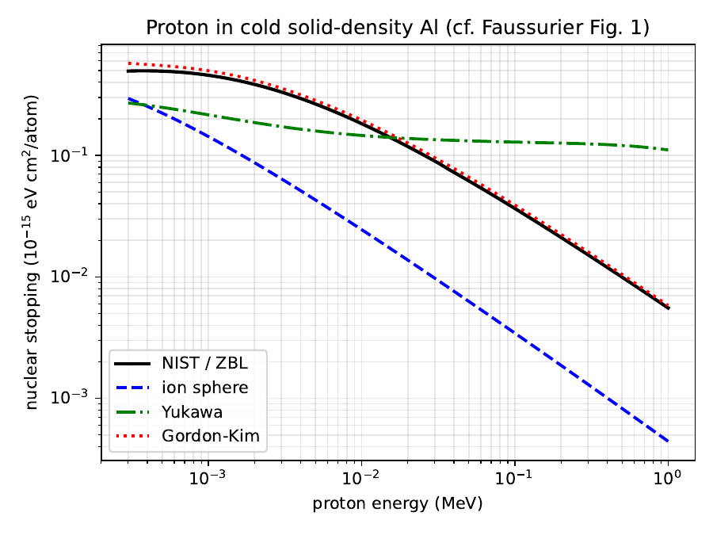
Figure 1. Proton in cold solid-density Al: ion-sphere, Yukawa, and Gordon–Kim nuclear stopping vs the NIST/ZBL reference. Gordon–Kim tracks NIST; the free-electron-screened analytic potentials fall below.
FAC vs. SCAALP (Fig. 2). The original model used the SCAALP average-atom model; here the densities come from FAC. For the recommended Gordon–Kim potential the two agree (and both land on NIST), because the potential is built from the total electron density, which integrates to Z independent of the average-atom model. The FAC mean ionization Z̄(Al) (2.97 cold → 12.8 at 1 keV, “nearly stripped”) matches SCAALP; the model-dependence appears only in the Z̄-based analytic potentials.
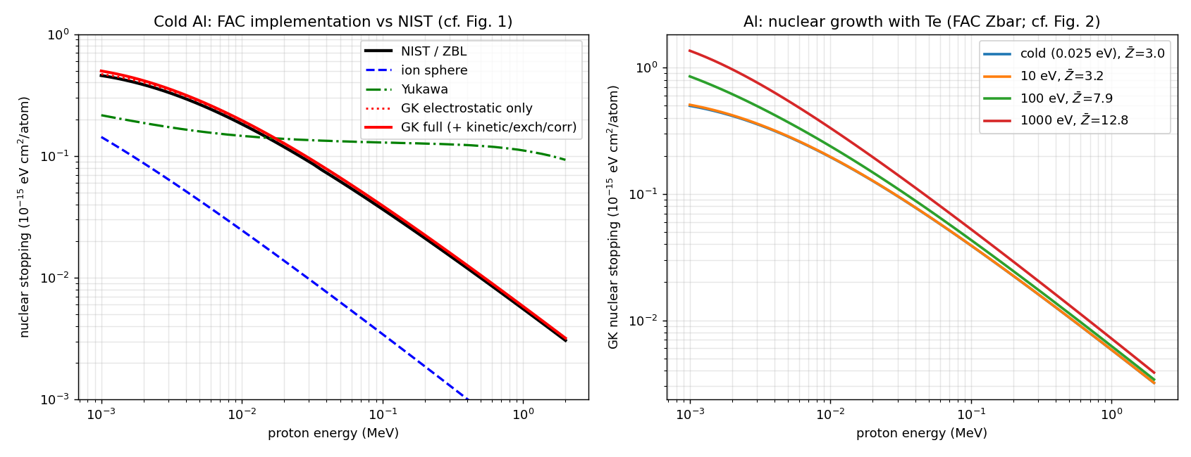
Figure 2. FAC implementation vs the paper. Left: cold-Al three potentials vs NIST. Right: Te-dependence of the Gordon–Kim nuclear stopping with the FAC mean ionization Z̄.
Fokker–Planck ion drag (Fig. 3). The finite-T ion stopping is the projectile-ion/target-ion term of the Fokker–Planck slowing-down. Driven by the same Maxwellian average and a Coulomb-log cross section, the model reproduces the analytic single-particle energy-gain threshold erf(x)/(x erf′(x)) = 1 + mₜ/m₀ in both mass-ratio regimes: for He in a fully-ionized H plasma at Te = Ti = 100 eV it gives E* = 134 eV, matching the MD-validated 132.7 eV in the source paper; for protons in ionized Al at 1 keV it gives E* = 164 eV (analytic 155 eV). The high-velocity magnitude reproduces the textbook ion–ion stopping 4πZ₀²Zₜ²e⁴nᵢ lnΛ/(mₜv²) with lnΛ ≈ 4–5.
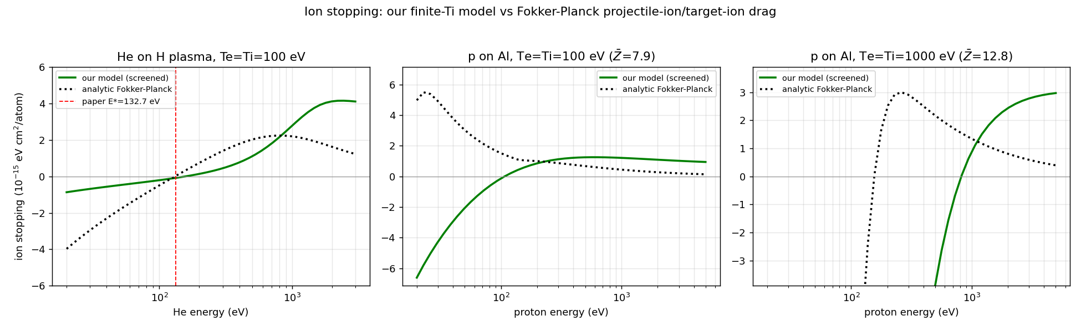
Figure 3. Finite-T ion stopping (our model) vs the analytic Fokker–Planck drag for He–H and p–Al, with the energy-gain thresholds. The paper’s MD-validated He–H threshold (132.7 eV) is reproduced.

E. Application — alpha self-heating in DT
As an end-to-end test of the total stopping power we treat a 3.5 MeV fusion alpha slowing in a DT plasma, integrating the slowing-down from 3.5 MeV to thermalization (the net stopping crosses zero near (3/2)kTe). The calculation reproduces the established ICF result (Fraley 1974; Mehlhorn 1981): the alpha deposits energy predominantly to electrons at low temperature and predominantly to ions above ~30 keV, with the electron/ion deposition fractions crossing at 28.9–32.6 keV for densities 0.213–100 g/cc, and an alpha range ρ_R of order 0.5 g/cm². The crossover arises because the electronic stopping falls as ~Te⁻³ᐟ² when the alpha becomes slow relative to the hot electrons, while the ion drag stays roughly flat.
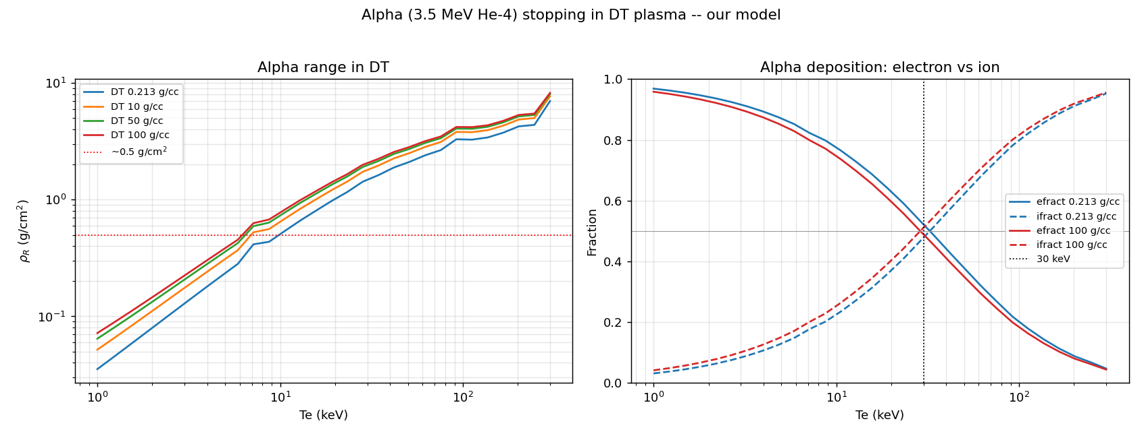
Figure 4. Alpha (3.5 MeV) in DT. Left: range ρ_R(Te) for several densities. Right: electron/ion deposition fractions, crossing at ~30 keV.

Verification summary
Check | Result
Rutherford scattering (analytic) | reproduced to < 10⁻⁶
Cold proton-Al nuclear (NIST/ZBL) | Gordon–Kim within ~7%
FAC vs SCAALP (Gordon–Kim) | agree; both match NIST
FP threshold, He–H (MD = 132.7 eV) | 134 eV (model 134; analytic 131)
FP threshold, p–Al at 1 keV | 164 eV (analytic 155)
alpha-DT e/ion crossover | 28.9–32.6 keV (≈ 30 keV)
alpha-DT range ρ_R | ≈ 0.5 g/cm² scale
LSS √E low-E electronic fix | slope −1.0 → +0.50; cold unchanged

Total stopping vs reference (optional figure)
For the cold insulators where the band-gap-corrected electronic stopping is calibrated, the figure below shows the total (best-κ electronic + Gordon–Kim nuclear) against PSTAR and experiment; the nuclear contribution fills part of the low-energy deficit.
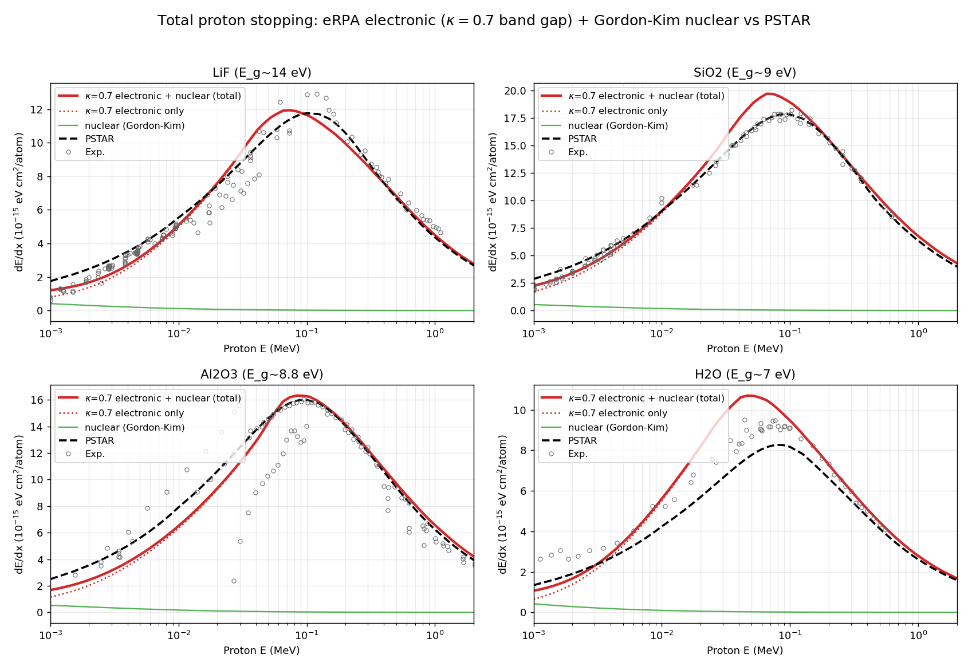
Figure 5. Total proton stopping (best-κ electronic + Gordon–Kim nuclear) vs PSTAR and experiment for LiF, SiO₂, Al₂O₃, H₂O.

F. Scope and limitations
- The Gordon–Kim potential is a frozen-density electron-gas model; its ~7% offset from the ZBL cold-nuclear reference is the expected sign and magnitude of frozen-density over-repulsion. The analytic ion-sphere/Yukawa potentials are provided for comparison and for fully-ionized conditions; the Yukawa form overestimates at high projectile energy (long screened-attractive tail), where the nuclear stopping is in any case negligible.
- The finite-T ion drag is the screened-potential generalization of the Fokker–Planck ion term; in the slow-projectile/heavy-field regime it differs from a fixed-lnΛ treatment because the screened cross section regularizes the Coulomb-log cutoff self-consistently.
- The projectile charge state is taken as fully stripped (exact for the proton/alpha cases here); a velocity-dependent effective charge is a natural extension.

