NAMA : DEDI IBRAHIM

NPM : 201843579086

TUGAS 1 MENCARI PROCEDURE ENQUEUE DAN DEQUEUE

A.Procedure enqueue dimana proses ini untuk memasukan nilai antrian

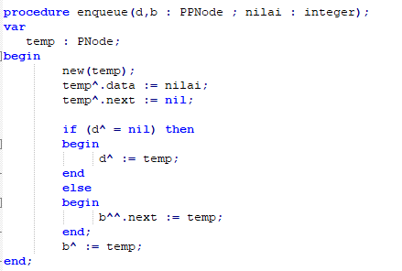

2.Procedure Dequeue dimana proses ini untuk menghapus nilai antrian

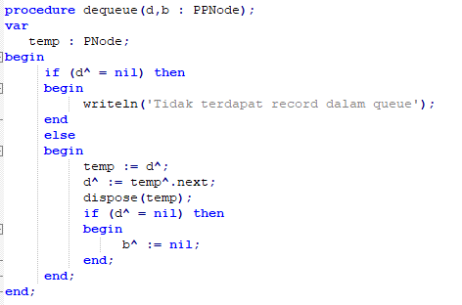

3.Output Queue

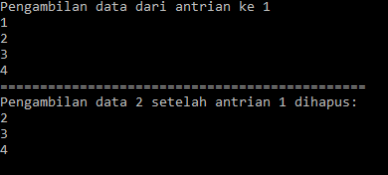

4.Sourcode queue;

Program antrian;

uses crt;

type

PPNode = ^PNode;

PNode = ^TNode;

TNode = record

data : integer;

next : PNode;

end;

procedure enqueue(d,b : PPNode ; nilai : integer);

var

temp : PNode;

begin

new(temp);

temp^.data := nilai;

temp^.next := nil;

if (d^ = nil) then

begin

d^ := temp;

end

else

begin

b^^.next := temp;

end;

b^ := temp;

end;

procedure dequeue(d,b : PPNode);

var

temp : PNode;

begin

if (d^ = nil) then

begin

writeln('Tidak terdapat record dalam queue');

end

else

begin

temp := d^;

d^ := temp^.next;

dispose(temp);

if (d^ = nil) then

begin

b^ := nil;

end;

end;

end;

procedure tampilkan(q : PNode);

var

nilai : integer;

begin

while(q<> nil) do

begin

nilai := q^.data;

writeln(nilai);

q := q^.next;

end;

end;

var

kiri, kanan : PNode;

begin

clrscr;

kiri := nil;

kanan := nil;

enqueue(@kiri, @kanan, 1);

enqueue(@kiri, @kanan, 2);

enqueue(@kiri, @kanan, 3);

enqueue(@kiri, @kanan, 4);

writeln('Pengambilan data dari antrian ke 1');

tampilkan(kiri);

dequeue(@kiri, @kanan);

writeln('==============================================');

writeln('Pengambilan data 2 setelah antrian 1 dihapus: ');

tampilkan(kiri);

readln;

end.

TUGAS 2 MEMBUAT INPUTAN ID,NAMA,GAJI,GOL MASUKAN DATA DAN TAMPILKAN DATA

1.OUTPUT MENU PILIHAN

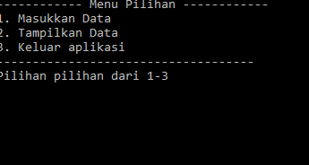

2.OUT PUT MENU MASUKAN DATA

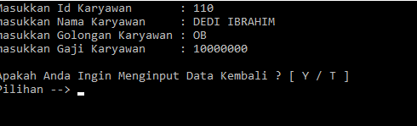

3.OUTPUT MENU TAMPILKAN DATA

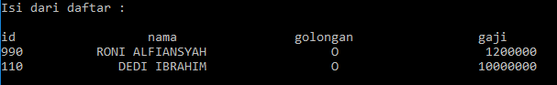

4.SOURCECODE

Program programStack;

Uses crt;

type

ListPointer = ^Listrecord;

Listrecord = record

id, nama : string;

golongan : char;

gaji : real;

NextField : ListPointer

end;

var

FirstPointer : ListPointer;

procedure BuildList(

var

FirstPointer: ListPointer;

id : string;

nama : string;

golongan : char;

gaji : real

);

var

ToolPointer : ListPointer;

begin

NEW(ToolPointer);

ToolPointer^.id := id;

ToolPointer^.nama := nama;

ToolPointer^.golongan := golongan;

ToolPointer^.gaji := gaji;

ToolPointer^.NextField := FirstPointer;

FirstPointer := ToolPointer

end;

procedure ReadList ( FirstPointer : ListPointer);

var

CurrentPointer : ListPointer;

begin

CurrentPointer := FirstPointer;

writeln ('id nama golongan gaji');

while CurrentPointer <> NIL DO

begin

writeln(CurrentPointer^.id, CurrentPointer^.nama:25, CurrentPointer^.golongan:18, CurrentPointer^.gaji:27:0);

CurrentPointer := CurrentPointer^.NextField;

end;

end;

procedure InputData(var FirstPointer : ListPointer);

var

id, nama : string;

golongan : char;

gaji : real;

ulang : char;

begin

ulang := 'Y';

while upcase (ulang) = 'Y' do

begin

clrscr;

write ('Masukkan Id Karyawan : '); readln(id);

write ('masukkan Nama Karyawan : '); readln(nama);

write ('masukkan Golongan Karyawan : '); readln(golongan);

write ('masukkan Gaji Karyawan : '); readln(gaji);

BuildList(FirstPointer, id, nama, golongan, gaji);

writeln;

writeln ('Apakah Anda Ingin Menginput Data Kembali ? [ Y / T ]');

write ('Pilihan --> '); readln(ulang);

end;

end;

procedure PrintData(FirstPointer : ListPointer);

begin

clrscr;

writeln('Isi dari daftar : ');

writeln;

ReadList(FirstPointer);

writeln;

write('Tekan sembarang tombol untuk lanjut...');

readln

end;

procedure Menu;

var

Option : integer;

begin

clrscr;

writeln('------------ Menu Pilihan ------------');

writeln('1. Masukkan Data');

writeln('2. Tampilkan Data');

writeln('3. Keluar aplikasi');

writeln('------------------------------------');

write('Pilihan pilihan dari 1-3');

readln(Option);

CASE Option OF

1 : InputData(FirstPointer);

2 : PrintData(FirstPointer);

3 : exit;

end;

Menu

end;

begin

clrscr;

FirstPointer := NIL;

menu

end.