KETERANGAN TUGAS INDIVIDU JARINGAN KOMPUTER

Nama : Dedi Ibrahim

NPM : 201843579086

1. Tentukan Topologi jaringan untuk setiap Divisi
2. Divisi Marketing Menggunakan Topologi Star

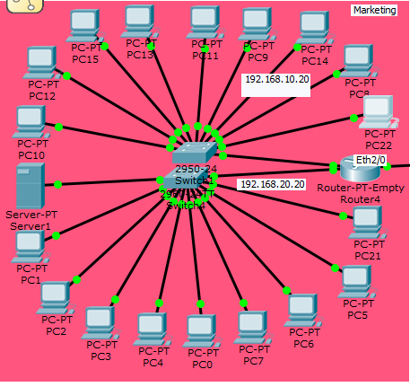

1. Divisi Personalia Menggunakan topologi Star

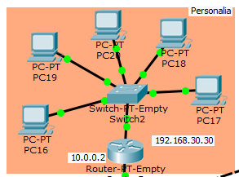

1. Divisi Keuangan Menggunakan topologi Star

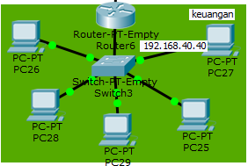

1. Gambarkan Topologi dengan kondisi diatas

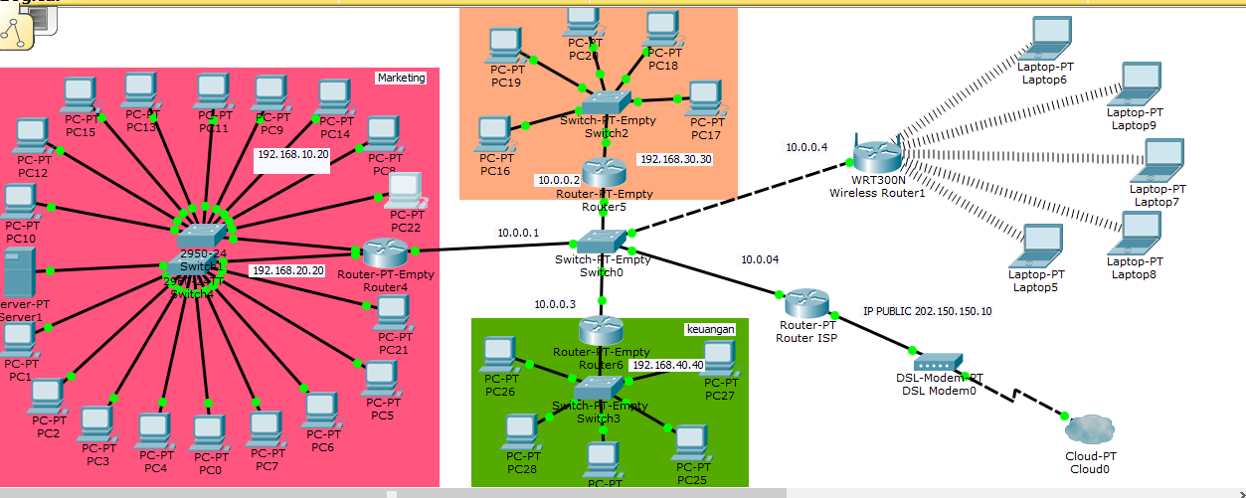

1. Tentukan Subnet Mask Default ,Network ID dari HOST ID dari IP Tersebut

|  |  |  |  |  |
| --- | --- | --- | --- | --- |
| Divisi | Network ID Kelas C | | HOST ID | |
| Marketing | 192 | 168 | 10 | 10 |
| 192 | 168 | 20 | 20 |
| Personalia | 192 | 168 | 30 | 30 |
| Keuangan | 192 | 168 | 40 | 40 |

1. Subnneting Untuk IP Address 202.150.150.10

|  |  |
| --- | --- |
| PC | Subnetting Mask |
| Divisi Keuangan | |
| PC 1 | 255.255.255.0 |
| PC 2 | 255.255.255.0 |
| PC 3 | 255.255.255.0 |
| PC 4 | 255.255.255.0 |
| PC 5 | 255.255.255.0 |
| PC 6 | 255.255.255.0 |
| PC 7 | 255.255.255.0 |
| PC 8 | 255.255.255.0 |
| PC 9 | 255.255.255.0 |
| PC10 | 255.255.255.0 |
| PC 11 | 255.255.255.0 |
| PC 12 | 255.255.255.0 |
| PC 13 | 255.255.255.0 |
| PC 14 | 255.255.255.0 |
| PC 15 | 255.255.255.0 |
| PC 16 | 255.255.255.0 |
| PC 17 | 255.255.255.0 |
| PC 18 | 255.255.255.0 |
| Divisi Marketing | |
| PC 1 | 255.255.255.0 |
| PC 2 | 255.255.255.0 |
| PC 3 | 255.255.255.0 |
| PC 4 | 255.255.255.0 |
| PC 5 | 255.255.255.0 |
| Divisi Personalia | |
| PC 1 | 255.255.255.0 |
| PC 2 | 255.255.255.0 |
| PC 3 | 255.255.255.0 |
| PC 4 | 255.255.255.0 |
| PC 5 | 255.255.255.0 |

1. Tentukan Network ID ,IP Broadcast, dan range IP

|  |  |  |  |
| --- | --- | --- | --- |
| Divisi Marketing | | | |
| Network ID | IP Broadcast | Range IP | Subnetting mask |
| 192.168.10.10 | 192.168.10.1 | 1-9 | 255.255.255.0 |
| 192.168.10.10 | 192.168.10.2 |
| 192.168.10.10 | 192.168.10.3 |
| 192.168.10.10 | 192.168.10.4 |
| 192.168.10.10 | 192.168.10.5 |
| 192.168.10.10 | 192.168.10.6 |
| 192.168.10.10 | 192.168.10.7 |
| 192.168.10.10 | 192.168.10.8 |
| 192.168.10.10 | 192.168.10.9 |
| 192.168.20.20 | 192.168.20.1 | 1-9 | 255.255.255.0 |
| 192.168.20.20 | 192.168.20.2 |
| 192.168.20.20 | 192.168.20.3 |
| 192.168.20.20 | 192.168.20.4 |
| 192.168.20.20 | 192.168.20.5 |
| 192.168.20.20 | 192.168.20.6 |
| 192.168.20.20 | 192.168.20.7 |
| 192.168.20.20 | 192.168.20.8 |
| 192.168.20.20 | 192.168.20.9 |
| Divisi Personalia | | | |
| 192.168.30.30 | 192.168.30.1 | 1-5 | 255.255.255.0 |
| 192.168.30.30 | 192.168.30.2 |
| 192.168.30.30 | 192.168.30.3 |
| 192.168.30.30 | 192.168.30.4 |
| 192.168.30.30 | 192.168.30.5 |
| Divisi Keuangan | | | |
| 192.168.40.40 | 192.168.40.1 | 1-5 | 255.255.255.0 |
| 192.168.40.40 | 192.168.40.1 |
| 192.168.40.40 | 192.168.40.1 |
| 192.168.40.40 | 192.168.40.1 |
| 192.168.40.40 | 192.168.40.1 |