**Design Document**

**Banana Project**

Made by:

Dmitrii Orlov

Deividas Lembertas

**22-02-2016**

**Content**

1. Project Banana Description p. 3
2. The Target Audience p. 4
3. Sitemap p. 5
4. Wireframes p. 6- 8
5. Visual Design p. 9- 11

**Project Banana Description**

Project Banana is a not-for-profit co-operative based in Eindhoven, which works for fair and sustainable banana trades. We raise awareness of the poor living and working conditions faced by plantation workers and small producers all over the world.

Your support can help us to make some impact. Buying tropical fruit is often the closest relationship any of us have with the developing world. The consumer choices we make can – and do – have a direct impact on how people are employed and paid, and how their environment is treated.

Project Banana works for fair and equitable production and trade in bananas based on environmental, social and economic sustainability.

**The Target Audience**

The Project Banana will target people aged between 30 and 45. We aim for people who had at least completed their undergraduate program. The Project Banana does not discriminate between social- economic status, religion, culture and gender. This gives every donator equal access, value and opportunity to support our views, ideas and project in general.

These people are aware of surrounding problems and they are able to understand that even with a small contribution they can make a big difference to the less fortunate social groups. In our case, banana production is exposed to many potential health dangers due to the use of chemicals, such as fungicides and herbicides, in conventional plantations. Thus our target audience, being aware of the situation, like to directly support the development of sustainable and organic banana farming. Others search for more fair distribution of money in banana industry.

**Sitemap**

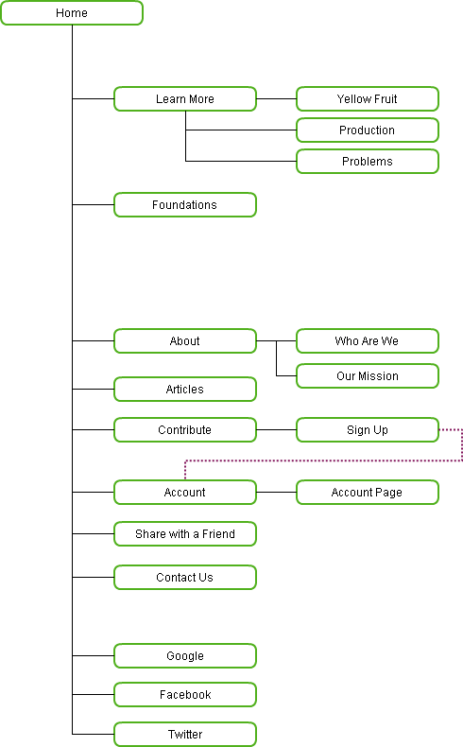

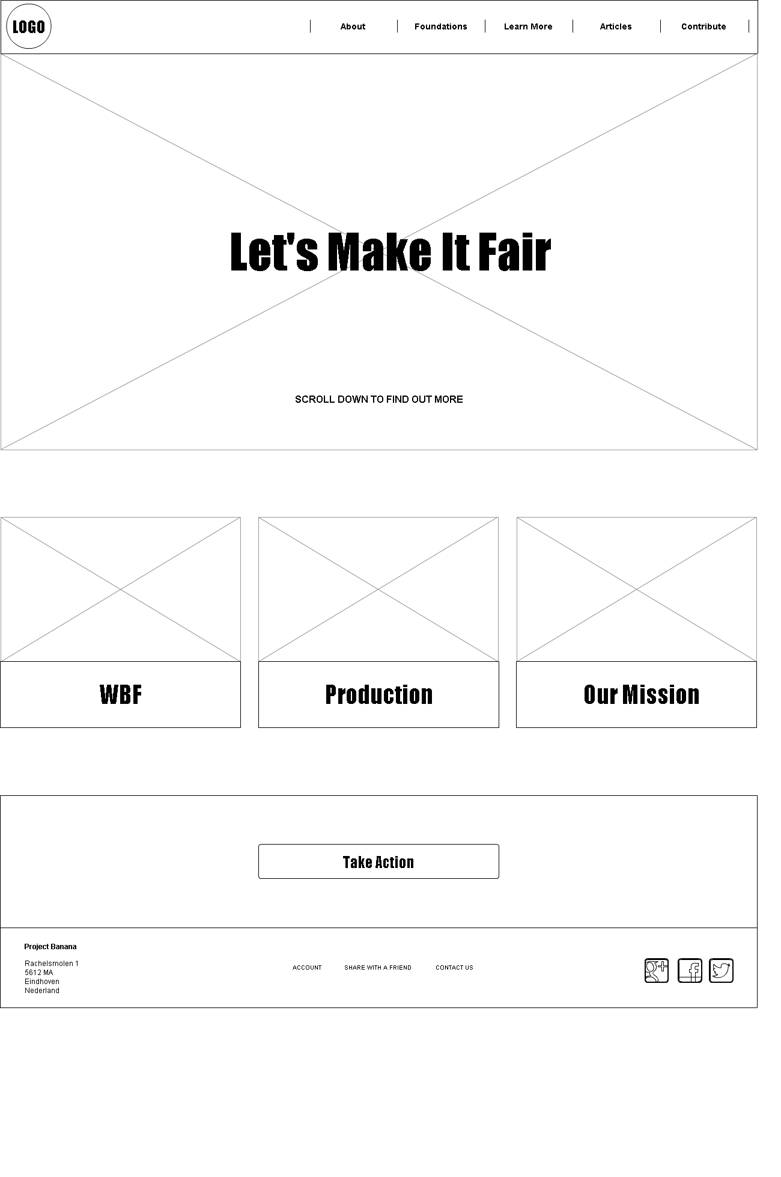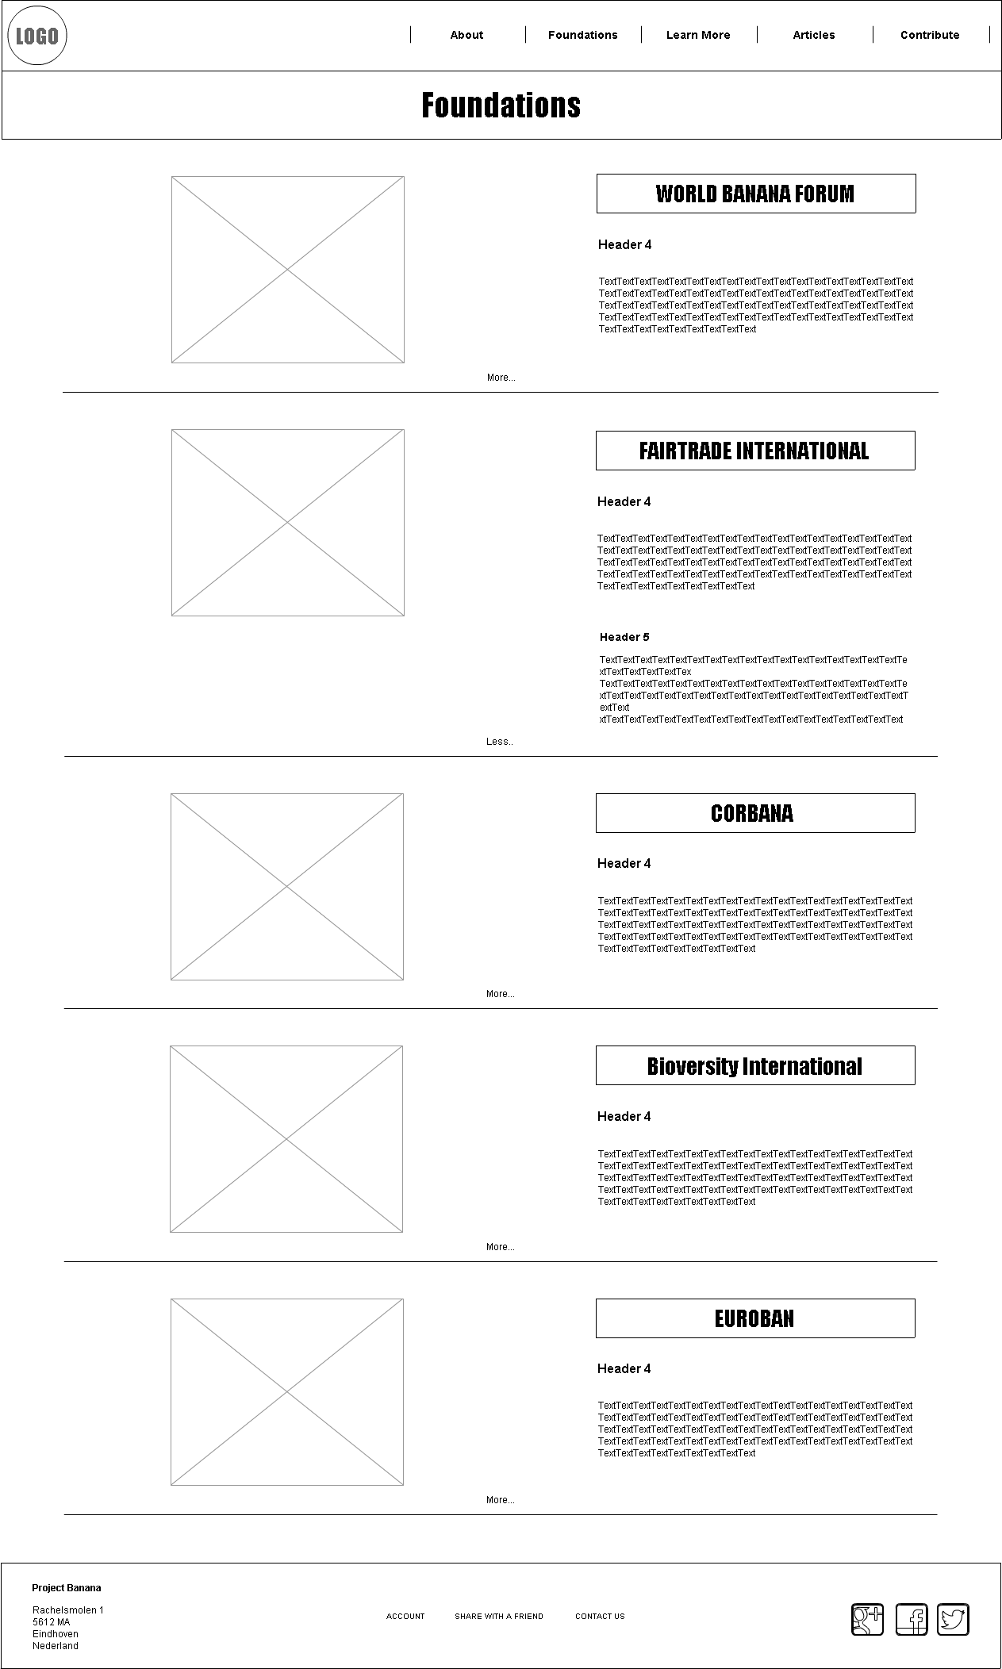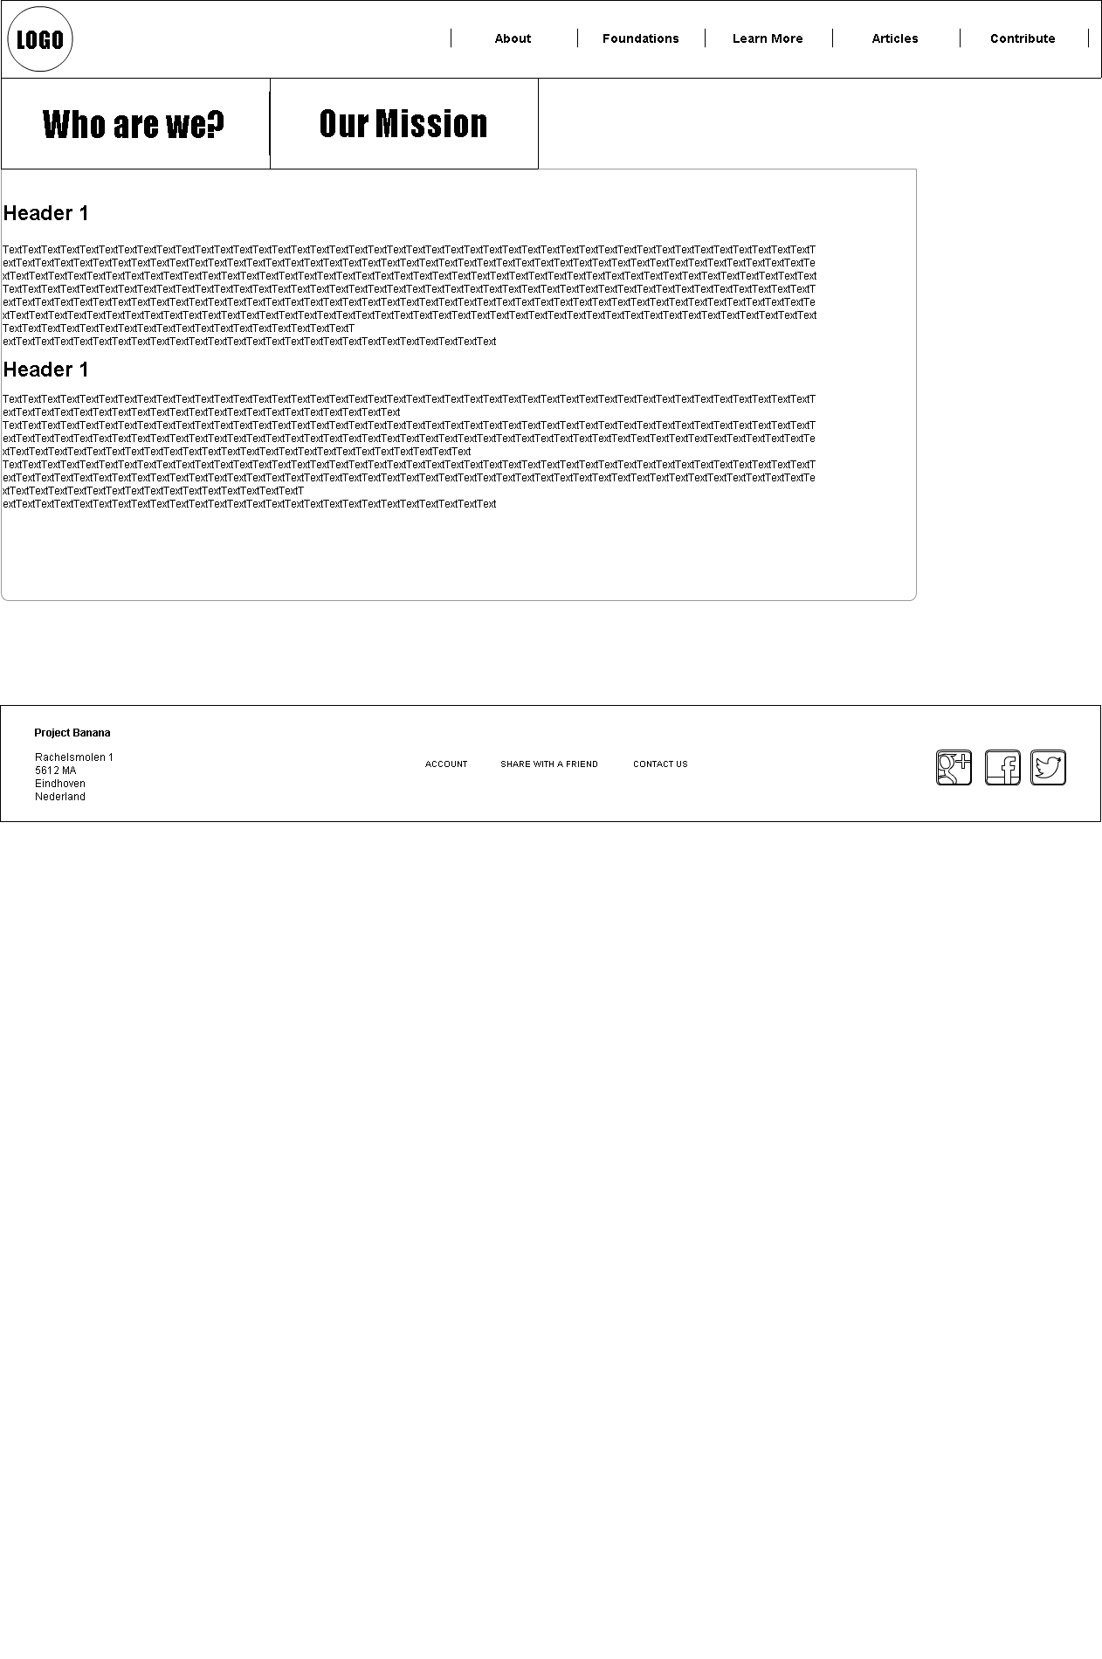**Wireframes**

**2**

**1**

**3**

1. **Home Page**
2. **About**
3. **Foundations**

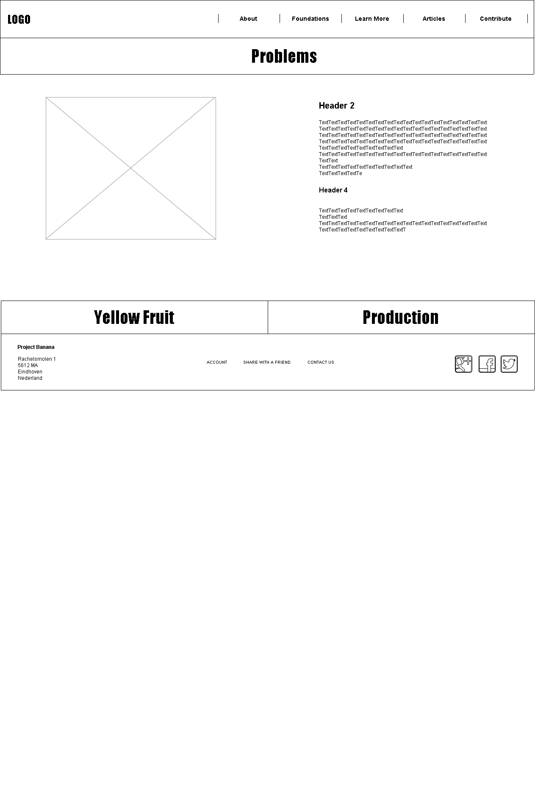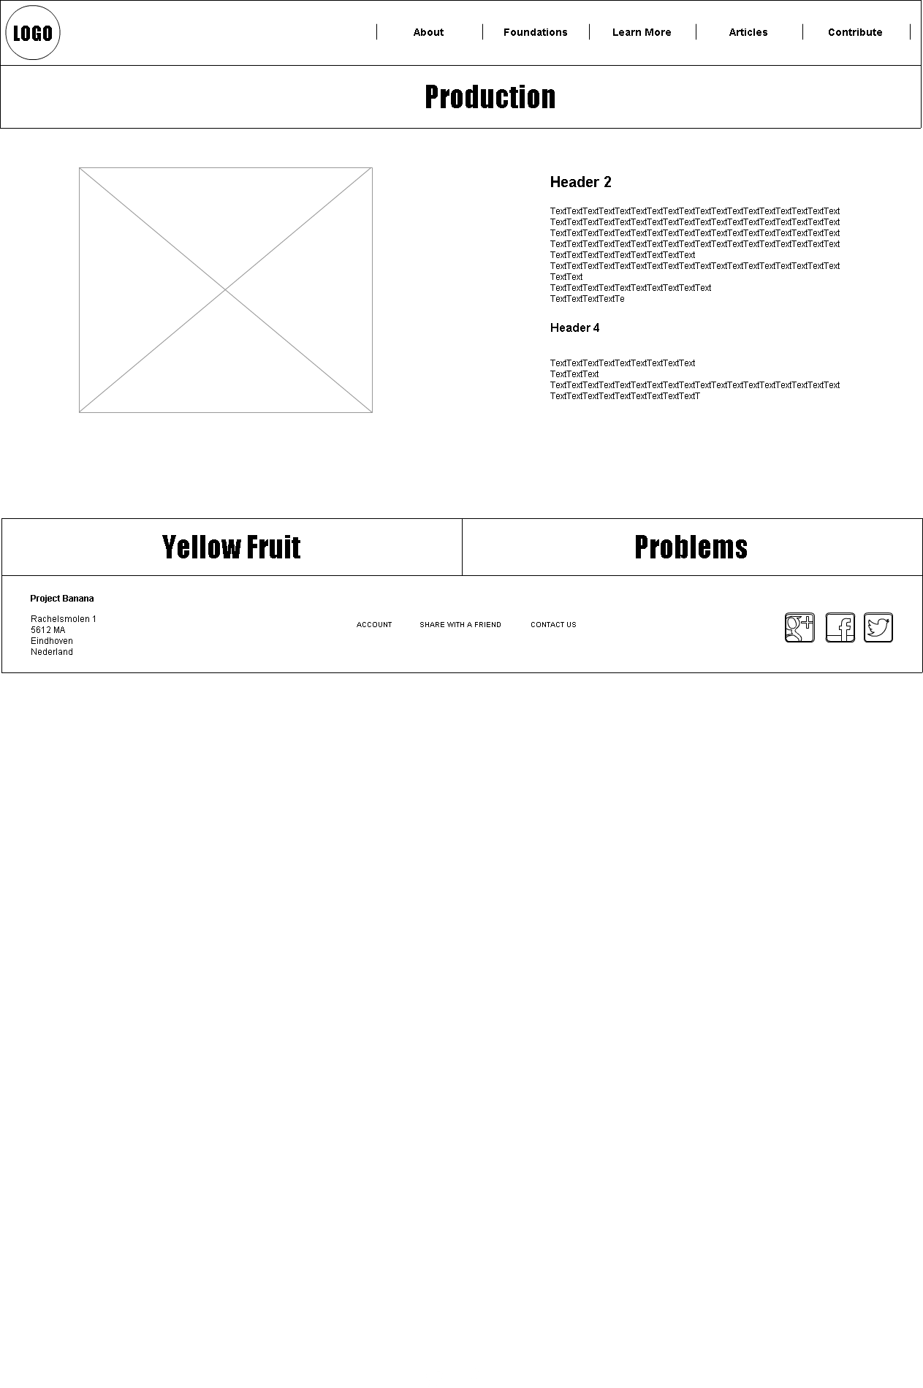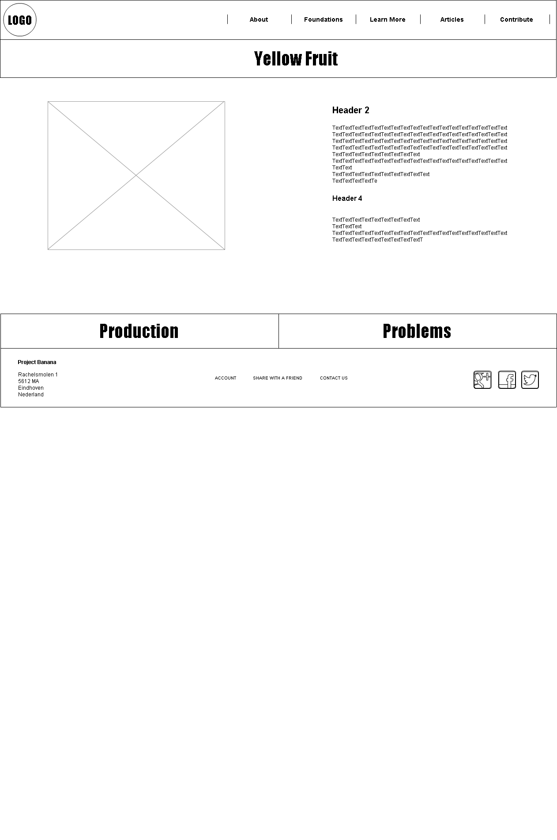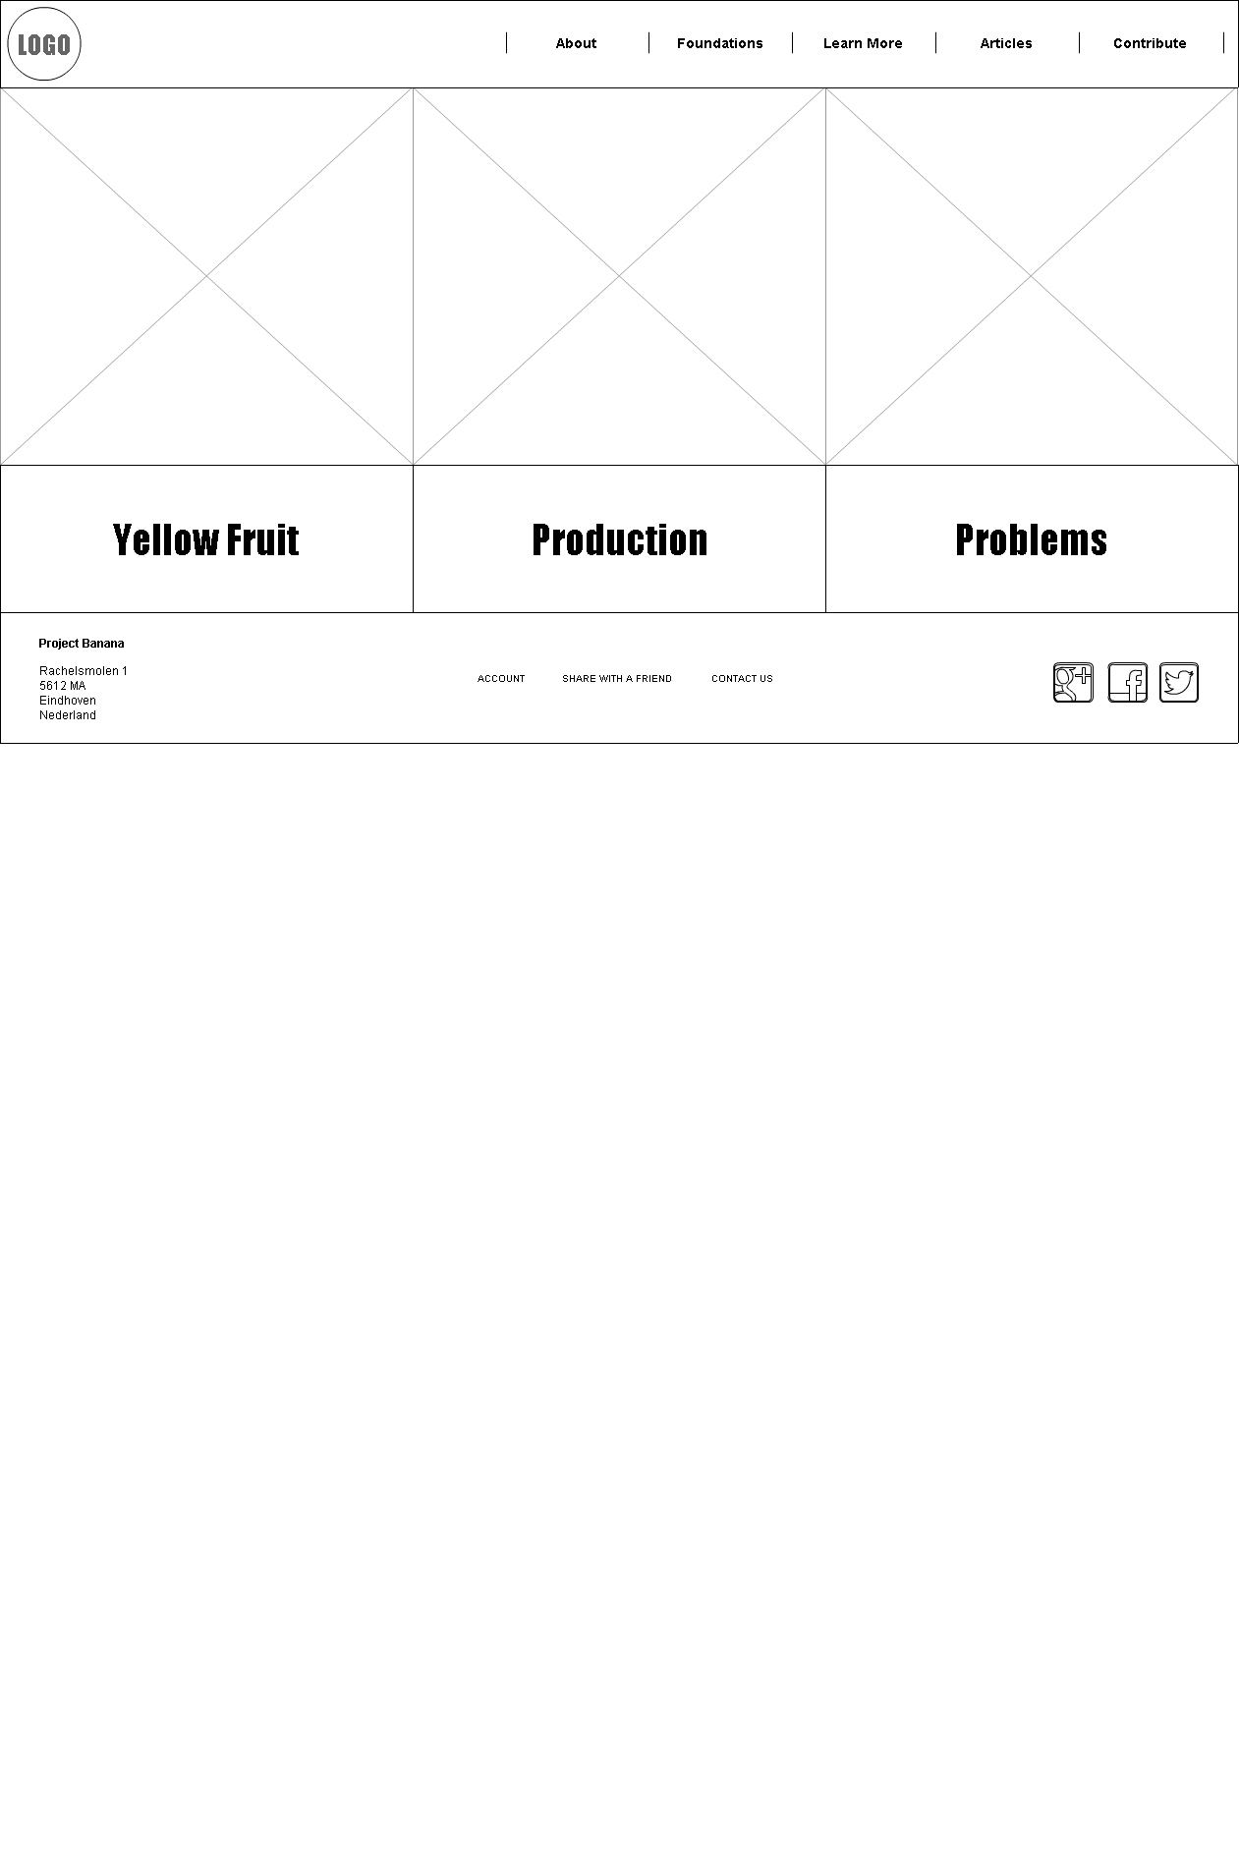

**7**

**6**

**5**

**4**

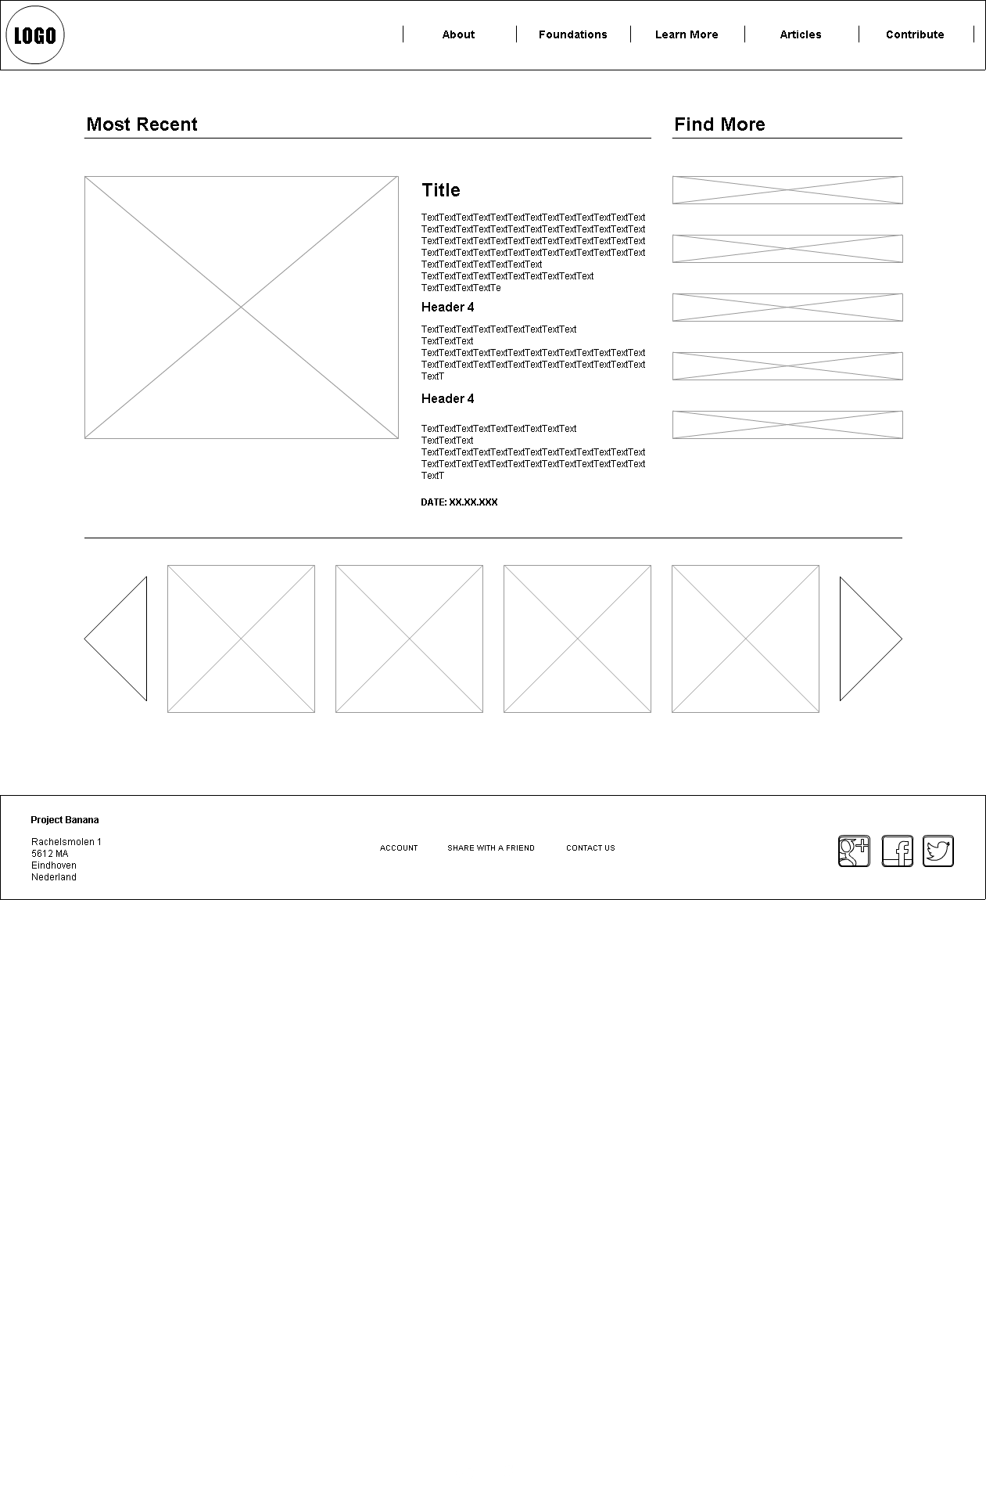

**8**

1. **Learn More**
2. **Learn More (Yellow Fruit)**
3. **Learn More (Problems)**
4. **Learn More (Production)**
5. **Articles**

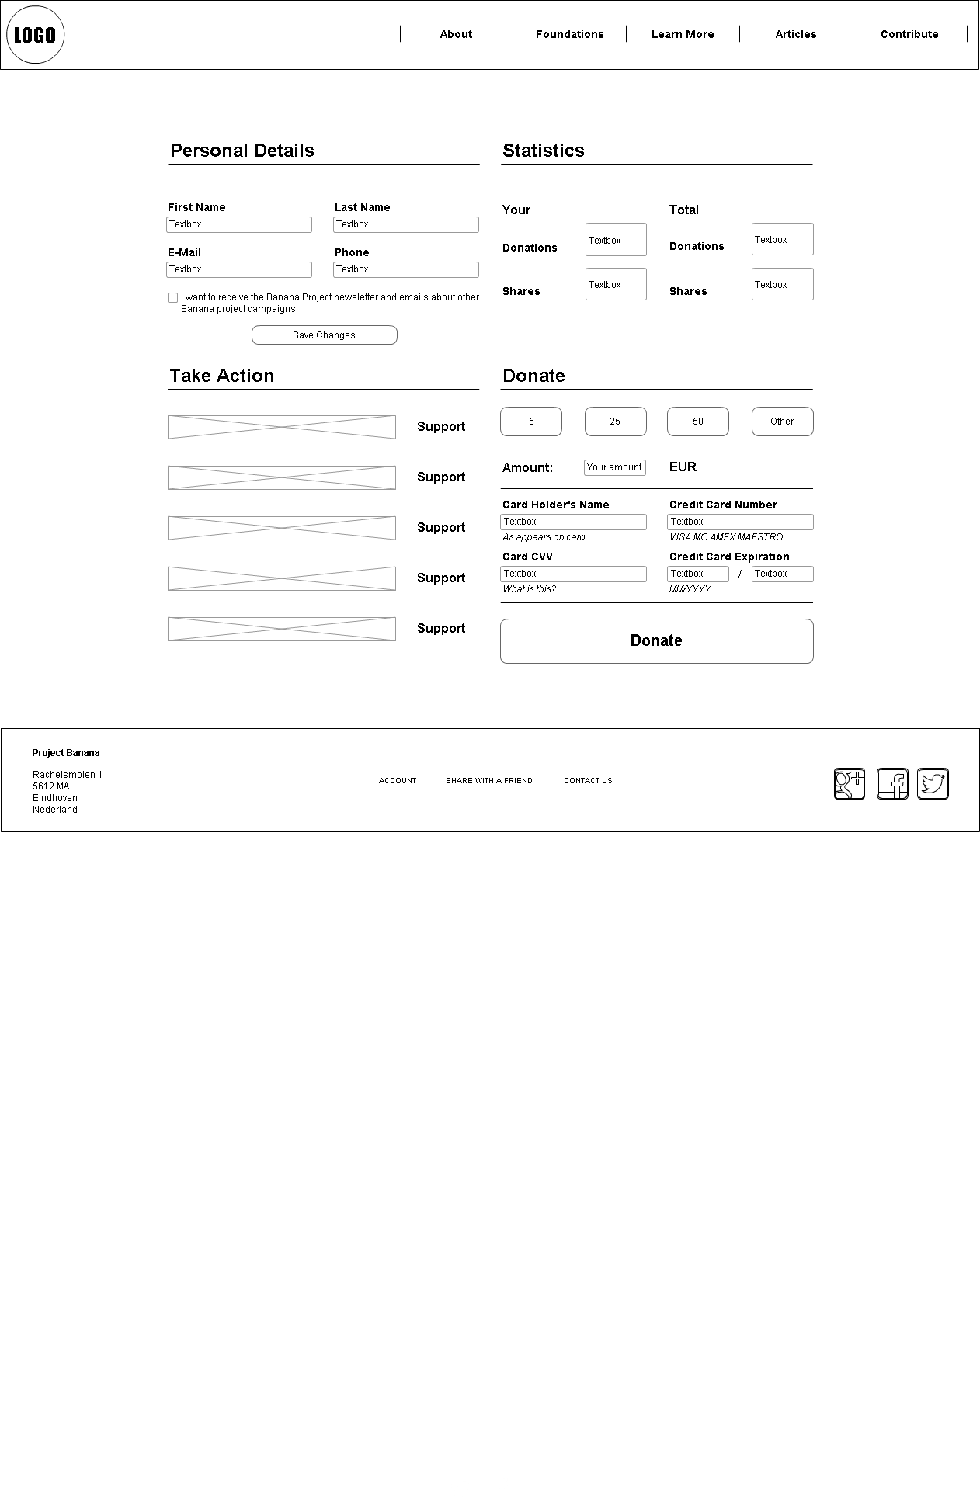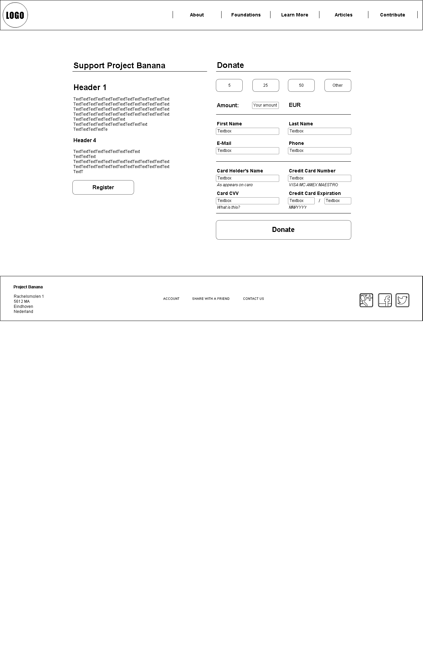

**10**

**9**

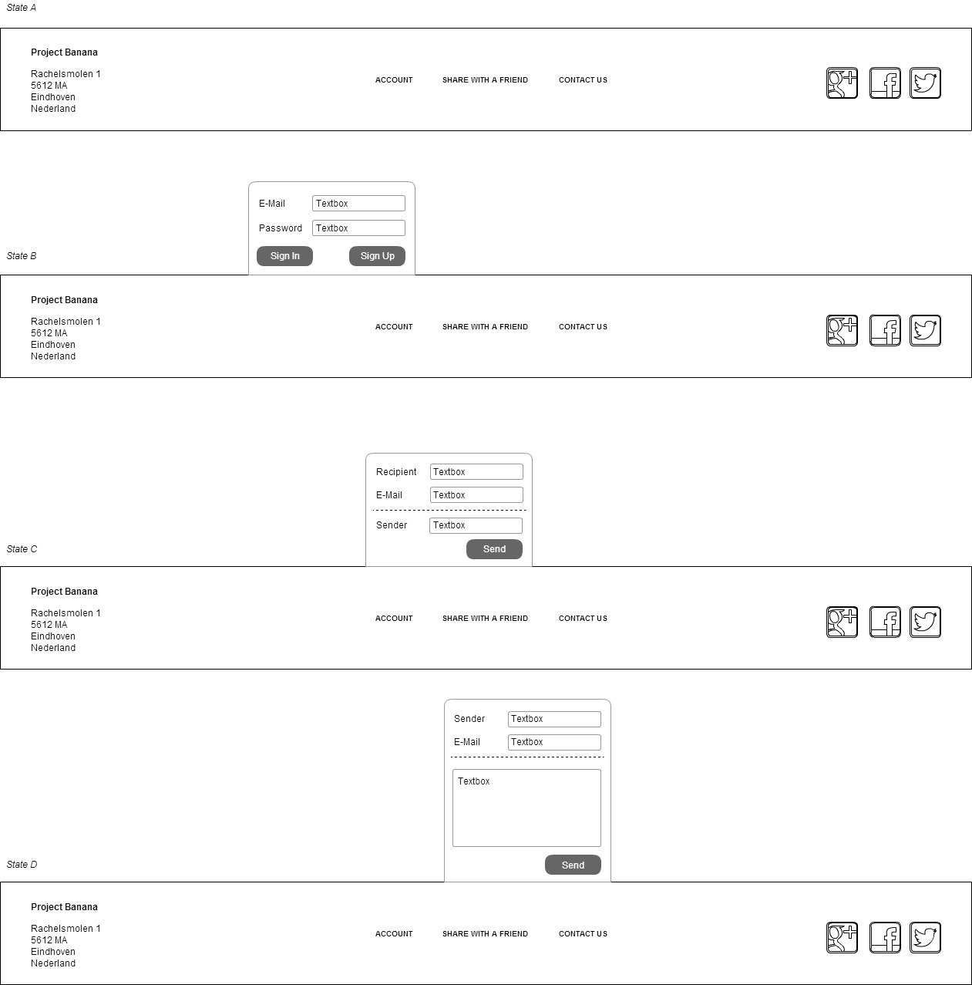

**12**

**11**

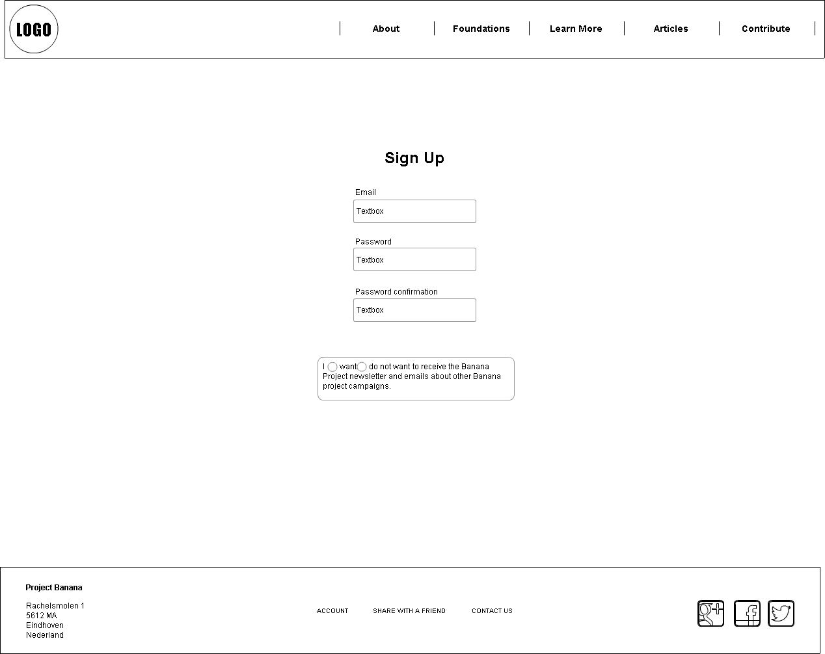

1. **Personal Page**
2. **Contribute**
3. **Sign Up**
4. **Bottom Footer States**

**Visual Design**

1. Home Page (State 0)

The initial page, which the user will encounter on our website.

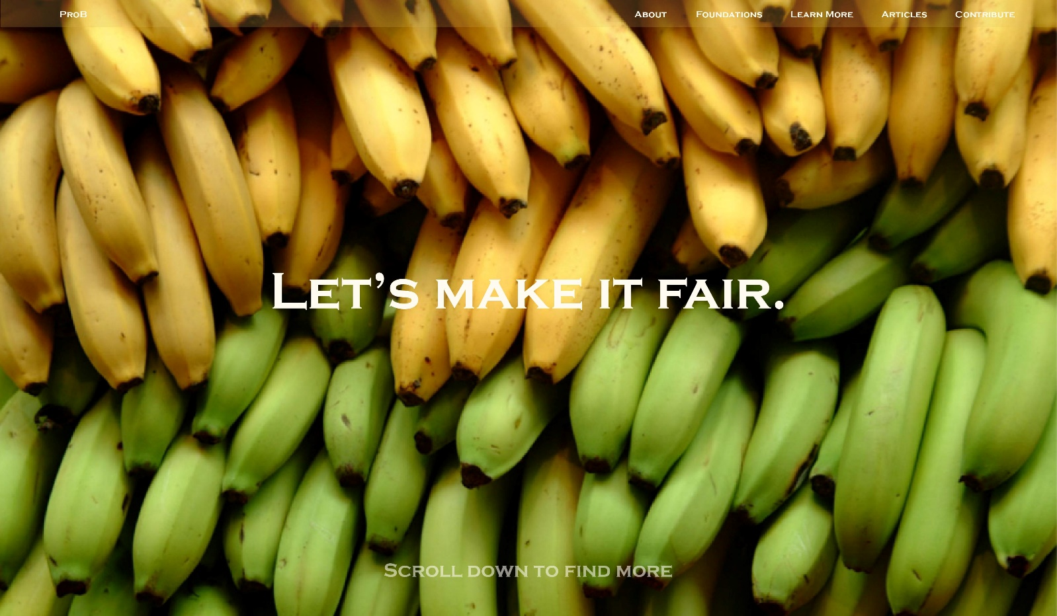

2. Home Page (State 1) – Scrolled Down

The same page, once the user had scrolled down. Here you find the links to the specific content of the website such as Contribute Page and find other useful information regarding our project.

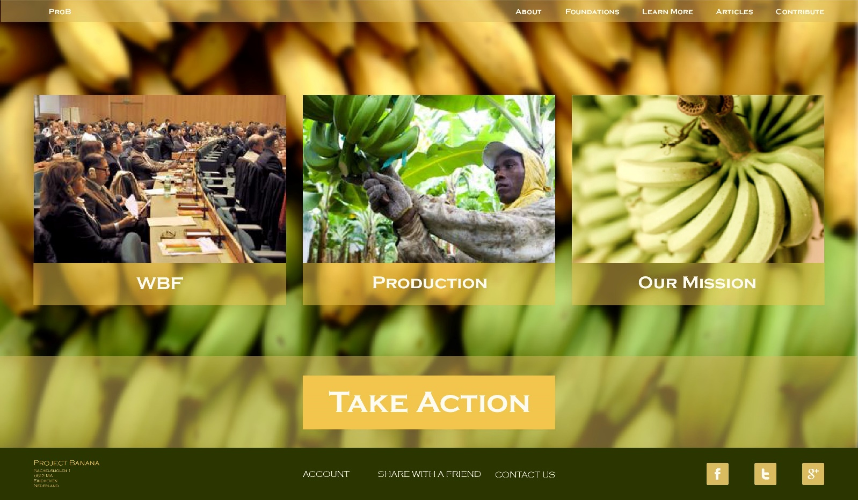

3. Foundations Page

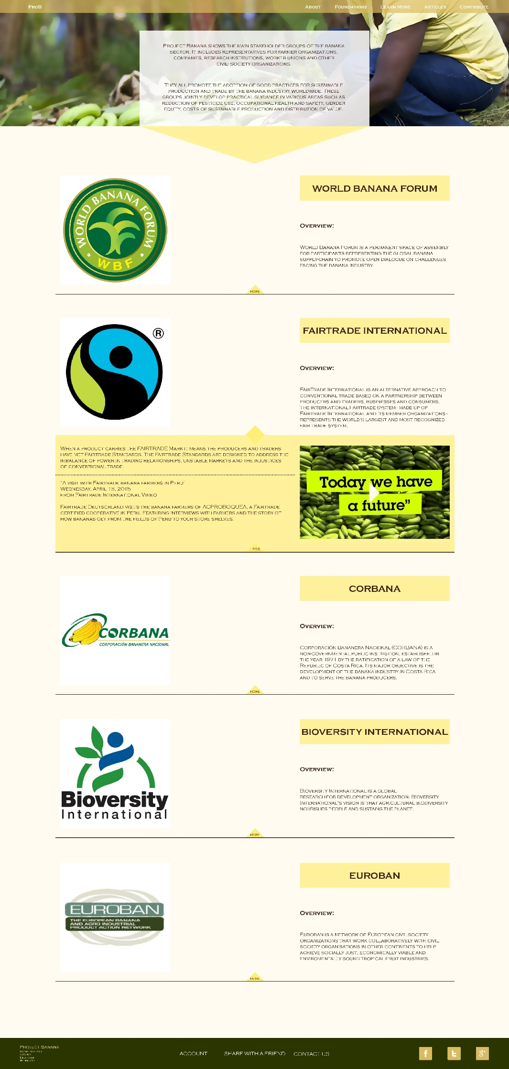

4. Articles Page

Here the user may find relevant news and featured content.

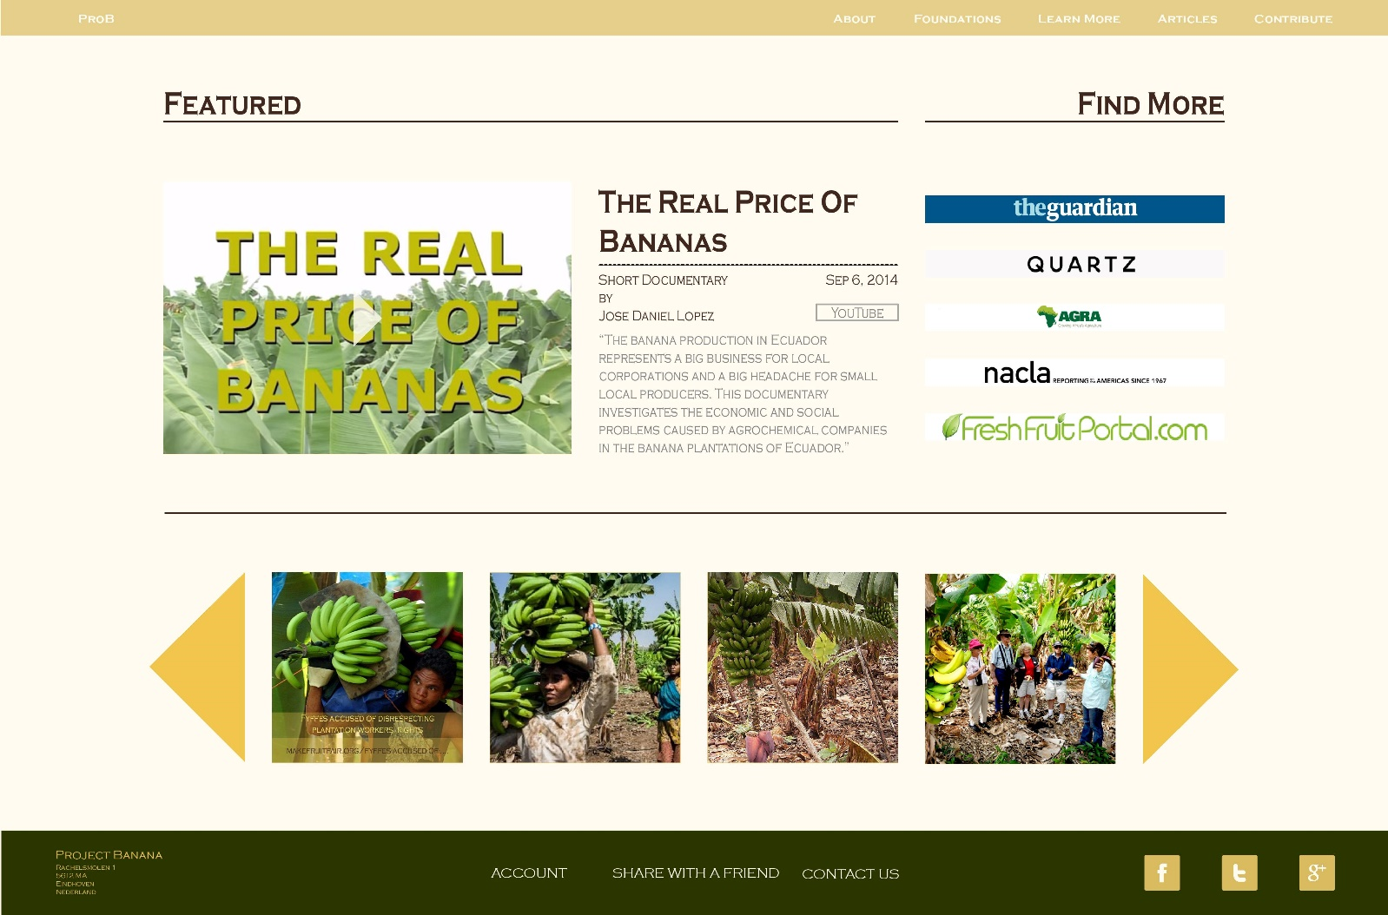

5. Sign Up Page

