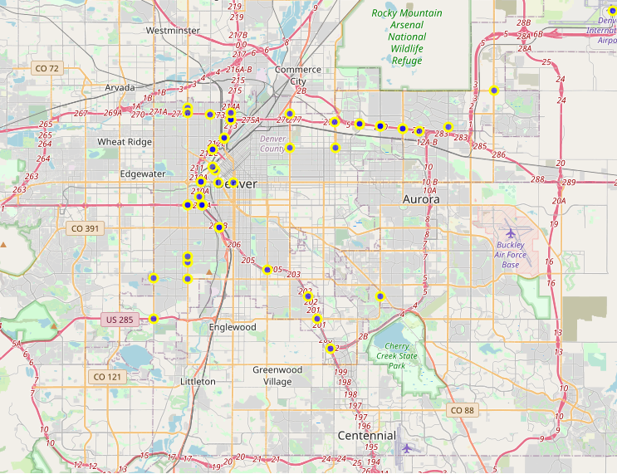

<https://assessment.datacamp.com/data-manipulation-with-python>

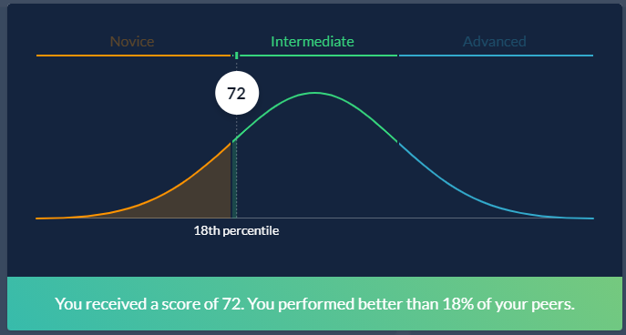

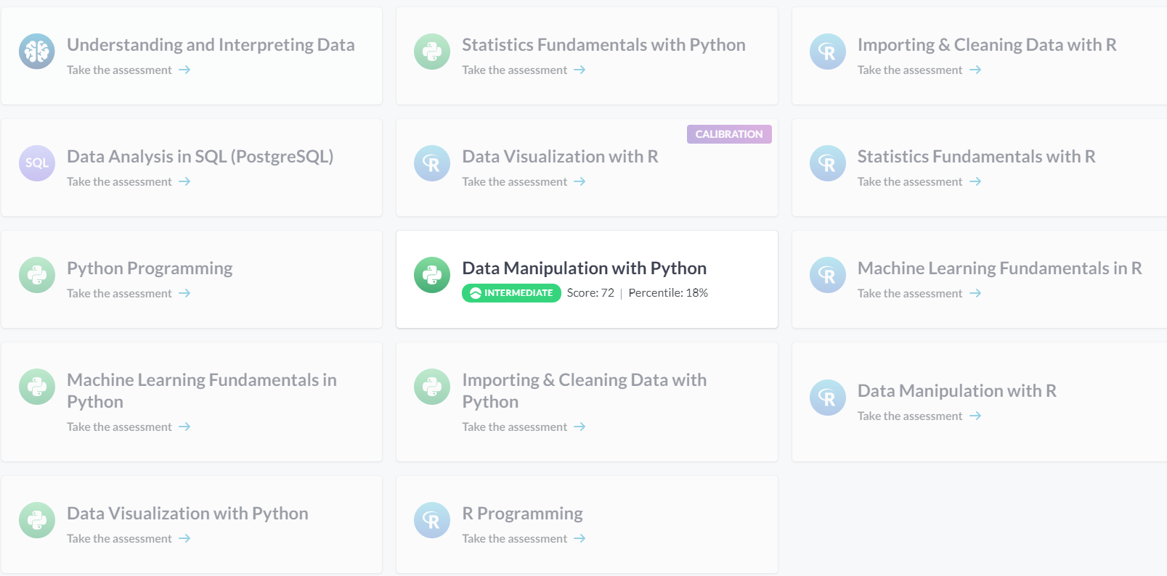

https://colab.research.google.com/drive/1ff9qB6xr7S5Lv4qkrfJjptl1POq_b6rs?usp=sharing