***User Requirements Specification***

Software solution for “Media Bazaar” GROUP 1

Members: Bohdan Tymofieienko, Stelian Rumenov, Andreea

Sindrilaru, Andrei Sava.

Tutor: Pencheva, Sabina S.

Date: 11/04/2021

Version: 1.1

***Table of contents***

**Agreements with client** **3**

**Functional requirements** **and prioritizing table 4**

**Use cases 8**

**Appendix A 34**

**Appendix B 35**

**Revision Table 36**

## Agreements with client

### Sides:

Client: Media Bazaar represented by Andre Postma, *“Client”* later in this document.

Contractor: Group 1 (name TREE), *“Contractor”* later in this document.

### Agreements:

1. Contractor does the problem analysis.
2. Contractor prepares the problem solution in form of information system.
3. Contractor implements the solution in form of standalone software application for Windows operating system.

Application is intended for employee management and shift scheduling. More information can be found in the “Project plan document. Software solution for Media Bazaar.”

1. Team presents the product to the Client.
2. First phase of the project must be completed before March 25th.

## Functional requirements

* All the requirements were discussed with client. *“User” later in the document is an abstract alias to describe the functionality.*
* *MoSCoW table represents four levels of task prioritizing. The abbreviation stands for Must, Should, Could and Won’t. You may find it in the column 4 (“Priority”).*

*We consider it crucially important to define priorities before implementation phase, so both developers and client have realistic expectations on project results.*

* *Naming convention:*

*{FR-(Abbreviation from user’s type name)-(count in two-digit format)}*

***Waterfall phase (until March 25th):***

|  |  |  |  |
| --- | --- | --- | --- |
| ID | Name | Description | Priority |
| Administration side | | | |
| **FR-A-01** | Login | User can login to the system with personal credentials | Must |
| **FR-A-02** | Change password | User can change the password | Must |
| **FR-A-03** | View employees | User can view list of employees | Must |
| **FR-A-04** | View employee’s details | User can view employee’s details |  |
| **FR-A-05** | Add employee | User can add new employee to the system  *See “Appendix A” for*  *information stored about employees* | Must |
| FR-A-06 | Update employee | User can update employee information | Must |
| FR-A-07 | Modify employee status | User can modify employee status  (Not started yet, working, stopped) | Must |
| FR-A-08 | View  shift schedule | User can view overall work shift schedule for a selected period of time. | Must |
| FR-A-9 | Assign  shifts to employee | User can assign one of the three shifts to employee.   * 1. Morning   (7:00 – 15:00)   * 1. Day   (15:00 – 23:00)   * 1. Night   (23:00 – 7:00) | Must |
| FR-A-10 | Update  employee’s schedule | User can update information concerning employee’s schedule. | Must |
| FR-A-11 | Cancel  employee’s  shift | User can cancel shift assignment for the employee | Must |
| FR-A-12 | Add  administrator | User can add new administrator to the system | Should |
| FR-A-13 | Add  manager | User can add new manager to the system | Should |

|  |  |  |  |
| --- | --- | --- | --- |
| ID | Name | Description | Priority |
| Management side | | | |
| **FR-M-01** | Login | User can login to the system with personal credentials | Must |
| **FR-M-02** | Change password | User can change the password | Must |
| **FR-M-03** | View employees | User can view list of employees | Must |
| FR-M-04 | View employee’s details | User can view employee’s details | Must |
| FR-M-05 | View  shift schedule | User can view overall work shift schedule for a selected period of time. | Must |
| FR-M-06 | View statistical information | User can view statistical information.  ***For a selected date :***   1. Total number of employees. 2. Total salary paid. 3. Total number of hours worked.   ***For a selected time period:***   1. Average number of employees per work shift. 2. Total salary paid to all employees. 3. Average hourly wage per employee 4. Total number of hours worked by all employees. 5. Average number of hours worked by an employee. | Should |

*Please note: More than one iteration is expected soon. In the section bellow we describe first iteration of length of 3 weeks (until April 18th, 2021).*

*See “Project plan. Phasing” for more details.*

***Iteration I (until April 18th):***

|  |  |  |  |  |
| --- | --- | --- | --- | --- |
| ID | Name | Description | Priority | Use case |
| **Employee side** | | | | |
| **FR-E-01** | Login | User can login to the website with personal credentials. | Must | US-W-01 |
| **FR-E-02** | Logout | User can logout from the system. | Must | US-W-02 |
| **FR-E-03** | Change password | User can change his/her password | Must | US-W-03 |
| **FR-E-04** | Change first name | User can change his/her first name | Must | US-W-04 |
| **FR-E-05** | Change last name | User can change his/her last name | Must | US-W-04 |
| **FR-E-06** | Change Address | User can change his/her address | Must | US-W-04 |
| **FR-E-07** | Change email address | User can change his/her email address | Must | US-W-04 |
| **FR-E-08** | Change username | User can change his/her username | Must | US-W-04 |
| **FR-E-09** | Change password | User can change his/her automated generated password | Must | US-W-04 |
| **FR-E-10** | View schedule | User can view own schedule for a certain week. | Must | US-W-05 |
| **FR-E-11** | Set preferences on schedule | User can set preferences (e.g., days off) on working schedule.  *See “Appendix B. Availability for shifts” for*  *Preferences arrangement.* | Must | US-W-06 |
| **FR-E-12** | Send message to administrators | User can contact administrators via message. | Should | US-W-07 |
| **FR-E-13** | View announcements | User can view announcements. | Could | US-W-08 |

|  |  |  |  |  |
| --- | --- | --- | --- | --- |
| ID | Name | Description | Priority | Use case |
| **Management side** | | | | |
| **FR-WM-01** | Login | User can login to the website with personal credentials. | Could | US-WM-01 |
| **FR-WM-02** | View statistical information. | User can view statistical information for a certain period.  *See “FR-M-06” for*  *details.* | Could | US-WM-02 |

***Use cases - Application***

1. ***US-A-01: Administrator logs in***

Actors: Administrator

Requirement(s): ***FR-A-01***

Main Success Scenario:

1. Administrator runs on app icon.
2. Login form is open.
3. Administrator inputs login and password.
4. Administrator presses “Log in”.
5. Administrator form is open.

Extension:

1. Field is empty

a. Notify user.

2. Login is incorrect

a. Notify user.

3. Password is incorrect

a. Notify user.

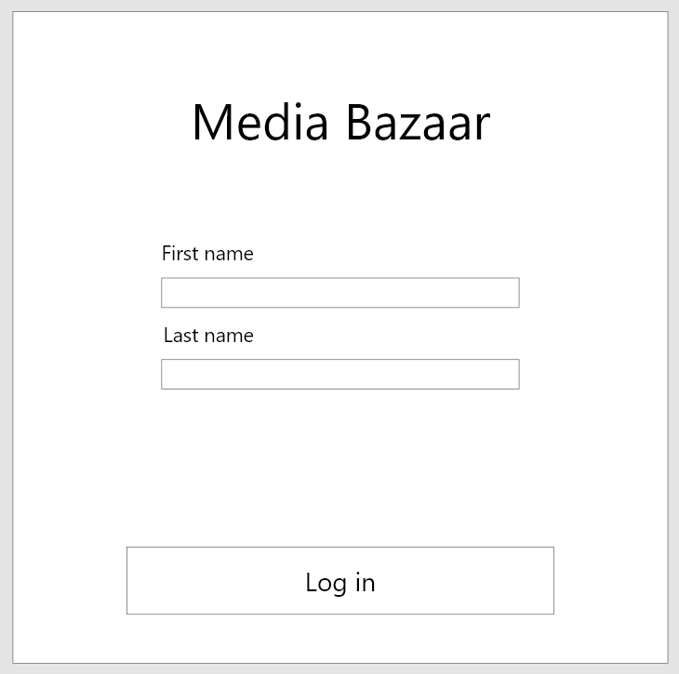

1. ***US-A-02: Administrator logs out***

Actors: Administrator

Requirement(s): ***FR-A-02***

Main Success Scenario:

1. Administrator clicks on “Log out”.

2. Log in form is opened.

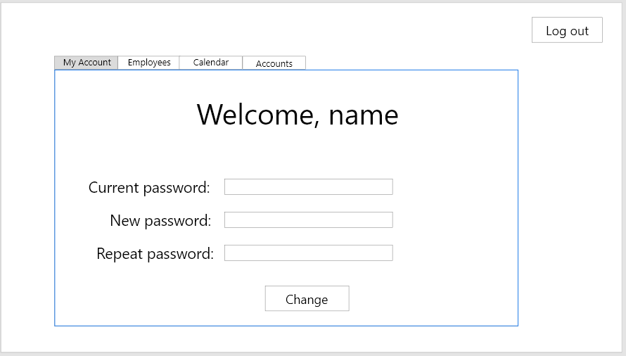

1. ***US-A-02: Administrator changes password***

Actors: Administrator

Requirement(s): ***FR-A-03***

Main Success Scenario:

1. Administrator clicks on “MyAccount”.
2. Administrator inserts current password.
3. Administrator inserts new password.
4. Administrator repeats new password.
5. Administrator clicks on *“Change”.*
6. System shows that information has been successfully updated.

Extension:

1. Field is empty

a. Notify user.

2. Current password is wrong.

a. Notify user.

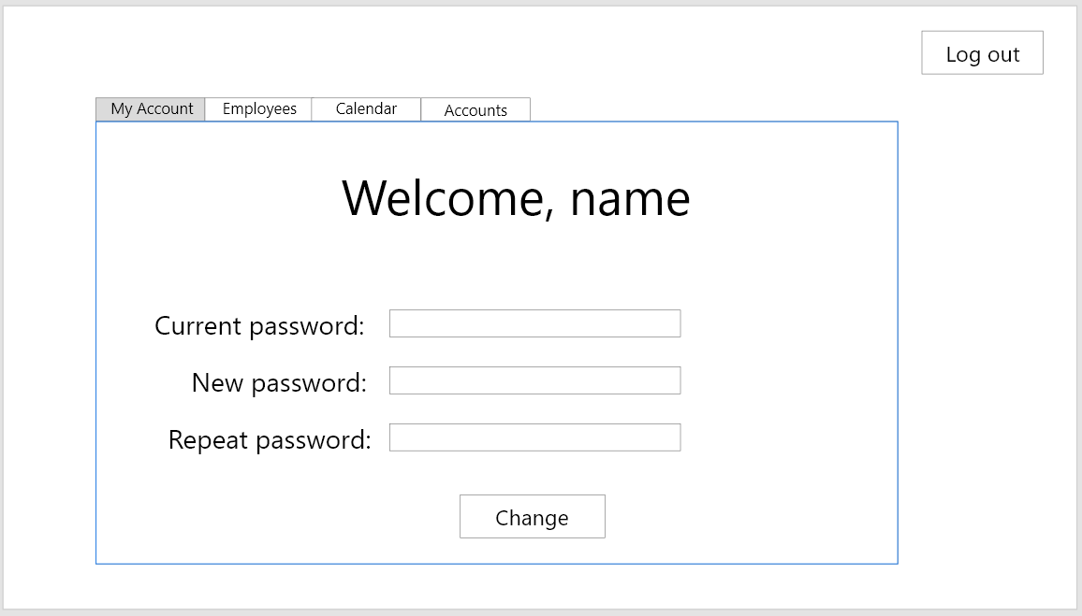

1. ***US-A-04: Administrator views the list of employees***

Actors: Administrator

Requirement(s): ***FR-A-04***

Main Success Scenario:

1. Administrator clicks on “Employees”.
2. Grid with employee information is shown

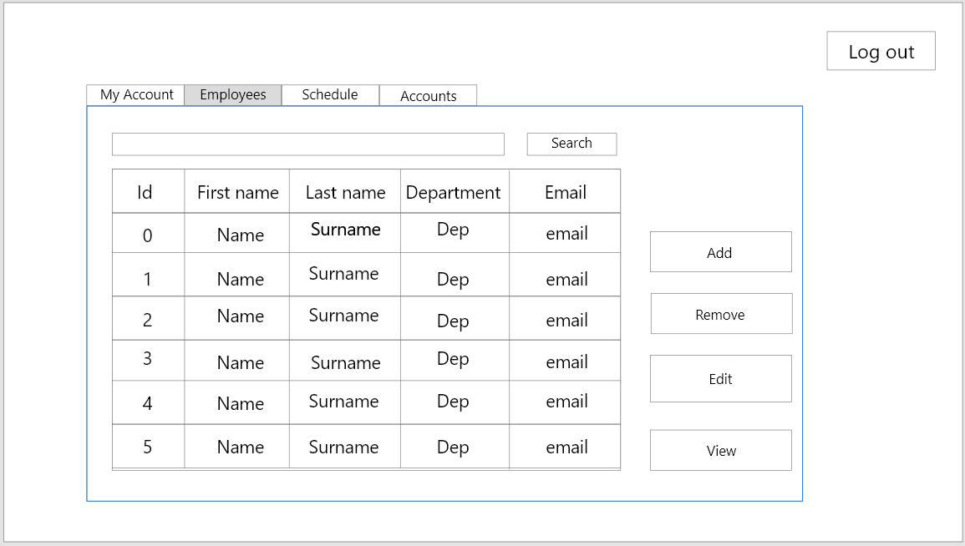

1. ***US-A-05: Administrator view details of certain employee***

Actors: Administrator

Requirement(s): ***FR-A-05***

Main Success Scenario:

1. Administrator clicks on “Employees”.
2. Grid with employee information is shown.
3. Administrator clicks on certain row.
4. Row, representing a certain employee is now selected.
5. Administrator clicks on view
6. Separate form with details is opened.

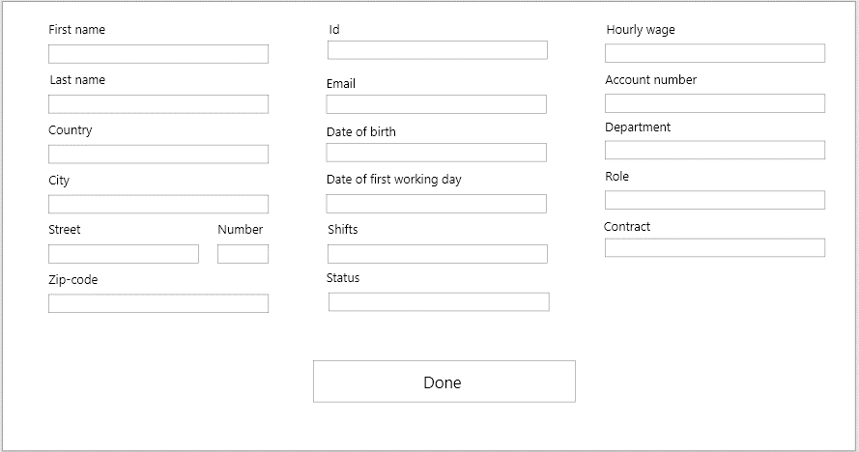

*Please note: In this case fields are read-only. Meaning one can read but not modify.*

1. ***US-A-06: Administrator adds new employee to the system***

Actors: Administrator

Requirement(s): ***FR-A-06***

Main Success Scenario:

1. Administrator clicks on “Employees”.
2. Administrator clicks on “Add employee”.
3. Separate form is opened.
4. Administrators insert all the data needed. *(See Appendix A for details)*
5. Administrator clicks on “Add”.
6. System notifies user that new employee was successfully added.
   1. Automatically generated password is shown on the screen
      1. Administrator writes it down on paper and closes the window with password.

Extension:

1. Field is empty

a. Notify user.

2. Email is invalid format.

a. Notify user.

3. Name is invalid format.

a. Notify user.

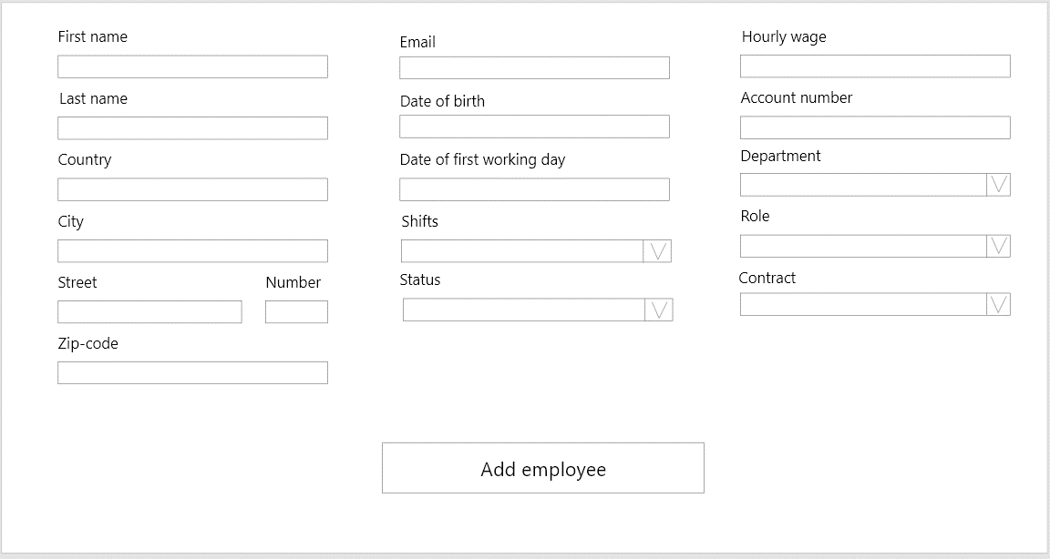

1. ***US-A-07: Administrator updates employee information***

Actors: Administrator

Requirement(s): ***FR-A-07, FR-A-08***

Main Success Scenario:

1. Administrator clicks on *“Employees”.*
2. Grid with employee information is shown.
3. Administrator clicks on certain row.
4. Row, representing a certain employee is now selected.
5. Administrator clicks on *“Edit”.*
6. Separate form with details is opened.
7. Administrator may change certain fields.
8. Employee status may be changed.

Extension:

1. Field is empty.

a. Notify user.

2. Email is invalid format.

a. Notify user.

3. Name is invalid format.

a. Notify user.

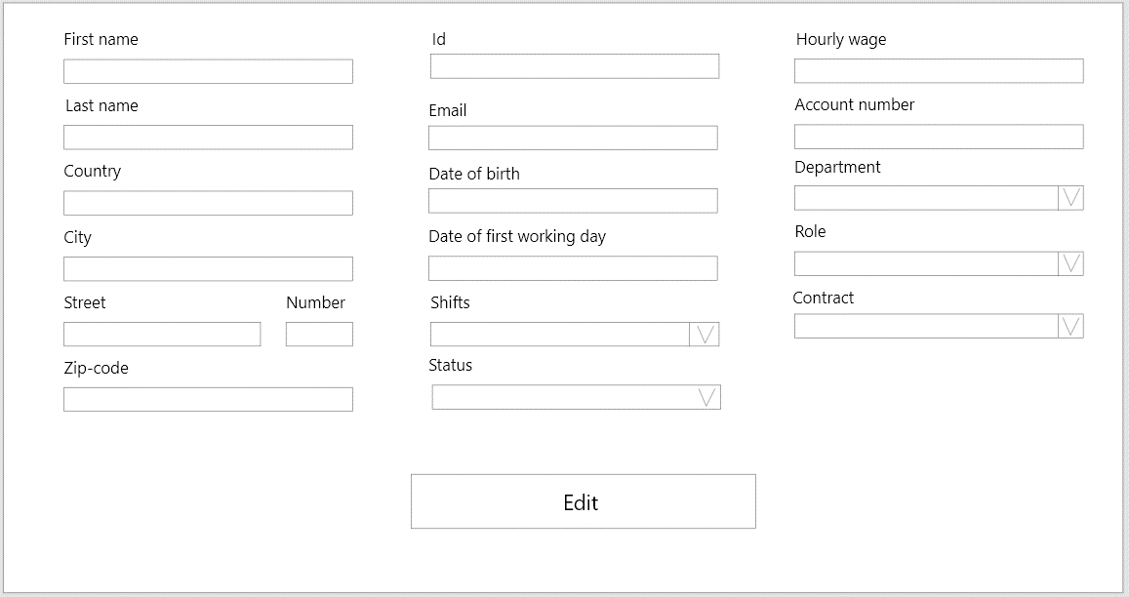

*Please note: Only certain field may be modified. See “Appendix A” for more details.*

1. ***US-A-08: Administrator* views overall work shift schedule for a selected period.**

Actors: Administrator

Requirement(s): ***FR-A-09***

Main Success Scenario:

1. Administrator clicks on *“Schedule”.*
2. Administrator selects the certain dates
3. Schedule with requested dates is shown.
4. Administrator clicks on certain shift.
5. Separate form with details is opened.
6. Administrator sees the list of employees assigned to the shift.
7. Administrator clicks on *“Done”.*

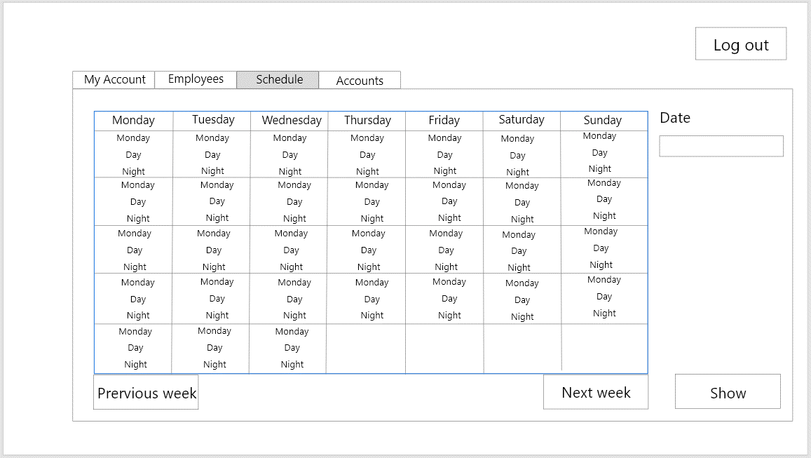

*A label referenced by red arrow (See picture above) is a button. Clicking on it opens a separate window (See next page).*

1. ***US-A-09: Administrator assigns shift to employee***

Actors: Administrator

Requirement(s): ***FR-A-10***

Main Success Scenario:

1. Administrator clicks on *“Schedule”.*
2. Administrator selects the certain dates
3. Schedule with requested dates is shown.
4. Administrator clicks on certain shift.
5. Separate form with details is opened.
6. Administrator sees the list of available employees.
7. Administrator chooses employee from the list.
8. Administrator clicks on *“Assign”.*
9. Administrator clicks on *“Done”.*

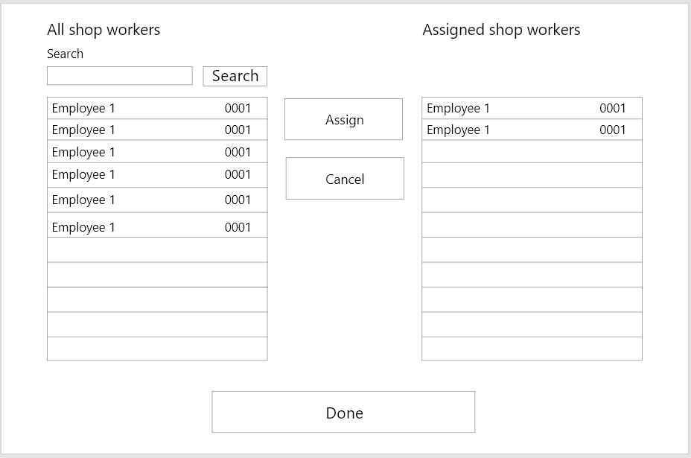

*In the separate window administrator can see the list of available shop workers and list of shop workers assigned for this shift.*

1. ***US-A-10: Administrator updates the schedule***

Actors: Administrator

Requirement(s): ***FR-A-11, FR-A-12***

Main Success Scenario:

1. Administrator clicks on *“Schedule”.*
2. Administrator selects the certain dates
3. Schedule with requested dates is shown.
4. Administrator clicks on certain shift.
5. Separate form with details is opened.
6. Administrator sees the list of employees.
7. Administrator chooses employee from the list
8. Administrator clicks on *“Cancel”.*
9. Administrator clicks on *“Done”.*



1. ***US-A-11: Administrator adds new user to the system***

Actors: Administrator

Requirement(s): ***FR-A-13, FR-A-14***

Main Success Scenario:

1. Administrator clicks on *“Accounts”.*
2. List of accounts is shown.
3. Administrator clicks on *“Add”.*
4. Separate form is opened.
5. Administrator fills in the textboxes.
6. Administrator clicks on *“Add”.*

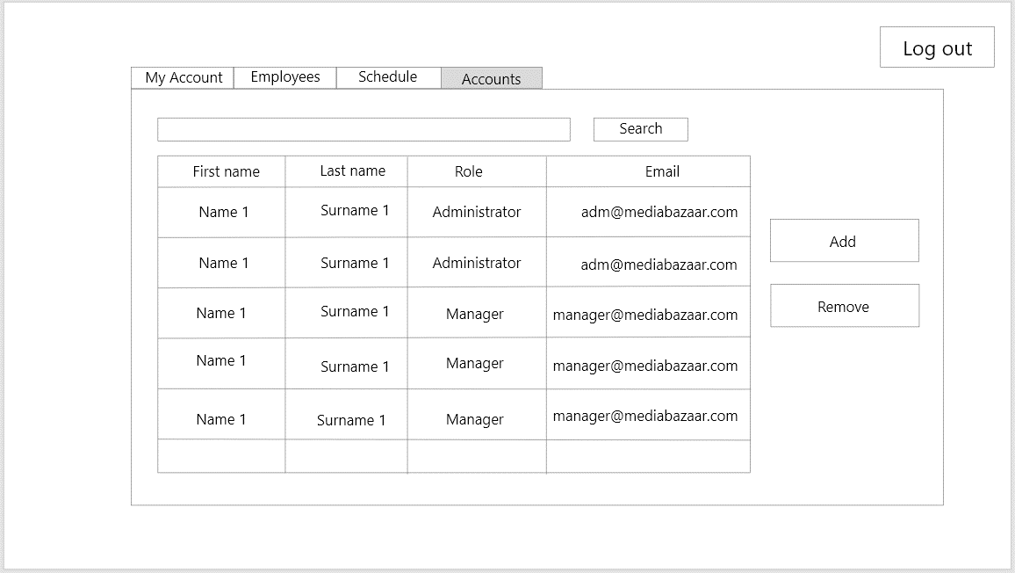

*See next page.*

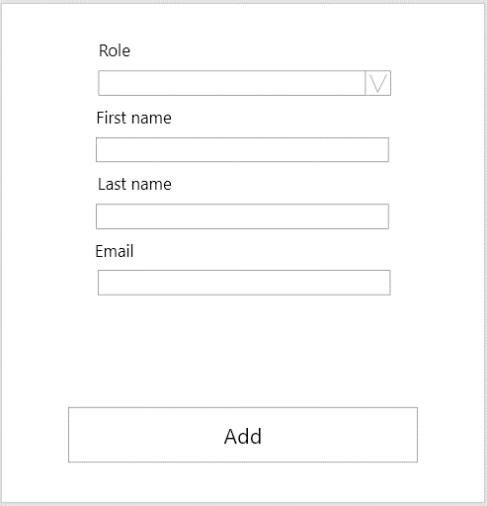

*Please note: This is the solution for the first phase of the project. Later more requirements for administrator and manager accounts can be discussed and added.*

1. ***US-A-12: Administrator removes user from the system***

Actors: Administrator

Requirement(s): ***FR-A-15, FR-A-16***

Main Success Scenario:

1. Administrator clicks on *“Accounts”.*
2. List of accounts is shown.
3. Administrator clicks on *“Remove”.*
4. System informs user that operation was successful.



1. ***US-M-01: Manager views the statistical information***

Actors: Manager

Requirement(s): ***FR-M-07***

Main Success Scenario:

1. Manager clicks on *“Statistics”.*
2. Manager chooses the indicator from the list.
3. Manager clicks on view.
4. Separate form representing a certain indicator is opened.

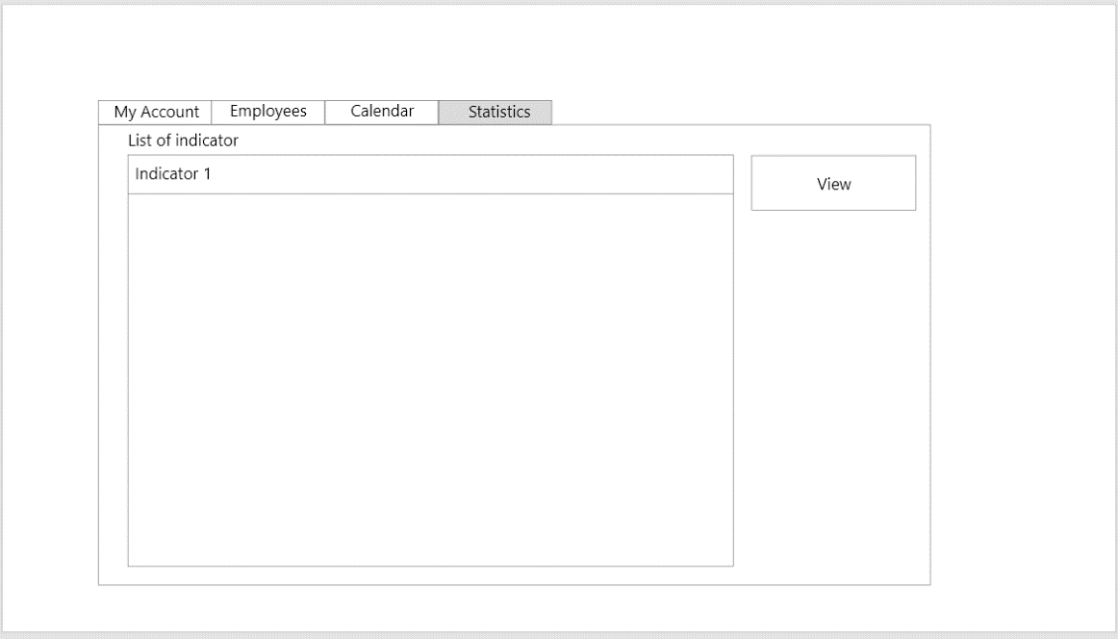

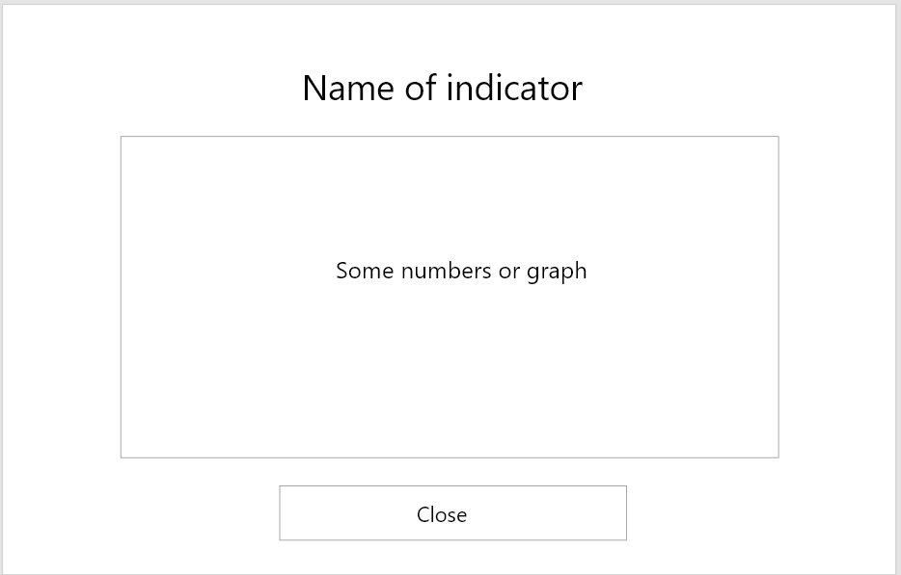

*Please note: Use cases for manager’s side functional requirements*

***FR-M-01*** *-* ***FR-M-06*** *repeat use cases for administrator side functional requirements. Hence, we made this table:*

|  |  |
| --- | --- |
| ***Functional requirement*** | ***Use case*** |
| *FR-M-01* | *US-A-01* |
| *FR-M-02* | *US-A-02* |
| *FR-M-03* | *US-A-03* |
| *FR-M-04* | *US-A-04* |
| *FR-M-05* | *US-A-05* |
| *FR-M-06* | *US-A-08* |

***Use cases – Website***

1. ***US-W-01: Employee logs in***

Actors: Employee

Requirement(s): ***FR-E-01***

Pre-condition: None

Main Success Scenario:

1. Employee is on login page
2. Employee inputs their username and password
3. Employee clicks the “Login” button
4. Employee is notified that they logged in successfully
5. Employee is redirected to home page

Extension:

4.a. Field is empty

a. Notify user.

b. Back to step 2 in MSS

4.b. Login is incorrect

a. Notify user.

b. Back to step 2 in MSS

4.c. Password is incorrect

a. Notify user.

b. Back to step 2 in MSS

4.d. Employee logs in first time

a. Show window to change password (mandatory).

b. End of Use case

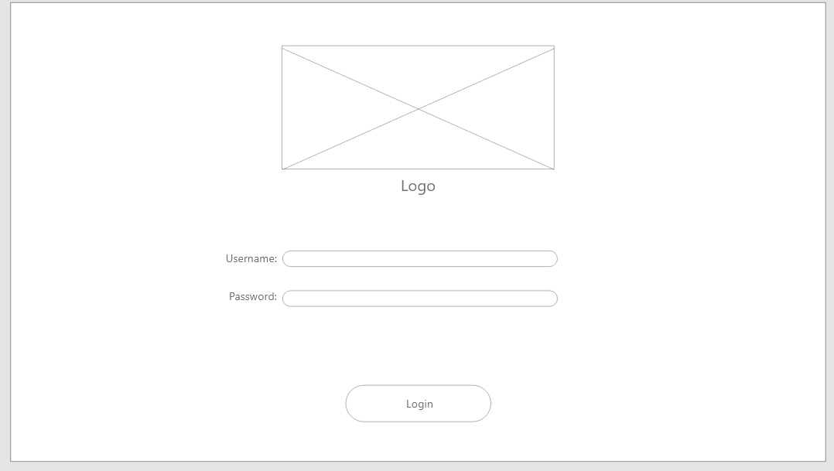

*First login:*

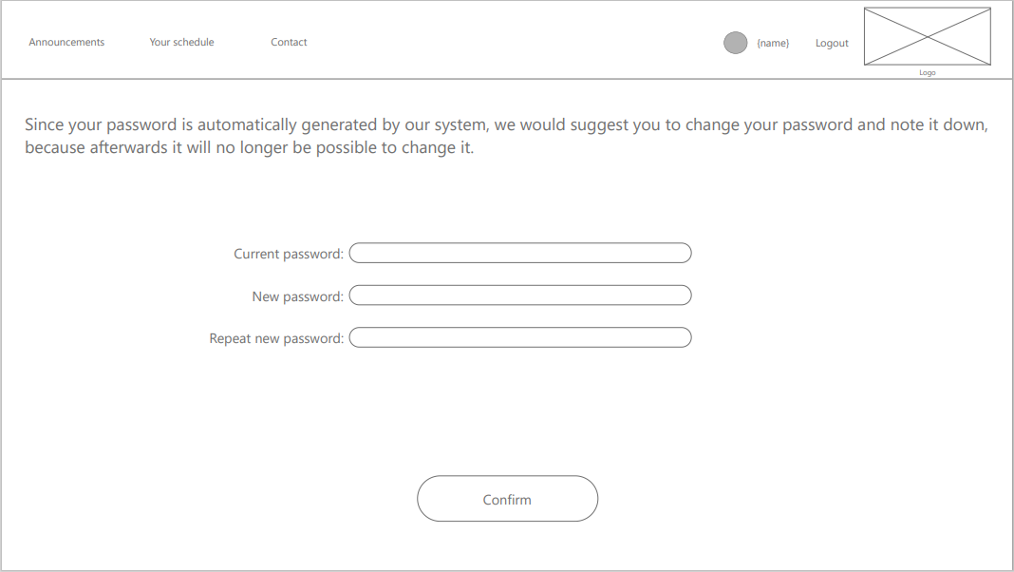

1. ***US-W-02: Employee logs out***

Actors: Employee

Requirement(s): ***FR-E-02***

Pre-condition: Employee is logged in successfully

Main Success Scenario:

1. Employee clicks on “Log out” button
2. Employee is redirected to Login page

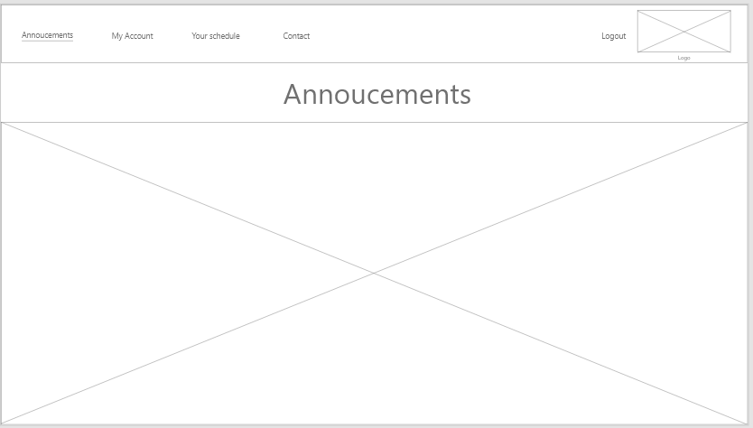

1. ***US-W-03: Employee changes password***

Actors: Employee

Requirement(s): ***FR-E-03***

Pre-condition: Employee is logged in successfully

Main Success Scenario:

1. Employee clicks on “My Account” button
2. Employee inserts current password
3. Employee inserts new password
4. Employee repeats new password
5. Employee clicks on the “Change password” button
6. System displays message that password was successfully changed

Extension:

5.a. Field is empty

a. Notify user.

b. Back to step 2 of MSS

5.b. Current password is wrong

a. Notify user.

b. Back to step 2 of MSS

5.c. New password and repeat password fields do not match

a. Notify user.

b. Back to step 2 of MSS

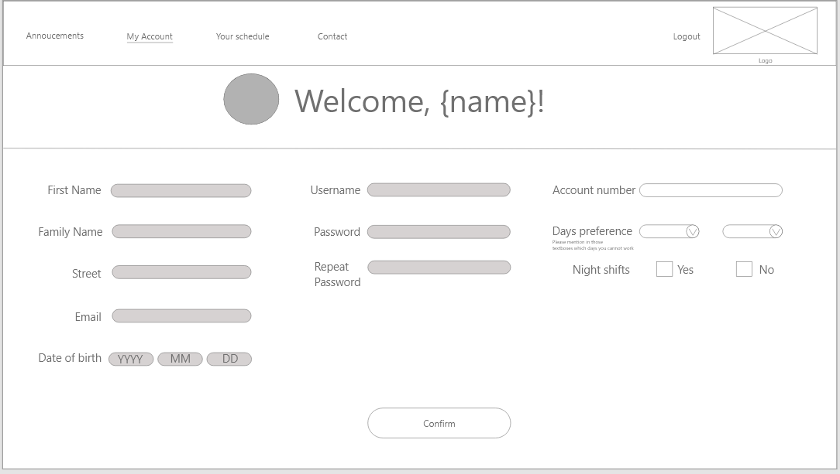

1. ***US-W-04: Employee changes personal details***

Actors: Employee

Requirement(s): ***FR-E-04***

Pre-condition: Employee is logged in successfully

Main Success Scenario:

1. Employee clicks on “My account” button
2. Employee clicks on “Edit” button
3. Employee changes whichever fields they would like to change
4. Employee clicks on the “Save” button
5. Employee is notified they successfully updated their data

Extension:

4.a. Field is empty

a. Notify user.

b. Back to step 4 in MSS

4.b. Field is not in correct format

a. Notify user.

b. Back to step 4 in MSS



1. ***US-W-05: Employee views schedule***

Actors: Employee

Requirement(s): ***FR-E-05***

Pre-condition: Employee is logged in successfully

Main Success Scenario:

1. Employee clicks on the “Schedule” button
2. Employee is shown their schedule for this week

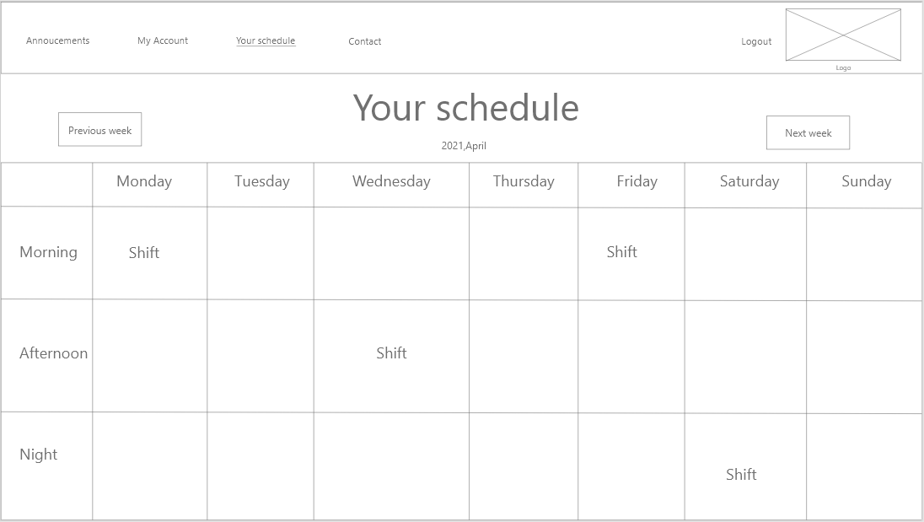

1. ***US-W-05: Employee views schedule for next week or previous week***

Actors: Employee

Requirement(s): ***FR-E-05***

Pre-condition: Employee is logged in successfully

Main Success Scenario:

1. Employee clicks on the “Schedule” button

2. Employee is shown their schedule for this week

3. Employee clicks on “Next week” or “Previous week” button

1. ***US-W-06: Employee sets a preference on schedule***

Actors: Employee

Requirement(s): ***FR-E-06***

Pre-condition: Employee is logged in successfully

Main Success Scenario:

1. Employee clicks on “Schedule” button
2. Employee clicks on “Preferences” button
3. Employee picks up to two days during which they cannot work or if they are unavailable for night shifts
4. Employee clicks on the “Save” button

Extension:

4.a. Employee picks more than two days

a. Notify user.

b. Back to step 3 of MSS



1. ***US-W-07: Employee sends message to administrator***

Actors: Employee

Requirement(s): ***FR-E-07***

Pre-condition: Employee is logged in successfully

Main Success Scenario:

1. Employee clicks on “Contact” button
2. Employee inputs their message
3. Employee chooses their administrator
4. Employee clicks on the “Send” button

Extension:

4.a. Field is empty

a. Notify user.

b. Back to step 2 of MSS

4.b. No administrator chosen

a. Notify user.

b. Back to step 3 of MSS

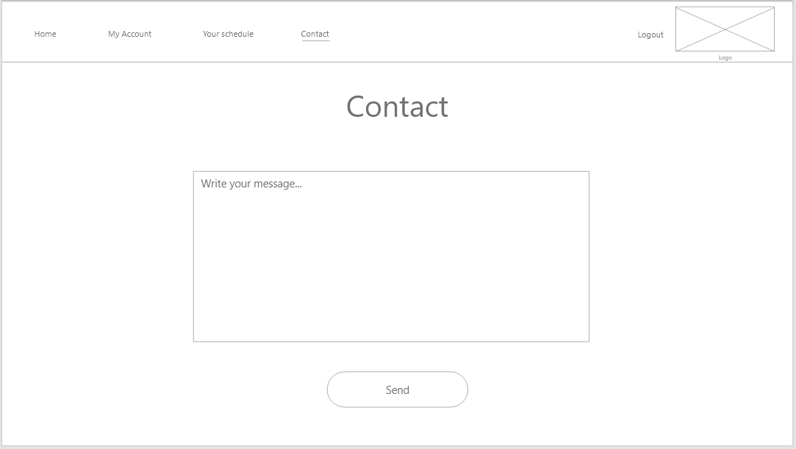

1. ***US-W-08: Employee views announcements***

Actors: Employee

Requirement(s): ***FR-E-08***

Pre-condition: Employee is logged in successfully

Main Success Scenario:

1. Employee clicks on “Announcements” button
2. Employee is redirected to Announcement’s page and shown recent announcements

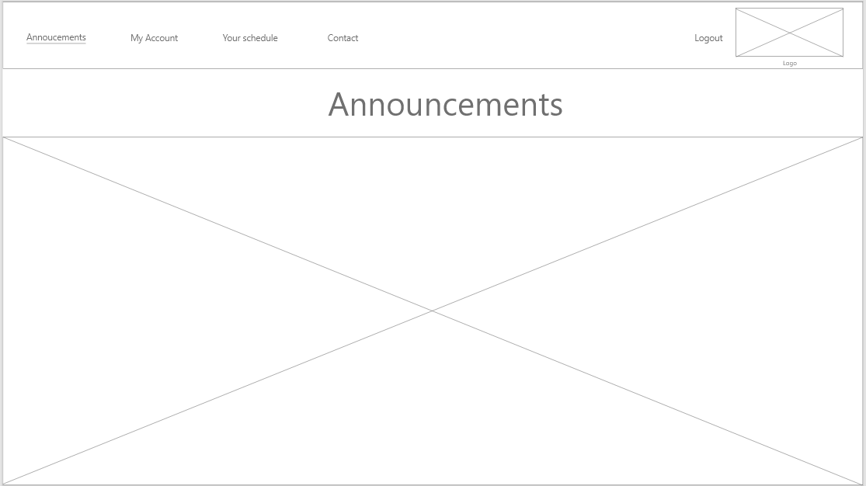

1. ***US-WM-01: Manager logs in***

Actors: Manager

Requirement(s): ***FR-WM-01***

Pre-condition: None

Main Success Scenario:

1. Manager is on login page
2. Manager inputs their username and password
3. Manager clicks the “Login” button
4. Manager is notified that they logged in successfully
5. Manager is redirected to home page

Extension:

4.a. Field is empty

a. Notify user.

b. Back to step 2 of MSS

4.b. Login is incorrect

a. Notify user.

b. Back to step 2 of MSS

4.c. Password is incorrect

a. Notify user.

b. Back to step 2 of MSS

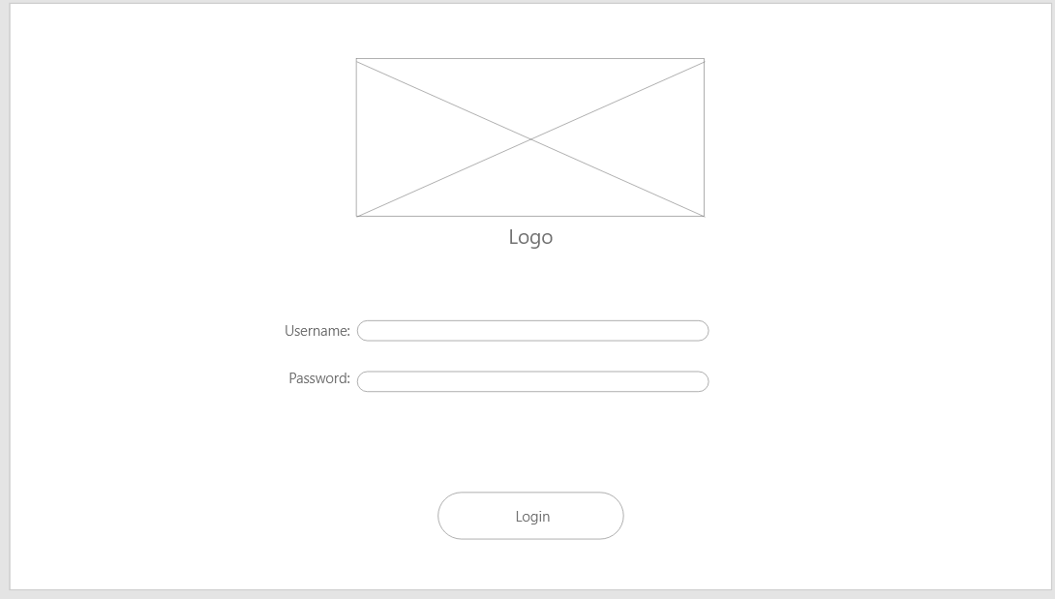

1. ***US-WM-01: Manager logs out***

Actors: Manager

Requirement(s): ***FR-WM-01***

Pre-condition: Manager is logged in successfully

Main Success Scenario:

1. Manager clicks on “Logout” button
2. Manager is redirected to Login page

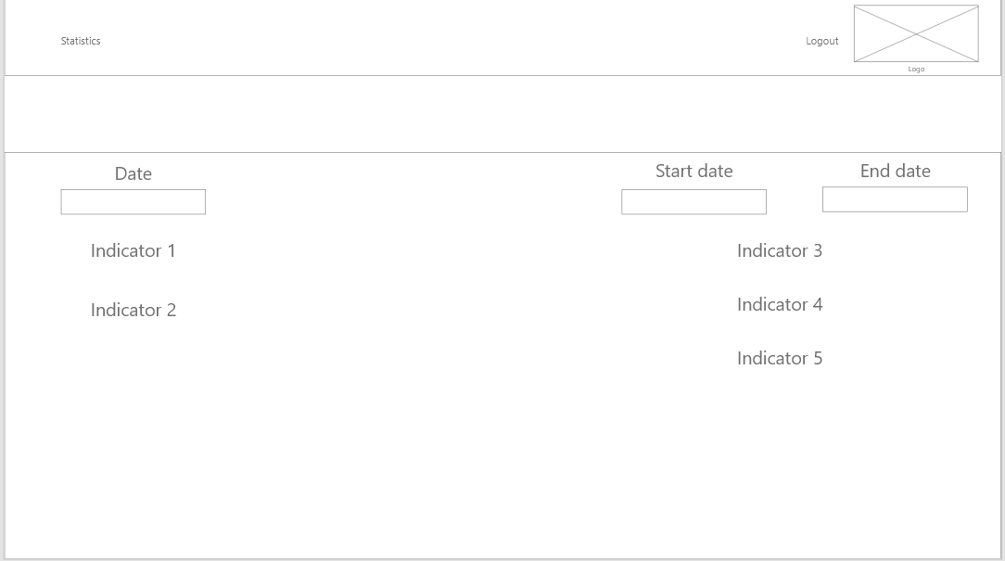

1. ***US-WM-01 : Manager views statistical information***

Actors: Manager

Requirement(s): ***FR-WM-01***

Pre-condition: Manager is logged in successfully

Main Success Scenario:

1. Manager clicks on “Statistics” button
2. Manager is redirected to Statistics page
3. Manager inputs dates
4. Indicators are shown.

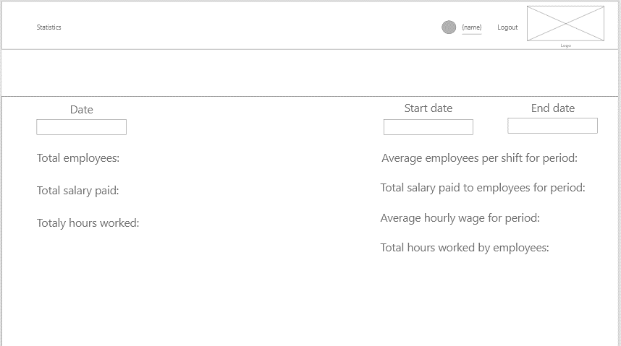

Mobile wireframes

*Mobile wireframes with all the other ones can be found in our git repository via this link.*

[*https://git.fhict.nl/I454066/prj-cb07-group1/-/blob/master/Documentation/WebsiteMediaBazaar.pdf*](https://git.fhict.nl/I454066/prj-cb07-group1/-/blob/master/Documentation/WebsiteMediaBazaar.pdf)

**Appendix A**

*Here you may find the information concerning Media Bazaar employees that will be stored in the system.*

1. First name
2. Family name
3. Address (street, street number, zip code, town, country)
4. E-mail address
5. Username
6. Password
7. Date of birth
8. Date of first working day
9. Hourly wage
10. Account number
11. Department(s)
12. Role
13. Photo
14. Kind of employee
    1. Fixed term contract
       1. 32 working hours a week
       2. 40 working hours a week
    2. Availability for shifts

(Employee may indicate up to two(2) days as unavailable.)

* + 1. Availability for nightshifts.

**Appendix B**

*Here you may find the which records can and which cannot be changed.*

*Legenda:*

*Green – Can be changed by employee.*

*Blue – Can be changed by administrator.*

*Red – Cannot be changed at all.*

1. First name
2. Family name
3. Address (street, street number, zip code, town, country)
4. E-mail address
5. Username
6. Password
7. Date of birth
8. Date of first working day
9. Hourly wage
10. Account number
11. Department(s)
12. Role
13. Photo
14. Kind of employee
    1. Fixed term contract
       1. 32 working hours a week
       2. 40 working hours a week
    2. Availability for shifts
       1. Employee may indicate up to two (2) days of week as unavailable.
       2. Availability for nightshifts.

**Revision table**

**v1.1**: **11/04 Bohdan** – Updated user requirements, table of contents, added updated wireframes to use cases and minor changes.

**v1.2**: **17/04 Andreea** – Updated functional requirements based on tutor’s feedback.

**v1.3**: **18/04 Stelian** – Updated use case for website based on client’s feedback.