***User Requirements Specification***

Software solution for “Media Bazaar” GROUP 1

Members: Bohdan Tymofieienko, Stelian Rumenov, Andreea

Sindrilaru, Andrei Sava.

Tutor: Pencheva,Sabina S.

Date: 07/03/2021

Version: 0.3

***Table of contents***

**Agreements with client**3

Sides: 3

Agreements: 3

**Functional requirements**4

Windows application (Manager and Administrator side): 4

Website (Employee side): 5

**Prioritizing table MosCow**6

**Use cases** 9

**Wireframes** 11

## Agreements with client

### Sides:

Client: Media Bazaar represented by Andre Postma, *“Client”* later in this document.

Contractor: Group 1 (name TREE), *“Contractor”* later in this document.

### Agreements:

1. Contractor does the problem analysis.
2. Contractor prepares the problem solution in form of information system.
3. Contractor implements the solution in form of standalone software application for Windows operating system.
4. Team presents the product to the Client.
5. First phase of the project must be completed before March 25th.

## Functional requirements

* All the requirements were discussed with client. *“User” later in the document is an abstract alias to describe the functionality.*
* *MoSCoW table represents four levels of task prioritizing. The abbreviation stands for Must, Should, Could and Won’t. You may find it in the column 4 (“Priority”).*

*We consider it crucially important to define priorities before implementation phase, so both developers and client have realistic expectations on project results.*

* *Naming convention:*

*{FR-(Abbreviation from user’s type name)-(count in two-digit format)}*

***Waterfall phase (until March 25th):***

*Please note: these are requirements for current phase. Later more features may be discussed and included to the document.*

|  |  |  |  |
| --- | --- | --- | --- |
| ID | Name | Description | Priority |
| Administration side | | | |
| **FR-A-01** | Login | User can login to the system with personal credentials | Must |
| **FR-A-02** | Logout | User can logout from the system | Must |
| **FR-A-03** | Change password | User can change the password | Must |
| **FR-A-04** | View employees | User can view list of employees | Must |
| **FR-A-05** | View employee’s details | User can view employee’s details |  |
| **FR-A-06** | Add employee | User can add new employee to the system  *Read “Appendix A” for*  *information stored about employees* | Must |
| FR-A-07 | Update employee | User can update employee information | Must |
| FR-A-08 | Modify employee status | User can modify employee status  (Not started yet, working, stopped) | Must |
| FR-A-09 | View  shift schedule | User can view overall work shift schedule for a selected period of time. | Must |
| FR-A-10 | Assign  shifts to employee | User can assign one of the three shifts to employee.   * 1. Morning   ( 7:00 – 15:00 )   * 1. Day   ( 15:00 – 23:00 )   * 1. Night   ( 23:00 – 7:00 ) | Must |
| FR-A-11 | Update  employee’s schedule | User can update information concerning employee’s schedule. | Must |
| FR-A-12 | Cancel  employee’s  shift | User can cancel shift assignment for the employee | Must |
| FR-A-13 | Add  administrator | User can add new administrator to the system | Should |
| FR-A-14 | Add  manager | User can add new manager to the system | Should |
| FR-A-15 | Remove administrator’s account | User can remove administrator’s account | Should |
| FR-A-16 | Remove manager’s account | User can remove manager’s account | Should |
| FR-A-17 | System  organizes employee schedule | System can  automatically organize employee schedule   1. Following employee preference if possible. 2. Based on work contract. 3. According to work regulation | Could |

|  |  |  |  |
| --- | --- | --- | --- |
| ID | Name | Description | Priority |
| Management side | | | |
| **FR-M-01** | Login | User can login to the system with personal credentials | Must |
| **FR-M-02** | Logout | User can logout from the system | Must |
| **FR-M-03** | Change password | User can change the password | Must |
| **FR-M-04** | View employees | User can view list of employees | Must |
| FR-M-05 | View employee’s details | User can view employee’s details | Must |
| FR-M-06 | View  shift schedule | User can view overall work shift schedule for a selected period of time. | Must |
| FR-M-07 | Cancel  employee’s  shift | User can cancel shift assignment for the employee | Must |

|  |  |  |  |
| --- | --- | --- | --- |
| ID | Name | Description | Priority |
| **FR-M-08** | View statistical information | User can view statistical information.  ***For a selected date :***   1. Total number of employees. 2. Total salary paid. 3. Total number of hours worked.   ***For a selected time period :***   1. Average number of employees per work shift. 2. Total salary paid to all employees. 3. Average hourly wage per employee 4. Total number of hours worked by all employees. 5. Average number of hours worked by an employee. | Should |

## 

***Use cases***

1. ***Use case [ FR-A-01 ]: Administrator logs in***

Actors: Administrator

Main Success Scenario:

1. Administrator runs on app icon.
2. Login form is open.
3. Administrator inputs login and password.
4. Administrator presses “Log in”.
5. Administrator form is open.

Extension:

1. Field is empty

a. Notify user.

2. Login is incorrect

a. Notify user.

3. Password is incorrect

a. Notify user.

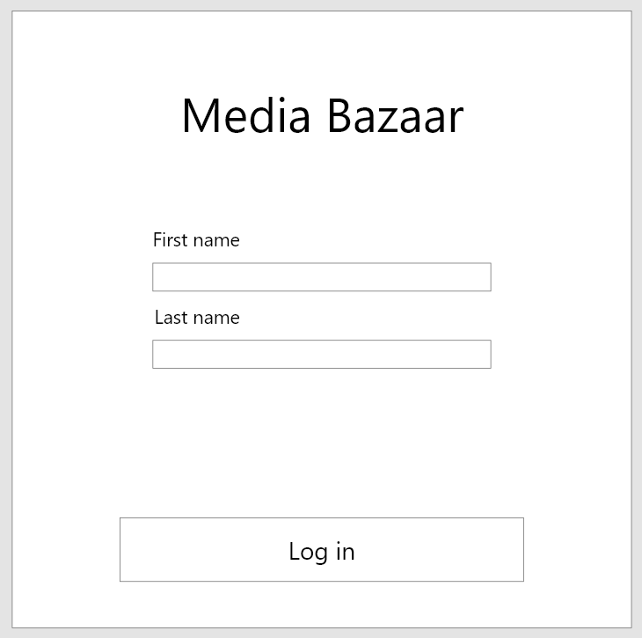

1. ***Use case [ FR-A-02 ]: Administrator logs out***

Actors: Administrator

Main Success Scenario:

1. Administrator clicks on “Log out”.

2. Log in form is opened.

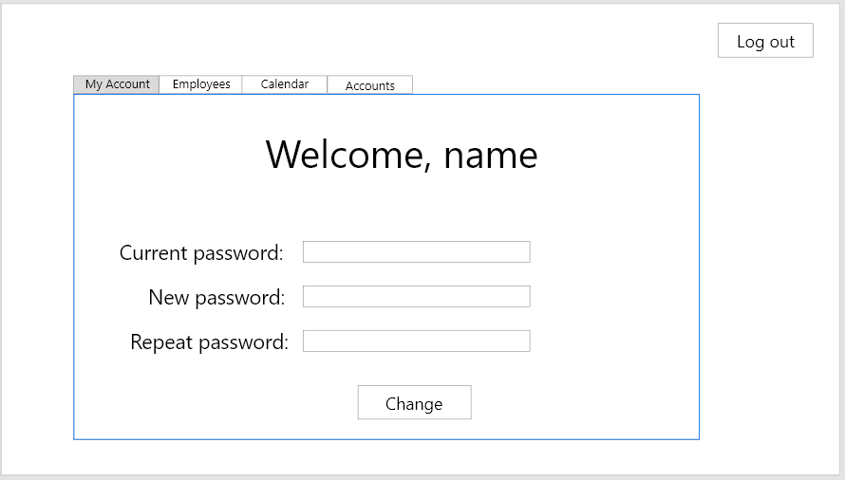

1. ***Use case [ FR-A-03 ]: Administrator changes password***

Actors: Administrator

Main Success Scenario:

1. Administrator clicks on “MyAccount”.
2. Administrator inserts current password.
3. Administrator inserts new password.
4. Administrator repeats new password.
5. Administrator clicks on *“Change”.*
6. System shows that information has been successfully updated.

Extension:

1. Field is empty

a. Notify user.

2. Current password is wrong.

a. Notify user.

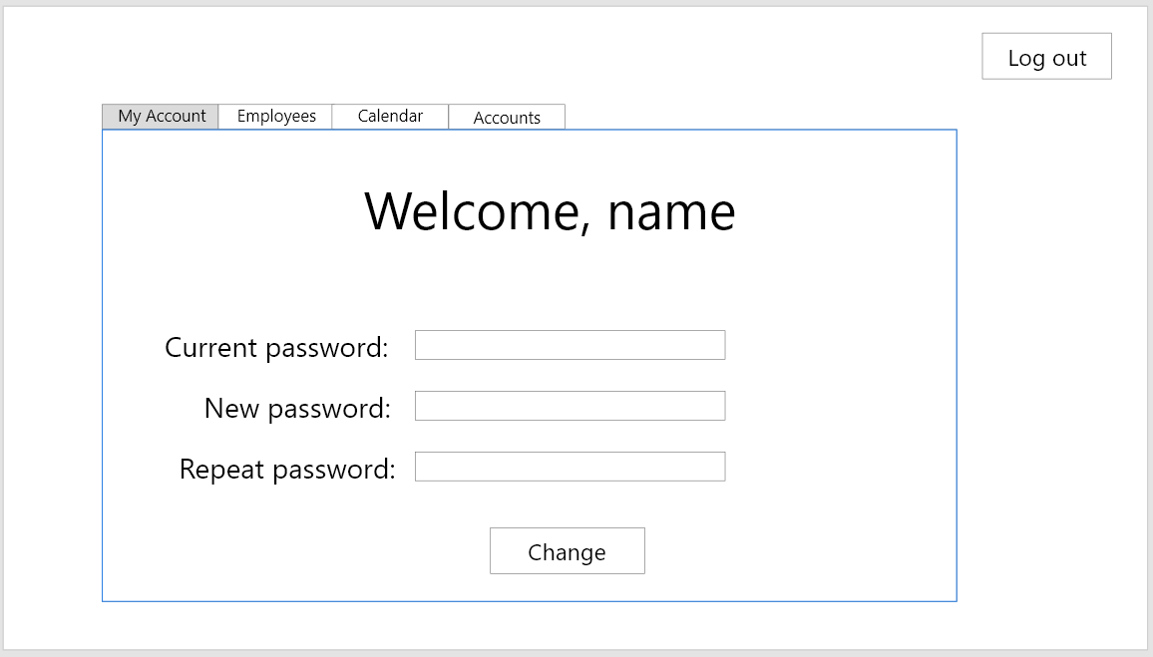

1. ***Use case [FR-A-04]: Administrator views the list of employees***

Actors: Administrator

Main Success Scenario:

1. Administrator clicks on “Employees”.
2. Grid with employee information is shown
3. ***Use case [FR-A-05] : Administrator view details of certain employee***

Actors: Administrator

Main Success Scenario:

1. Administrator clicks on “Employees”.
2. Grid with employee information is shown.
3. Administrator clicks on certain row.
4. Row, representing a certain employee is now selected.
5. Administrator clicks on view
6. Separate form with details is opened.
7. ***Use case [FR-A-06] : Administrator adds new employee to the system***

Actors: Administrator

Main Success Scenario:

1. Administrator clicks on “Employees”.
2. Administrator clicks on “Add employee”.
3. Separate form is opened.
4. Administrator insert all the data needed. *(See Appendix A for details)*
5. Administrator clicks on “Add”.
6. System notifies user that new employee was successfully added.
   1. Automatically generated password is shown on the screen
      1. Administrator writes it down on paper and closes the window with password.

Extension:

1. Field is empty

a. Notify user.

2. Email is invalid format.

a. Notify user.

3. Name is invalid format.

a. Notify user.

***Use case: Manager logs in first time***

Actors: Manager

Main Success Scenario:

1. Manager opens an application.
2. Login form is opened.
3. Manager logs in with credentials received from administrator.
4. Manager opens MyAccount module.
5. Manager enters current password and new password.
6. System shows that password was successfully changed.

***Use case: Manager views the employee statistics***

Actors: Manager

Main Success Scenario:

1. Manager opens a statistics section.
2. Manager clicks on “Employees”.
3. Manager may go through the employee list.
4. Manager may search for certain employee.
5. Manager may see the graph with average attendance.
6. Manager may filter the departments to see attendance of specific department.
7. Manager closes the form.

## Wireframes

*Employee section (list of employees with search bar and button referencing to dialog windows)*

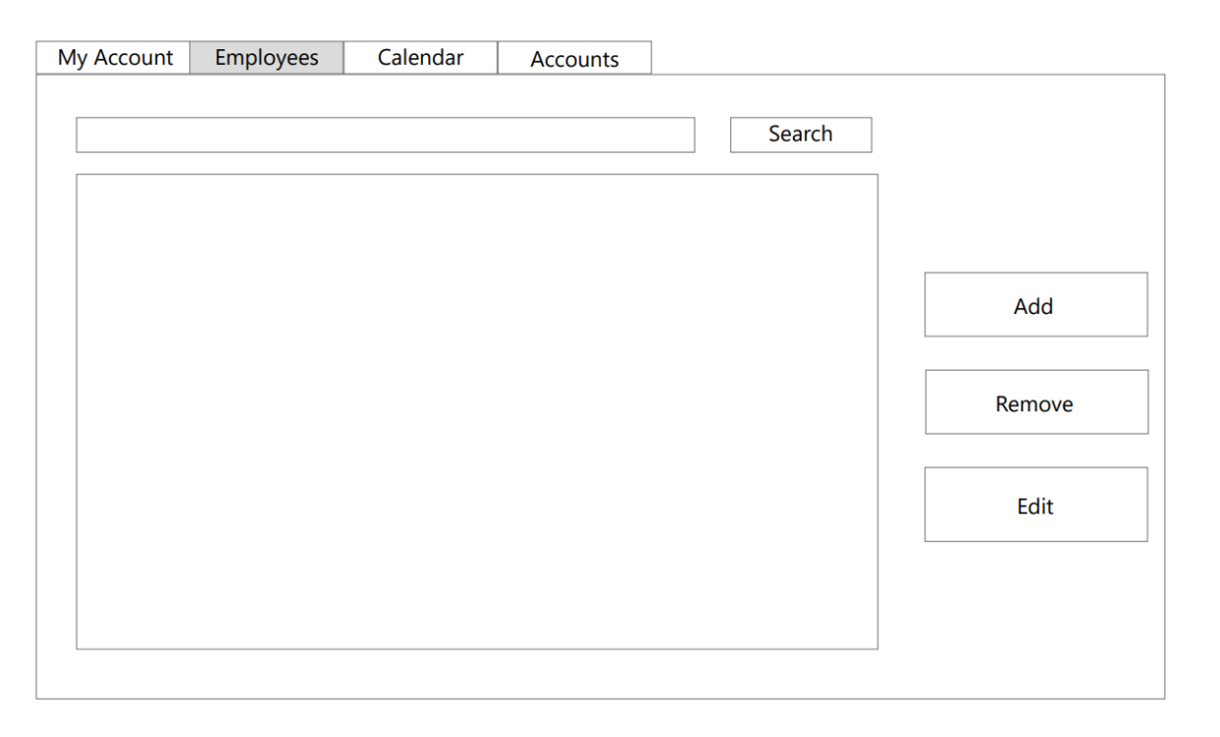

*MyAccount section (user may change the password).*

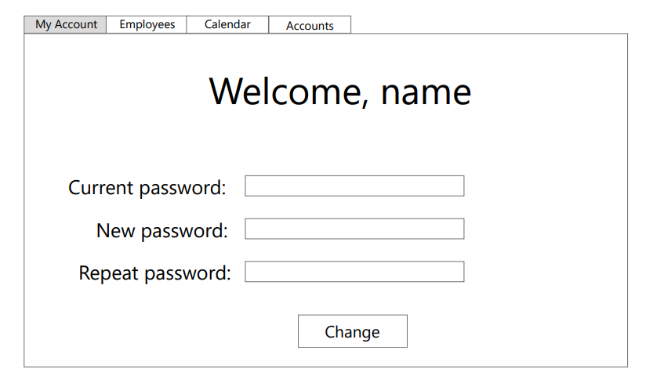

*Example of dialogue window with all forms needed to add new employee.*

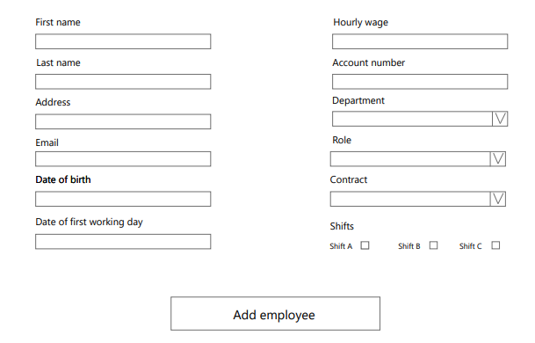

*More wireframes can be found in our GIT repository:*

[*https://git.fhict.nl/I454066/prj-cb07-group1/-/tree/master/Documentation/Wireframes.pdf*](https://git.fhict.nl/I454066/prj-cb07-group1/-/tree/master/Documentation/Wireframes.pdf)