***Configuring Valgrind on Clion***

**After having installed everything, now it is time for the Clion configurations.**

**Step 1: Go to File-> Settings -> Build, Execution, Deployment, Cmake .  
 Or use the key-combination : Ctrl+ Alt + S**

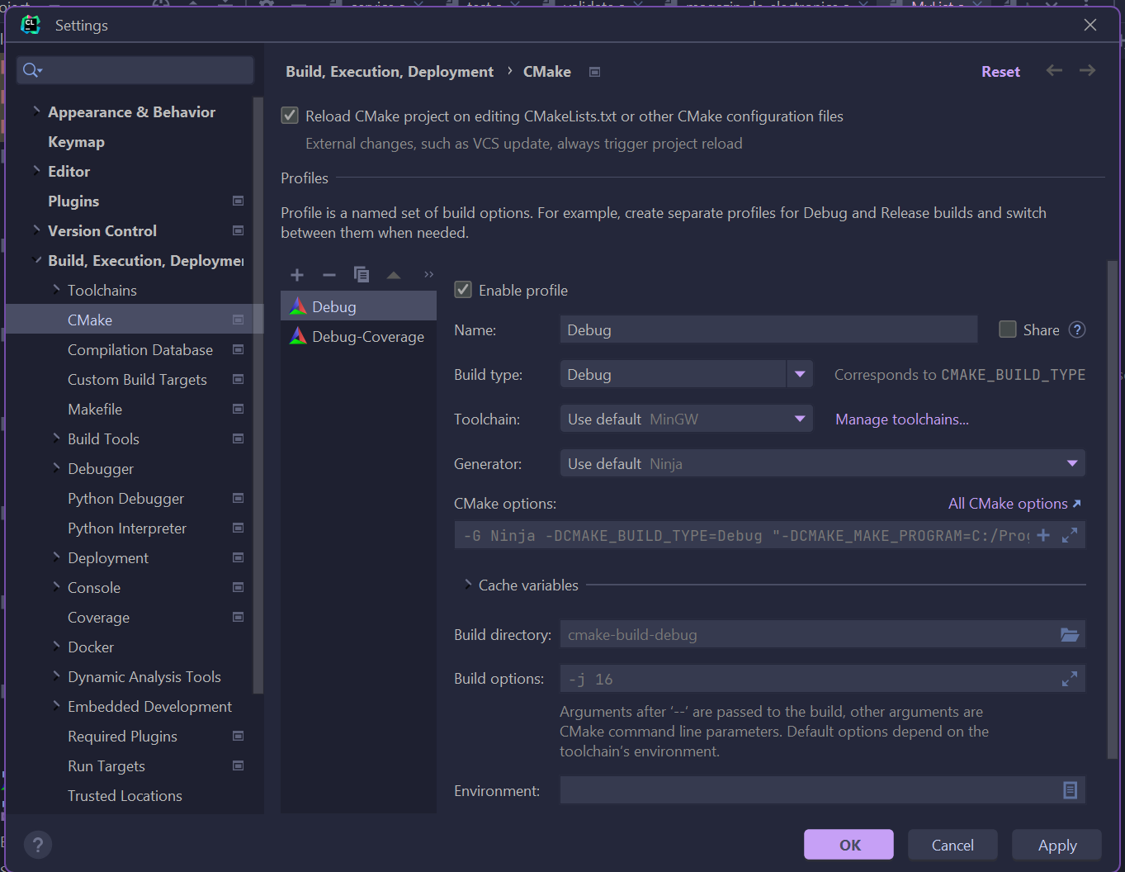

*Now we need to add your CMake configuration! ( YOU HAVE TO DO THIS FOR EVERY PROJECT! It will not save across projects unfortunately…. )*

This is what it should open:

Now we need to name it and change some of the fields ( TO THIS EXACT SETTINGS).

I will just name it Valgrind.

This should be all for it. Click apply and then OK to save.

Now go back to the same window as before but go to **TOOLCHAINS**.

We need the WSL configuration. So, click plus and select it.

For me it found them all automatically .

Also just to be sure you should check if you have the right location for your Valgrind.

Go to **Dynamic Analysis Tools**, click it and then go to Valgrind.

And see if it found it in your WSL configuration. If it is not detected automatically, it should be in **usr\bin** in your WSL files.

Now you can click OK.

YOU ALSO NEED TO MAKE SURE YOU HAVE THE SAME VERSION FOR CMAKE IN CMakeList.txt!!! Please check your cmake version in ubuntu. You can see it when you go to Toolchains but also through the command in the ubuntu terminal “ cmake –version”.

Now look in the upper right corner:

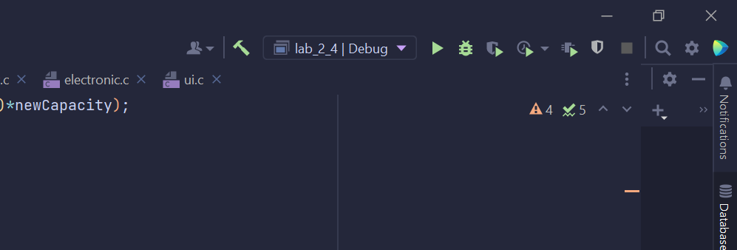

Select Valgrind (or whatever name you chose)

Now just try to run it with Valgrind:

I commented something in the program to have a memory leak:  
Now go to Valgrind.  
And done ! It should show all of your memory leaks!

