L&T-Data Analytics Exercise
1. Create a line graph interpreting the data and mention the steps one by one.

- Selected Number of languages known column for analysis
- Performed data cleaning by removing blank values
- Created line graph
2. Create a bar chart and interpret the data and mention stepwise procedure.
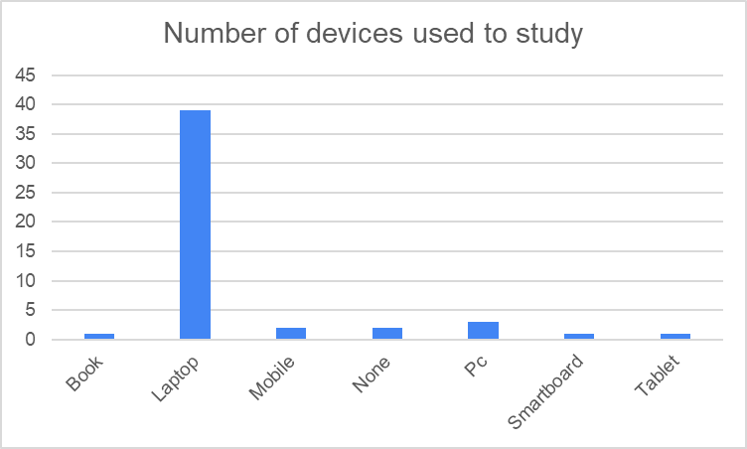
- Selected Devices used to study column for the analysis
- Used Proper(Trim()) to clean the data
- Created Bar Graph
3. Create a pie chart and interpret the result and mention stepwise procedure.

4. Mention three Excel formulas and method of applying it, paste the formula along with both input and output.
=SUM(Number of languages known) = 196
=AVERAGE(Number of languages known) = 4
=COUNT(Number of languages known) = 49
5. Apply statistics to any of the columns and interpret the findings.
Statistics
Median | 5
Max | 9
Min | 4
Standard Deviation | 1.426696
- Performed statistics for number of languages known column

