**ASSIGNMENT - 1**

**DEEBAK KUMAR . K**

**192324064**

**1. Write a program to print all the composite numbers between a and b?**

**Sample Input:**

1. **= 12**
2. **= 19**

**Sample Output**

**14, 15, 16, 18**

**CODE:**

import java.util.Scanner; public class pav{ public static void main(String[] args){

Scanner obj=new Scanner(System.in); System.out.print("Enter starting number: ");

int a=obj.nextInt();

System.out.print("Enter ending number: ");

int b=obj.nextInt();

int i,j;

if (a>b | a==b){

System.out.println("GIVE THE STARTING AND END NUMBER PROPERLY");

}

else{ for(i=a;i<b;i++){ for(j=2;j<i;j++){ if(i%j==0){

System.out.println(i); break;

}

}

}

}

}

}

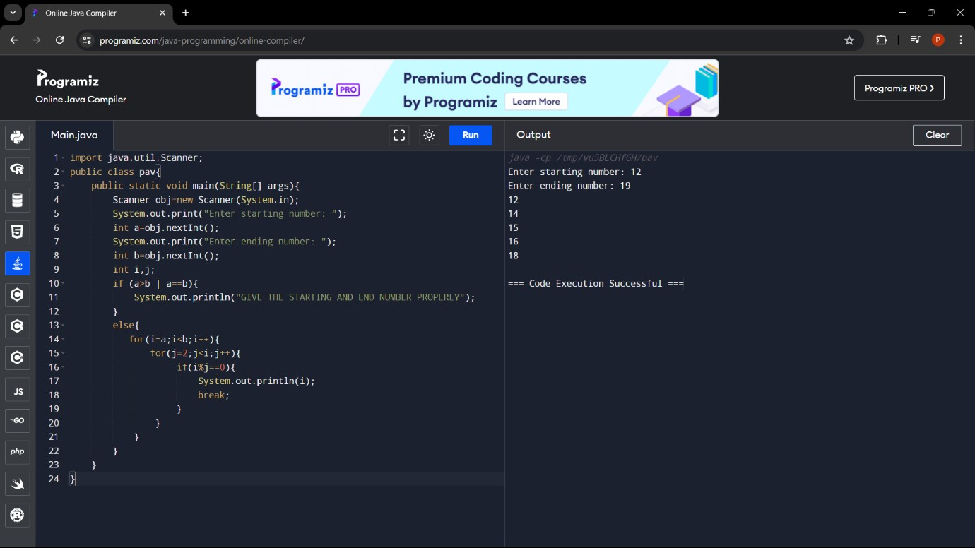

**2. Write a program to print the numbers from M to N by skipping K numbers in between?**

**CODE:**

import java.util.Scanner; public class pav{ public static void main(String[] args){

Scanner obj=new Scanner(System.in); System.out.print("Enter starting number: ");

int a=obj.nextInt();

System.out.print("Enter ending number: ");

int b=obj.nextInt();

System.out.print("Enter skip number: ");

int k=obj.nextInt();

int i;

for(i=a;i<=b;i+=k+1){

System.out.println(i);

}

}

}

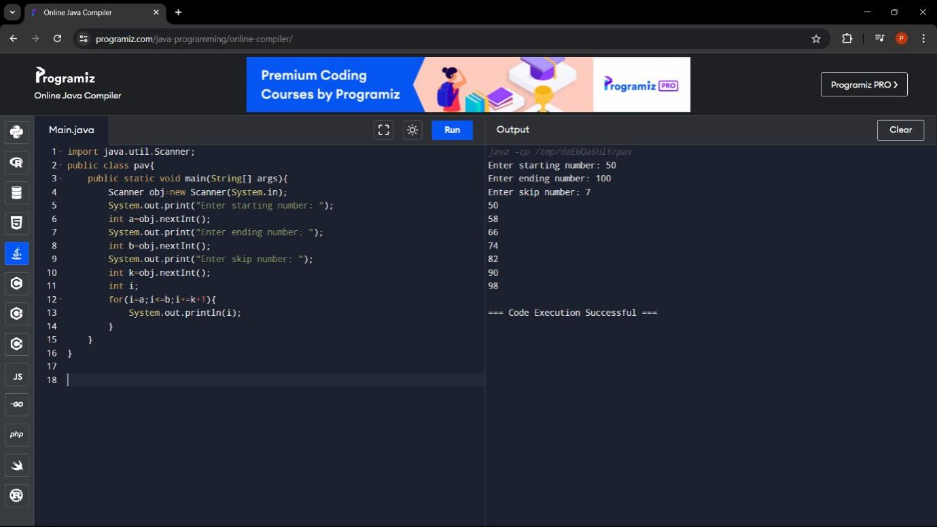

**3. Write a program to enter the marks of a student in four subjects. Then calculate the total and aggregate, display the grade obtained by the student. If the student scores an aggregate greater than 75%, then the grade is Distinction. If aggregate is 60>= and <75, then the grade is First Division. If aggregate is 50 >= and <60, then the grade is Second Division. If aggregate is 40>= and <50, then the grade is Third Division. Else the grade is Fail.**

**CODE:**

import java.util.Scanner; public class pav{ public static void main(String[] args){

Scanner obj=new Scanner(System.in); System.out.print("Enter Python marks: "); float a=obj.nextFloat();

System.out.print("Enter C Programming marks: ");

float b=obj.nextFloat();

System.out.print("Enter Mathematics marks: ");

float c=obj.nextFloat();

System.out.print("Enter Physics marks: "); float d=obj.nextFloat(); float total=a+b+c+d; float aggregate=total/4;

System.out.println("Toatl: "+total);

System.out.println("Aggregate: "+aggregate); if (aggregate>=75 & aggregate <=100){

System.out.print("DISTINCTION");

}

else if(aggregate>=60 & aggregate<75){

System.out.print("First Division");

}

else if(aggregate>=50 & aggregate<60){

System.out.print("Second Division");

}

else if(aggregate>=40 & aggregate<50){

System.out.println("Third Division");

}

else if(aggregate>=0 & aggregate<40){

System.out.println("Fail");

}

}

}

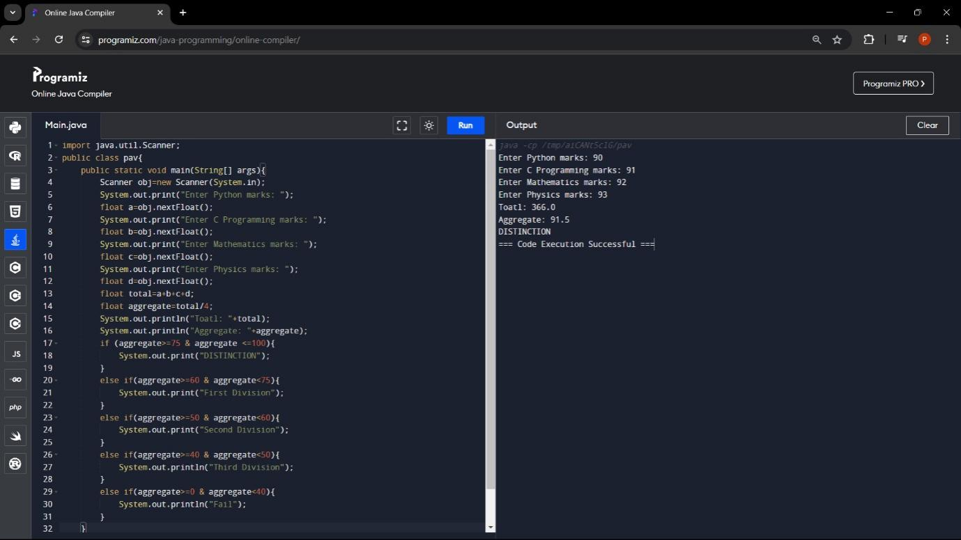

4**. Write a program to calculate tax given the following conditions:**

1. **If income is less than or equal to 1,50,000 then no tax**
2. **If taxable income is 1,50,001 – 3,00,000 the charge 10% tax**
3. **If taxable income is 3,00,001 – 5,00,000 the charge 20% tax**
4. **If taxable income is above 5,00,001 then charge 30% tax**

**CODE:**

import java.util.Scanner; public class pav{ public static void main(String[] args){

Scanner obj=new Scanner(System.in); System.out.print("Enter Income: "); float temp=obj.nextFloat(); double b=0; if (temp>=0 & temp<=150000){

System.out.print("NO TAX");

}

else if(temp>150001 & temp<=300000){ b=temp*0.1;

System.out.print("Tax = "+b);

}

else if(temp>300001 & temp<=500000){

b=temp*0.2;

System.out.print("Tax = "+b);

}

else if(temp>500001){ b=temp*0.3;

System.out.print("Tax = "+b);

}

}

}

