**ASSIGNMENT - 3**

**DEEBAK KUMAR .K**

**192324064**

1. **Write java Program for Consider a scenario, Bank is a class that provides functionality to get rate of interest. But, rate of**

**interest varies according to banks. For example, SBI, ICICI and AXIS banks could provide 8%,**

**7% and 9% rate of interest.(Method Overriding)**

class Bank {

public double getRateOfInterest() {

return 0;

}

}

class SBI extends Bank {

@Override

public double getRateOfInterest() {

return 8.0;

}

}

class ICICI extends Bank {

@Override

public double getRateOfInterest() {

return 7.0;

}

}

class AXIS extends Bank {

@Override

public double getRateOfInterest() {

return 9.0;

}

}

public class Main {

public static void main(String[] args) {

Bank sbi = new SBI();

Bank icici = new ICICI();

Bank axis = new AXIS();

System.out.println("SBI Interest Rate: " + sbi.getRateOfInterest() + "%");

System.out.println("ICICI Interest Rate: " + icici.getRateOfInterest() + "%");

System.out.println("AXIS Interest Rate: " + axis.getRateOfInterest() + "%");

}

}

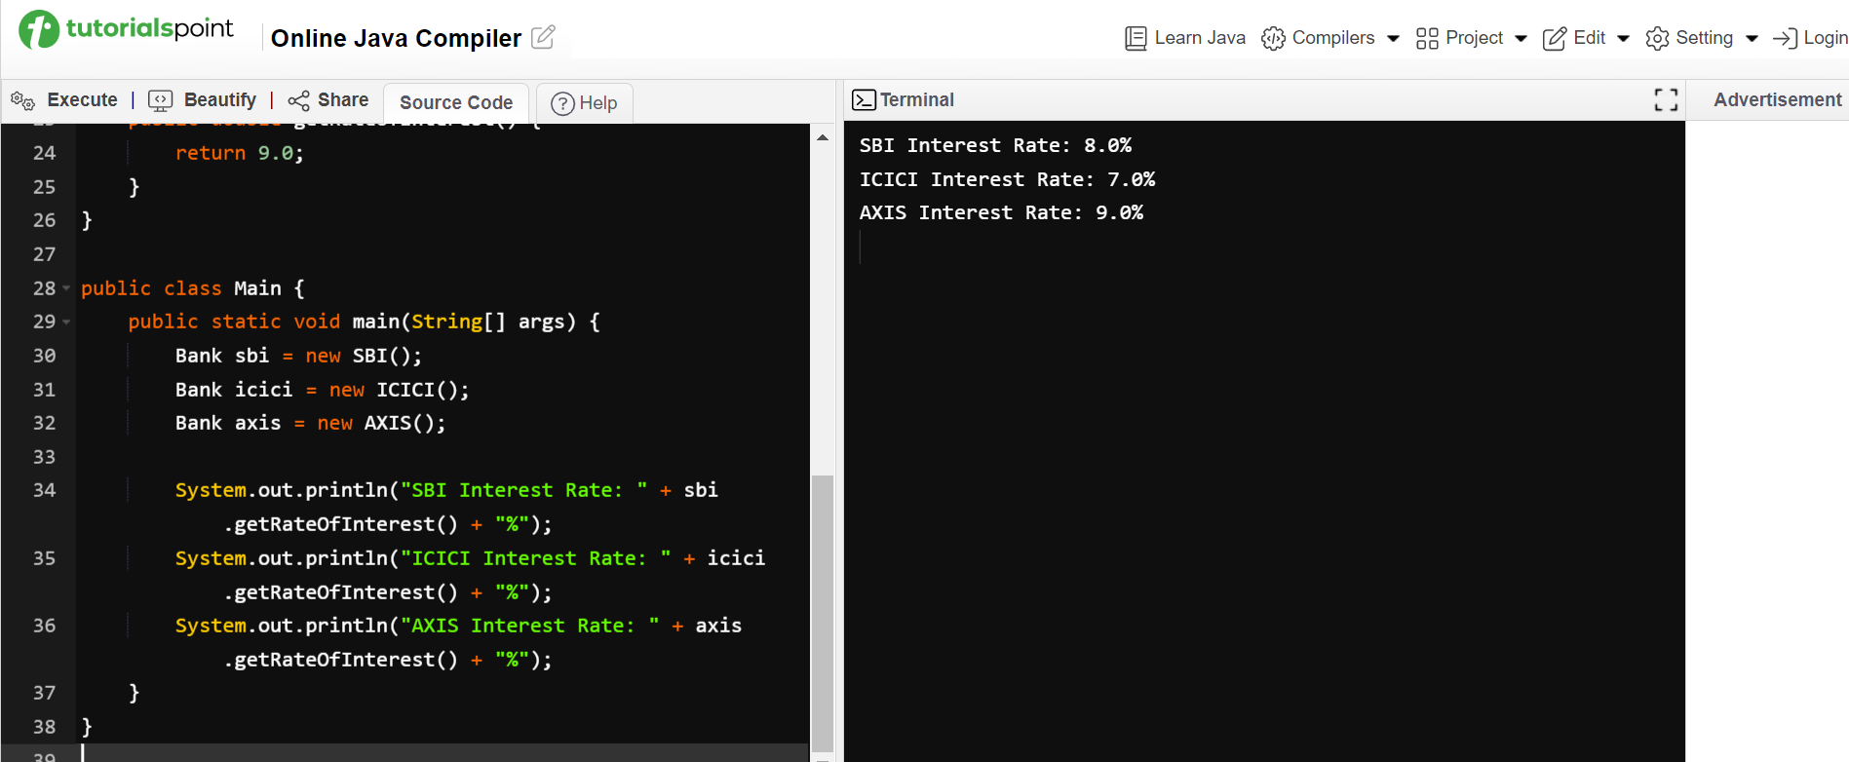

**2) Develop a JAVA code to display the balance. Include the following members:**

**• Design a class to represent a bank account.**

**• Data Members: Name of the depositor, Account number, Type of account(Savings/Current), Balance amount in the account(Minimum balance is Rs.500.00)**

**• Methods:**

**1. To read account number, Depositor name, Type of account.**

**2. To deposit an amount (Deposited amount should be added with it)**

**3. To withdraw an amount after checking balance(Minimum balance must be Rs.500.00**

**Note : Assume that balance amount = 10000**

**Test Cases**

**1. 100, Raja, S, 8000**

**2. Raja, 100, S, 9000**

**3. 101, Rani, S, 12000**

**4. 102, Ragu, W, 8000**

**5. 103, Ravi, C, 10000**

**CODE:**

public class BankAccount {

private String depositorName;

private int accountNumber;

private String accountType;

private double balance;

public BankAccount(int accountNumber, String depositorName, String accountType, double balance) {

this.accountNumber = accountNumber;

this.depositorName = depositorName;

this.accountType = accountType;

this.balance = balance;

}

public void deposit(double amount) {

balance += amount;

}

public void withdraw(double amount) {

if (balance - amount >= 500) {

balance -= amount;

} else {

System.out.println("Insufficient balance to withdraw.");

}

}

public void displayBalance() {

System.out.println("Account Number: " + accountNumber);

System.out.println("Depositor Name: " + depositorName);

System.out.println("Account Type: " + accountType);

System.out.println("Balance: Rs. " + balance);

}

public static void main(String[] args) {

BankAccount account = new BankAccount(100, "Raja", "Savings", 8000);

account.displayBalance();

}

}

