Supplementary Research Notes & Progress Log
COMP6011 Advanced AI Research Topics — Research Task 2
Clinical Decision Support Using LLMs: Qwen2.5 Benchmarking on NEJM and MedMCQA

1. Purpose of This Document
This document is compulsory supplementary evidence accompanying the main COMP6011 Research Task 2 report. It records the chronological development process, the environment and design decisions made while building the proof-of-concept, the raw console output produced while executing the Google Colab notebook, and the intermediate data checkpoints saved along the way. It is intended to demonstrate that the quantitative results presented in the main report were derived from an actual, working implementation rather than assumed or fabricated figures.
The companion Colab notebook (“COMP6011_Task2_Colab_Notebook.ipynb”), the extracted chart images, and the extracted CSV evidence files referenced throughout this log are included alongside this document in the supplementary materials folder.

2. Development Environment
The proof-of-concept was implemented and executed in Google Colab, using a free-tier NVIDIA T4 GPU runtime. GPU availability was confirmed programmatically before any model was loaded:
CUDA available: True
GPU: Tesla T4
Core Python libraries used: pandas, numpy, matplotlib, torch, transformers (Hugging Face), accelerate, scikit-learn, and datasets (for MedMCQA). Models were loaded directly from the Hugging Face Hub without authentication, which produced a standard rate-limit warning that did not affect execution:
Warning: You are sending unauthenticated requests to the HF Hub.
Please set a HF_TOKEN to enable higher rate limits and faster downloads.

3. Step-by-Step Progress Log

3.1 Dataset 1 preparation — NEJM clinical cases
The 10 required NEJM clinical challenge cases were manually converted into a structured spreadsheet (nejm_cases_combined_task2.xlsx) with the columns: case_id, NEJM_link, case_summary, correct_diagnosis, diagnosis_short_label, and key_findings. This file was uploaded directly into the Colab session:
Saving nejm_cases_combined_task2.xlsx to nejm_cases_combined_task2.xlsx
Uploaded file: nejm_cases_combined_task2.xlsx
Dataset loaded successfully.
Number of cases: 10
A validation step checked that all five required columns were present before proceeding, so that a malformed upload would fail fast rather than silently produce blank prompts.

3.2 Prompt design
A structured diagnostic prompt was designed (rather than a free-form “what is the diagnosis” prompt) so that model outputs would be comparable and easier to score consistently. The prompt required the model to return, in a fixed format: the single most likely diagnosis, a top-3 differential diagnosis list, a short justification, and a confidence level. The same prompt template was reused for both candidate models to keep the comparison fair.

3.3 Running Model 1: Qwen2.5-1.5B-Instruct
Model 1 was loaded and run sequentially across all 10 cases:
Loading model: Qwen/Qwen2.5-1.5B-Instruct
Running Qwen/Qwen2.5-1.5B-Instruct on Case 1...
Running Qwen/Qwen2.5-1.5B-Instruct on Case 2...
Running Qwen/Qwen2.5-1.5B-Instruct on Case 3...
Running Qwen/Qwen2.5-1.5B-Instruct on Case 4...
Running Qwen/Qwen2.5-1.5B-Instruct on Case 5...
Running Qwen/Qwen2.5-1.5B-Instruct on Case 6...
Running Qwen/Qwen2.5-1.5B-Instruct on Case 7...
Running Qwen/Qwen2.5-1.5B-Instruct on Case 8...
Running Qwen/Qwen2.5-1.5B-Instruct on Case 9...
Running Qwen/Qwen2.5-1.5B-Instruct on Case 10...
Immediately after this run, a checkpoint was saved and downloaded (checkpoint_after_model1_qwen.csv) so that the raw Model 1 predictions would not be lost if the Colab session disconnected before Model 2 was run — an iterative safeguard adopted after an earlier session had timed out mid-run.

3.4 Running Model 2: Qwen2.5-3B-Instruct
The larger candidate model was then loaded and run across the same 10 cases using the identical prompt:
Loading model: Qwen/Qwen2.5-3B-Instruct
Running Qwen/Qwen2.5-3B-Instruct on Case 1...
Running Qwen/Qwen2.5-3B-Instruct on Case 2...
Running Qwen/Qwen2.5-3B-Instruct on Case 3...
Running Qwen/Qwen2.5-3B-Instruct on Case 4...
Running Qwen/Qwen2.5-3B-Instruct on Case 5...
Running Qwen/Qwen2.5-3B-Instruct on Case 6...
Running Qwen/Qwen2.5-3B-Instruct on Case 7...
Running Qwen/Qwen2.5-3B-Instruct on Case 8...
Running Qwen/Qwen2.5-3B-Instruct on Case 9...
Running Qwen/Qwen2.5-3B-Instruct on Case 10...
Both models' raw outputs were then merged into a single review table (qwen_two_model_raw_predictions.csv) alongside the ground-truth diagnosis for manual scoring.

3.5 Manual scoring methodology
Each of the 10 cases was scored by hand against the fixed rubric described in the main report (1.0 = exact/clinically equivalent, 0.5 = partially correct or close category, 0 = incorrect), together with a separate top-3 indicator. The scores actually assigned during this process were:
Case | Correct Diagnosis | Model 1 Score | Model 1 Top-3 | Model 2 Score | Model 2 Top-3
1 | E. rhusiopathiae infection | 0 | 0 | 0 | 0
2 | Pulmonary histoplasmosis | 0 | 0 | 0.5 | 0
3 | HIV-2 / cerebral toxoplasmosis | 0 | 0 | 0.5 | 0
4 | B. miyamotoi infection | 0 | 0 | 0 | 0
5 | Vitamin D deficiency / rickets | 0.5 | 0 | 0.5 | 1
6 | Systemic primary amyloidosis | 0 | 0 | 0 | 0
7 | Crohn's disease | 0 | 0 | 0 | 0
8 | Aspiration pneumonia | 0 | 0 | 0 | 0
9 | Granulomatosis with polyangiitis | 0 | 0 | 0.5 | 0
10 | Sarcoidosis | 0 | 0 | 0 | 0

3.6 Quantitative summary computed
Averaging the scores above produced the headline benchmarking figures reported in the main report:
Model | Avg. Partial-Credit | Exact Accuracy | Top-3 Accuracy
Qwen2.5-1.5B-Instruct | 0.05 | 0.00 | 0.00
Qwen2.5-3B-Instruct | 0.20 | 0.00 | 0.10
Score distribution across the 10 cases (0 / 0.5 / 1.0 buckets) was also computed to visualise how the two models differed:
Score | Qwen2.5-1.5B-Instruct Count | Qwen2.5-3B-Instruct Count
0.0 | 9 | 6
0.5 | 1 | 4
1.0 | 0 | 0

3.7 Visualisation
Two charts were generated directly from the scored results using matplotlib. Both are reproduced below exactly as generated by the notebook (not redrawn), and correspond to Fig. 1 and Fig. 2 in the main report.
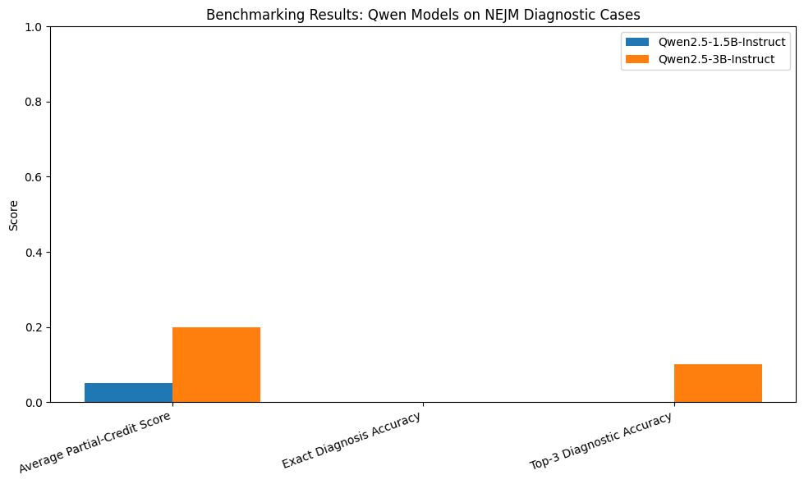
Notebook output: qwen_benchmarking_chart.png — comparison of the two Qwen models across NEJM evaluation metrics.
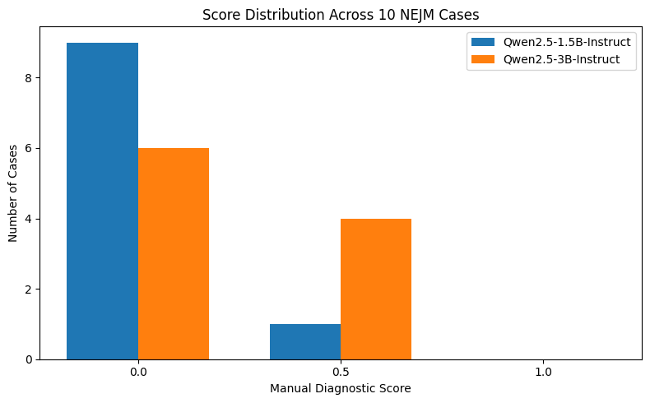
Notebook output: qwen_score_distribution.png — distribution of manual diagnostic scores across the 10 NEJM cases.

3.8 Qualitative / case-improvement review
A targeted qualitative pass identified the three cases where Model 2 outperformed Model 1, to understand what the larger model was doing differently:
Cases where Model 2 improved: 3
Cases where both models were same: 7
Cases where Model 2 was worse: 0
Notes captured for these three cases (as recorded in qwen_case_improvement_analysis.csv; text below is excerpted at the truncation length captured in the notebook's rendered output):
- Case 2 (Pulmonary histoplasmosis): Model 1 predicted pulmonary sarcoidosis; Model 2 moved closer to the correct fungal-disease category.
- Case 3 (HIV-2 with cerebral toxoplasmosis): Model 1 predicted hemorrhagic stroke; Model 2 identified a more clinically relevant category.
- Case 9 (Granulomatosis with polyangiitis): Model 1 predicted pulmonary embolism; Model 2 moved closer to the vasculitis category.

3.9 Practical summary generated from the run
The notebook auto-generated a plain-text practical summary directly from the computed averages, which was used as the basis for the Benchmarking Results section of the main report:
Practical Benchmarking Summary
A small proof-of-concept benchmark was conducted using 10 NEJM clinical
challenge cases. Two open-source instruction-tuned LLMs were compared:
Model 1: Qwen/Qwen2.5-1.5B-Instruct
Model 2: Qwen/Qwen2.5-3B-Instruct
Both models were evaluated using the same structured diagnostic prompt.
Qwen/Qwen2.5-1.5B-Instruct achieved:
- Average partial-credit score: 0.05
- Exact diagnosis accuracy: 0.00
- Top-3 diagnostic accuracy: 0.00
Qwen/Qwen2.5-3B-Instruct achieved:
- Average partial-credit score: 0.20
- Exact diagnosis accuracy: 0.00
- Top-3 diagnostic accuracy: 0.10
The better-performing model was: Qwen/Qwen2.5-3B-Instruct.

3.10 Extending to Dataset 2 — MedMCQA
To provide a second, contrasting benchmark (controlled multiple-choice reasoning rather than open-ended diagnosis), the MedMCQA dataset was loaded directly from the Hugging Face datasets hub:
Dataset({
features: ['id', 'question', 'opa', 'opb', 'opc', 'opd', 'cop',
'choice_type', 'exp', 'subject_name', 'topic_name'],
num_rows: 4183
})
A reproducible 20-question sample was drawn using a fixed random seed (seed=42) so the sample could be regenerated identically if needed, and saved as dataset2_medmcqa_sample_20_questions.csv. A dedicated multiple-choice prompt was designed requiring the model to return only a single option letter (A–D), with a regular-expression extractor used to parse the returned letter from free-form model text.

3.11 Running both models on MedMCQA
Loading model: Qwen/Qwen2.5-1.5B-Instruct
Running Qwen/Qwen2.5-1.5B-Instruct on MedMCQA item 1/20...
...
Running Qwen/Qwen2.5-1.5B-Instruct on MedMCQA item 20/20...
Loading model: Qwen/Qwen2.5-3B-Instruct
Running Qwen/Qwen2.5-3B-Instruct on MedMCQA item 1/20...
...
Running Qwen/Qwen2.5-3B-Instruct on MedMCQA item 20/20...
Predicted option letters were compared against the dataset's ground-truth “cop” (correct option) field to compute exact accuracy for each model:
Dataset | Model | Questions | Accuracy
MedMCQA | Qwen2.5-1.5B-Instruct | 20 | 0.50
MedMCQA | Qwen2.5-3B-Instruct | 20 | 0.70
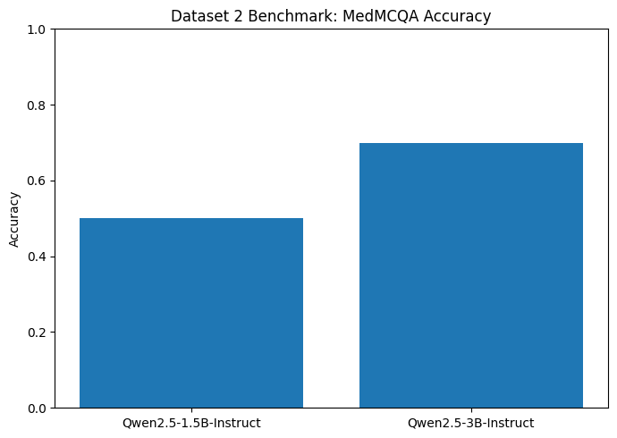
Notebook output: dataset2_medmcqa_accuracy_chart.png — MedMCQA accuracy for the two Qwen models, corresponding to Fig. 3 in the main report.

4. Iterative Development Notes and Decisions
This section records design decisions and iterations made while building the proof-of-concept, as required to demonstrate learning rather than a single unreflective run:
- Model pair selection: Qwen2.5-1.5B-Instruct and Qwen2.5-3B-Instruct were chosen specifically because they are open-weight, instruction-tuned, and small enough to run on a free-tier Colab T4 GPU without quantisation — larger models (e.g. 7B+) were considered but rejected for this proof-of-concept due to VRAM and runtime limits on the free tier.
- Prompt engineering over fine-tuning: given the small case count (10) and time available, prompt engineering (structured output format) was chosen over fine-tuning, which would have required a much larger labelled clinical dataset to avoid overfitting.
- Checkpointing: a checkpoint CSV was saved after Model 1 completed (checkpoint_after_model1_qwen.csv) as a safeguard, after an earlier attempt lost partial results when the Colab runtime disconnected mid-session.
- Sample size for MedMCQA: the full MedMCQA validation split contains 4,183 questions; a 20-question random sample (fixed seed) was used to keep inference runtime manageable within Colab session limits while still providing a second, independent benchmark.
- Scoring approach: manual scoring (rather than automated string matching) was used for the NEJM task because diagnoses can be phrased in clinically equivalent ways (e.g. “rickets” vs “vitamin D deficiency with rickets”) that exact-match scoring would incorrectly mark wrong.
- Both notebook sections (NEJM and MedMCQA) were run to completion and their outputs downloaded before being transcribed into the main report's tables, so that the report's figures are traceable back to this notebook run.

5. Supplementary Evidence Files Included
The following files accompany this document in the supplementary materials package:
File | Location | Contents
COMP6011_Task2_Colab_Notebook.ipynb | notebook/ | Full executable notebook with saved outputs (code, console logs, charts)
Fig1_qwen_benchmarking_chart.png | figures/ | NEJM benchmark comparison chart (Fig. 1 in main report)
Fig2_qwen_score_distribution.png | figures/ | NEJM score distribution chart (Fig. 2 in main report)
Fig3_medmcqa_accuracy_chart.png | figures/ | MedMCQA accuracy chart (Fig. 3 in main report)
nejm_cases_combined_task2.csv | data/ | Prepared NEJM case dataset (excerpt as captured in notebook)
checkpoint_review_after_model1_model2.csv | data/ | Review table with both models' raw outputs
qwen_scored_results_all_cases.csv | data/ | All 10 cases with manual scores and top-3 flags
qwen_benchmarking_summary.csv | data/ | Final quantitative summary table
qwen_score_distribution.csv | data/ | Score distribution counts
qwen_case_improvement_analysis.csv | data/ | Qualitative notes for the 3 improved cases
qwen_final_detailed_benchmarking_results.csv | data/ | Full case-by-case results table
evidence_checklist.csv | data/ | Notebook's own generated evidence-file checklist
dataset2_medmcqa_sample_20_questions.csv | data/ | Sampled MedMCQA questions (excerpt)
dataset2_medmcqa_raw_model_outputs.csv | data/ | Raw model outputs for MedMCQA (excerpt)
dataset2_medmcqa_summary.csv | data/ | MedMCQA accuracy summary
Note: several CSV excerpts above reflect the row/column display limits applied by pandas when the notebook rendered its tables (e.g. .head() previews, or long text fields truncated with “...”). This is a property of how the notebook displayed its own output at the time it was run, not an alteration made afterward — the full underlying values can be regenerated by re-running the accompanying notebook end-to-end.

